

Edinburgh Learns
Inclusion Framework
August 2026-2029


Contents
Purpose and Scope 3
What is Inclusion? 3
Our Vision for Inclusion 4
Key Principles of Inclusion 6
Delivering Our Vision 6
Edinburgh Learns Inclusion Board 8
Inclusion Ambassadors 9
Inclusion Board Strategic Actions 10
Key Performance Indictors 10
Roles and Responsibilities 11

Purpose and Scope
This framework aims to ensure all learners, regardless of background, ability or additional support needs receive an equitable high-quality education by removing barriers, celebrating diversity and fostering belonging; ultimately enabling every learner to belong, contribute, learn and reach their full potential in a supportive school environment.
This framework outlines our delivery of key national legislation and guidance in relation to inclusion including:
- Standards in Scotland’s Schools etc. Act (2000)
- The Education (Disability Strategies and Pupil Records) (Scotland) Act 2002
- Children and Young People Act (2014)
- The Education (Additional Support for Learning) Scotland Act 2004
- Equality Act (2010)
- Children (Scotland) Act (1995)
- UN Convention on the Rights of the Child
- Guidance on Planning Improvements for Disabled Pupil’s access to Education (2014)
- Guidance on the Presumption to Provide Education in a Mainstream Setting (2019)
- How Good is our School (4th Edition)
- GTCS: The Standard for Full Registration
- GTCS: The Standard for Career Long Professional Learning (January 2021)
- National Framework for Inclusion (3rd Edition 2022)
- Working with the National Framework for Inclusion: A Guide for Teacher Educators (2023)

What is Inclusion?
Education is a fundamental human right. It requires that all learners access high-quality education throughout their lives, without discrimination or exclusion.
Inclusive education is essential to the realisation of this right. It is grounded in the principle that all children can learn and that diversity in characteristics, interests, abilities, and learning needs is a valued feature of education systems. An inclusive approach requires education systems to respond to this diversity so that all learners can participate fully and achieve meaningful outcomes together.
“Every learner belongs, and every learner has an equal right to participate and achieve.”
(UNESCO, 2024)

Inclusion can be further defined as per the statements below:

- Inclusion is an ongoing process
Inclusion is a never-ending search to find better ways of responding to learner diversity. It is about respecting diversity and the different needs, abilities and characteristics of learners. It is both about learning how to support difference and learning how to learn from difference. In this way, differences come to be seen more positively as a stimulus for fostering learning among children, young people and adults.

- Inclusion is concerned with the identification and removal of barriers to learning
Inclusion means taking positive action to enable achievement for all by encouraging and developing the potential of every child or young person. Barriers may take different forms, some of which are to do with the way schools are organised, the pedagogy of the teaching provided, and the ways in which children’s progress is evaluated.

- Inclusion is about being present, participating, achieving and being supported
Being ‘Present’ is concerned with attendance in education; ‘participating’ relates to the quality of learners learning experiences and their engagement in them; ‘achievement’ is about the outcomes of their learning across the curriculum; and being ‘supported’ is about ensuring appropriate and adequate support when required.

- Inclusion involves a particular emphasis on those learners who may be at risk of marginalisation, exclusion or at risk of underachievement
This indicates the moral responsibility to ensure identified groups of learners, who may be most at risk, are carefully monitored and where necessary, steps are taken to ensure they are present, participating, achieving and supported within schools. Every learner matters and matters equally.

Our Vision for Inclusion
Our vision for inclusion is that every child or young person irrespective of identity, background or ability is part of a resilient and positive learning community where they feel:

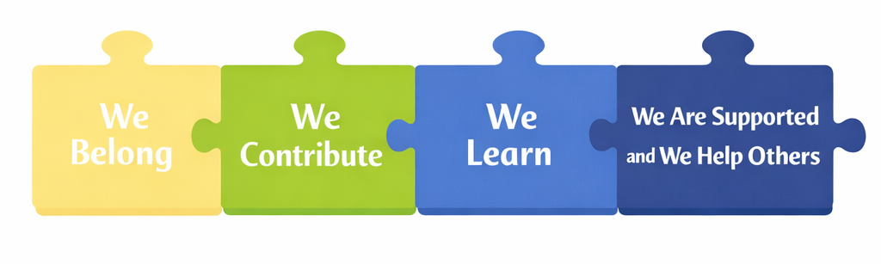

Our vision will be taken forward through the delivery of the National Pillars of Inclusion which can be used to set expectations and evaluate inclusive practice in schools and early learning and childcare settings. These are present, participating, achieving, and supported.

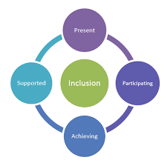

Together these four features support the delivery of inclusive learning environments for all children and young people to enable them to reach their full potential. Every child and young person in Edinburgh should belong, contribute, learn and be supported within an inclusive learning community that recognises and removes barriers to participation and achievement.

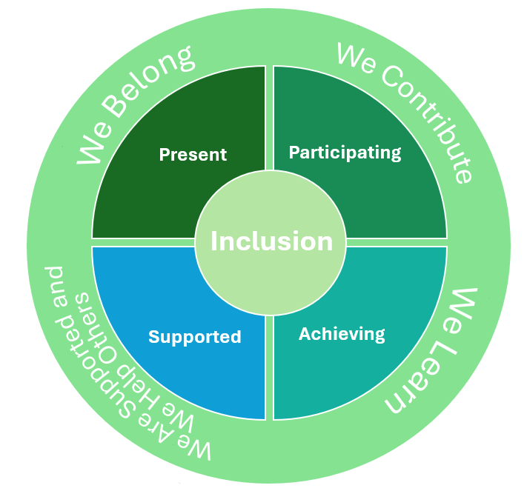

Key Principles of Inclusion

The City of Edinburgh Council aims to deliver high quality inclusive practice that supports the holistic needs of the child whilst planning for and recognising changing needs over time.

Key Principles:
- We will identify and provide support to allow children and young people to overcome any barriers to learning;
- Prevent discrimination of pupils with disabilities/protected characteristics and provide reasonable adjustments to ensure equality of opportunity in learning;
- Plan for accessibility of the physical environment, curriculum and information;
- Promote the wellbeing of children and young people.

Children and young people:
- Have a universal and inalienable right to an education directed towards realising their potential:
- Are supported to attend school and be included, engaged and involved in their learning;
- Feel safe in school have access to a school ethos and culture that promotes respect for all, equality, diversity, and positive relationships;
- Will be given the right help, at the right time, from the right people, to reduce barriers and support their learning and wellbeing;
- Will have access to an equitable, high-quality curriculum tailored to meet their needs;
- Will be educated within their own community to support their sense of belonging, other than in exceptional circumstances.

Delivering Our Vision
The City of Edinburgh Council is committed to supporting and resourcing schools to plan, implement and review inclusive approaches.

Staged Intervention Model
The implementation of GIRFEC is through early identification and assessment of wellbeing needs, meeting these through a range of support which is proportionate and helps to achieve improved outcomes for children, young people and families. This approach must be flexible, outcome focused with concerns and needs being fully considered and addressed at appropriate stages of intervention which in the City of Edinburgh are described as Universal, Targeted or Intensive.
This staged approach to intervention provides the framework for all agencies to identify, assess and meet the needs of children and young people at the earliest opportunity, whist empowering children and young people and families to be part of the process. The process aims, wherever possible, to meet a child or family’s needs via universal services. All families benefitting from universal supports have the named person as a key point of contact.

The process is based on the principle that the practitioner who knows the child or young person well, in partnership with the parent, is best placed to provide help and support in the first instance. Universal services are provided by Education and Health through Health Visitors, Early Learning and Child-Care settings and Schools. Most children and young people develop into adulthood needing only the support available from universal services.
Only when the child or young person’s needs escalate or become more complex should other agencies or professionals offering targeted or intensive supports become involved.
The diagram below shows the Staged Intervention Model from Universal Services which meet the needs of most children and young people, to the most acute end of the continuum which provides intensive support for the smaller number of children and young people with complex needs.

Intensive support is designed for children and young people with more complex or significant, long-term, and potentially life-altering needs. This is provided on a multiagency basis.

Targeted support is additional, focused, and sometimes time-limited support for children and young people who require something extra or different to meet their learning objectives.

Universal support is the initial level of support, available to all children and young people. It is built upon the ethos, climate, and relationships within every learning environment.

Stage | Description
Universal | Universal support is provided by the universal provision of services that are available to all children and young people. Sometimes children and young people need extra support within a universal service (e.g. a support or nurture class) and may be delivered by more than one agency (e.g. education and school nursing service). The support should be co-ordinated and monitor by the named person. Any additional support should be determined by a wellbeing assessment and informed by the views and wishes of the child or young person and their parent or carer. It may be recorded in a Child’s Plan.
Targeted | Targeted support extends beyond what is available universally. Targeted support is not needed by most children and young people. With the agreement of the child or young person and family, a wellbeing assessment will be undertaken to identify needs and specify the targeted support required. A multi-agency Child’s Plan is necessary at this stage to co-ordinate supports and clarify professional roles and responsibilities. A Child’s Planning meeting will be convened involving the parents or carers, the child or young person (if appropriate), the universal service and partner services. At this meeting the Team Around the Child (TAC) will determine and agree if a lead professional is required.
Intensive | Some children and young people require highly specialist support from two or more agencies to address their wellbeing needs. At this stage, the Lead Professional will almost always be a social worker. If the child or young person is involved in a child protection process and/or is Care Experienced (looked after at home or away from home) or subject to a Compulsory Supervision Order, the Lead Professional will always be from Social Work. Support at this stage is intensive and applied because the child or young person has significant and complex support and protection needs. For these reasons, it is expected that support at this stage will be time limited. The Child’s Plan must be reviewed regularly and amended as necessary to maximise impact upon positive outcomes for the child or young person. The aim of the Child’s Plan is to intervene minimally in the child or young person’s life to reduce or remove barriers to the child or young person’s happy and healthy development and to strengthen family capacity.

Local Polices and Guidance
- GIRFEC Multi-agency Guidance (2026)
- Positive Relationships and Behaviour Policy and Procedures (2026)
- Maximising Attendance Policy and Procedures (2025)
- The City of Edinburgh Councils Accessibility Strategy (2026 – 2029)
- Education Resource Group Guidance (2025)
- Preventing and Responding to Bullying and Prejudice amongst Children and Young People Procedure (2021)

Professional Learning
- Support worker professional learning framework
- Positive relationships and behaviour professional learning strategy
- My learning Hub Resources for inclusion and wellbeing
- Education Scotland – Inclusion, Wellbeing and Equalities framework Inclusion, wellbeing and equalities framework | Leading professional learning | Professional Learni…

Edinburgh Learns Inclusion Board

The Edinburgh Learns Inclusion board will meet quarterly to monitor progress towards actions, make recommendations for future actions, and report to the Education Senior Leadership Team.

The Edinburgh Learns Inclusion board is chaired by a Head Teacher and the Head of Education (Inclusion) and comprises:
- Head Teachers from each sector
- Early Years Head of Centre
- Quality Improvement Education Officer, Inclusion
- Service Manager, Inclusion Support
- Education Support Officers, Inclusion and Wellbeing
- Principal Educational Psychologist
- Depute Principal Educational Psychologist
- Wider Achievement and Lifelong Learning Officer
- Head of Allied Health Professionals, NHS

The Edinburgh Learns Inclusion board is supported in its work by the Inclusion Ambassadors and a Parents’ Reference Group.

In addition, the Edinburgh Learns Inclusion Board will:
- Provide an annual report to the Education, Children and Families Committee;
- Take forward improvement actions as outlined in (but not exclusive to) the Education Service Improvement Plan, Accessibility Strategy, Corporate Parenting Plan;
- Agree Local Authority Key Performance Indicators for inclusion;
- Maintain an oversight of resourcing for inclusion to ensure appropriate distribution and best value;
- Maintain and direct professional learning for inclusion to ensure appropriate workforce knowledge, skills and understanding;
- Ensure policies and procedures pertaining to inclusion are relevant, developed and implemented in line with current legislation and communicated effectively;
- Seek out and contribute positively to partnerships which lead to better outcomes for children and young people and for those at greatest risk due to social circumstances and additional support needs;
- Ensure whole establishment/service approaches to self-evaluation and a commitment to continuous improvement over time.

Inclusion Ambassadors
Each and every child and young person should be involved in their own education and have a voice to shape their experience.
The Edinburgh Inclusion Ambassadors (EIA) are currently a group of secondary school-aged pupils who each have a range of additional support needs and attend a variety of school provision across the city. The purpose of the EIAs is to ensure the views of young people with additional support needs specifically are heard and represented in discussions about education within the City of Edinburgh. They meet regularly in their schools and at least twice a year as a whole group.
Their discussions about these priorities are recorded and shared with the Inclusion Board who can then share at school, learning community and CEC senior leadership level. This will inform discussion and help shape school and city-wide policy and guidance.

Our Inclusion Ambassadors have identified the following priority actions:

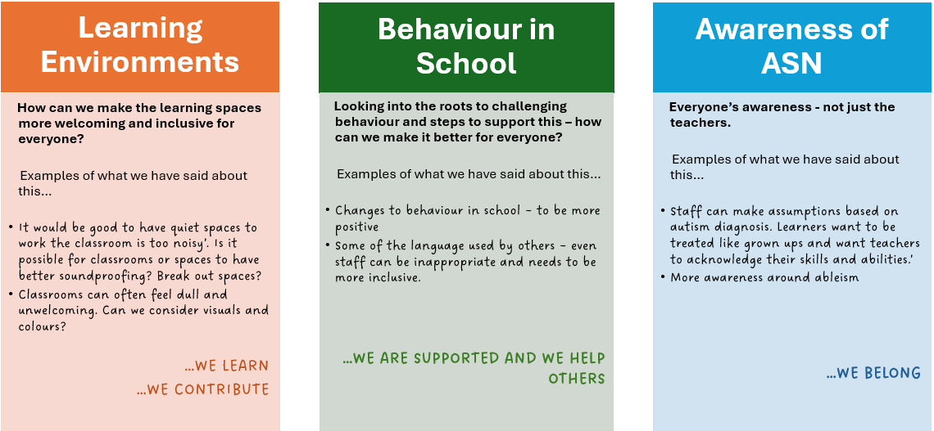

Inclusion Board Strategic Actions

The Inclusion Board aims to support and develop:
- Universal inclusive pedagogy that informs learning and teaching approaches for all learners;
- Universal inclusive practice that is evidence informed and influenced by the views and experiences of children, young people and families;
- A range of policies, procedures and guidance that reflect National guidance and supports schools to prioritise inclusive practice;
- An inclusive learning estate that supports all learners needs;
- The principles of GIRFEC, staged intervention model and the Child Planning Framework to assess and meet children’s needs;
- Use data to understand school contexts, pupil cohorts, and maintain a focus on the outcomes for children and young people who are disadvantaged.

Key Performance Indictors

The following key performance indicators will be monitored and tracked:
- Sustained increase in overall attendance and a sustained decrease in persistent absence and part time timetables.
- Sustained decrease in overall exclusion rates.
- Children, young people and families report that they feel they belong, feel safe and valued within the school community.
- Children, young people and families report that they are active partners in decision making.
- Young people transition from school into a positive destination.
- Children and young people report that they feel well supported in school.
- Children and young people and families report that they have impactful engagement with appropriate services where needed.
- Sustained increase in overall attainment and achievement specifically for learners with disabilities and other vulnerable groups.
- Increased rates of engagement of children and young people in Wider Achievement activities.
- School communities actively promote inclusion, equity ad belonging, reflected in everyday practice, relationships and decision-making.
- Schools will self-evaluate How Good is Our School Quality Indicators 3.1 Ensuring Wellbeing, Equity and Inclusion and 2.4 Personalised Support as a 4 (Good) or above on the 6-point scale.

Roles and Responsibilities

To support schools to ensure inclusive education is of the highest priority and demonstrate a commitment to bring about greater equality and social justice through universal and targeted provision the following responsibilities have been agreed:

Local Authority Officers will:
- Demonstrate a commitment to our vision for inclusion and the four key pillars ensuring all children are: present, participating, achieving and supported.
- Provide support and challenge to schools and settings to bring about improvements in inclusive practice and pedagogy.
- Identify, promote and share effective practice across settings.
- Provide support to Headteachers and Heads of Centres to ensure continuous professional development to meet high internal standards and external work demands and achieve full potential of the workforce.
- Lead on quality assurance requirements providing support and challenge across establishments to identify opportunities for continuous improvement.
- Demonstrate professional values and personal commitment to social justice, integrity, trust and respect and professional commitment as incorporated in professional standards.
- Evaluate their own professional development, work collaboratively with all stakeholders, and model best possible practice in relation to inclusion.
- Keep children and young people, and their wellbeing at the heart of all decisions that are made, working collaboratively to find solutions.

Head Teachers, Heads of Centre and Senior Leadership Teams will:
- Lead and model the best possible practice in relation to inclusion in their setting and challenge any practice that does not meet relevant standards and expectations.
- Ensure that policies, procedures and guidance in relation to inclusion are fully and effectively implemented, and that planning to meet individual needs through the Child’s Planning Framework is embedded in practice.
- Evaluate their own professional development and keep up to date with legislation, policy and research on inclusion; communicating any changes to their staff ensuring everyone understands their roles and responsibilities.
- Demonstrate a shared commitment to self-evaluation using the four key features of inclusion to measure whether all children are: present, participating, achieving and supported.
- Contribute to the development of inclusive practice in both principle and practice across the City of Edinburgh.

Teachers will:
- Ensure that they fully know and understand the needs of each learner, particularly those with additional support needs, who are care-experienced and those living in poverty.
- Plan systematically for effective teaching and learning across different contexts and experiences by developing a positive learning environment, with explicit reference to skills, formative assessment for learning strategies and differentiation to meet the needs of all learners.
- See differences in learning as professional challenges and opportunities for development for teachers not learner deficits.
- Understand their role as leaders of curriculum development (GTCS: The Standard for Full Registration and GTCS: The Standard for Career Long Professional Learning, January 2021) by demonstrating a secure working knowledge and detailed understanding to justify what is taught within the curricular areas, in relation to the curriculum and the relevance to the needs of all learners.
- Plan for learning and teaching and assessment using current Education Scotland guidelines and the National Framework for Inclusion: a guide for Teacher Educators (2023).
- Engage with professional learning for the core aspects of the Teaching Charter specifically in relation to inclusive practice and pedagogy.
- Involve all learners in evaluating the effectiveness of their learning experiences and leading their own learning.
- Engage with How Good Is Our School 4 as a tool for self-evaluation and improvement.

Early Learning and Childcare practitioners will:
- Be child centred, acknowledge children’s views and actively involve children in meaningful ways in everyday decisions within the setting.
- Ensure awareness of and understand the needs of each learner, particularly those with additional support needs, who are care-experienced and those living in poverty.
- Plan systematically for effective play and learning using observations to inform appropriate and well-timed interventions across different contexts and experiences.
- Demonstrate understanding of child development and early learning pedagogy and skilfully put this into practice.
- Develop strong positive relationships and know children very well as learners to make accurate judgements about progress and next steps.
- Involve learners in evaluating the effectiveness of their learning experiences and work in partnership with the child's family to promote and secure next steps for learning and development.
- Actively demonstrate their role as leaders of curriculum development (underpinned by Early years National frameworks and guidance e.g. Realising the Ambition and SSSC: Codes of Practice)
- Engage in professional learning to ensure high quality learning, teaching and assessment. Applying this into practice and pedagogy.

Support Staff will:
- Ensure that they are aware of and understand the needs of each learner, particularly those with additional support needs, who are care-experienced and those living in poverty.
- Ensure that they have accessed professional learning that provides guidance on how to deescalate and support regulation and understand our position of the use of physical intervention.
- Support delivery of whole school and individual plans to support inclusion.
- Support the development of positive relationships and emotional wellbeing of children and young people using evidence-based interventions with individual learners and groups.
- Assist teachers and pupils in all aspects of learning and development by supporting creativity and skills for life and learning; supporting planned group and individual programmes.
- Demonstrate creativity by playing an active role in setting up and supervising a range of activities aimed at supporting pupil learning, development and play, amongst other tasks.
- Demonstrate ability to problem solve and make decisions by taking responsibility and using their initiative to respond to the care and support needs of children and young people, amongst other situations
- Participate in professional development opportunities, in-service- and refresher training, as deemed appropriate

