Annotated nomination papers – Scottish Council elections
- Process and forms
  - Generally, there are two forms that you must submit to make your nomination valid:
- Nomination form
- Home Address form
You must deliver these forms by hand, and they must be originals -so not copies. Any documents sent by email or fax will not be accepted.
1.2 If you are standing on behalf of a registered political party you will also need to submit:
  - a certificate of authorisation
  - an emblem request form (if they want an emblem on the ballot paper)
These can be delivered by hand or by post but must be originals. Any documents sent by email or fax will not be accepted.

  - You may also submit an agent appointment form. This does not need to be submitted with your other nomination forms but must arrive before the deadline to be accepted. If you do not submit an agent appointment form, you become your own agent by default.
  - If you have any issues with completing your nomination forms, please contact the Election Office City Chambers, High Street, Edinburgh EH1 1YJ. elections@edinburgh.gov.uk
  - It is a good idea to have your nomination paperwork informally checked by the elections office before you formally submit it. You can send a photo or scan to elections@edinburgh.gov.uk This can allow you to make corrections or complete new nomination forms if there are any mistakes.
  - Once your nomination is formally submitted you cannot amend any details. But if you change your mind and no longer want to stand for election, you can withdraw your nomination until 4pm on 31 July 2026.

2 Further Information

Other useful guidance sources
Electoral Commission Guidance for candidates and agents
The Scottish Local Government Elections Order 2011

- Annotated forms
These annotated forms cover areas of common confusion or difficulty for you to refer to as you complete your nomination paper.
Notes have been added to draw attention to areas where mistakes are often made, or where you are likely to have questions.

Form 1 – Nomination paper (header)
This section should be completed by election staff when the form is formally submitted.

The ward in which your standing should be added here.

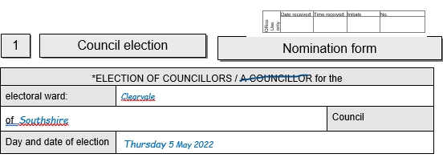
Should be deleted to show if there is one or more vacancy in the division/ward.

The name of the council should be added here.
E.g., if you are standing for a ward in City of Edinburgh it should be added here.
If you put the council’s name in full this would not invalidate the nomination.

It has not been pre-printed; the day and date of the election should be added here.

Form 1 – Nomination paper (Candidate’s details)

Full names must be added here – no initials.
Prefixes like Sir or suffixes like Snr must not be used.

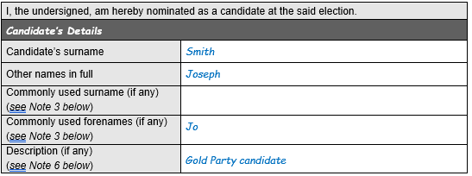
The description may be left blank.

OR you could use the description ‘Independent’.

OR - for political party candidates, you will need to enter the registered party name or description as authorised by the party. This must be as registered with the Electoral Commission, and must match EXACTLY with the description authorised on Form 2 – the Certificate of Authorisation.

It is important to read Electoral Commission guidance if a description is used.

This is optional.
If your commonly known by a different name to your actual name, you should enter it here.
The commonly used name will appear on the ballot paper and the Statement of Persons Nominated instead of your actual name.
It is important to read Electoral Commission guidance if a commonly used name is used.

Form 1 – Nomination paper (consent and witness)
You must strike through any qualification that does not apply, leaving at least one not struck through.
The qualifications which apply must match the information given in the Home Address form.
If qualification (a) applies, the electoral number must be given

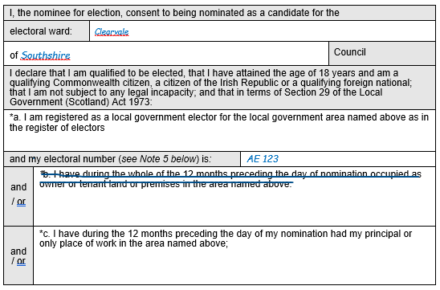
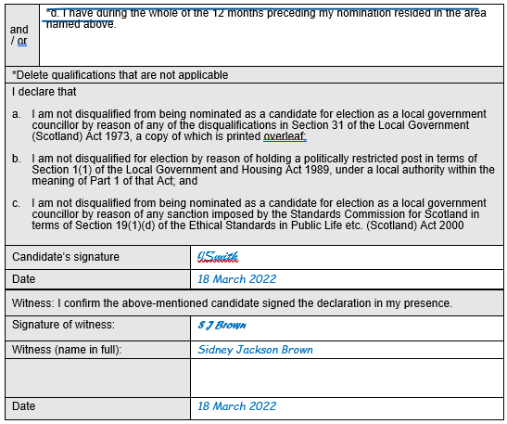
There are no restrictions on who can be a witness, but the same person will need to witness the Home Address form.
For further information see the Electoral Commission guidance.

You must sign here, and the date should not be earlier than 1 month before the deadline for nominations.

Home address form (header)
This section will be completed by election staff when the form is formally submitted.

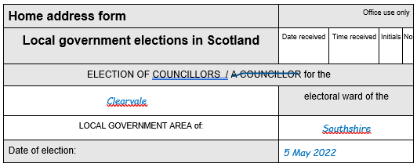
It has not been pre-printed; the date of the election should be added here.
The name of the council should be added here.
E.g., if your standing for a ward in the City of Edinburgh, City of Edinburgh Council ’ should be added here.

The ward in which your standing should be added here.

Home address form (Part 1)
Your home address must be given here:
- in full and without any abbreviations
- it must be your current home address
- it must not be a business address (unless you run a business from your home)
For further information see the EC guidance.

All candidates must complete Part 1 of Form 1b

This should be your actual full name rather than any commonly used name.

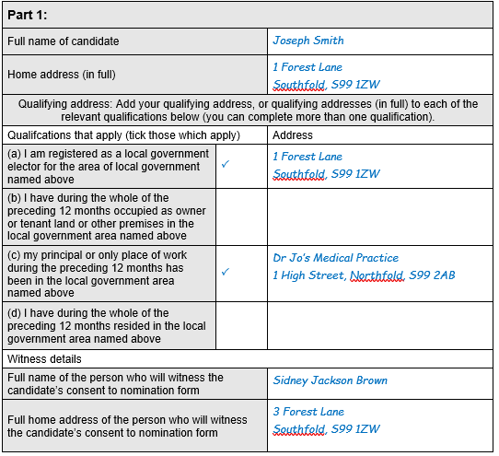
The full address should be written next to each of the qualification that applies to you.
If relevant, a different address may be used for each qualification.
Must match the information given on Form 1.

There are no restrictions on who can be a witness, but the same person will need to witness Form 1.

Home address form (Part 2)
All candidates must complete Part 2 of the Home Address form

If you DO NOT want your home address to appear on the ballot paper, you must insert the name of the relevant area here, or the country if the home address is outside the UK.
You do not need to complete the statement below.

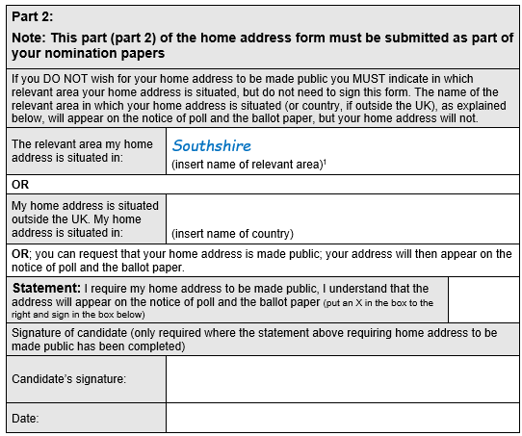
The relevant area is the local government area your home address is in.
For example, if your home address is in the City of Edinburgh council area, the name of the relevant area is City of Edinburgh’.
For further information see the Electoral Commission guidance.

If you DO want your home address to appear on the ballot paper you must put an ‘X’ in this box and sign below.

Form 3 – Certificate of authorisation
For party candidates only

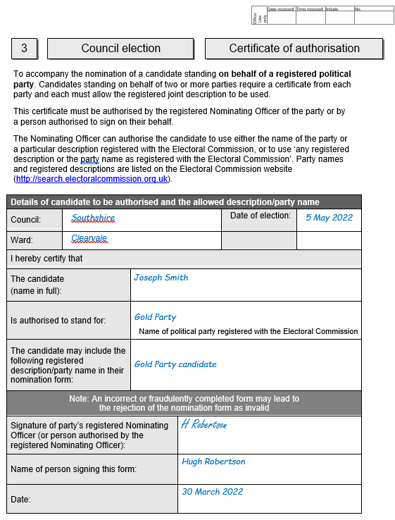
Must be signed by the party’s Nominating Officer or someone authorised by them.

If your authorised to use a specific registered description or the party name, it should be written here. Must match description on Form 1.
Or, if your authorised to choose from a range of registered descriptions or party names, it should say ‘any registered description or the party’s name as registered with the Electoral Commission’
Check the Electoral Commission website for descriptions.

Registered party names and descriptions can be found on the Electoral Commission website.
Searching the registration details of the party and
click for more details to view the descriptions
available to choose from.

Form 4 – Emblem request form
For party candidates only

(To request an emblem as registered with the EC)
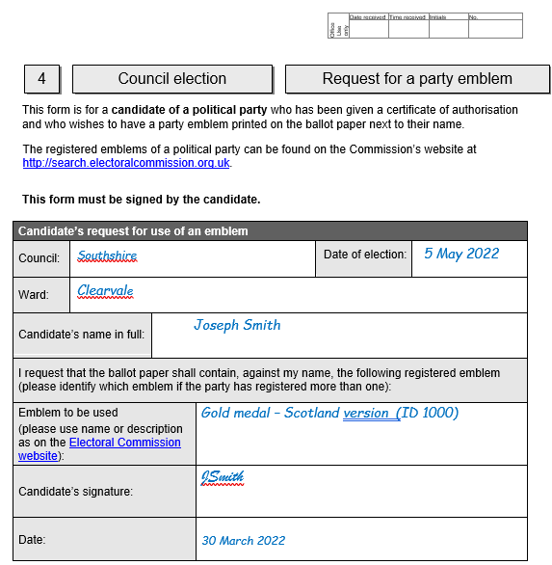
Emblems can be found on the Electoral Commission website by searching the registration details for the party and clicking for more details to view the emblems.
This should be the name as registered with the EC e.g., “Emblem for use in Scotland” or “Emblem ID 1000”.

Must be signed by you.

Form 5 – Agent notification form
Optional – if you do not appoint an agent you will become your own agent by default.
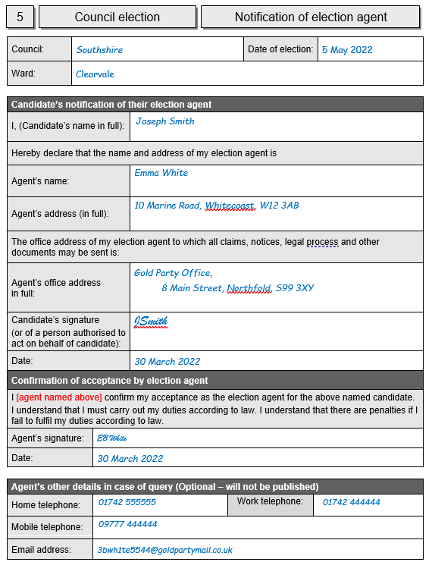
Must be signed by your agent
Must be signed by you
It is useful to provide this information in case of query or follow up contact.
If you appoint yourself as your election agent, but are withholding your home address from the ballot paper and also do not want it to appear on the Notice of Election Agents, you could provide an office address which is different to your home address.
For further information see the Electoral Commission guidance

Must be a physical address, within the same council, or in a constituency within the local government area, or in an English district adjoining it
The agent’s office address will appear on the Notice of Election Agents

Appendix A – Example of correctly completed nomination
