
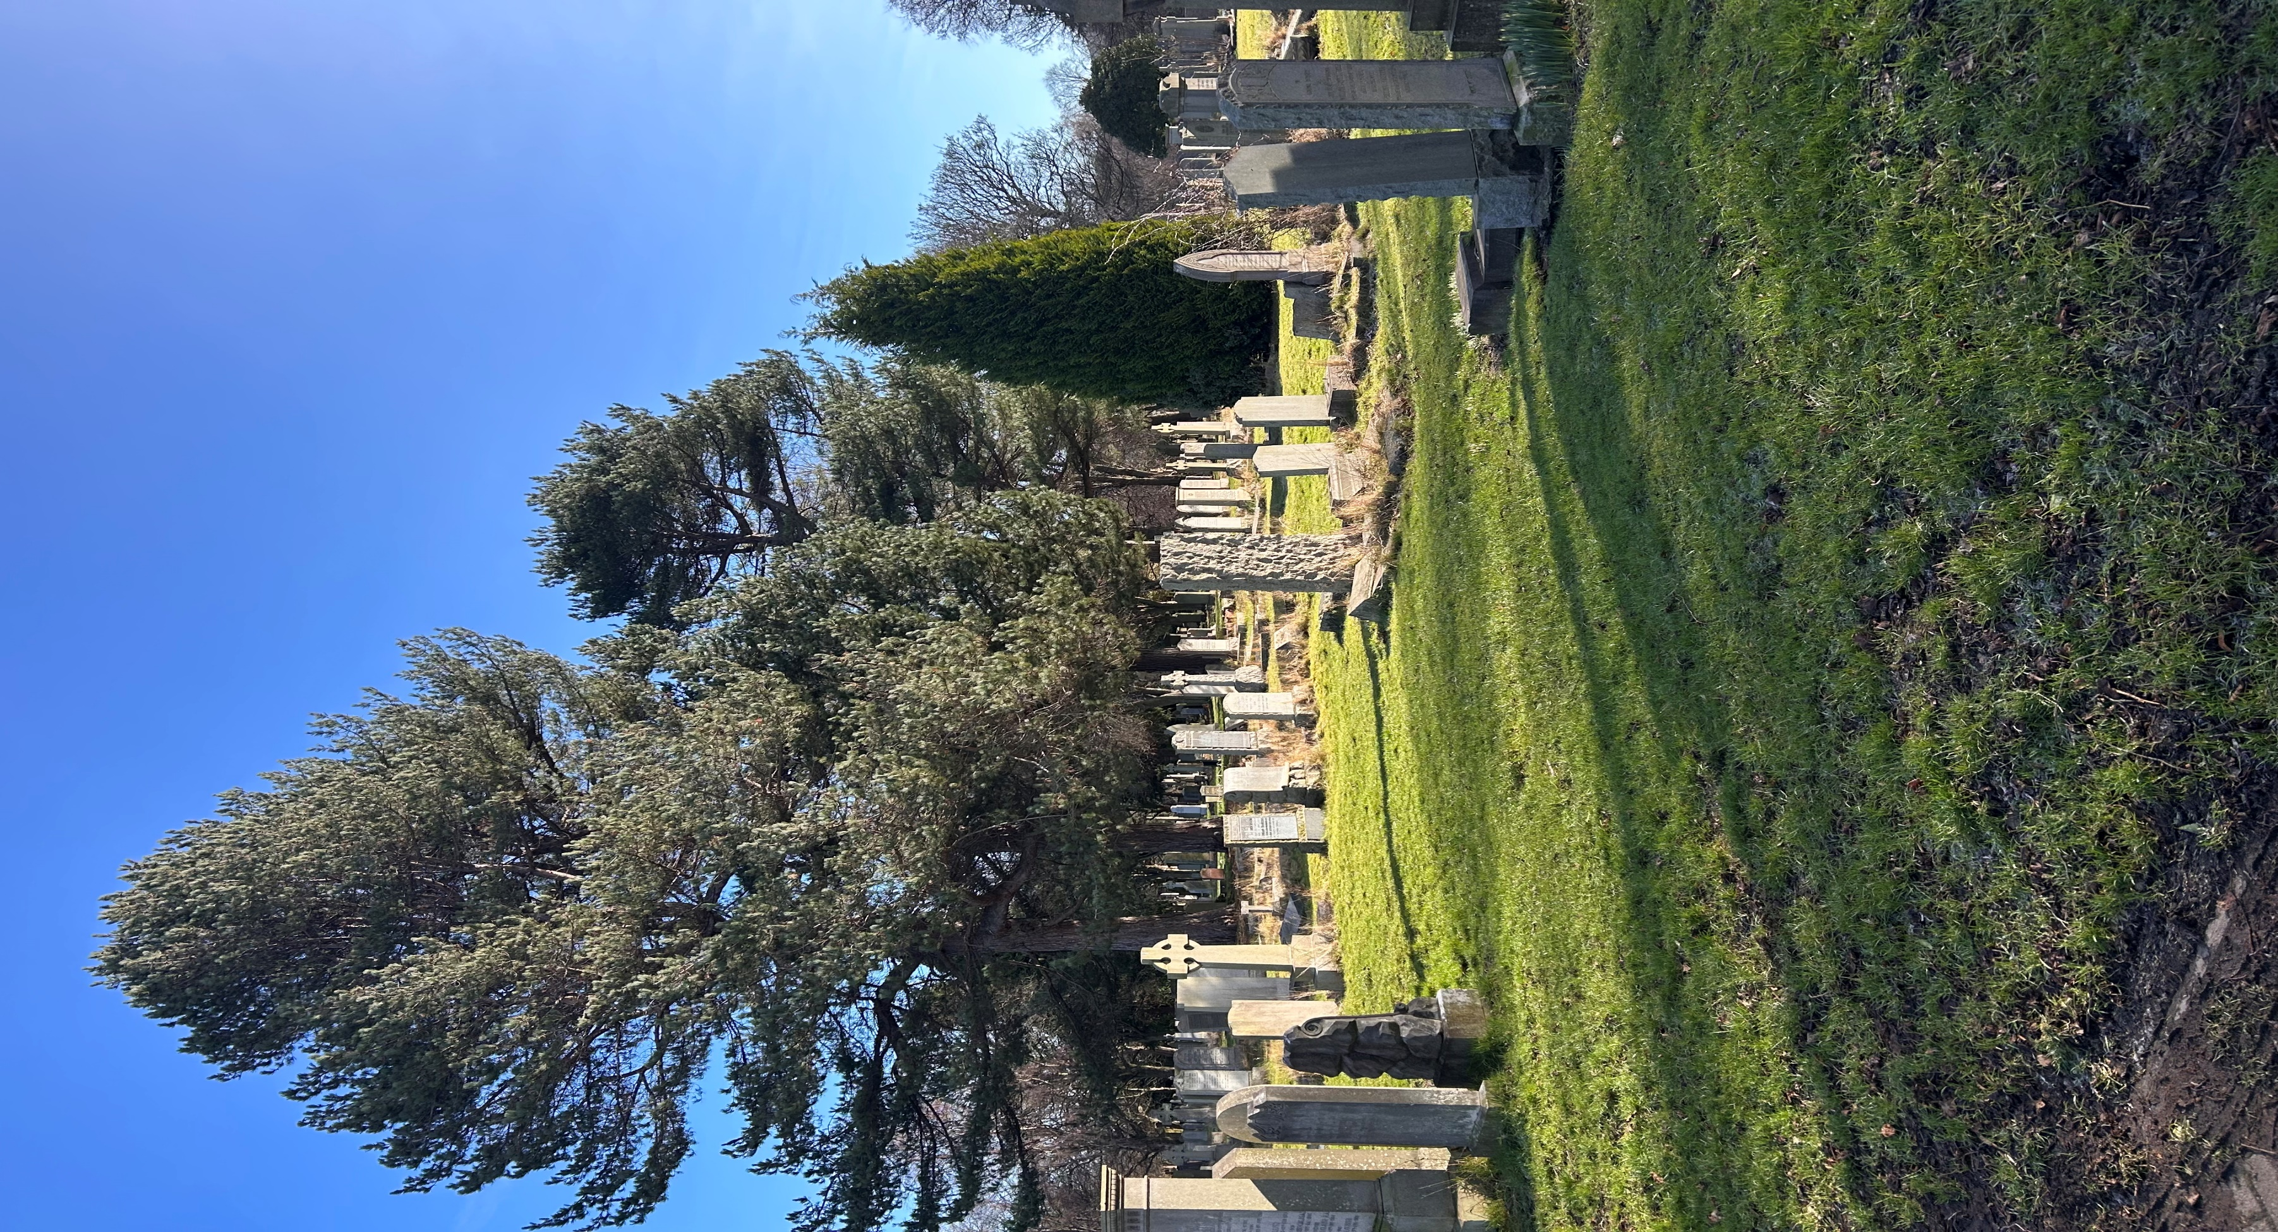
WARRISTON CEMETERY

Version | Author(s) | Comments | Dates
V1.1 | Danielle Gartland-Quinn | Photos by Tam Magee | 25/2/2026

This document will be reviewed on an annual basis. However, a review or revision of any parts can be carried out at any time for service improvements and will be carried out following new legislation or changes to codes of practice.
This document can be viewed by the public during office hours or online.

`

Contents

- Brief history
- Site description
- Site summary
- Asset list
- Grounds maintenance and biodiversity
- Lair types and availability
- Community involvement
- Notable burials and monuments
- Map

- Brief history
Opened in 1843, Warriston Cemetery originally known as The Edinburgh Cemetery was owned by the newly founded Edinburgh Cemetery Company. Designed by architect David Cousin, it was Edinburgh’s very first garden cemetery, the 19th-century movement toward park-like burial grounds, replacing overcrowded city kirkyards. Cousin’s design was so successful that Warriston became the model for many other Scottish cemeteries, and he went on to design other major Edinburgh cemeteries, including those at Dalry and Newington. The site’s architectural landscape features a grand line of neo-Tudor style catacombs built into a terrace to provide above-ground burials; these were further expanded in 1862 when architect John Dick Peddie doubled their original length. Historically, a mortuary chapel stood prominently above these catacombs, though it was demolished some time before 1930. Since the first burial on 3 June 1843, the cemetery has become the final burial place for over 60,000 individuals. The layout was significantly altered in 1845 by the construction of the Edinburgh, Leith and Newhaven Railway, which divided the grounds. To maintain access, John Dick Peddie designed a neo-Tudor style tunnel to connect the two parts of the cemetery. Historically, the cemetery also featured an entrance via a bridge over the Water of Leith at its southernmost point. After falling into severe disrepair, the City of Edinburgh Council acquired Warriston via compulsory purchase in 1994, alongside five other abandoned cemeteries. Today, the site is recognized for its immense heritage value; the cemetery, monuments, catacombs, bridge, and boundary walls are all Category A listed. Now a dedicated local nature conservation area, it is preserved as a peaceful sanctuary for both history and biodiversity.
- Site description
Access to the large Warriston Cemetery is gained via a single point on Warriston Gardens, where visitors cross a bridge over a cycle path (formerly a railway line) and pass two private properties to reach the main entrance. Here, black iron gates set into stone pillars open onto a monoblock driveway that acts as the main access through the grounds, bordered by burial sections. This path connects the upper and lower areas, while a series of winding carriage ways leads toward open lawn sections. True to the garden cemetery style, the layout is spacious and well-organised, enclosed throughout by stone boundary walls of varying heights. The cemetery’s character is defined by a gentle slope that splits the site into two distinct atmospheres, with a line of neo-Tudor catacombs and an overhead terrace serving as the physical division between the maintained and non-maintained areas. The upper sections maintain a formal and accessible feel, featuring the most recent burials and a variety of memorial types. Below the architectural divide of the catacombs, the atmosphere shifts into a lower wilderness. Access to this area is facilitated by both a grand staircase located near a gothic tunnel and the continuation of the winding carriage ways. Under a dense canopy of trees, this lower section offers a contrasting experience of overgrowth and limited maintenance, evoking the feeling of a woodland walk. Within this area, a specific walled-off section contains both a burial area and the remains of a gardeners’ cottage. The undisturbed flora and fauna throughout these grounds further enhance its status as a Local Nature Conservation Site. Nearby, the Commonwealth War Graves Commission memorial is positioned close to the tunnel, while through the tunnel the southernmost portion of the cemetery provides a scenic backdrop along the Water of Leith. Throughout the site, an impressive range of memorials reflects the diverse cultural trends and social history of their time. A virtual tour of the cemetery can be viewed here.

- Site Summary
Name | Warriston Cemetery
Address | 42 Warriston Gardens Edinburgh
Postcode | EH3 5NE
Ownership | The City of Edinburgh Council
Date site acquired | 1994
Size | 9.24 hectares
Conservation area | Yes
Tree preservation | Yes
Listing | A
Access | Vehicle and pedestrian
Opening hours | 24 hours

- Asset List
Asset | Location | Information
Waiting room | No
Toilets | No
CCTV | No
Signage | Cemetery gates | Signs detailing name of the cemetery, cemetery user information, safety signs
Cabinet signage | Cemetery entrance | Sign welcoming cemetery users, displaying cemetery rules, biodiversity information, other useful information
Car park | Outside cemetery gates | 3 dedicated cemetery parking spaces
Disabled parking | No
Taps | No
Litter bins | Yes, throughout site see map
Benches | Yes, throughout site see map
Catacombs | Yes, middle of cemetery
War memorials | Yes, 2 lower part of cemetery, see map | More information can be found on Commonwealth War Grave Commission webpage.

- Grounds maintenance and biodiversity

The Council has revised its approach to grounds maintenance in response to the current nature emergency. This approach aims to protect and enhance existing biodiversity while encouraging the development of new habitats across the cemetery. This means less frequent grass cutting, no use of weedkiller, introduction of wildflowers, and the encouragement of natural grassland growth.

The upper section of the cemetery receives a higher level of grounds maintenance, including lawn cutting and strimming. In contrast, the lower section is managed on a low-intervention basis, with no cutting or clearance to encourage the development of the natural flora and fauna.

Routine maintenance activities are outlined below. A complete summary of our ground’s maintenance plans can be found in the Bereavement Services Cemeteries Management Plan.

Routine Maintenance | Frequency | Additional information
Grass cutting | Approx. every 10-12 weeks during appropriate seasons | No grass cutting during No Mow May
Strimming | Approx. every 10-12 weeks during appropriate seasons | No grass cutting during No Mow May
Leaf clearance | When required | Removal from hard standing areas and pathways only.
Sunken graves | When required
Re-turfing / grass seeding | When required | Method will depend on season
Hedge cutting | Annually | No hedge / shrub work during bird nesting season (March-August)
Emptying bins | When required

A biodiversity study conducted in 2021 identified that Warriston Cemetery already supports a large range of biodiversity, including a variety of trees, grasses, animals, and insects. The council is committed to protecting these existing habitats and encouraging biodiversity across the site. A list of species found in the cemetery in 2021 are detailed below.

Species List | Details
Trees | Ash, beech, hawthorn, hazel, holm oak, horse chestnut, lime, maple, monkey puzzle, scots pine, silver birch, sycamore, whitebeam.
Shrubs | Brambles, buddleia, cotoneaster, holly, honesty, ivy, privet, rhododendron.
Grasses | Cocksfoot, poa pratensis.
Flowers | Bluebells, broad leaved willowherb, comfrey sp, common hogweed, common mallow, cornflower, cow parsley, cransesbill, creeping buttercup, cuckoo flower, daffodil, daisy, dandelion, dock, few flowered leek, fox and cubs, glory of the snows, nettles, primrose, purple loosestrife, ribwort plantain, rosebay willowherb, spear thistle, white clover, wood avens, geranium, marigold, narcissus, nasturtium, michaelmas daises.
Fungi | Common ink cap, coral spot, honey fungus
Mosses | Hypnum sp.
Mammals | Badger, fox, grey squirrel, vole
Birds | Blackbird, blackcap, blue tit, bullfinch, buzzard, carrion crow, chaffinch, chiffchaff, coal tit, dunnock, goldcrest, goldfinch, great spotted woodpecker, great tit, grey wagtail, house martin, long tailed tit, magpie, mallard, nuthatch, redwing, robin, song thrush, sparrowhawk, stock dove, swift, tawny owl, tree creeper, wood pigeon, wren. A list of birds spotted in the cemetery by birdwatchers can be found here.
Insects | Hoverflies, Narcissus bulb fly, bee mimic fly, marmalade hoverfly, comma butterfly, green veined white butterfly, large white butterfly, meadow brown butterfly, orange tip butterfly, peacock red admiral butterfly, small white butterfly, speckled woof butterfly, wall butterfly, leaf leaning moth, common carder, cuckoo bumble bee, common wasp. 2, 7, 10, 18 spot ladybirds, crem spot ladybirds, harlequin lady bird, pine ladybird, orange ladybird, striped ladybird, red soldier beetle, rosemary beetle, ground beetle, shield bugs.

As part of our ongoing biodiversity work, the Council have placed nature cameras in Warriston Cemetery to monitor the wildlife using the cemetery. Although a cemeteries primary purpose is as a place of remembrance and reflection wildlife are often attracted to cemeteries due to their quiet unchanging environment.

- Lair type and availability

There are no new lair’s available at Warriston Cemetery, burial can only be arranged in an existing lair.

- Community involvement

The Friends of Warriston Cemetery were established in 2013 and are dedicated to caring for the heritage and biodiversity of the cemetery. Their involvement enhances the condition of the cemetery and contributes significantly to the improvements seen across the site. Their commitment, local knowledge and hands-on involvement have made a meaningful difference to the appearance, accessibility and historical understanding of Warriston Cemetery. Members of the Friends of Warriston group have a deep interest in and knowledge of the cemetery's local history, researching the stories of those buried there and helping preserve the cemetery’s cultural heritage.

Activities carried out by the Friends group include:

- Family research
- Gardening and maintaining planted area
- Improving paths and general access around the cemetery
- Providing homes for birds, bats, insects and other wildlife
- Cleaning headstones of vegetation
- Hosting community events and open days
- Assisting with landscape improvements alongside members of staff
- Leading guided talks and walks to share the cemetery's history
- Contributing to the ongoing management and future planning of the site
- Conducting Remembrance Day services

The Friends group's involvement not only supports essential maintenance but also helps visitors better understand and appreciate the site's significance.
Contact details for volunteering, supporting or becoming a member of this Friends group can be found on the friends webpage.
Establishing or joining a 'Friends of' group is a meaningful way to contribute to your community while helping us protect these spaces. If you are interested in forming a new group or would like to enquire about future opportunities, please contact Bereavement Services.

- Notable burials and monuments

Warriston Cemetery includes many notable burials. One of the most significant is Dr James Young Simpson (1811 – 1870), who is an important figure in medical history. He was the first physician to display the use of chloroform in humans and helped promote its use in medicine. When he died in 1870, his family were offered a burial space in West Minster Abbey, which they declined deciding to bury him in Warriston Cemetery instead. His grave is marked by a large obelisk memorial located in section D of the cemetery.

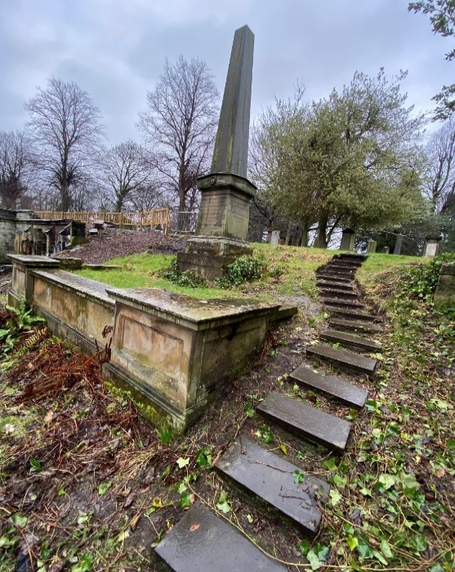
The cemetery also contains a number of war graves dating from the first and second world wars. A memorial within the cemetery records the names of those buried in unmarked graves. In addition, a large war memorial located the lower part of the cemetery and forms a significant commemorative feature. More information can be found on the Commonwealth War Graves Commission webpage.
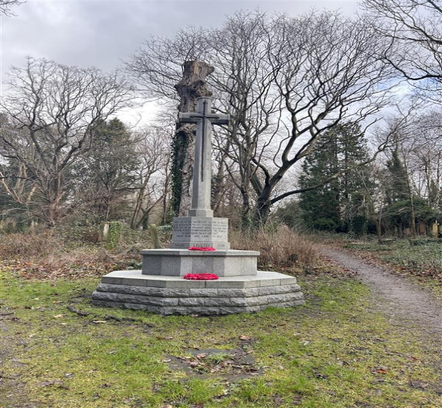

- Map
