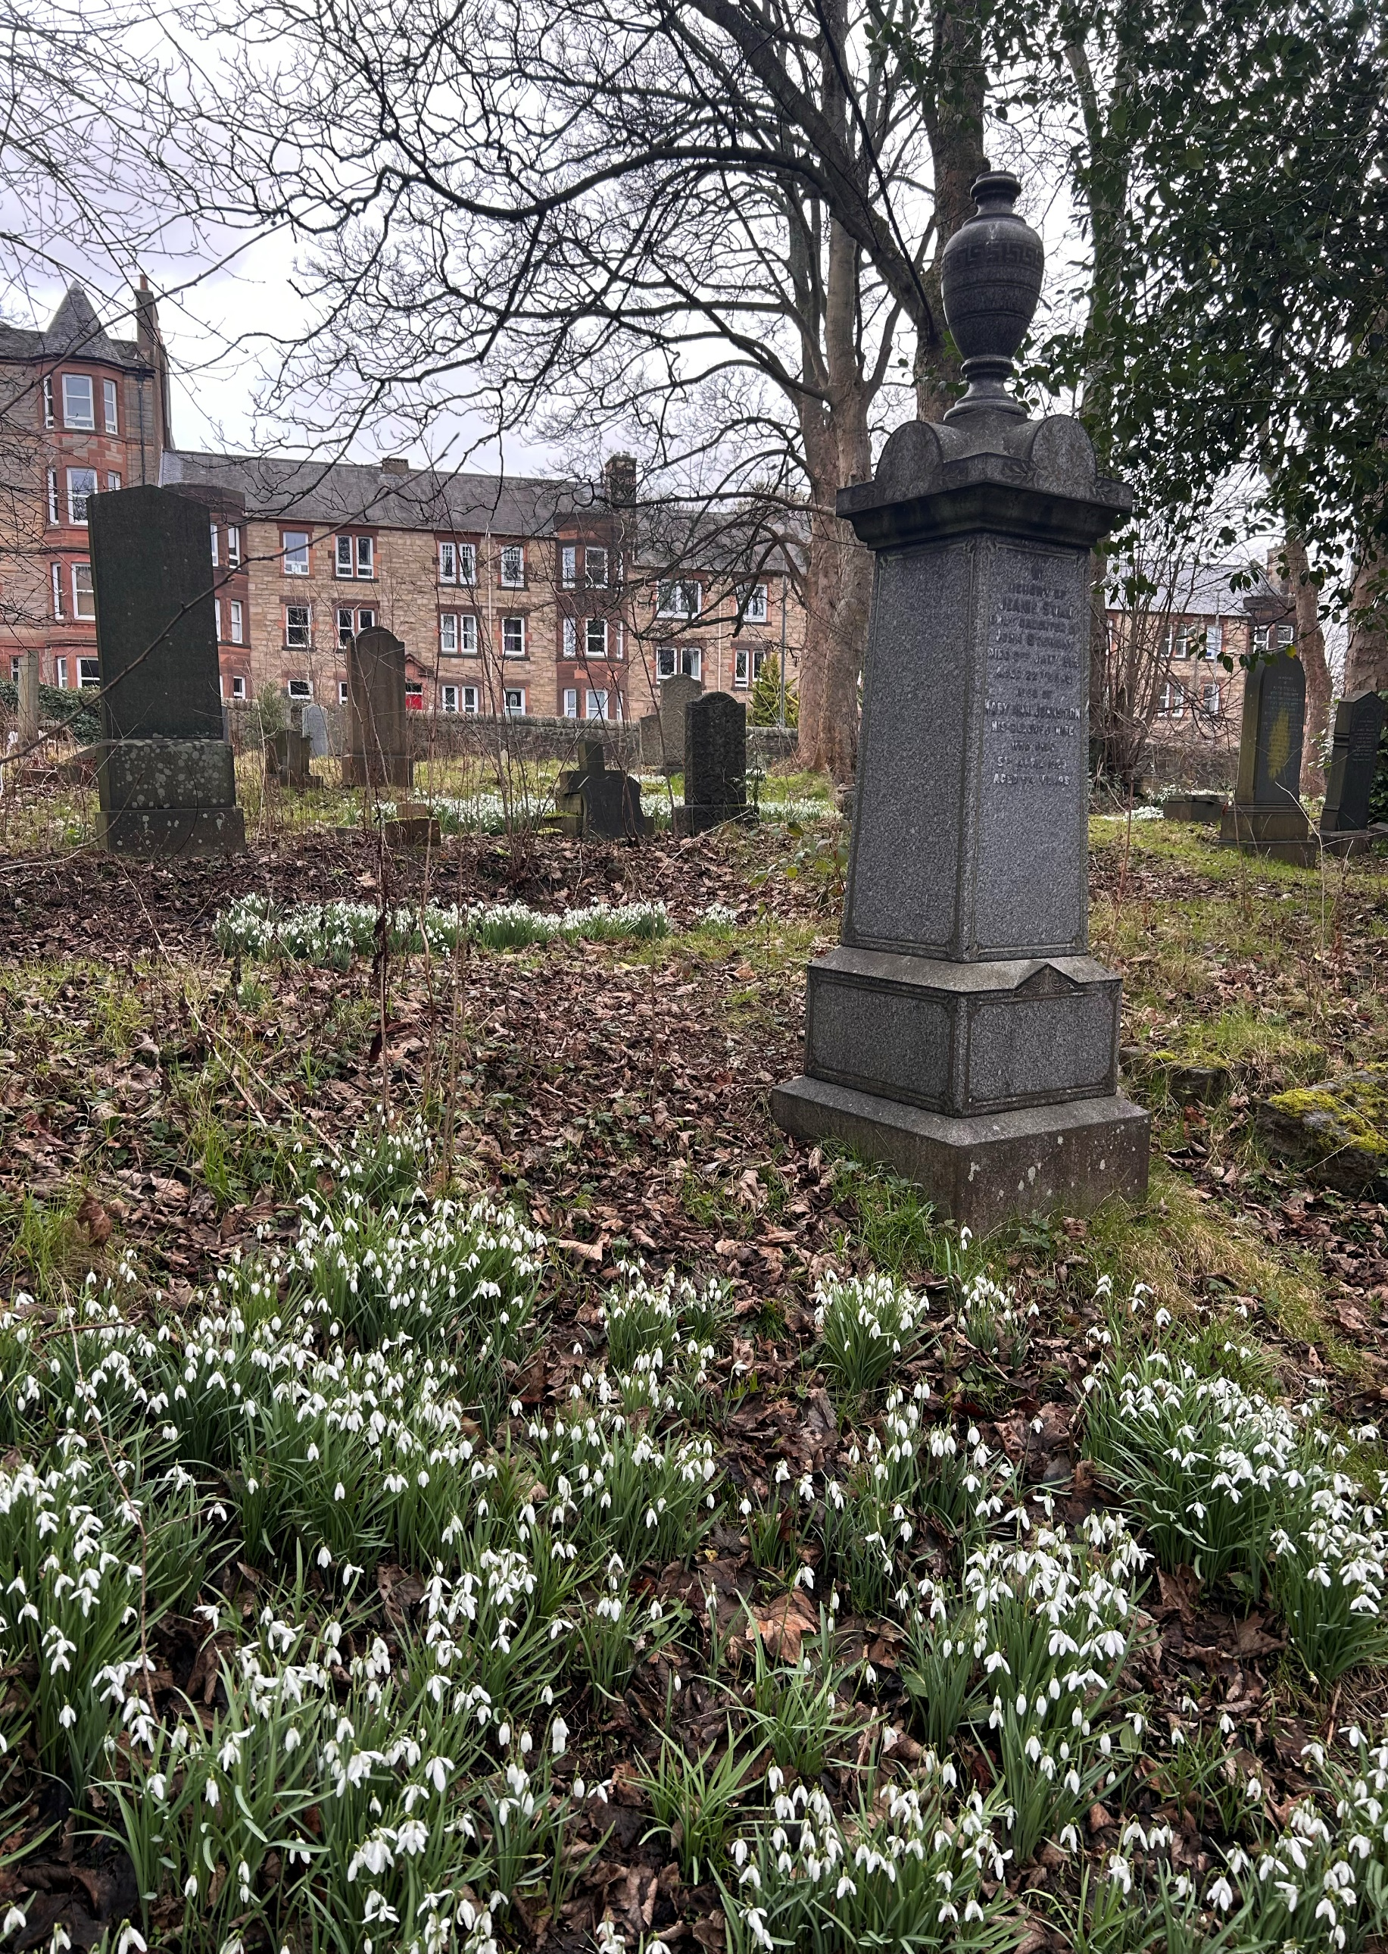


NEWINGTON CEMETERY

Version | Author(s) | Comments | Dates
V1.1 | Danielle Gartland-Quinn | Photos by Tam Magee | 25/2/2026

This document will be reviewed on an annual basis. However, a review or revision of any parts can be carried out at any time for service improvements and will be carried out following new legislation or changes to codes of practice.
This document can be viewed by the public during office hours or online.

`

Contents

- Brief history
- Site description
- Site summary
- Asset list
- Grounds maintenance and biodiversity
- Lair types and availability
- Community involvement
- Notable burials and monuments
- Map

- Brief history

Established in 1846 by the Metropolitan Cemetery Association, Newington Cemetery originally named Newington Necropolis, then Echo Bank Cemetery, and very briefly Southern Cemetery is a typical example of the mid-19th-century garden cemetery movement. Designed by Edinburgh architect David Cousin, the site was part of a cultural shift away from overcrowded parish kirkyards toward scenic, park-like burial grounds. Cousin’s layout masterfully blended the natural landscape with grand features, including the Victorian Gothic lodge and gates at the Dalkeith Road entrance and the neo-Norman west-facing catacombs and terrace situated in the centre of the grounds. Since the first interment on 29 March 1846, the cemetery has become the final burial place for over 68,000 individuals, including those in Commonwealth War Graves (primarily from WWI) and a specific railed-off section by Dalkeith Road used for Jewish burials until 1945. Throughout its history, the site’s accessibility progressed; a grand carriage drive from Craigmillar Park was added in the late 1860s but was later closed and the land sold for private residential development. In the 1880s, the arrival of the South Suburban Railway and Newington Station, along with an adjacent tram stop, provided vital transport links for visitors. Following a period of severe neglect and vandalism, the City of Edinburgh Council acquired the cemetery via compulsory purchase in 1994. Today, Newington Cemetery serves as a peaceful urban greenspace and a vital wildlife sanctuary, prioritising biodiversity and urban sustainability within Edinburgh’s urban landscape.

- Site description

Newington Cemetery is accessed via Dalkeith Road through an entrance marked by Gothic-style pillars and ornate iron gates, where a matching Gothic lodge house, now a private residence, sits on the right of the entrance. A gravel carriageway serves as the primary roadway, leading into a network of winding roads that provide access to the various burial sections throughout the large, unusually shaped site. The perimeter is defined mainly by traditional stone walls, with some areas featuring modern fencing. Immediately to the right of the entrance lies a dedicated Jewish burial section, enclosed by fencing and notable for its many headstones with Hebrew inscriptions. As a classic example of a garden-style cemetery, the grounds are spacious and well-organised with grassed burial sections. At the heart of the cemetery, the catacombs, staircases and an elevated terrace serve as an architectural focal point, complemented by a significant war memorial close by. The memorials themselves vary greatly in size, style, and colour, ranging from grand monuments to more modest stones; while many have been laid flat for safety purposes, they continue to provide a visual history of those interred. Managed today with a strong focus on biodiversity, the cemetery has become a vital urban greenspace. The combination of open grassed areas, winding paths, and undisturbed overgrowth creates a secluded, peaceful atmosphere where historic masonry meets wild nature, offering a quiet retreat from the surrounding city.

- Site Summary
Name | Newington Cemetery
Address | 222B Dalkeith Road Edinburgh
Postcode | EH16 6SX
Ownership | The City of Edinburgh Council
Date site acquired | 1993
Size | 5.74 hectares
Conservation area | Yes
Tree preservation | Yes
Listing | B
Access | Vehicle and pedestrian
Opening hours | 24 hours

- Asset List
Asset | Location | Information
Waiting room | No
Toilets | No
CCTV | No
Signage | Cemetery gates, throughout site | Signs detailing name of the cemetery, cemetery user information, safety signs, signs placed by Friends regarding biodiversity, War Grave information
Cabinet signage | Cemetery entrance | Sign welcoming cemetery users, displaying cemetery rules, biodiversity information, other useful information
Car park | No
Disabled parking | No
Taps | No
Litter bins | Yes, throughout site see map
Benches | Yes, throughout site see map
Catacombs | Yes, see map
War memorials | Yes, throughout site | More information can be found on Commonwealth War Grave Commission webpage.

- Grounds maintenance and biodiversity

The Council has revised its approach to grounds maintenance in response to the current nature emergency. This approach aims to protect and enhance existing biodiversity while encouraging the development of new habitats across the cemetery. This means less frequent grass cutting, no use of weedkiller, introduction of wildflowers, and the encouragement of natural grassland growth.

Newington Cemetery is managed with a low-intervention approach to prioritize biodiversity and the flourishing of local wildlife. By intentionally limiting formal grounds maintenance, the site serves as a protected habitat where native flora and fauna can thrive undisturbed. This sustainable management strategy transforms the cemetery into a vibrant urban ecosystem, balancing its role as a place of remembrance with a commitment to ecological conservation.

Routine maintenance activities are outlined below. A complete summary of our ground’s maintenance plans can be found in the Bereavement Services Cemeteries Management Plan.

Routine Maintenance | Frequency | Additional information
Grass cutting | Approx. every 10-12 weeks during appropriate seasons | No grass cutting during No Mow May
Strimming | Approx. every 10-12 weeks during appropriate seasons | No grass cutting during No Mow May
Leaf clearance | When required | Removal from hard standing areas and pathways only.
Sunken graves | When required
Re-turfing / grass seeding | When required | Method will depend on season
Emptying bins | When required

A biodiversity study conducted in 2021 identified that Newington Cemetery already supports a large range of biodiversity, including a variety of trees, grasses, animals, and insects. The council is committed to protecting these existing habitats and encouraging biodiversity across the site. A list of species found in the cemetery in 2021 are detailed below.

Species List | Details
Trees | Ash (some with signs of dieback), cherry, cypress; False Acacia; Fig, Giant Redwood; Holly; Honey Locust; Hornbeam; Horse Chestnut, Laburnum, laurel (including Common Laurel and Portugal Laurel); Lime, London Plane; Norway Maple; oak (including Turkey oak); pine (including Corsican Pine and Scots Pine); Sweet Chestnut; Sycamore, Walnut, Yew
Shrubs | Bramble, Buddleia; Camellia; Cotoneaster, Elder, Honesty, Honeysuckle; Hydrangea, Rhododendron, Snowberry
Grasses | Cocksfoot; Meadow grass (Poa pratensis); Timothy grass and others.
Flowers | Bluebell, Broad Leaved Willowherb, Chickweed; Cleavers; Common Hogweed, Creeping Buttercup, Crocus, Daffodil; Daisy; Dandelion; Dock, Feverfew; Few Flowered Leek, Foxglove, Garlic Mustard; Giant Hogweed; Glory Of The Snows; Grape Hyacinth; Green Alkanet; Groundsel; Herb Robert, Lesser Celandine; Lungwort, Michaelmas Daisy, Narcissus, Nettle, Primula; Ragwort, Rosebay Willowherb; Ribwort Plantain; Scilla, Shepherd's Purse; Snowdrop, Spear Thistle (and one other species of thistle); speedwell (Ivy Leaved Speedwell and one other species); Water Avens; White Clover, Wild Garlic, Wild Strawberry; Wood Avens
Fungi | Artist's Pallette (Ganoderma applanatum), Blue Wood Fungus (Chlorociboria aeruginascens), Bracket Fungi; Candlesnuff; Collared Earthstar (Geastrum triplex); Dead Men's Fingers (Xylaria polymorpha); Mycena sp; Purple Jelly Disc; a slime mould; Tar Spot on sycamore.
Mosses | Anomalous Bristle Moss ( Orthotrichum anomalum); Grimmia pulvinata, Hypnum sp, Plagiomnium undulatum; Springy Turf Moss (Rhytididelphus squarrosum); Wall Screw Moss (Tortula muralis) and others.
Mammals | Hedgehog; Grey Squirrel
Birds | Blackbird, Blackcap, Blue Tit (using one of the nest boxes), Bullfinch, Buzzard, Carrion Crow, Chaffinch, Chiffchaff, Coal Tit, Dunnock, Goldcrest, Goldfinch, Great Spotted Woodpecker, Great Tit, Long Tailed Tit, Song Thrush, Tawny Owl, Treecreeper, Woodpigeon, Wren
Insects | Bees and Wasps: Buff Tailed Bumblebee; Common Carder Bee; Common Wasp; Honey bee; Marsham's Nomad bee; Red Tailed Bumblebee Tree bumblebee; White tailed Bumblebee  Hoverflies: Banded Hoverfly (Syrphus sp); Marmalade Hoverfly and at least two other species  Ladybirds: 2-Spot Ladybird; 7 Spot Ladybird, 10-Spot Ladybird; 18 Spot Ladybird; Cream-Spot Ladybird, Eyed Ladybird; Harlequin Ladybird, Larch Ladybird; Pine Ladybirds, Orange Ladybird  Moths: Bittersweet Fanner (Acrolepia autumnitella); Blastobasis vittata; Buff Footman (Eilema depressa); Clouded Cosmet (Mompha langiella); Common Nettle Tap (Anthophila fabriciana); Golden Pigmy Moth (Stigmella aurella); Grey Chi; Horse Chestnut Leaf-Miner (Cameraria ohridella); March Tubic (Diurnea fagella); Rusty Dot Pearl Moth (Udea ferrugalis); Small Red Slender Moth (Caloptilia rufipennella)  Butterflies: Comma; Green Veined White; Orange Tip; Peacock; Small Skipper; Small Tortoiseshell; Small White; Speckled Wood  Beetles: Euophryum confine (a weevil); at least one species of flower beetle; a species of latridiid beetle; Loricera pilicornis; Phloiophilus edwardsii; Rabocerus gabrieli; Rosemary Beetle; Salpingus planirostris; Sphaeriestes castaneus  Shield Bugs: Birch Shield Bug; Hawthorn Shieldbug; Juniper Shieldbug; Red Legged Shield Bug.  Other Bugs: Buchananiella continua; Deraeocoris lutescens (a Mirid bug); Flower Bugs (Anthocoris nemoralis and Anthocoris confusus): Harpocera thoracica; Shield Bugs  Bark Flies: Chilenocaecilius ornatipennis; Ectopsocus axillaris; Elipsocus hyalinus and Epicaecilius pilipennis  Other Flies: a species of dagger fly; Dolerus haematodes (a sawfly); Greenbottle; Leucophenga maculata; Limnephilus sparsus (a caddis fly); Limonia nubeculosa (a crane fly); Peplomyza litura; a species of Psychodidae fly.  Other Insects: aphids, bark lice (Ectopsocus axillaris and Ectopsocus petersi); Entomobrya albocincta (a species of springtail); Gelis areator (an ichneumonid), Great Four-Spot Treerunner (Dromius quadrimaculatus), Pine Treerunner (Dromius angustus);  Spiders and harvestmen: Garden Orb-Web Spider (Araneus diadematus); money spider; Neriene peltata (a small spider); Running Crab Spider; Three species of harvestman (Oligolophus hanseni, Opilio canestrinii and Platybunus pinetorum)

As part of our ongoing biodiversity work, the Council may place nature cameras in the cemetery to monitor the wildlife. Although a cemeteries primary purpose is as a place of remembrance and reflection wildlife are often attracted to cemeteries due to their quiet unchanging environment.

- Lair type and availability

There are no new lair’s available at Newington Cemetery, burial can only be arranged in an existing lair.

- Community involvement

The Friends of Newington Cemetery are dedicated to caring for the heritage and biodiversity of the cemetery. Their involvement enhances the condition of the cemetery and contributes significantly to the improvements seen across the site. Their commitment, local knowledge and hands-on involvement have made a meaningful difference to the appearance, accessibility and historical understanding of Newington Cemetery. Members of the Friends Group have a deep interest in and knowledge of the cemetery's local history, researching the stories of those buried there and helping preserve the cemetery’s cultural heritage.
Activities carried out by the Friends group include:
- Tree planting and habitat creation
- Gardening and maintaining planted areas
- Improving paths and general access around the cemetery
- Creating and maintaining wildflower meadows
- Providing homes for birds, bats and other wildlife
- Assisting with landscape improvements alongside Council staff
- Leading guided talks and walks to share the cemetery’s history
- Contributing to the ongoing management and future planning of the site
The Friends group's involvement not only supports essential maintenance but also helps visitors better understand and appreciate the site's significance.

Contact details for volunteering, supporting or becoming a member of this Friends group can be found on the friends webpage.

Establishing or joining a 'Friends of' group is a meaningful way to contribute to your community while helping us protect these spaces. If you are interested in forming a new group or would like to enquire about future opportunities, please contact Bereavement Services.

- Notable burials and monuments

As the only woman listed among the cemetery’s war dead, Dorothy (Peddie) Borrow represents a pivotal moment in military history. Serving as an Assistant Administrator in Queen Mary’s Army Auxiliary Corps (QMAAC), Dorothy was awarded the British and Victory medals for her service in a theatre of war. Despite the destruction of many personnel files during the Blitz, her legacy is preserved here and through the records of the Commonwealth War Graves Commission. Discover more about Dorothy’s story on the Friends of Newington Cemetery website and the Commonwealth War Graves Commissions’ website.

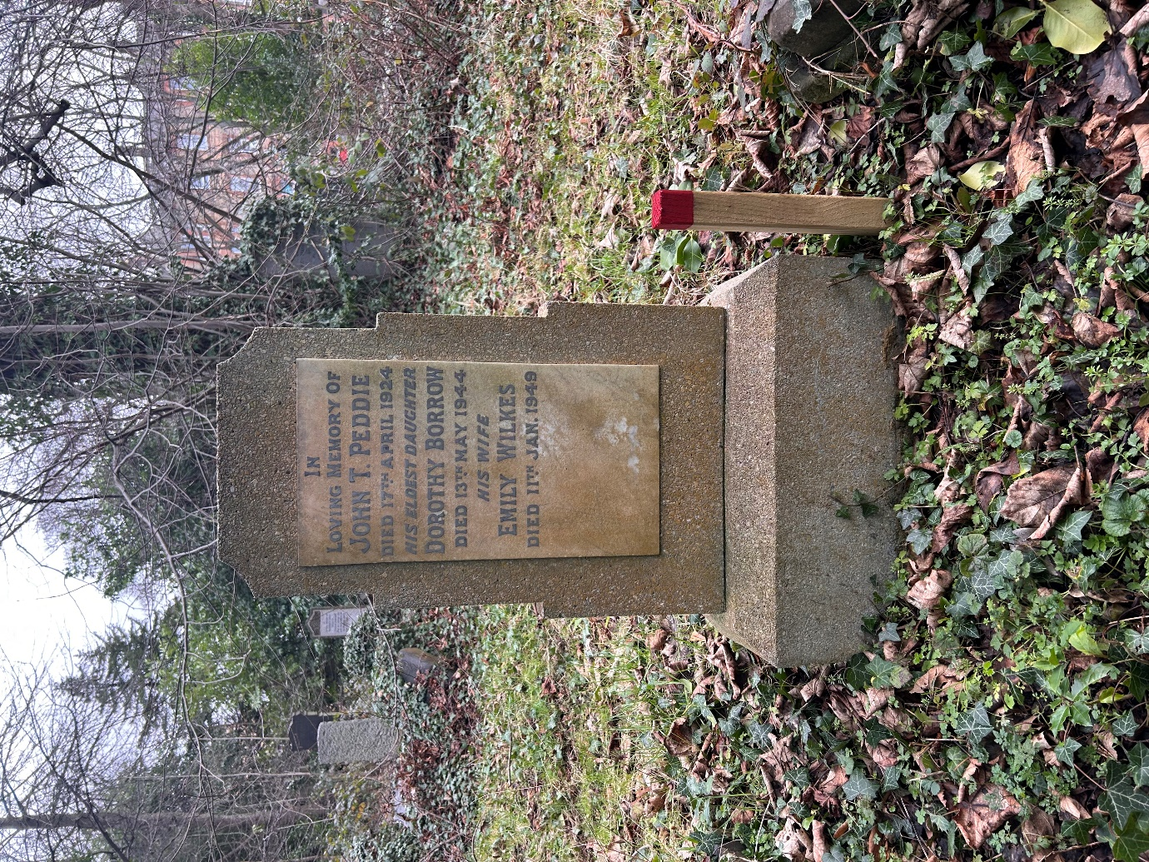

- Map
