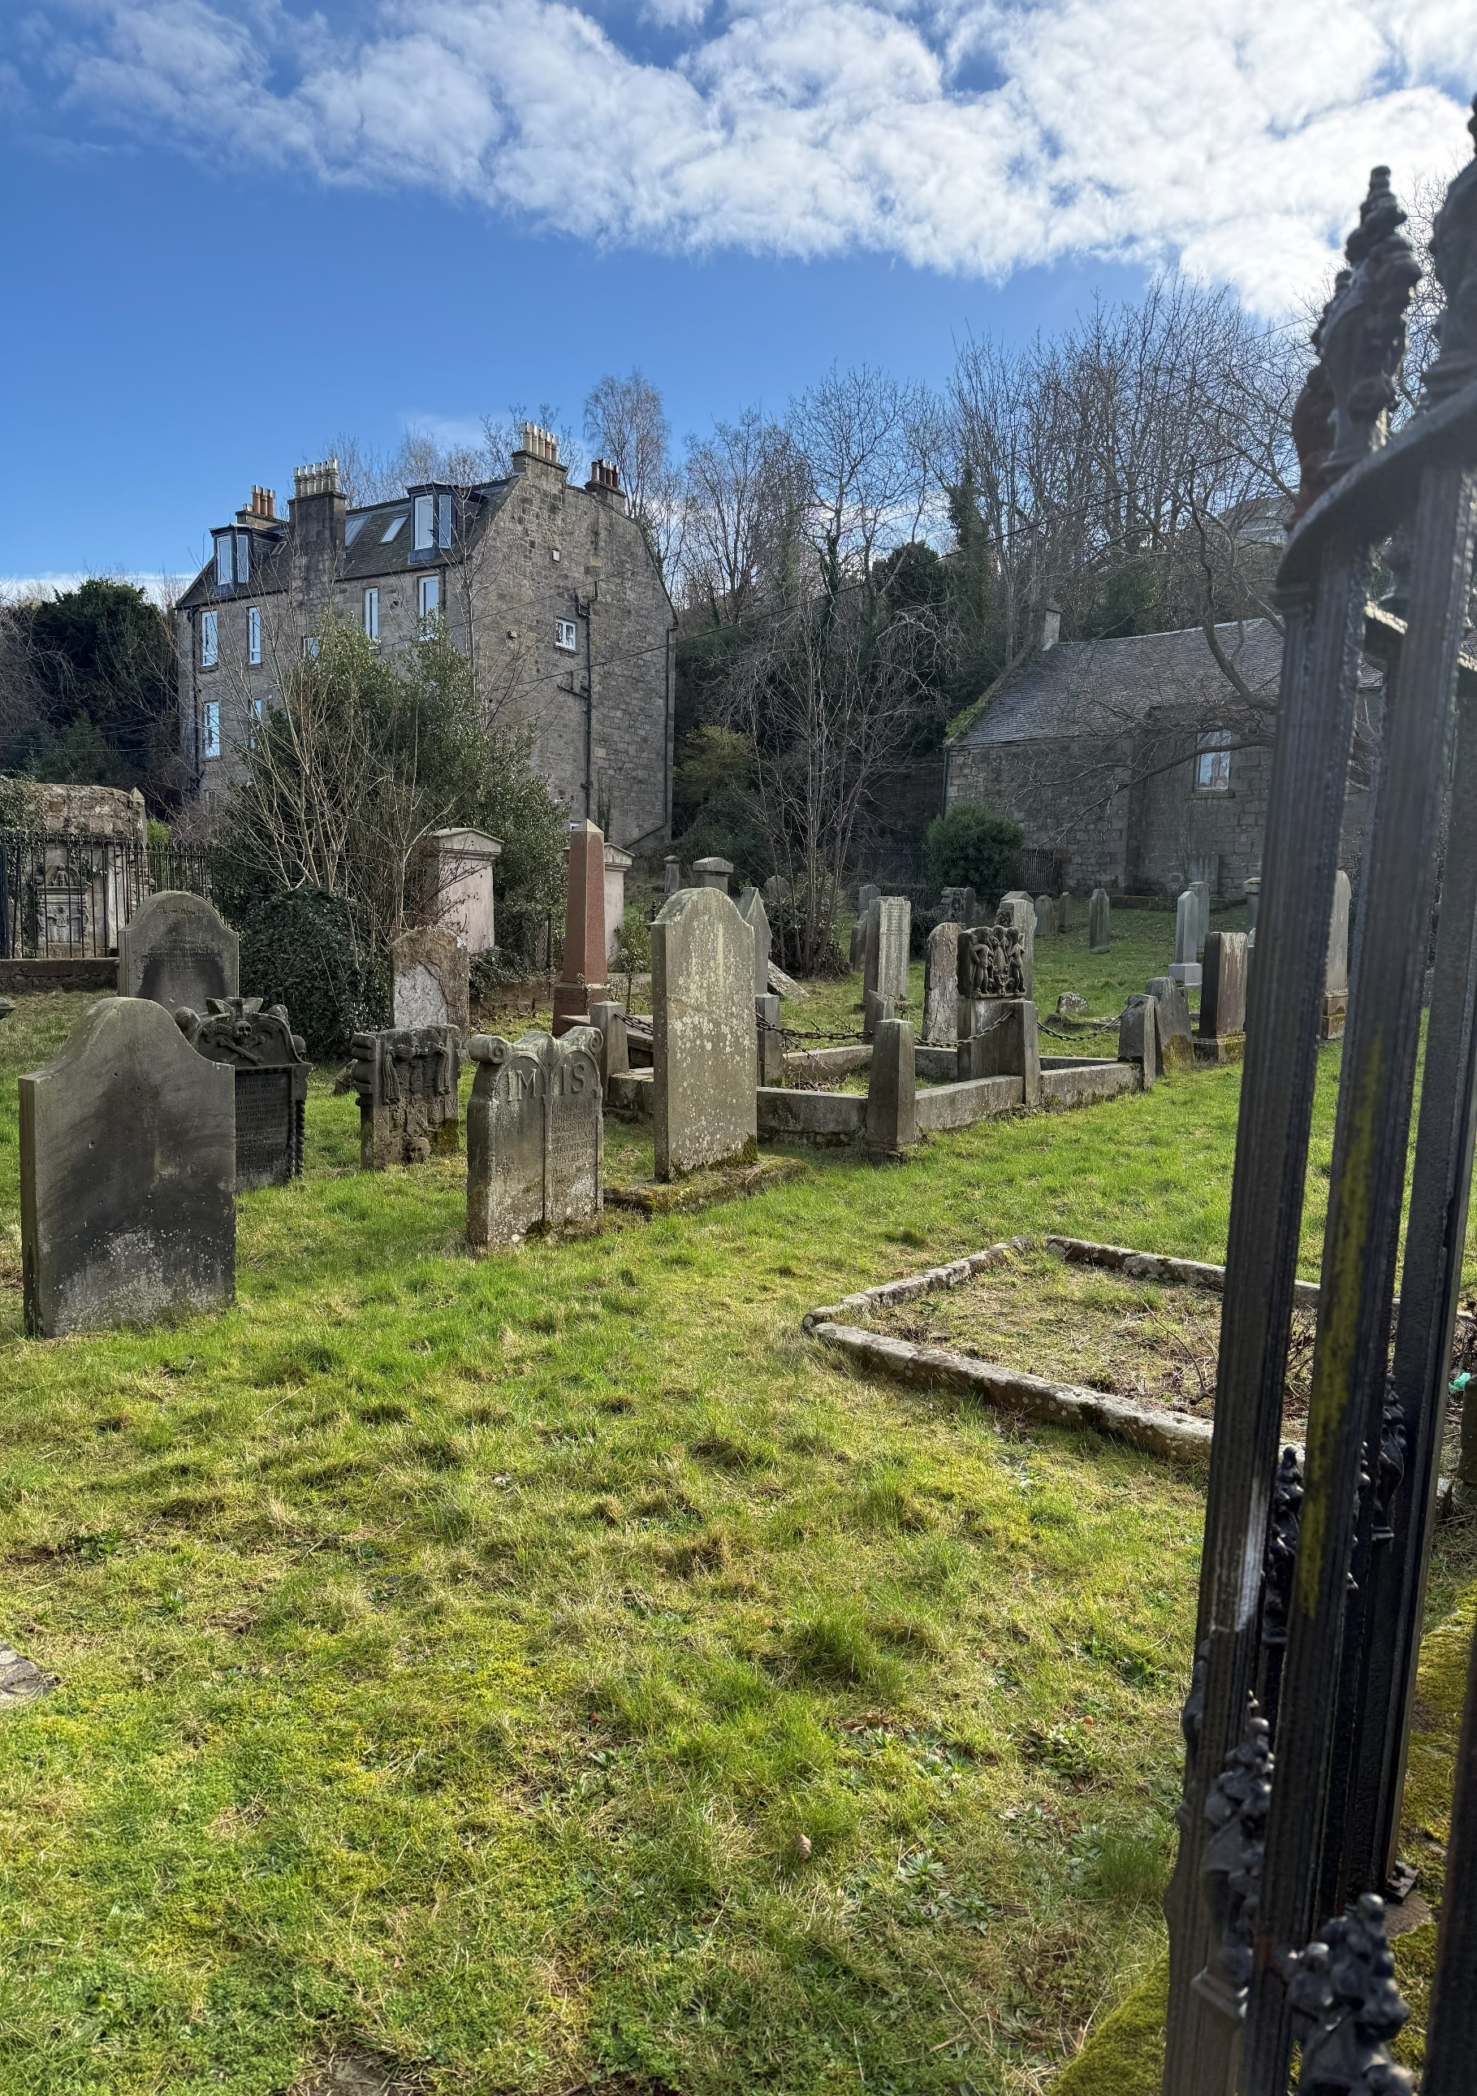

THE VENNELL CEMETERY



Version | Author(s) | Comments | Dates
V1.1 | Danielle Gartland-Quinn | Photos by Tam Magee | 25/2/2026

This document will be reviewed on an annual basis. However, a review or revision of any parts can be carried out at any time for service improvements and will be carried out following new legislation or changes to codes of practice.
This document can be viewed by the public during office hours or online.

`

Contents

- Brief history
- Site description
- Site summary
- Asset list
- Grounds maintenance
- Lair types and availability
- Community involvement
- Notable burials and monuments
- Map

- Brief history

While historical records for the South Queensferry Vennel Cemetery are limited, its origins are largely linked to the adjacent church, which dates back to 1662. This date is reflected in the cemetery’s oldest headstone, marking over three centuries of the town's history. By 1888 the Town Council declared the site a "nuisance", likely due to lack of remaining space, eventually resulting in a formal closing order on 12 March 1900. By this time, the new South Queensferry Cemetery had already opened to serve the community’s needs. The church building continued its religious service for another sixty years until 1962, after which it underwent a series of modern transitions. It was first repurposed as commercial offices before being converted into the private residential property it remains today. Despite these changes to the surrounding buildings, the cemetery persists as a historic record of the community’s early residents and the town's 17th-century roots.

- Site description

Accessed via The Vennel, a long and narrow street, the cemetery is entered through locked iron gates set into stone walls. The grounds are modest in size and consist mainly of a flat lawn with no separated burial sections, reflecting a traditional churchyard style. A few mature trees are scattered across the site, while the boundary is formed by a combination of stone walls and adjacent private properties. Within the walls, the memorials vary significantly in design, age, and material, featuring a mixture of headstones and tombs that showcase the long history of the site.

- Site Summary
Name | The Vennell Cemetery
Address | 10/1 The Vennell Edinburgh
Postcode | EH30 9HT
Ownership | The City of Edinburgh Council
Date site acquired | 1975
Size | 0.16 acres
Conservation area | Yes
Tree preservation | No
Listing | B
Access | Pedestrian
Opening hours | By appointment only

- Asset List
Asset | Location | Information
Waiting room | No
Toilets | No
CCTV | No
Signage | Cemetery gates | Signs detailing name of the cemetery, cemetery user information, safety signs
Cabinet signage | Cemetery entrance | Sign welcoming cemetery users, displaying cemetery rules, biodiversity information, other useful information
Car park | No
Disabled parking | No
Taps | No
Litter bins | No
Benches | No
Catacombs | No
War memorials | No

- Grounds maintenance and biodiversity

The Council has revised its approach to grounds maintenance in response to the current nature emergency. This approach aims to protect and enhance existing biodiversity while encouraging the development of new habitats across the cemetery. This means less frequent grass cutting, no use of weedkiller, introduction of wildflowers, and the encouragement of natural grassland growth.

Routine maintenance activities are outlined below. A complete summary of our ground’s maintenance plans can be found in the Bereavement Services Cemeteries Management Plan.

Routine Maintenance | Frequency | Additional information
Grass cutting | Approx. every 10-12 weeks during appropriate seasons | No grass cutting during No Mow May
Strimming | Approx. every 10-12 weeks during appropriate seasons | No grass cutting during No Mow May
Sunken graves | When required
Re-turfing / grass seeding | When required | Method will depend on season

- Lair type and availability

There are no new lairs available.

- Community involvement

There are no established Friends Group for this cemetery.
Establishing or joining a 'Friends of' group is a meaningful way to contribute to your community while helping us protect these spaces. If you are interested in forming a new group or would like to enquire about future opportunities, please contact Bereavement Services.

- Notable burials and monuments

The cemetery holds a diverse range of memorials spanning several centuries. These vary from contemporary granite obelisks, stone tabletombs and some featuring traditional 'memento mori' carvings of skulls and crossbones.
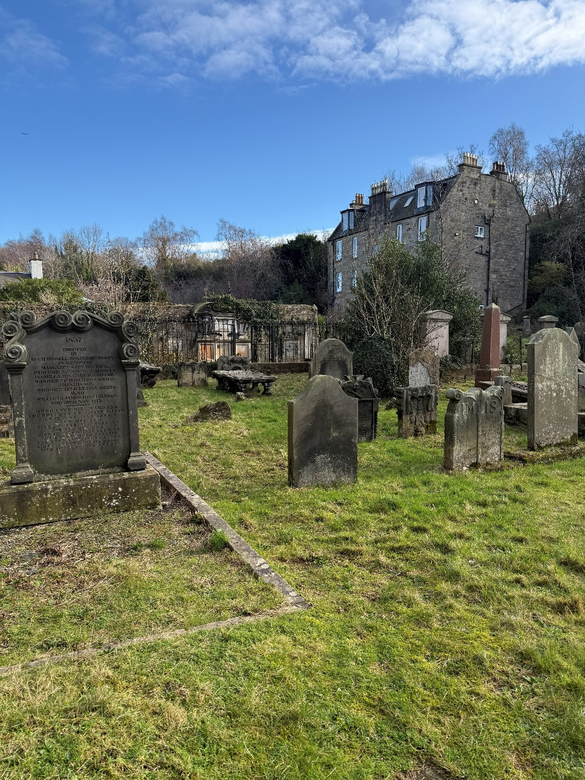

- Map
