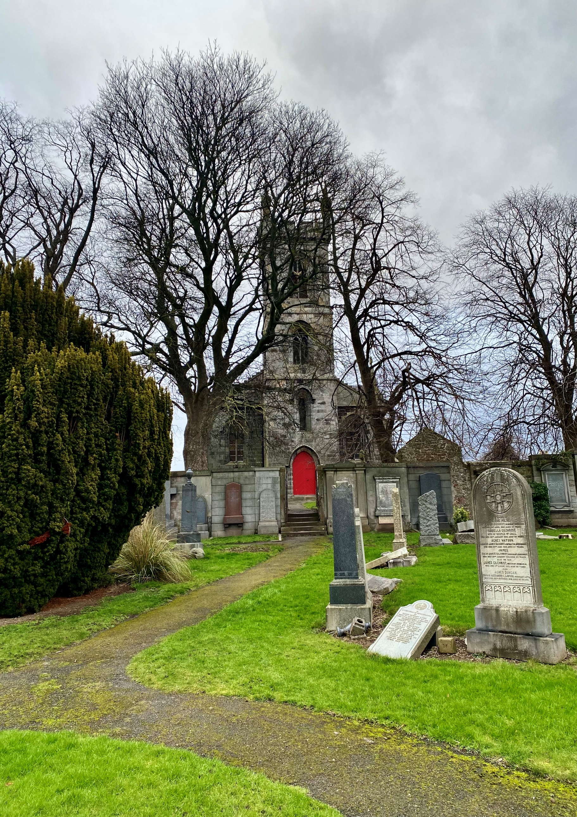


LIBERTON CEMETERY

Version | Author(s) | Comments | Dates
V1.1 | Danielle Gartland-Quinn | Photos by Tam Magee | 25/2/2026

This document will be reviewed on an annual basis. However, a review or revision of any parts can be carried out at any time for service improvements and will be carried out following new legislation or changes to codes of practice.
This document can be viewed by the public during office hours or online.

`

Contents

- Brief history
- Site description
- Site summary
- Asset list
- Grounds maintenance and biodiversity
- Lair types and availability
- Community involvement
- Notable burials and monuments
- Map

- Brief history

Liberton Cemetery was established in 1878 as an extension to the original Liberton Kirkyard, created to meet the rapidly increasing demand for burial space within the growing parish. The first burial was conducted on 18 October 1878, marking the beginning of its use for decades with over 20,000 since. While historical records remain vague regarding a specific architect or formal design plan, the site was clearly well thought out, is well-designed and laid out in a highly practical manner, featuring a structured grid that ensures excellent access throughout the entire site. The cemetery holds significant importance as a historical record of the area, serving as a transitional link between the ancient kirkyard and the more modern suburban developments of south Edinburgh. Its importance is further elevated by its role as a site of remembrance, with a dedicated war memorial. Although the cemetery has reached its capacity for new plots and no new lairs are available, it remains available for the re-opening of existing family lairs for burials. The layout reflects the 19th-century transition toward more organised, accessible burial spaces, moving away from the cramped conditions of older churchyards. This spacious and orderly arrangement allows the cemetery to function as both a dignified final burial place and a peaceful green space for the community.

- Site description

Liberton Cemetery is a well-structured burial ground situated on a slight slope, offering a stunning scenic backdrop of the Edinburgh skyline, including clear views of Edinburgh Castle. The site is accessed via two separate entrances on Liberton Brae, both of which provide vehicle and pedestrian entry through black iron gates set into traditional stone pillars. Upon entry, these gates open onto a tarmacked roadway that branches into several directions, leading around the perimeter and providing clear access between the various burial sections. The grounds are fully enclosed by stone walls, and the cemetery is physically divided into two distinct areas by an internal stone wall, with two roadways allowing for easy passage between them. In the eastern corner of the site, a group of staff buildings is situated, complemented by a traditional stone shed located along the eastern boundary. The burial sections themselves are designed as open grass areas, appearing well-organised and uniformed in their layout. A pedestrian access point through the boundary wall serves as a direct link to the adjacent Liberton Kirk and Kirkyard. The landscape features a small number of established trees, though the site is defined more by its numerous areas of established shrubbery which enhance the grounds and are important for biodiversity. The memorials reflect the long history of the cemetery, varying significantly in size, style, and age. This visual timeline showcases changing artistic trends, with modern granite stones now found throughout the sections alongside older monuments. A dedicated war memorial is also located within the grounds at cemetery entrance, further cementing the site's role as a place of local importance for remembrance.

- Site Summary
Name | Liberton Cemetery and Churchyard
Address | 5B Kirkgate Edinburgh
Postcode | EH16 6JY
Ownership | The City of Edinburgh Council
Date site acquired | 1974
Size | 2.61 hectares
Conservation area | No
Tree preservation | No
Listing | A
Access | Vehicle and pedestrian
Opening hours | 24 hours

- Asset List
Asset | Location | Information
Waiting room | No
Toilets | No
CCTV | No
Signage | Cemetery gates | Signs detailing name of the cemetery, cemetery user information, safety signs
Cabinet signage | Cemetery entrance | Sign welcoming cemetery users, displaying cemetery rules, biodiversity information, other useful information
Car park | No
Disabled parking | No
Taps | Yes, see map
Litter bins | Yes, throughout site see map
Benches | Yes, throughout site see map
Catacombs | No
War memorials | Yes | More information can be found on Commonwealth War Grave Commission webpage.

- Grounds maintenance and biodiversity

The Council has revised its approach to grounds maintenance in response to the current nature emergency. This approach aims to protect and enhance existing biodiversity while encouraging the development of new habitats across the cemetery. This means less frequent grass cutting, no use of weedkiller, introduction of wildflowers, and the encouragement of natural grassland growth.

Routine maintenance activities are outlined below. A complete summary of our ground’s maintenance plans can be found in the Bereavement Services Cemeteries Management Plan.

Routine Maintenance | Frequency | Additional information
Grass cutting | Approx. every 8-10 weeks during appropriate seasons | No grass cutting during No Mow May
Strimming | Approx. every 8-10 weeks during appropriate seasons | No grass cutting during No Mow May
Leaf clearance | When required | Removal from hard standing areas and pathways only.
Sunken graves | When required
Re-turfing / grass seeding | When required | Method will depend on season
Hedge cutting | Annually | No hedge / shrub work during bird nesting season (March-August)
Emptying bins | When required

A biodiversity study conducted in 2021 identified that Liberton Cemetery already supports a large range of biodiversity, including a variety of trees, grasses, animals, and insects. The council is committed to protecting these existing habitats and encouraging biodiversity across the site. A list of species found in the cemetery in 2021 are detailed below.

Species List | Details
Trees | Beech, cherry, cypress sp, elder, hawthorn, holly, horse chestnut, laburnum, lime, maple sp, rhododendron, rowan, silver birch, sycamore, willow leaved pear, yew
Shrubs | buddleia, cotoneaster, hydrangea, Hypericum, ivy, Pieris, privet, rose, snowberry, Solomon's Seal, Virginia Creeper
Grasses | Meadow grass (Poa pratensis), Pampas grass, perennial rye grass.
Flowers | begonias, broad leaved willowherb, creeping buttercup,cyclamen, daisy, dandelion, dock, doves-foot cranesbill, feverfew, fox and cubs, fuchsia, Geranium sp, groundsel, heathers, hedge bindweed, iris, michaelmas daisy, nettle, ox eye daisy, pansy, pricky sow thistle, primulas, red campion, ribwort plantain, rosebay willowherb, speedwell sp, sweet pea, thistle sp, valerian, white clover, wood avens, yarrow
Fungi | some present including tar spot on sycamore leaves (this fungus does not damage the trees).
Mosses | Grimmia pulvinata, Marchantia polymorpha (a liverwort), Orthotrichum anomalum, Tortula muralis.
Mammals | Grey squirrel
Birds | blackbird, blue tit, carrion crow, jackdaw, magpie, robin, rook, woodpigeon.
Insects | common wasp, craneflies (Probably Tipula oleracea and Tipula confusa), common carder bumblebee, earwig, green leafhopper (not identified to species level), red admiral butterfly,

As part of our ongoing biodiversity work, the Council may place nature cameras the cemetery to monitor the wildlife. Although a cemeteries primary purpose is as a place of remembrance and reflection wildlife are often attracted to cemeteries due to their quiet unchanging environment.

- Lair type and availability

Lair type | Availability | Details
Non-denomination Coffin Lairs | No
Catholic Lairs | No
Green Burial | No
Cremated remains | Yes | 6 cremated remains urn burials
Baby | No
Muslim | No
Muslim baby | No
Above ground vault | No

- Community involvement
There are no established Friends Groups for this cemetery.
Establishing or joining a 'Friends of' group is a meaningful way to contribute to your community while helping us protect these spaces. If you are interested in forming a new group or would like to enquire about future opportunities, please contact Bereavement Services.

- Notable burials and monuments

Located at the cemetery entrance is a poignant war memorial dedicated "to the men from the district of Liberton who died in the Great War." This monument serves as a solemn gateway to the grounds, honouring the local residents who lost their lives during the First World War.

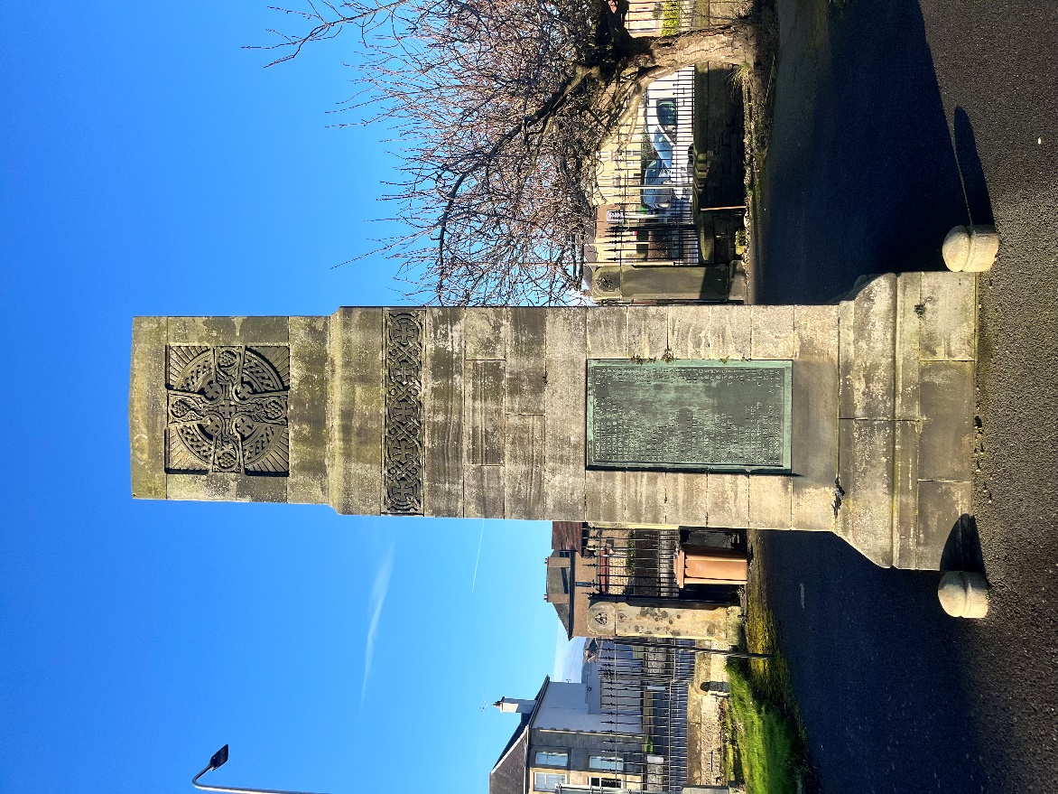

- Map

