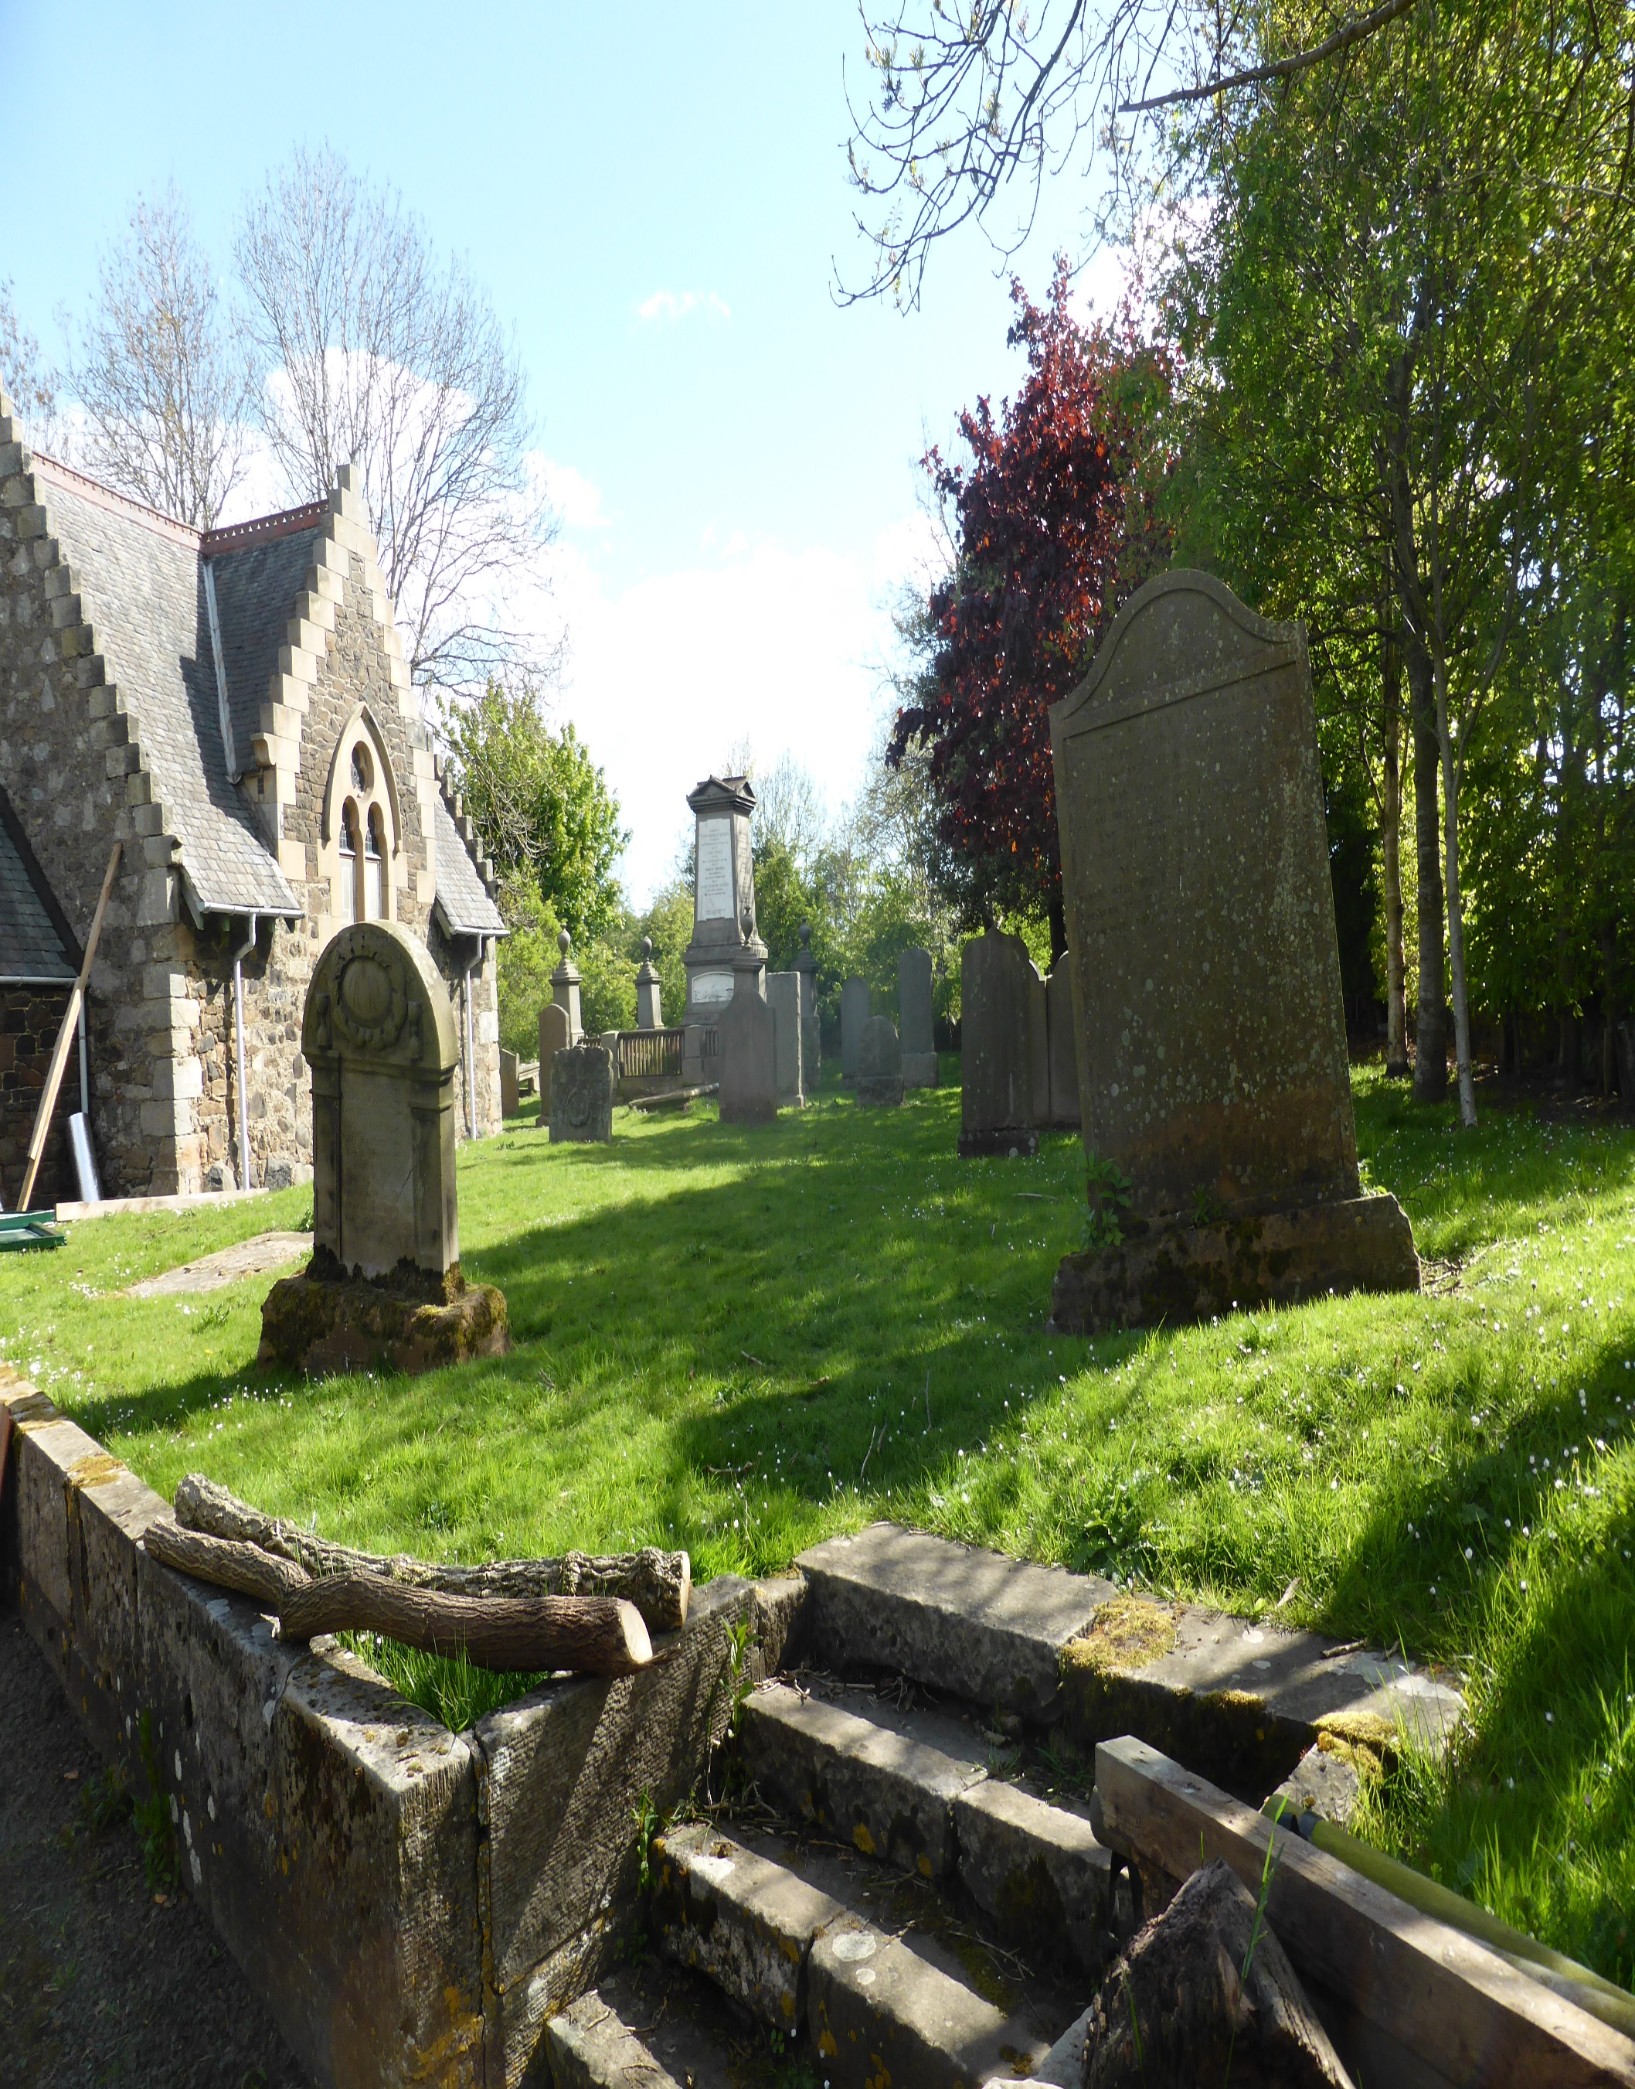

GOGAR CHURCHYARD


Version | Author(s) | Comments | Dates
V1.1 | Danielle Gartland-Quinn | Photos by Tam Magee | 24/2/2026

This document will be reviewed on an annual basis. However, a review or revision of any parts can be carried out at any time for service improvements and will be carried out following new legislation or changes to codes of practice.
This document can be viewed by the public during office hours or online.

`

Contents

- Brief history
- Site description
- Site summary
- Asset list
- Grounds maintenance
- Lair types and availability
- Community involvement
- Notable burials and monuments
- Map

- Brief history

Surrounded by the remnants of a vanished community, Gogar Churchyard stands as a historic sentinel for the "lost" village of Nether Gogar, with records of a church on the site stretching back to at least the 16th century. While the settlement has long since disappeared, the church itself underwent a major Victorian transformation in 1890–91 under the direction of architect J.A. Williamson. In its later years of ministry, the church became closely associated with the nearby Gogarburn Hospital, serving its community until the final service was held in 1954. Although the building has since been converted into a Gogar Cabinet Works, a private cabinet works business, the churchyard continues to preserve the site's legacy; despite limited surviving burial records, the physical memorials remain as a vital link to the generations buried there.

- Site description

Located just off Glasgow Road and situated across the new tram line, the entrance to Gogar Churchyard is reached via a short, quiet driveway. Despite its proximity to a busy part of town, the site is surrounded by fields, providing a surprisingly rural feel. The site is intimately enclosed by a blend of traditional stone walls and dense shrubbery, creating a secluded atmosphere for this small churchyard. The church itself sits at the heart of the grounds, with the burial areas fully surrounding the central building. Upon entering through the iron gate, a modern pathway leads visitors toward the church, bordered by burial sections. These sections are located on raised areas accessed by small sets of steps, with the main path cutting a clear route between them. While the burial sections themselves lack formal pathways, the raised areas consist of flat lawn, making it accessible for those exploring the monuments. Throughout the site, a diverse range of memorials can be found, varying significantly in age, size, and style, reflecting the history of the community who once lived here.

- Site Summary
Name | Gogar Churchyard
Address | 194/1 Glasgow Road Edinburgh
Postcode | EH12 9BR
Ownership | The City of Edinburgh Council
Date site acquired | 1855
Size | 0.13 hectares
Conservation area | No
Tree preservation | No
Listing | B
Access | Pedestrian
Opening hours | 24 hours

- Asset List
Asset | Location | Information
Waiting room | No
Toilets | No
CCTV | No
Signage | Cemetery gates | Signs detailing name of the cemetery, cemetery user information, safety signs
Cabinet signage | Cemetery entrance | Sign welcoming cemetery users, displaying cemetery rules, biodiversity information, other useful information
Car park | No
Disabled parking | No
Taps | No
Litter bins | No
Benches | No
Catacombs | No
War memorials | No

- Grounds maintenance and biodiversity

The Council has revised its approach to grounds maintenance in response to the current nature emergency. This approach aims to protect and enhance existing biodiversity while encouraging the development of new habitats across the cemetery. This means less frequent grass cutting, no use of weedkiller, introduction of wildflowers, and the encouragement of natural grassland growth.

Routine maintenance activities are outlined below. A complete summary of our ground’s maintenance plans can be found in the Bereavement Services Cemeteries Management Plan.

Routine Maintenance | Frequency | Additional information
Grass cutting | Approx. every 10-12 weeks during appropriate seasons | No grass cutting during No Mow May
Strimming | Approx. every 10-12 weeks during appropriate seasons | No grass cutting during No Mow May
Leaf clearance | When required | Clearance from hard standing areas only
Sunken graves | When required
Re-turfing / grass seeding | When required | Method will depend on season

A biodiversity study conducted in 2021 identified that Gogat Churchyard already supports a large range of biodiversity, including a variety of trees, grasses, animals, and insects. The council is committed to protecting these existing habitats and encouraging biodiversity across the site. A list of species found in the cemetery in 2021 are detailed below.

Species List | Details
Trees | Ash, beech, hawthorn, holly, pear, rowan, silver birch
Shrubs | Bramble, ivy
Flowers | Creeping buttercup, daisy, dandelion, nettle, snowdrop, a species of thistle.
Mosses | Anomalous bristle moss (Orthotrichum anomalum), Grimmia pulvinata, Hypnum sp, Springy Turf Moss (Rhytidiadelphus squarrosus), Wall Screw Moss (Tortula muralis).
Birds | Blackbird, blue tit, goldfinch, jackdaw
Grasses | Meadow grass (Poa pratensis) and others

- Lair type and availability

There are no new lairs available.

- Community involvement

There are no established Friends Group for this cemetery.
Establishing or joining a 'Friends of' group is a meaningful way to contribute to your community while helping us protect these spaces. If you are interested in forming a new group or would like to enquire about future opportunities, please contact Bereavement Services.

- Notable burials and monuments

Thomas Grainger (1794–1852) was a pioneering Victorian railway engineer responsible for many of the earliest lines in Scotland and Northern England. His grave remains a prominent and notable feature of the churchyard.

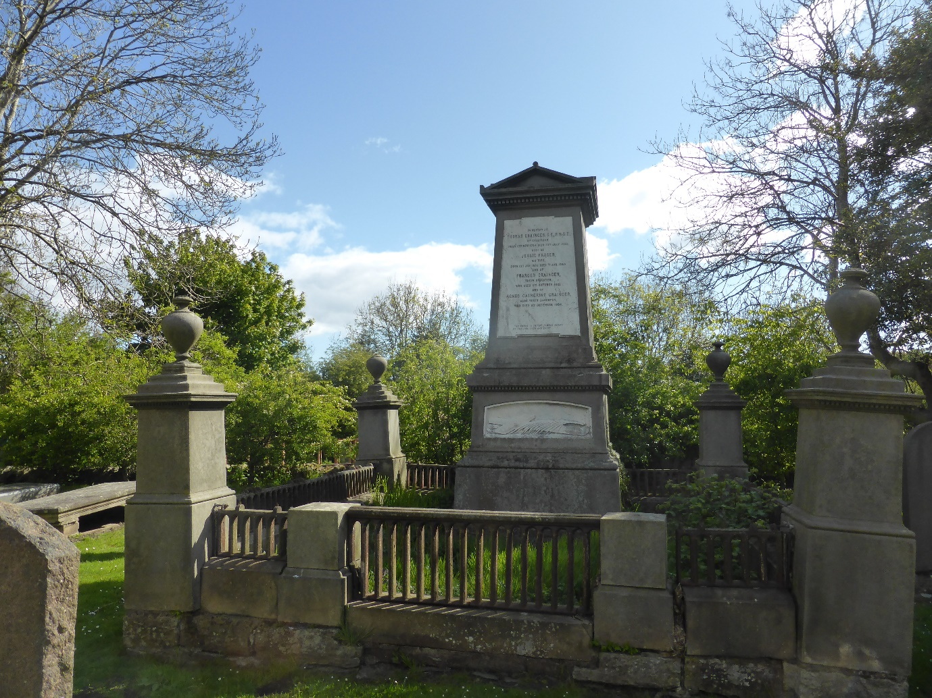

- Map
