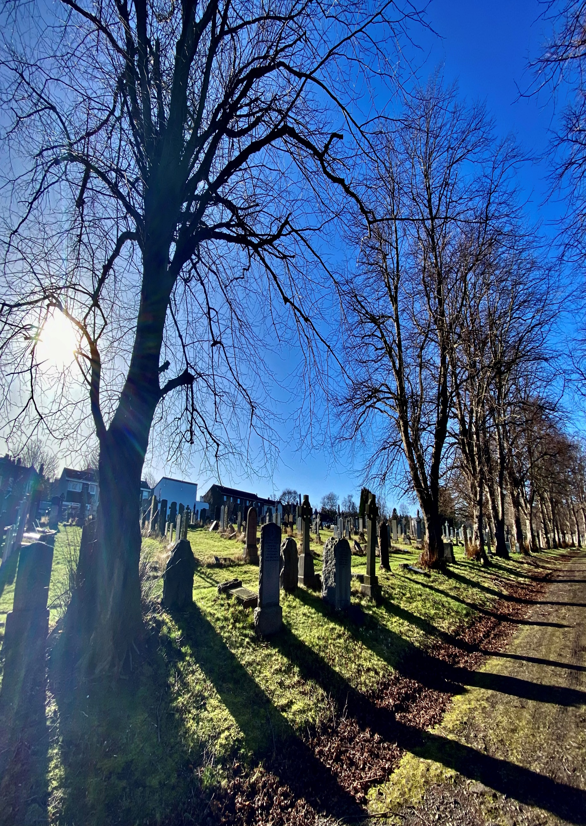


MORNINGSIDE CEMETERY

Version | Author(s) | Comments | Dates
V1.1 | Danielle Gartland-Quinn | Photos by Tam Magee | 25/2/2026

This document will be reviewed on an annual basis. However, a review or revision of any parts can be carried out at any time for service improvements and will be carried out following new legislation or changes to codes of practice.
This document can be viewed by the public during office hours or online.

`

Contents

- Brief history
- Site description
- Site summary
- Asset list
- Grounds maintenance and biodiversity
- Lair types and availability
- Community involvement
- Notable burials and monuments
- Map

- Brief history

Morningside Cemetery was opened in 1878 by the Metropolitan Cemetery Company, though historical records regarding its specific architectural design and original planning remain relatively limited. The site was initially intended to be much larger; however, a significant portion of the land was sold off for the development of private housing. Evidence of this original, grander footprint can still be found today on Belhaven Terrace, where the cemetery’s original entrance stone pillars, iron gates, and perimeter fencing remain in situ, now detached from the current boundaries. Unlike many of the prestigious garden cemeteries established during the Victorian era, Morningside was notably designed without catacombs, focusing instead on an entirely open-air design. The first burial took place on 4 June 1878, and the grounds have since become the final burial place for over 30,000 people. During its years of private ownership, the cemetery suffered through periods of "asset stripping," where areas of the grounds were sold for private development. The cemetery fell into disrepair and suffered from vandalism. In 1992, the Council compulsory purchased the cemetery to ensure its restoration and ongoing maintenance. It remains an active burial ground today, with new lairs still available.

- Site description

Morningside Cemetery is a large and open cemetery which can be accessed via two points on opposite sides of the cemetery: the primary entrance on Morningside Drive, which provides both vehicle and pedestrian access between residential housing, and a secondary pedestrian-only entrance via Balcarres Street. The Morningside Drive entrance opens onto a monoblock driveway bordered by burial sections, which serves as the main access through the grounds as the grounds follow a slight declining slope. A defining feature of the cemetery’s landscape is a central avenue of mature trees, which provides a striking focal point and creates a clear division between the two main areas of the site. The burial sections themselves are designed as open grassed areas, maintaining a well-organized and spacious feel typical of the period. The grounds are fully enclosed, with a combination of traditional stone walls and private properties forming a secure and intimate boundary. Throughout the cemetery, the memorials reflect a broad social history, featuring a mix of grand, imposing monuments and more modest headstones. As the cemetery remains active, many modern granite memorials are situated within the most recent burial areas. Additionally, a dedicated war memorial is positioned close to the Balcarres Street entrance. Established trees can be found throughout the site, Morningside Cemetery stands as a peaceful and well-accessible sanctuary that continues to serve the residents of south Edinburgh. Today, the management of the grounds focus on biodiversity, ensuring the site functions as a flourishing urban greenspace and a respectful burial space.

- Site Summary
Name | Morningside Cemetery
Address | Morningside Drive Edinburgh
Postcode | EH16 6SX
Ownership | The City of Edinburgh Council
Date site acquired | 1994
Size | 5.52 acres
Conservation area | Yes
Tree preservation | Yes
Listing | Original Gate C
Access | Vehicle and pedestrian
Opening hours | 24 hours

- Asset List
Asset | Location | Information
Waiting room | No
Toilets | No
CCTV | No
Signage | Cemetery gates | Signs detailing name of the cemetery, cemetery user information, safety signs
Cabinet signage | Cemetery entrances | Sign welcoming cemetery users, displaying cemetery rules, biodiversity information, other useful information
Car park | No
Disabled parking | No
Taps | No
Litter bins | Yes, throughout site see map
Benches | Yes, throughout site see map
Catacombs | No
War memorials | Yes | More information can be found on Commonwealth War Grave Commission webpage.

- Grounds maintenance and biodiversity

The Council has revised its approach to grounds maintenance in response to the current nature emergency. This approach aims to protect and enhance existing biodiversity while encouraging the development of new habitats across the cemetery. This means less frequent grass cutting, no use of weedkiller, introduction of wildflowers, and the encouragement of natural grassland growth.

Morningside Cemetery is primarily managed through a low-intervention maintenance strategy. As one of the first sites in the city to cease the use of chemical weedkillers, the cemetery has become a model for sustainable urban spaces. The grounds now balance traditional upkeep with natural preservation; while specific areas continue to receive higher levels of maintenance, other sections are intentionally left to flourish to support local wildlife and plant diversity.

Routine maintenance activities are outlined below. A complete summary of our ground’s maintenance plans can be found in the Bereavement Services Cemeteries Management Plan.

Routine Maintenance | Frequency | Additional information
Grass cutting | Approx. every 10-12 weeks during appropriate seasons | No grass cutting during No Mow May
Strimming | Approx. every 10-12 weeks during appropriate seasons | No grass cutting during No Mow May
Leaf clearance | When required | Removal from hard standing areas and pathways only.
Sunken graves | When required
Re-turfing / grass seeding | When required | Method will depend on season
Hedge cutting | Annually | No hedge / shrub work during bird nesting season (March-August)
Emptying bins | When required

A biodiversity study conducted in 2021 identified that Morningside Cemetery already supports a large range of biodiversity, including a variety of trees, grasses, animals, and insects. The council is committed to protecting these existing habitats and encouraging biodiversity across the site. A list of species found in the cemetery in 2021 are detailed below.

Species List | Details
Trees | Ash, cherry, cypress; holly, horse chestnut, lime, monkey puzzle; rowan, Scots pine, silver birch; sycamore
Shrubs | broom; cotoneaster; elder; Hypericum; ivy; laurel; rose.
Grasses
Flowers | broad leaved willowherb, creeping buttercup, daisy, dandelion, dock, groundsel, herb robert, nettle, purple loosestrife, ragwort; ribwort plantain, rosebay willowherb; smooth sowthistle; a species of thistle, white clover, wood avens, yarrow. Plus garden plants
Fungi | collared earth stars, waxcaps (including parrot waxcap, snowy waxcap and probably golden waxcap and yellow waxcap), wrinkled club fungus
Mosses | Grimmia pulvinata, Polytrichastrum formosum, Hypnum sp,
Mammals | Grey squirrel
Birds | black headed gull; blue tit, carrion crow, goldfinches; jackdaw, long tailed tits; magpie, robin, woodpigeon
Insects | 2 spot ladybird; 10 spot ladybird; cream spot ladybird; Eyed ladybird, larch ladybird; pine ladybird; orange ladybird, a species of cranefly, an assassin bug; Chilenocaecilius ornatipennis (an adventive barkfly); Dromius quadrimaculatus (a small ground beetle); Elipsocus hyalinus (another barkfly); Empis digramma ( a dagger fly); Lime bent-wing (Bucculatrix thoracella); a Mirid bug (probably common green capsid bug); Orchesella cincta (a springtail); Pediopsis tiliae (a leaf hopper, the first record for Scotland); Phytocoris sp; Rosemary beetle

As part of our ongoing biodiversity work, the Council may place nature cameras in the cemetery to monitor the wildlife. Although a cemeteries primary purpose is as a place of remembrance and reflection wildlife are often attracted to cemeteries due to their quiet unchanging environment.

- Lair type and availability

Lair type | Availability | Details
Non-denomination Coffin Lairs | Yes | 2 coffin burials and 6 cremated remains urn burials
Catholic Lairs | No
Green Burial | No
Cremated remains | Yes | 6 cremated remains urn burials
Baby | No
Muslim | No
Muslim baby | No
Above ground vault | No

- Community involvement

The Friends of Morningside Cemetery are dedicated to caring for the heritage and biodiversity of the cemetery. Their involvement enhances the condition of the cemetery and contributes significantly to the improvements seen across the site. Their commitment, local knowledge and hands-on involvement have made a meaningful difference to the appearance, accessibility and historical understanding of Morningside Cemetery. Members are helping to preserve the cemetery’s cultural heritage. The Friends group's involvement not only supports essential maintenance but also helps visitors better understand and appreciate the site's significance.

Activities carried out by the Friends group include:

- Gardening and maintaining planted areas
- Improving paths and general access around the cemetery
- Creating and maintaining wildflower meadows
- Hosting community events, open days and remembrance activities
- Assisting with landscape improvements alongside members of staff
- Contributing to the ongoing management and future planning of the site
- Conducting Remembrance Day services

For information about volunteering, supporting or becoming a member of this Friends group please contact them via email Fomc1878@gmail.com.
Establishing or joining a 'Friends of' group is a meaningful way to contribute to your community while helping us protect these spaces. If you are interested in forming a new group or would like to enquire about future opportunities, please contact Bereavement Services.

- Notable burials and monuments

A defiant pioneer of both medicine and social reform, Dr Grace Ross Cadell was among the first women to train at the Edinburgh School of Medicine for Women. Described by contemporaries as an 'advanced suffragette,' she put her professional skills at the service of the movement, tending to those on hunger strike. Her commitment to women’s welfare extended to her leadership of The Hospice on the Royal Mile, a hospital founded by Elsie Inglis which Cadell directed from 1911 until her death, she is buried in grave J-667.
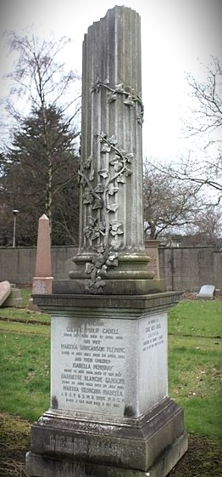

- Map
