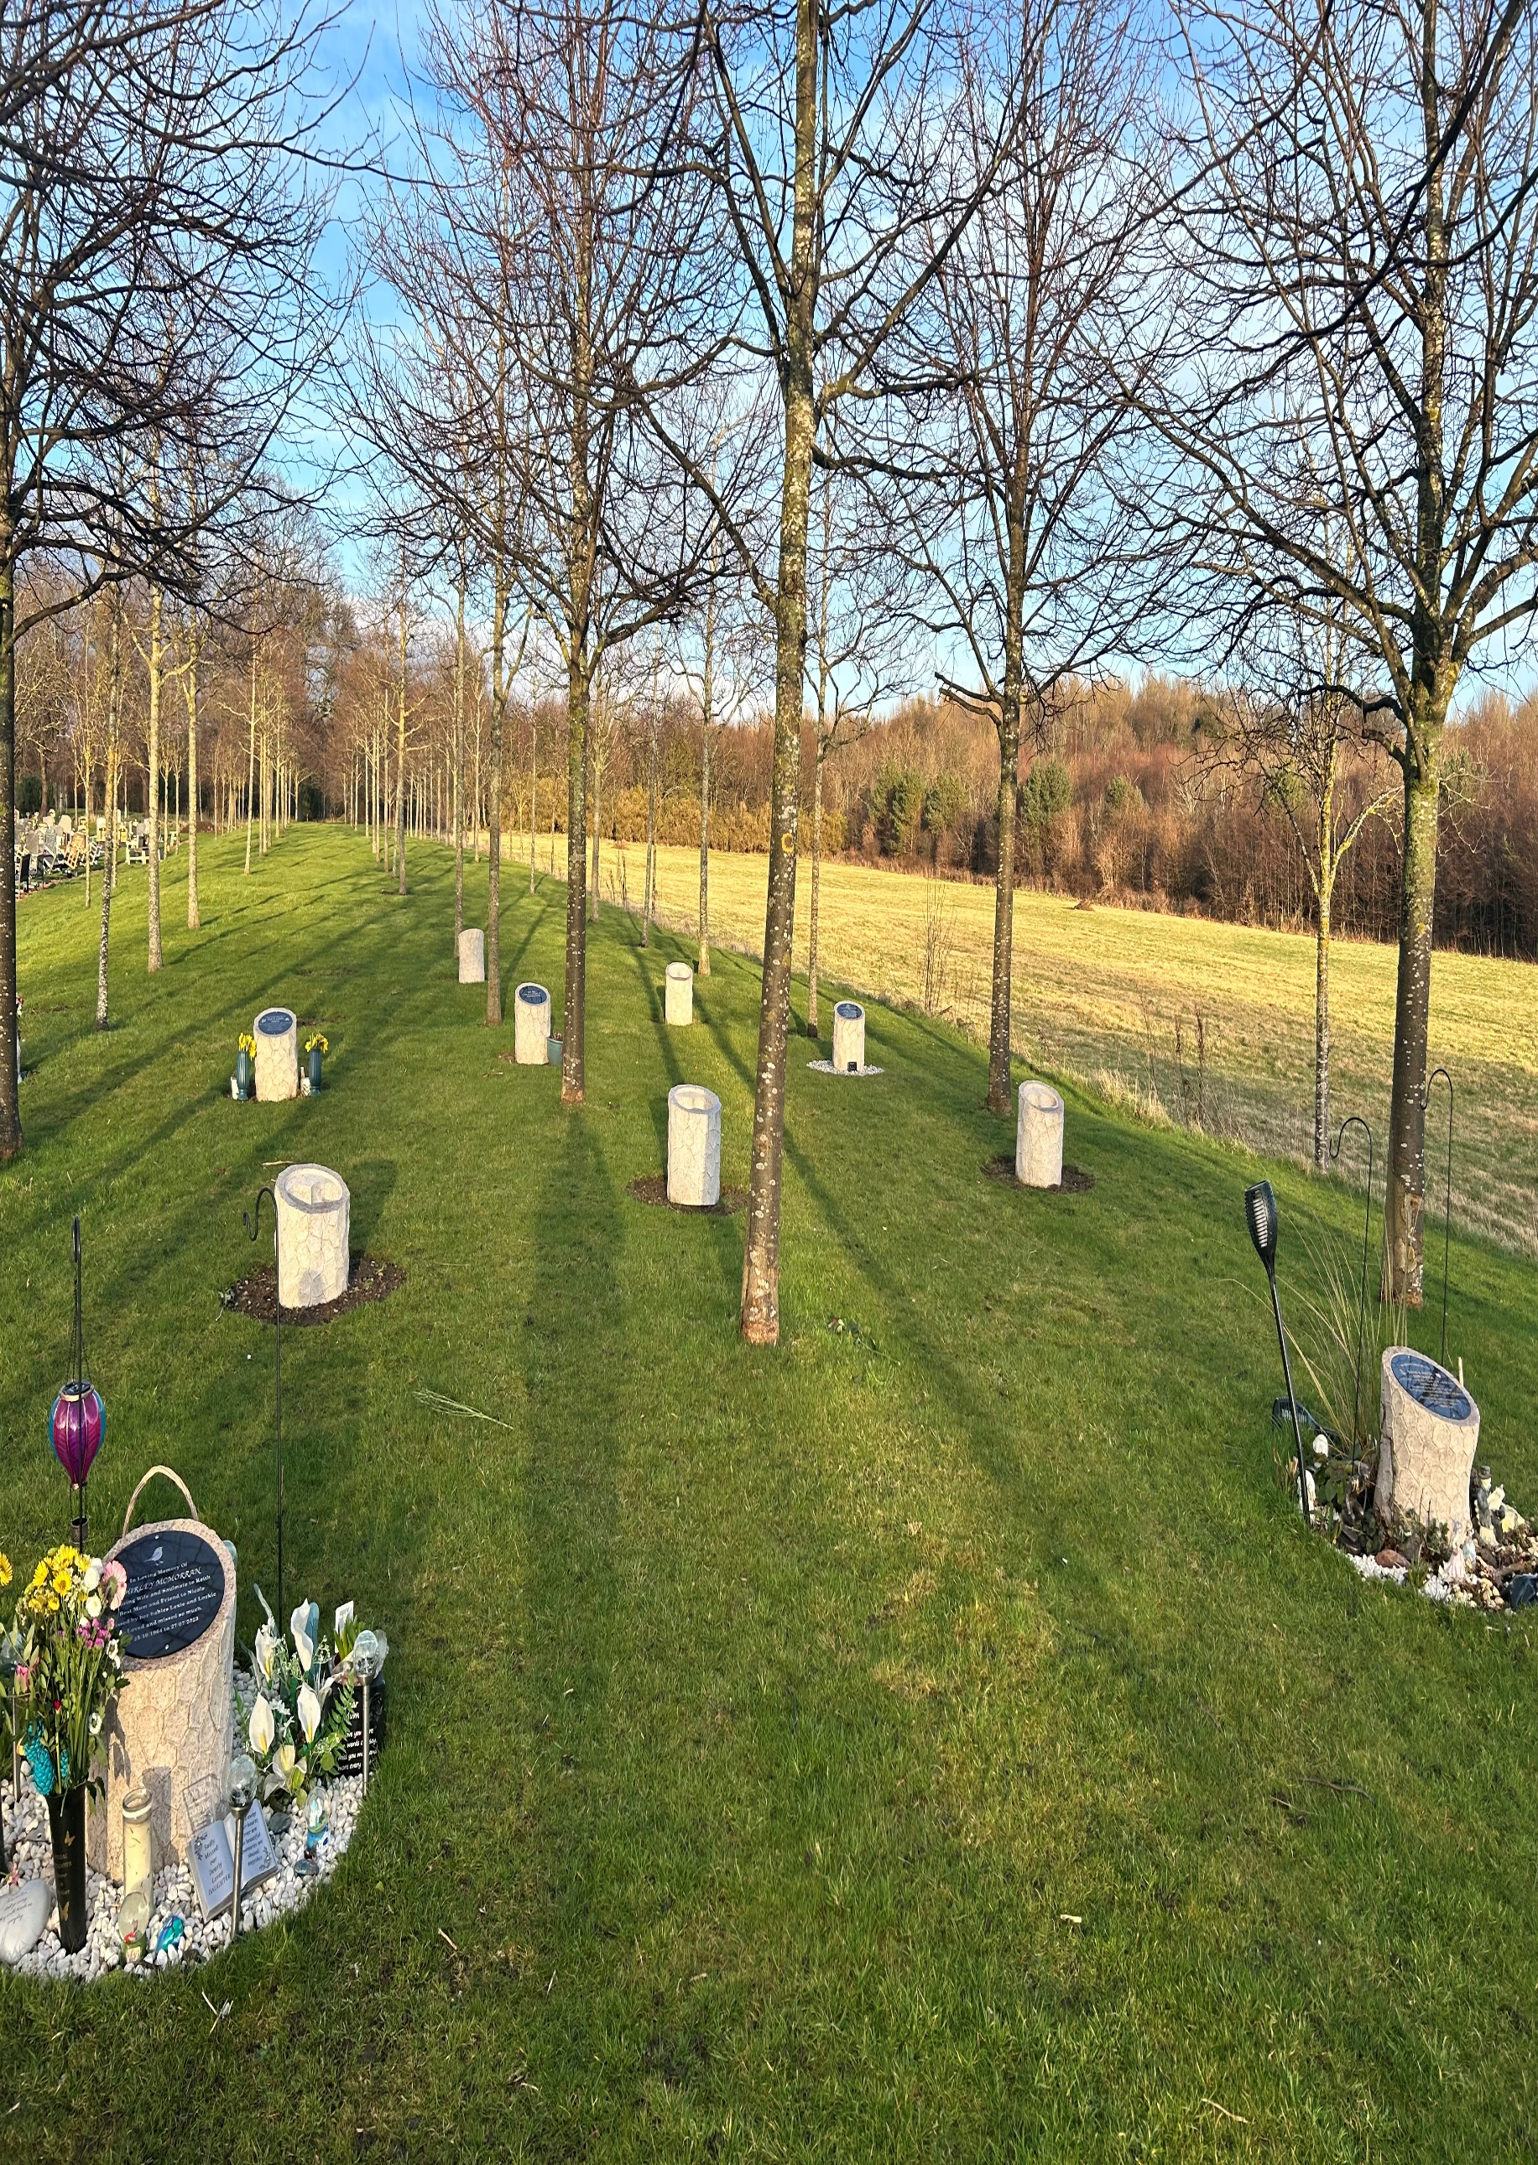


CRAIGMILLAR CASTLE PARK CEMETERY

Version | Author(s) | Comments | Dates
V1.1 | Danielle Gartland-Quinn | Tam Magee | 24/2/2026

This document will be reviewed on an annual basis. However, a review or revision of any parts can be carried out at any time for service improvements and will be carried out following new legislation or changes to codes of practice.
This document can be viewed by the public during office hours or online.

`

Contents.
- Brief history
- Site description
- Site summary
- Asset list
- Grounds maintenance and biodiversity
- Lair types and availability
- Community involvement
- Notable burials and monuments
- Map

1.Brief history

Craigmillar Castle Park Cemetery is a modern burial ground with deep historical roots, situated in the south east of Edinburgh on Old Dalkeith Road. The 15-acre site occupies land historically owned by the Gilmour family, the former lairds of Craigmillar who resided at the nearby Craigmillar Castle before it was handed into state care in 1946. For centuries, these grounds served as productive farmland for both arable and livestock farming within the wider estate. The transition from agricultural land to its current use began in 2006 when the City of Edinburgh Council was granted planning permission to establish a new burial ground. Construction commenced in 2009, with the first phase of development taking eight months to complete. The design and operation of the site were informed by an extensive consultation process, during which numerous religious and secular groups were invited to share their specific needs. The cemetery held a formal opening ceremony in early 2010 to mark its launch, it is notably only the second cemetery to be opened by the council, following the opening of Mortonhall Cemetery in 1960. The first burial was conducted on 2 February 2010, marking the beginning of its service to the local community. The cemetery continues to cater to a wide range of faiths, cultures, and burial types. To date, there have been over 1,500 burials and the addition of more than 900 headstones or memorials. Set within the Craigmillar Castle National Heritage Park and Hawkhill Woods, six acres of the site are currently developed and in active use, while the remaining nine acres are in the early planning stages for future expansion.

2.Site description

Craigmillar Castle Park is a modern and thoughtfully designed cemetery, fully enclosed by a combination of traditional stone walls and contemporary fencing. The main entrance is marked by formal iron gates set into sturdy stone pillars, which open onto a wide double driveway running the entire length of the grounds. This central access is bordered by gravel sidewalks on either side, providing easy pedestrian access to the open and spacious burial sections. Upon entering, visitors will find a waiting room and toilets situated immediately to the left. The driveway features dedicated disabled parking along the main drive and two larger car parks located at the rear of the cemetery. The cemetery consists of some slightly raised areas that lead into the primary flat burial sections, all set against a scenic backdrop of Craigmillar Castle and the Pentland Hills. The cemetery’s character is defined by its blend of traditional and contemporary elements. The memorials feature modern headstones that vary widely in design, material, and colour, while a raised embankment hosts a series of modern granite above-ground burial vaults. Along the boundary, established trees and hedges provide a sense of seclusion, while wildflowers and established shrubbery throughout the grounds contribute to a peaceful, nature-focused atmosphere. To the rear, a dedicated green burial section offers an environmentally conscious option, further enhancing the site's connection to the surrounding National Heritage Park. A virtual tour of the cemetery can be viewed here.

3.Site Summary
Name | Craigmillar Castle Park Cemetery
Address | 47 Old Dalkeith Road Edinburgh
Postcode | EH16 4TE
Ownership | The City of Edinburgh Council
Date site acquired | 2008
Size | 6.19 hectares
Conservation area | No
Tree preservation | Yes
Listing | None
Access | Vehicle and pedestrian
Opening hours | 6am – 6pm

4.Asset List
Asset | Location | Information
Waiting room | Yes, cemetery entrance
Toilets | Yes, cemetery entrance
CCTV | Yes, covering waiting room only
Signage | Cemetery gates | Signs detailing name of the cemetery, cemetery user information, safety signs
Cabinet signage | Cemetery entrance | Sign welcoming cemetery users, displaying cemetery rules, biodiversity information, other useful information
Car park | Yes, rear of cemetery | 2 car parks
Disabled parking | Yes, throughout drive | 5 designated disabled parking
Taps | Yes, throughout site see map
Litter bins | Yes, throughout site see map
Benches | Yes, throughout site see map
Catacombs | No
War memorials | No

5.Grounds maintenance and biodiversity

The Council has revised its approach to grounds maintenance in response to the current nature emergency. This approach aims to protect and enhance existing biodiversity while encouraging the development of new habitats across the cemetery. This means less frequent grass cutting, no use of weedkiller, introduction of wildflowers, and the encouragement of natural grassland growth.

Routine maintenance activities are outlined below. A complete summary of our ground’s maintenance plans can be found in the Bereavement Services Cemeteries Management Plan.

Routine Maintenance | Frequency | Additional information
Grass cutting | Approx. every 8-10 weeks during appropriate seasons | No grass cutting during No Mow May
Strimming | Approx. every 8-10 weeks during appropriate seasons | No grass cutting during No Mow May
Leaf clearance | When required | Removal from hard standing areas and pathways only.
Sunken graves | When required
Re-turfing / grass seeding | When required | Method will depend on season
Hedge cutting | Annually | No hedge / shrub work during bird nesting season (March-August)
Emptying bins | When required

A biodiversity study conducted in 2021 identified that Craigmillar Castle Park Cemetery already supports a large range of biodiversity, including a variety of trees, grasses, animals, and insects. The council is committed to protecting these existing habitats and encouraging biodiversity across the site. A list of species found in the cemetery in 2021 are detailed below.

Species List | Details
Trees | Alder, ash, beech, cherry, horse chestnut, lime, rowan, oak, scots pine, sycamore, willow, wych elm.
Shrubs | Beech hedge, bramble, cotoneaster, dog rose, elder, holly, ivy, laurel, rose, yew hedges, garden species
Grasses | Meadow grass, pampas grass.
Flowers | Common puffball, conical waxcap, sulphur tuft, tar spot, yellow field cap.
Fungi | Hypnum sp.
Mosses | Camouflage lichen, common greenshield lichen, lecanore albescens
Mammals | Rabbit, roe deer, foxes
Birds | Blackbird, blue tit, buzzard, carrion crow, herring gull, long tailed tit, magpie, pied wagtail, robin, sparrowhawk, woodpigeon
Insects | Hoverflies, banded hoverfly, drone fly, marmalade hoverfly, spangle galls (made by wasp)

As part of our ongoing biodiversity work, the Council may place nature cameras in the cemetery to monitor the wildlife using the cemetery. Although a cemeteries primary purpose is as a place of remembrance and reflection wildlife are often attracted to cemeteries due to their quiet unchanging environment.

6.Lair type and availability

Lair type | Availability | Details
Non-denomination Coffin Lairs | Yes | 2 coffin burials and 6 cremated remains urn burials
Catholic Lairs | Yes | 2 coffin burials and 6 cremated remains urn burials
Green Burial | Yes | 1 coffin burial
Cremated remains | Yes | 6 cremated remains urn burials
Baby | Yes | 1 baby coffin burial
Muslim | No
Muslim baby | Yes | 1 baby coffin burial
Above ground vault | Yes | 2 cremated remains urn above ground interments

7.Community involvement

There are no established Friends Groups for this cemetery.
Establishing or joining a 'Friends of' group is a meaningful way to contribute to your community while helping us protect these spaces. If you are interested in forming a new group or would like to enquire about future opportunities, please contact Bereavement Services.

8.Notable burials and monuments

Craigmillar Castle Park Cemetery features a diverse range of memorial styles marking individual burial lairs. A significant focal point within the baby section is the memorial donated by Sands Lothian (now known as Held In Our Hearts), providing a vital sanctuary for reflection and a formal space to validate the grief of bereaved families.

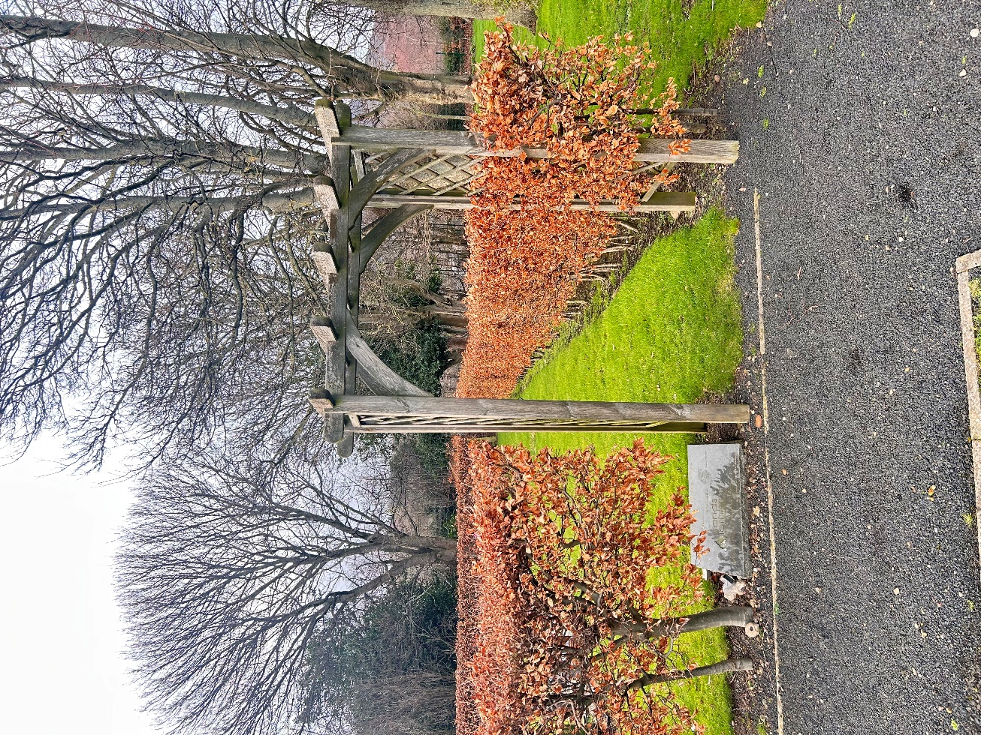

8.

9. Map
