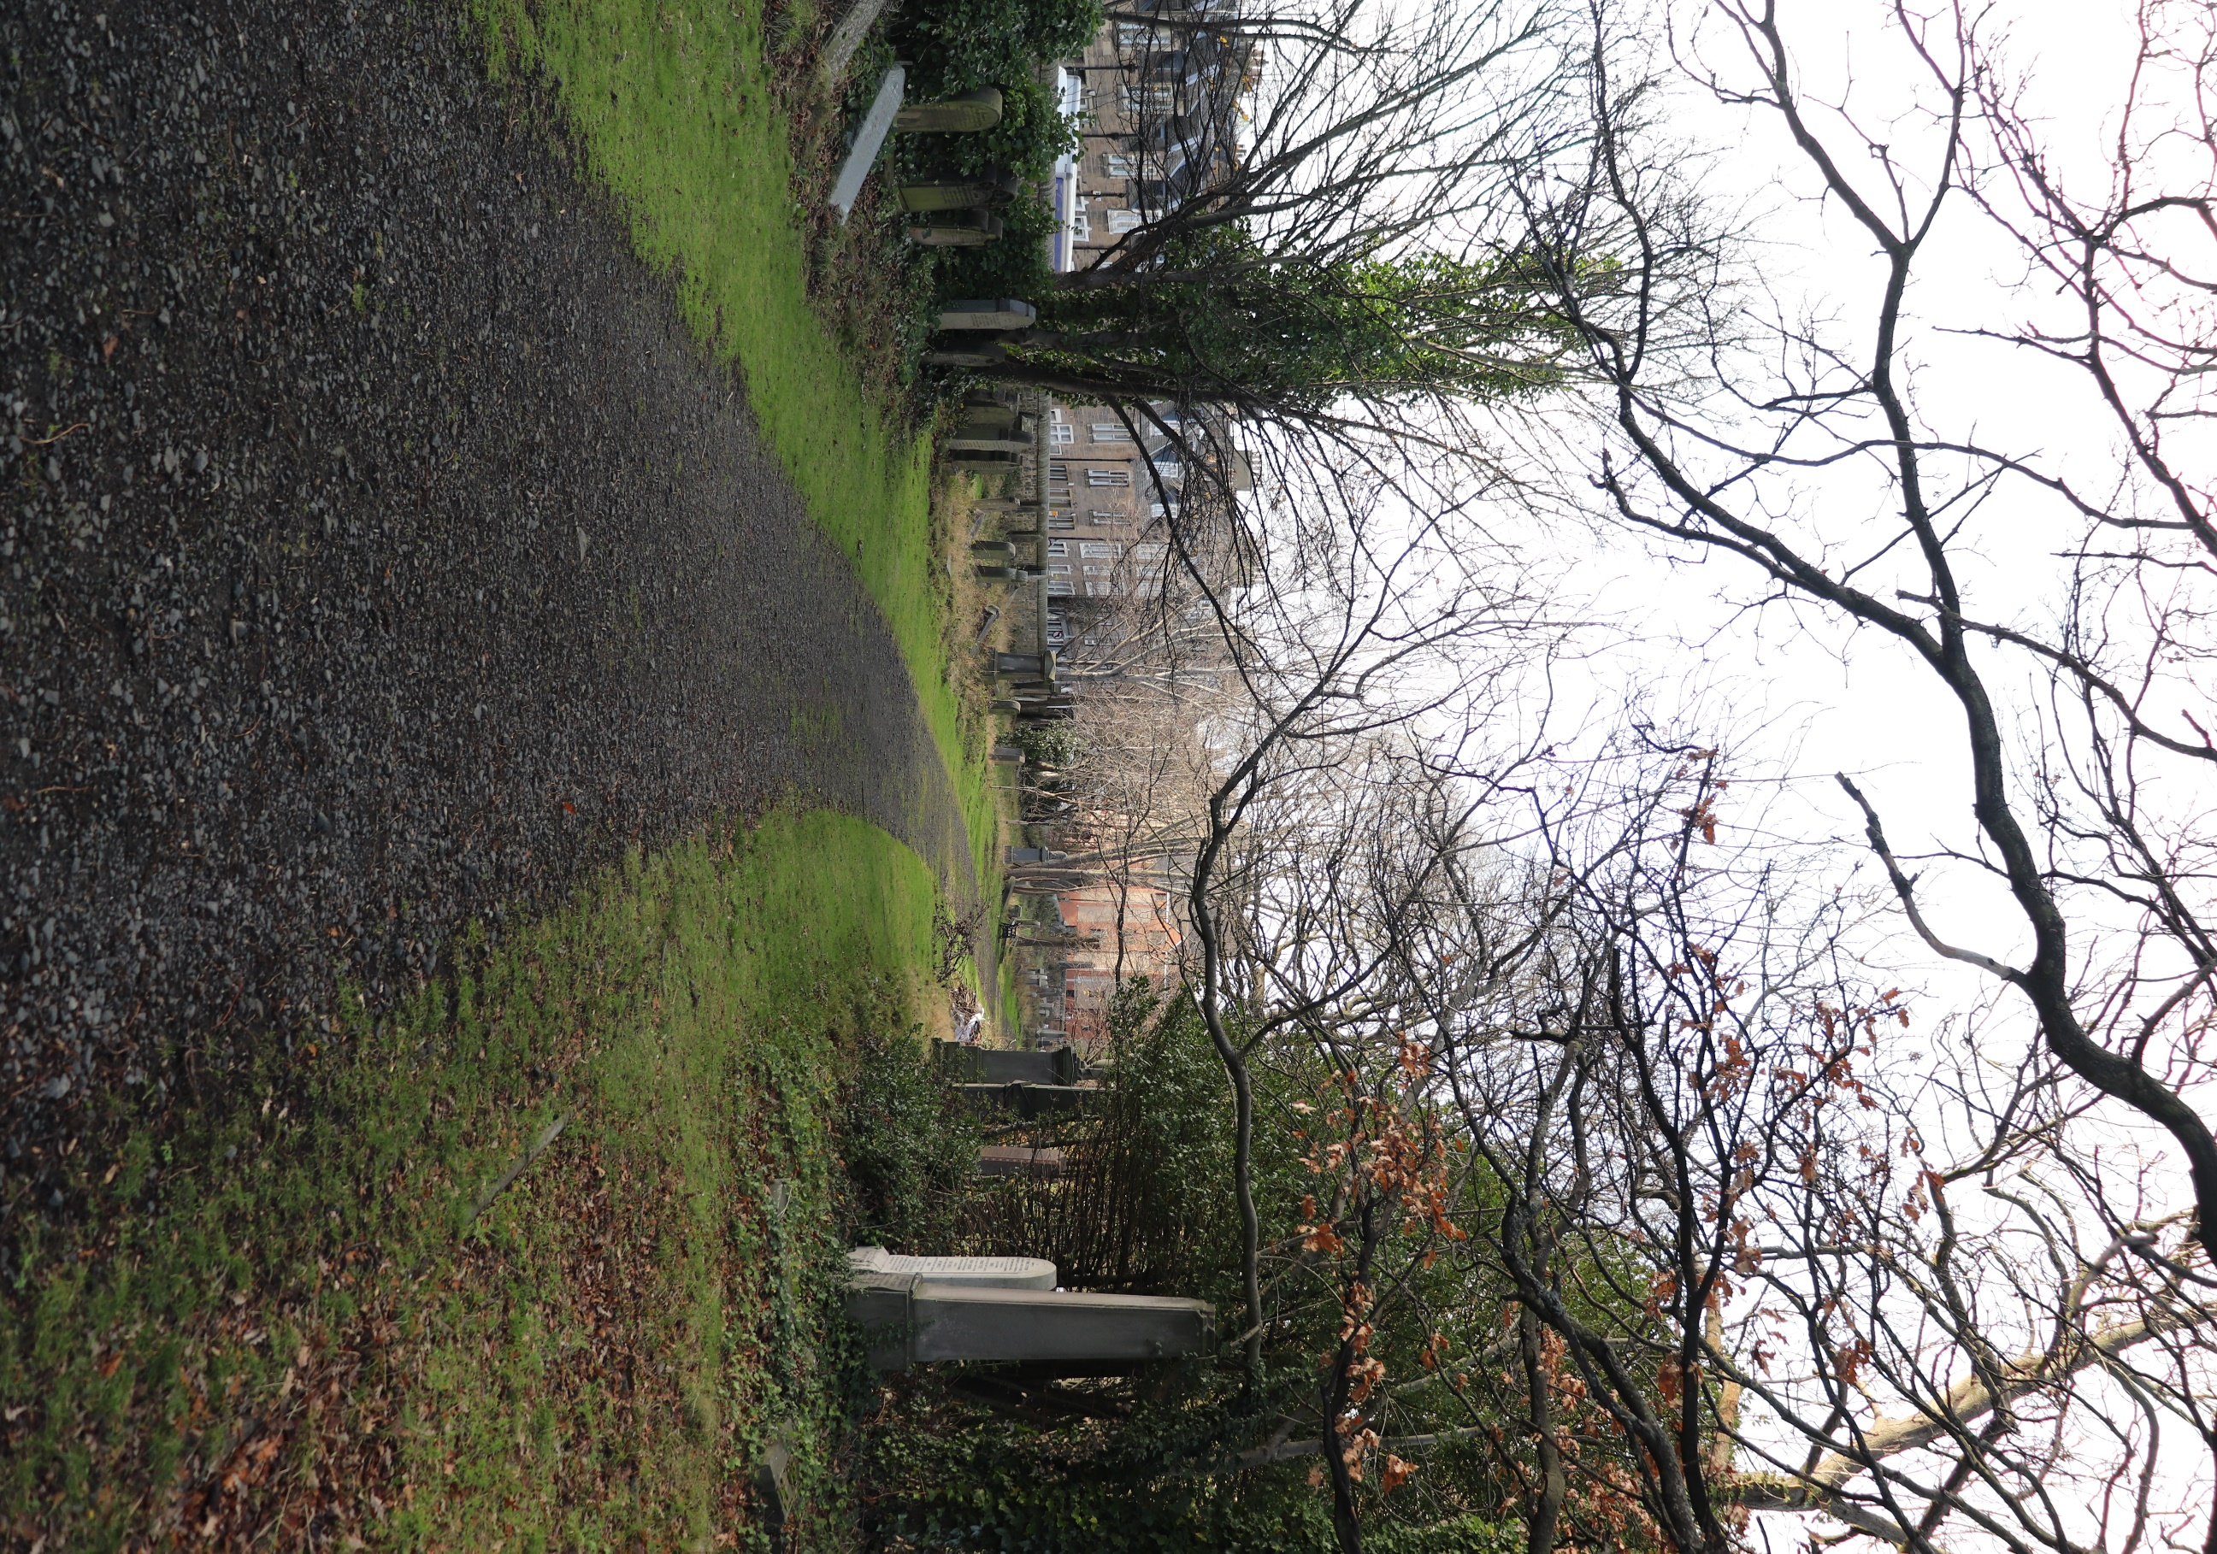


DALRY CEMETERY

Version | Author(s) | Comments | Dates
V1.1 | Danielle Gartland-Quinn | Tam Magee | 24/2/2026

This document will be reviewed on an annual basis. However, a review or revision of any parts can be carried out at any time for service improvements and will be carried out following new legislation or changes to codes of practice.
This document can be viewed by the public during office hours or online.

`

Contents

- Brief history
- Site description
- Site summary
- Asset list
- Grounds maintenance and biodiversity
- Lair types and availability
- Community involvement
- Notable burials and monuments
- Map

- Brief history

Dalry Cemetery, originally known as Dalry Necropolis, was opened in 1846 by the Metropolitan Cemetery Association (later known as The Edinburgh Cemetery Company) and is a typical example of the mid-19th-century garden cemetery movement and cultural shift toward more park-like burial grounds outside of overcrowded kirkyards. The cemetery was designed by Edinburgh architect David Cousin, who modelled the grounds on a more intimate scale after his previous work at Warriston Cemetery. His layout mixed nature with grand architectural including Gothic catacombs with an above terrace, designed for 48 above-ground burials. Despite their grand design, the vaults were never used however remain an architectural focal point. While a chapel was part of the cemetery’s original design, it was never actually built. It appears only in the initial architectural drawings used for early advertisements. A gothic style lodge house was also added; this is now a private residence. Following the first interment on 14 July 1846, the cemetery served the community for many years, eventually becoming the final burial place for over 26,000 people. By the 1970s, the site had fallen into severe neglect and suffering from vandalism. Many attempts to restore the cemetery were made, including restoration work by The Action for Dalry Cemetery Group. In 1987 the Council compulsory purchased the cemetery and closed it to the public to conduct intense maintenance and safety works, the cemetery reopened to the public in 1991. Today, Dalry Cemetery is managed with a focus on biodiversity, preserving its Victorian Gothic atmosphere as a peaceful urban greenspace within the city.
- Site description

Dalry Cemetery is a typical example of the 19th-century garden cemetery movement, designed to blend romantic landscape architecture with a peaceful space for reflection. Situated on a gentle slope, the grounds transition from the bustling urban environment into a quiet, biodiverse haven of mature trees and dense greenery. The cemetery is accessible from two distinct vantage points. The Dalry Road entrance serves as the lower gateway, marked by stone pillars and ornate black iron gates. Upon entering, visitors are met by a striking Tudor Gothic lodge house, which sits at the cemetery’s lowest point. From here, a modern monoblock driveway leads to the right, providing access a path to all burial points. In contrast, the Dundee Street entrance offers access at the cemetery’s highest elevation. Lined by its own stone pillars and gates, this entrance leads directly onto a traditional stone slab pathway that leads into burial sections. A focal point of the cemetery is a row of vaulted catacombs topped with a terrace. The surrounding monuments show a range of artistic methods, materials and colours that reflect the trends of different eras. While many headstones have been laid flat for modern safety, the craftsmanship of the memorials highlights the gothic and classical influences of the time. Managed today with a strong focus on biodiversity, the cemetery has evolved into an urban greenspace. The combination of open grassed areas, winding paths, and uninhibited overgrowth creates a secluded, peaceful atmosphere. It is a place where historic masonry meets wild nature, offering a quiet retreat from the surrounding city.

- Site Summary
Name | Dalry Cemetery
Address | 227/1 Dalry Road Edinburgh
Postcode | EH11 2EQ
Ownership | The City of Edinburgh Council
Date site acquired | 1987
Size | 2.29 hectares
Conservation area | Yes
Tree preservation | No
Listing | C
Access | Vehicle and pedestrian
Opening hours | 24 hours

- Asset List
Asset | Location | Information
Waiting room | No
Toilets | No
CCTV | No
Signage | Cemetery gates | Signs detailing name of the cemetery, cemetery user information, safety signs,
Cabinet signage | Cemetery entrance | Sign welcoming cemetery users, displaying cemetery rules, biodiversity information, other useful information, biodiversity signs placed by Friends
Car park | No
Disabled parking | No
Taps | No
Litter bins | Yes, throughout site see map
Benches | Yes, throughout site see map
Catacombs | Yes, see map
War memorials | Yes, throughout site | More information can be found on Commonwealth War Grave Commission webpage.

- Grounds maintenance and biodiversity

The Council has revised its approach to grounds maintenance in response to the current nature emergency. This approach aims to protect and enhance existing biodiversity while encouraging the development of new habitats across the cemetery. This means less frequent grass cutting, no use of weedkiller, introduction of wildflowers, and the encouragement of natural grassland growth.

Dalry Cemetery is managed with a low-intervention approach to prioritize biodiversity and the flourishing of local wildlife. By intentionally limiting formal grounds maintenance, the site serves as a protected habitat where native flora and fauna can thrive undisturbed. This sustainable management strategy transforms the cemetery into a vibrant urban ecosystem, balancing its role as a place of remembrance with a commitment to ecological conservation

Routine maintenance activities are outlined below. A complete summary of our ground’s maintenance plans can be found in the Bereavement Services Cemeteries Management Plan.

Routine Maintenance | Frequency | Additional information
Grass cutting | Approx. every 10-12 weeks during appropriate seasons | No grass cutting during No Mow May
Strimming | Approx. every 10-12 weeks during appropriate seasons | No grass cutting during No Mow May
Leaf clearance | When required | Removal from hard standing areas and pathways only.
Sunken graves | When required
Re-turfing / grass seeding | When required | Method will depend on season
Emptying bins | When required

A biodiversity study conducted in 2021 identified that Dalry Cemetery already supports a large range of biodiversity, including a variety of trees, grasses, animals, and insects. The council is committed to protecting these existing habitats and encouraging biodiversity across the site. A list of species found in the cemetery in 2021 are detailed below.

Species List | Details
Trees | Ash (with signs of die back), Black Poplar; Elder; Elm (including weeping elm); Crab Apple, Hawthorn, hollies (including common holly and Highclere holly); Horse Chestnut, Laburnum, Lime, Silver Birch; Spanish Oak, Sycamore, Whitebeam.
Shrubs | Aucuba; Golden Privet
Grasses | Cocksfoot, Meadow Grass (Poa pratensis); Perennial Rye-grass; Timothy Grass; Yorkshire Fog and others
Flowers | Bluebells (Spanish and hybrid), Brambles, Broad Leaved Willowherb, Cleavers, Common Chickweed, Common Hogweed, Common Sorrel, Cow Parsley, Crocus, Cuckoo Flower, Daisy, Dandelion, Dock, Doves Foot Cranesbill, Few Flowered Leek, Garlic Mustard, Green Alkanet, Ground Elder, Groundsel, Hedge Bindweed; Herb Robert, Ivy, Lesser Celandine, Meadow Buttercup, Nettles, Nipplewort, Pink Purslane, Prickly Sow Thistle, Red Campion, Red Dead Nettle, Ribwort Plantain, Rosebay Willowherb, Shepherd's Purse; Smooth Sow Thistle, Snakes-head Fritillary; Snowdrop; Spear Thistle (and one other thistle species), speedwells (at least 2 species), White Clover, White Dead-Nettle, Wood Anemone, Wood Avens (aka Herb Bennet), Yarrow.
Fungi | Common Ink Cap; Dryad's Saddle, Jelly Ear Fungus, Giant Puffballs, earthstar sp, Nettle Rust and others.
Mosses | Brachythecium rutabulum (?); Capillary Thread Moss (Bryum capillare), Grimmia pulvinata; Hypnum sp plus others.
Mammals | Fox, grey squirrel, rat
Birds | Blackbird, Blackcap (nesting), Blue Tit, Bullfinch, Chaffinch, Chiffchaff, Dunnock, Fieldfare, Goldfinch, Great Spotted Woodpecker, Great Tit, Greenfinch, Jackdaw, Kestrel, Long-Tailed Tit (nesting), Magpie, Mistle Thrush, Redwing, Robin, Song Thrush, Sparrowhawk, Stock Dove, Willow Warbler, Wood Pigeon (nesting), Wren.
Insects | Butterflies: Comma, Green Veined White; Peacock, Orange Tip, Red Admiral, Small White, Small Tortoiseshell, Speckled Wood.  Moths: Buff Footman; Green Longhorn Moth, Map Winged Swift; Olive Pearl Moth, Nettle Tag Moth; Small Grey Moth (Eudonia mercurella); White-shouldered House Moth (Endrosis sarcitrella) and others  Ladybirds: 2 Spot Ladybird, 10 Spot Ladybird, Cream Spot Ladybird, Larch Ladybird, Orange Ladybird, Pine Ladybird.  Bees and wasps: Buff Tailed Bumble Bee; Chocolate Mining Bee, Common Carder Bee, Early Bumble Bee, Garden Bumblebee; a species of nomad cuckoo bee; Red Tailed Bumble Bee,Tree Bumble Bee. Common Wasp and at least 2 other species of wasp.  Hoverflies: Banded Hoverfly (Syrphus sp); Batman Hoverfly (Myathropa florea), Footballer Hoverfly (Helophilus pendulus and H. hybridus), Marmalade Hoverfly (Episyrphus balteatus), Narcissus Bulb Fly (Meredon equestris), Pellucid Hoverfly (Volucella pellucens), plus those with only scientific names: Baccha elongata, Cheilosia sp, Dasysyrphus venustus, Eristalis intricaria, Eristalis pertinax, Eupeoides latifasciatus, Eupeoides sp, Epistrophe eligans, Epistrophe grossulariae, Leucozona lucorum, Meliscaeva auricollis, Melangyna lasiophthalma, Melanostoma sp, Pipiza sp, Platycheirus albimanus, Platycheirus sp, Sphaerophoria sp. Xylota segni.  Shield Bugs: Birch Shield Bug; Deraeocoris lutescens; Hawthorn Shield Bug; Red Legged Shield Bug.  Other Bugs: Anothocoris nemorum (common flower bug); Anthocoris confusum (another species of flower bug); Black Kneed Capsid Bug; Pinalitus cervinus (a Mirid Bug).  Springtails: Dicyrtomina saundersi; Entomobrya albocincta; Entomobrya intermedia; Orchesella cincta  Flies: Broad Centurion Fly (Chloromyia formosa), Chilenocaecilius ornatipennis (a bark fly); Dark Edged Bee Fly; Ectopsocus petersi (a bark fly); St Marks Fly, green bottle fly, Picture Wing Fly (Xyphosia miliaria), a species of crane fly, Smoky-winged woodlouse fly (Melanophora roralis); Tenthredo mesomela (a sawfly)  Beetles: a species of soldier beetle; Nebria brevicollis (a species of ground beetle), Nettle Weevil.  Other Insects: Psyllopsis fraxini (a jumping plant louse);  Other Invertebrates  Harvestmen: Dicranopalpus ramosus; Leiobunum rotundum.  Spiders: Garden spider, green orb weaver

As part of our ongoing biodiversity work, the Council may place nature cameras in Dalry Cemetery to monitor the wildlife using the cemetery. Although a cemeteries primary purpose is as a place of remembrance and reflection wildlife are often attracted to cemeteries due to their quiet unchanging environment.

- Lair type and availability

There are no new lair’s available at Dalry Cemetery, burial can only be arranged in an existing lair.

- Community involvement

The Friends of Dalry Cemetery were established during the covid pandemic and are dedicated to caring for the heritage and biodiversity of the cemetery. Their involvement enhances the condition of the cemetery and contributes significantly to the improvements seen across the site. Their commitment, local knowledge and hands-on involvement have made a meaningful difference to the appearance, accessibility and historical understanding of Dalry Cemetery. Members of the Friends of Dalry group have a deep interest in and knowledge of the cemetery's local history, researching the stories of those buried there and helping preserve the cemetery’s cultural heritage.

Activities carried out by the Friends group include:

- Tree planting and habitat creation.
- Setting Up a Little Free Library
- Gardening and maintaining planted areas.
- Improving paths and general access around the cemetery.
- Providing homes for birds, bats, insects and other wildlife.
- Fundraising to support conservation projects.
- Hosting community events and open days.
- Assisting with landscape improvements alongside members of staff.
- Leading guided talks and walks to share the burial grounds history.
- Contributing to the ongoing management and future planning of the site.
- Paying for and reinstalling memorials
- Historical research, open days and involvement with Remembrance Days
- Biodiversity focused

The Friends group's involvement not only supports essential maintenance but also helps visitors better understand and appreciate the site's significance.
For information about volunteering, supporting or becoming a member of this Friends group please contact Jakob via email jakob@openprint.co.uk.
Establishing or joining a 'Friends of' group is a meaningful way to contribute to your community while helping us protect these spaces. If you are interested in forming a new group or would like to enquire about future opportunities, please contact Bereavement Services.

- Notable burials and monuments

In the south-central section of Dalry Cemetery, a shared memorial marks the resting place of a remarkable Victorian literary partnership: George Cupples (1822–1891) and Anne Jane Cupples (1839–1898). George was a celebrated maritime novelist and critic, earning lasting fame for his nautical classic The Green Hand, which was originally serialised in the prestigious Blackwood's Magazine. His deep understanding of the sea was not merely academic; during a return voyage from India, he famously demonstrated his courage by taking command of the merchant ship Star of Bengal after the captain fell ill, successfully navigating the vessel all the way back to London. His wife, Anne Jane, who wrote under the name Mrs George Cupples, was an exceptionally prolific author in her own right, producing nearly 50 books primarily aimed at young readers. Her stories, such as Terrapin Island and The Cockatoo's Story, were beloved for their focus on natural history and animal welfare. As key figures in Edinburgh’s 19th-century intellectual circles, the couple maintained close friendships with other local luminaries, including the physician and author Dr John Brown. Today, their modest headstone in Dalry Cemetery stands as a quiet tribute to two lives dedicated to the craft of storytelling, spanning the worlds of high-seas adventure and educational children's fiction.

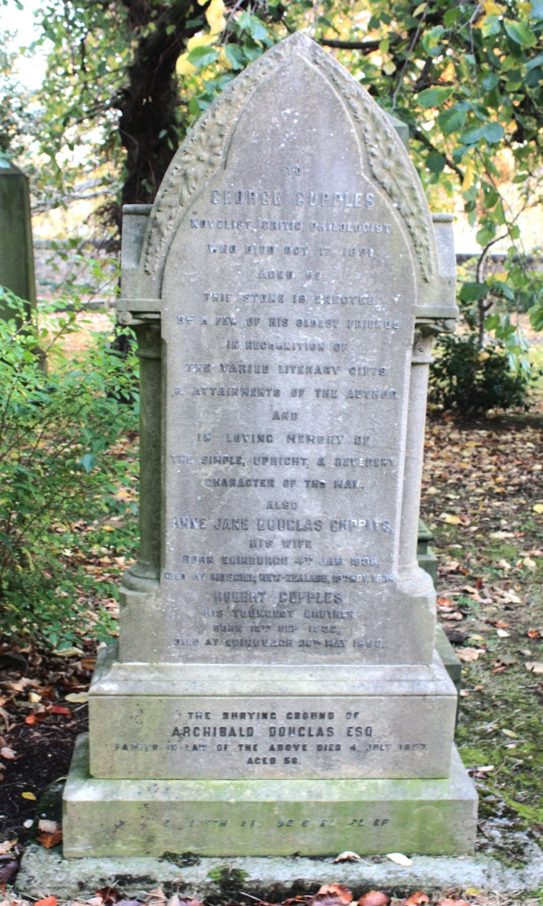

- Map
