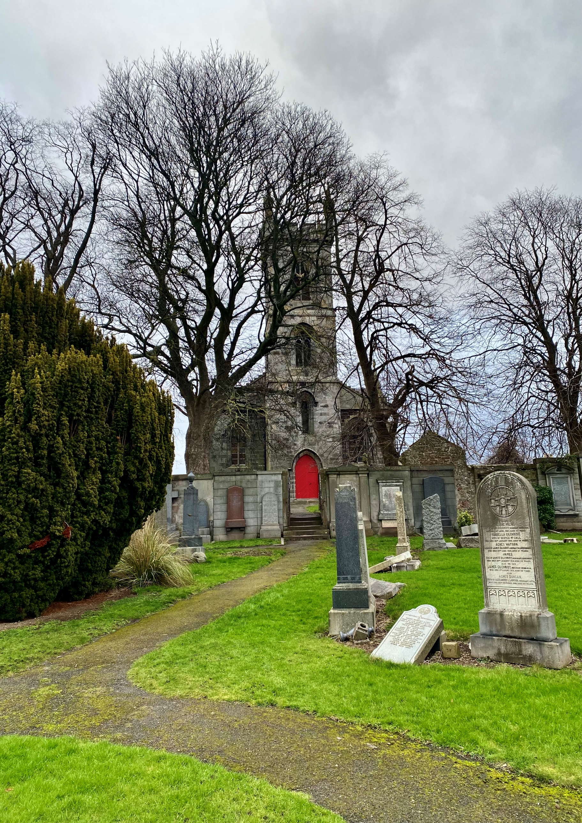


LIBERTON KIRKYARD

Version | Author(s) | Comments | Dates
V1.1 | Danielle Gartland-Quinn | Photos by Tam Magee | 25/2/2026

This document will be reviewed on an annual basis. However, a review or revision of any parts can be carried out at any time for service improvements and will be carried out following new legislation or changes to codes of practice.
This document can be viewed by the public during office hours or online.

`

Contents

- Brief history
- Site description
- Site summary
- Asset list
- Grounds maintenance and biodiversity
- Lair types and availability
- Community involvement
- Notable burials and monuments
- Map

- Brief history

Liberton Kirk dates back to the 12th century and serves as a prominent landmark on Edinburgh's southern ridgeline. Following a devastating fire, the old church was demolished in 1814, making way for the current semi-Gothic structure designed by the celebrated architect James Gillespie Graham, which was completed in 1815. This historic kirk is surrounded by its original kirkyard, an extensive burial ground that archives centuries of local life through its diverse memorials. The grounds are particularly noted for their 18th-century "trades stones," which feature intricate carvings of agricultural tools and scenes, reflecting the area’s deep-rooted farming heritage. As the original kirkyard reached its capacity, it was significantly extended in 1882 with the opening of the adjacent Liberton Cemetery.

- Site description

Accessed via Kirkgate, the entrance to Liberton Kirkyard is marked by black iron gates set into stone pillars, with a matching pedestrian gate located directly to the right. Upon entering, a stone building stands immediately to the right, and a tarmac path branches in three directions to lead visitors toward the kirk entrance or the left and right sections of the grounds. The kirkyard completely surrounds the church building, consisting of flat, well-maintained open lawn burial sections. The site features a diverse range of memorials, from modest headstones to large, ornate monuments, including one prominent tomb. The entire kirkyard is enclosed by traditional stone walls, though it offers direct pedestrian access into the adjacent Liberton Cemetery. While established trees are limited, giving the site an open feel, a notable modern addition is a memorial plaque on the church wall dedicated by the kirk to those who lost their lives during the COVID-19 pandemic. This blend of historic "trades stones" and contemporary memorials ensures the kirkyard remains a living record of the community’s history.

- Site Summary
Name | Liberton Cemetery and Churchyard
Address | 5B Kirkgate Edinburgh
Postcode | EH16 6JY
Ownership | The City of Edinburgh Council
Date site acquired | 1974
Size | 0.53 hectares
Conservation area | No
Tree preservation | No
Listing | A
Access | Vehicle and pedestrian
Opening hours | 24 hours

- Asset List
Asset | Location | Information
Waiting room | No
Toilets | No
CCTV | No
Signage | Cemetery gates | Signs detailing name of the cemetery, cemetery user information, safety signs
Cabinet signage | Cemetery entrance | Sign welcoming cemetery users, displaying cemetery rules, biodiversity information, other useful information
Car park | No
Disabled parking | No
Taps | Yes, see map
Litter bins | Yes, throughout site see map
Benches | Yes, throughout site see map
Catacombs | No
War memorials | Yes | More information can be found on Commonwealth War Grave Commission webpage.

- Grounds maintenance and biodiversity

The Council has revised its approach to grounds maintenance in response to the current nature emergency. This approach aims to protect and enhance existing biodiversity while encouraging the development of new habitats across the cemetery. This means less frequent grass cutting, no use of weedkiller, introduction of wildflowers, and the encouragement of natural grassland growth.

Routine maintenance activities are outlined below. A complete summary of our ground’s maintenance plans can be found in the Bereavement Services Cemeteries Management Plan.

Routine Maintenance | Frequency | Additional information
Grass cutting | Approx. every 10-12 weeks during appropriate seasons | No grass cutting during No Mow May
Strimming | Approx. every 10-12 weeks during appropriate seasons | No grass cutting during No Mow May
Leaf clearance | When required | Removal from hard standing areas and pathways only.
Sunken graves | When required
Re-turfing / grass seeding | When required | Method will depend on season
Hedge cutting | Annually | No hedge / shrub work during bird nesting season (March-August)
Emptying bins | When required

A biodiversity study conducted in 2021 identified that Liberton Cemetery already supports a large range of biodiversity, including a variety of trees, grasses, animals, and insects. The council is committed to protecting these existing habitats and encouraging biodiversity across the site. A list of species found in the cemetery in 2021 are detailed below.

Species List | Details
Trees | Beech, cherry, cypress sp, elder, hawthorn, holly, horse chestnut, laburnum, lime, maple sp, rhododendron, rowan, silver birch, sycamore, willow leaved pear, yew
Shrubs | buddleia, cotoneaster, hydrangea, Hypericum, ivy, Pieris, privet, rose, snowberry, Solomon's Seal, Virginia Creeper
Grasses | Meadow grass (Poa pratensis), Pampas grass, perennial rye grass.
Flowers | begonias, broad leaved willowherb, creeping buttercup,cyclamen, daisy, dandelion, dock, doves-foot cranesbill, feverfew, fox and cubs, fuchsia, Geranium sp, groundsel, heathers, hedge bindweed, iris, michaelmas daisy, nettle, ox eye daisy, pansy, pricky sow thistle, primulas, red campion, ribwort plantain, rosebay willowherb, speedwell sp, sweet pea, thistle sp, valerian, white clover, wood avens, yarrow
Fungi | some present including tar spot on sycamore leaves (this fungus does not damage the trees).
Mosses | Grimmia pulvinata, Marchantia polymorpha (a liverwort), Orthotrichum anomalum, Tortula muralis.
Mammals | Grey squirrel
Birds | blackbird, blue tit, carrion crow, jackdaw, magpie, robin, rook, woodpigeon.
Insects | common wasp, craneflies (Probably Tipula oleracea and Tipula confusa), common carder bumblebee, earwig, green leafhopper (not identified to species level), red admiral butterfly,

As part of our ongoing biodiversity work, the Council may place nature cameras the cemetery to monitor the wildlife. Although a cemeteries primary purpose is as a place of remembrance and reflection wildlife are often attracted to cemeteries due to their quiet unchanging environment.

- Lair type and availability

There are no new lairs available in this kirkyard.

- Community involvement
There are no established Friends Groups for this churchyard.
Establishing or joining a 'Friends of' group is a meaningful way to contribute to your community while helping us protect these spaces. If you are interested in forming a new group or would like to enquire about future opportunities, please contact Bereavement Services.

- Notable burials and monuments

Liberton Kirkyard has many different memorials that vary in size and style. You can find everything from small, simple markers to large, grand monuments. These stones are made from various materials and feature unique designs that tell the story of the local area's long history.

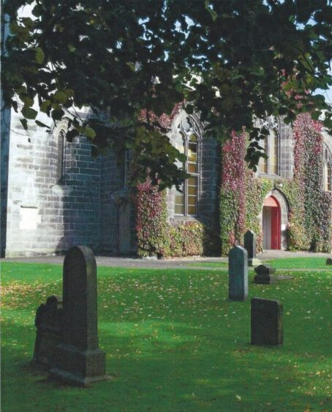

- Map

