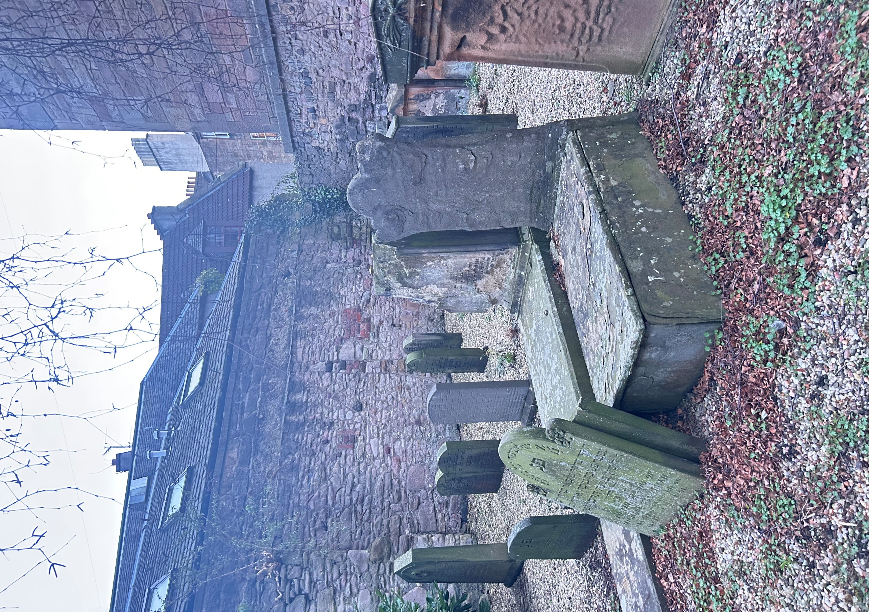


JEWISH BURIAL GROUND

Version | Author(s) | Comments | Dates
V1.1 | Danielle Gartland-Quinn | Photos by Tam Magee | 24/2/2026

This document will be reviewed on an annual basis. However, a review or revision of any parts can be carried out at any time for service improvements and will be carried out following new legislation or changes to codes of practice.
This document can be viewed by the public during office hours or online.

`

Contents

- Brief history
- Site description
- Site summary
- Asset list
- Grounds maintenance and biodiversity
- Lair types and availability
- Community involvement
- Notable burials and monuments
- Map

- Brief history

The Sciennes Jewish Burial Ground was opened in 1816 by the local Jewish burial congregation to serve a small but established community. Records from the time indicate that at least 20 Jewish families resided in the area, a population that remained relatively stable for several decades. While no official burial records for the site have survived, the physical history of the ground is anchored by its earliest headstone, which dates back to the year of its opening. Today, fewer than 30 headstones remain on the site, some of which have become badly weathered and unreadable over the two centuries since its founding. The cemetery officially closed for burials in 1867, after which the community moved their interments to a specifically allocated Jewish section within Newington Cemetery. This small, historic site stands as a significant testament to the early roots of the Jewish community in Edinburgh.

- Site description

Located on Sciennes House Place, the Sciennes Jewish Burial Ground is a small site secured by locked iron gates mounted within a stone wall and iron fencing. Access to the cemetery is via two small steps leading to the gate. The cemetery is tightly bordered by the stone walls of neighbouring residential buildings. Unusually for a burial ground, the site is not grassed but is instead finished with stone chippings, and it contains no formal paths or roadways. Within the grounds, headstones are arranged in four orderly rows, all facing the same direction. These markers vary in size and artistic style, including a notable table tomb, though many have become so badly weathered over time that the stone has completely eroded leaving a hole in the sandstone memorial. However, several stones still feature clear Hebrew inscriptions, serving as a lasting physical record of the community's heritage.

- Site Summary
Name | Jewish Burial Ground
Address | Sciennes House Place Edinburgh
Postcode | EH9 1NW
Ownership | The City of Edinburgh Council
Date site acquired | 1886
Size | 0.03 hectares
Conservation area | No
Tree preservation | No
Listing | B
Access | Pedestrian
Opening hours | By appointment only

- Asset List
Asset | Location | Information
Waiting room | No
Toilets | No
CCTV | No
Signage | Cemetery gates | Signs detailing name of the cemetery, cemetery user information, safety signs
Cabinet signage | Cemetery entrance | Sign welcoming cemetery users, displaying cemetery rules, biodiversity information, other useful information
Car park | No
Disabled parking | No
Taps | No
Litter bins | No
Benches | No
Catacombs | No
War memorials | No

- Grounds maintenance and biodiversity

The Council has revised its approach to grounds maintenance in response to the current nature emergency. This approach aims to protect and enhance existing biodiversity while encouraging the development of new habitats across the cemetery. This means less frequent grass cutting, no use of weedkiller, introduction of wildflowers, and the encouragement of natural grassland growth. With no grass or shrubs to tend, the cemetery requires minimal routine maintenance.

Routine maintenance activities are outlined below. A complete summary of our ground’s maintenance plans can be found in the Bereavement Services Cemeteries Management Plan.

Routine Maintenance | Frequency | Additional information
Grass cutting | Not required
Strimming | Approx. every 10-12 weeks during appropriate seasons | No grass cutting during No Mow May
Leaf clearance | Not required
Sunken graves | When required
Re-turfing / grass seeding | Not required

A biodiversity study conducted in 2021 identified that the Jewish Burial Ground already supports a small range of biodiversity. The council is committed to protecting these existing habitats and encouraging biodiversity across the site. A list of species found in the cemetery in 2021 are detailed below.

Species List | Details
Trees | Silver birch
Shrubs | Buddleia, ivy, laurel
Flowers | creeping buttercup, dandelion, a species of speedwell, wall lettuce, wood avens
Birds | blue tit, feral pigeon, magpie

- Lair type and availability

There are no new lairs available.

- Community involvement

There are no established Friends Group for this cemetery.
Establishing or joining a 'Friends of' group is a meaningful way to contribute to your community while helping us protect these spaces. If you are interested in forming a new group or would like to enquire about future opportunities, please contact Bereavement Services.

- Notable burials and monuments

Arranged in uniform rows, the memorials within the Jewish Burial Ground all face eastward. The site features a mix of traditional table tombs and headstones adorned with Hebrew inscriptions, though some have weathered so severely over the centuries that their surfaces have completely eroded.

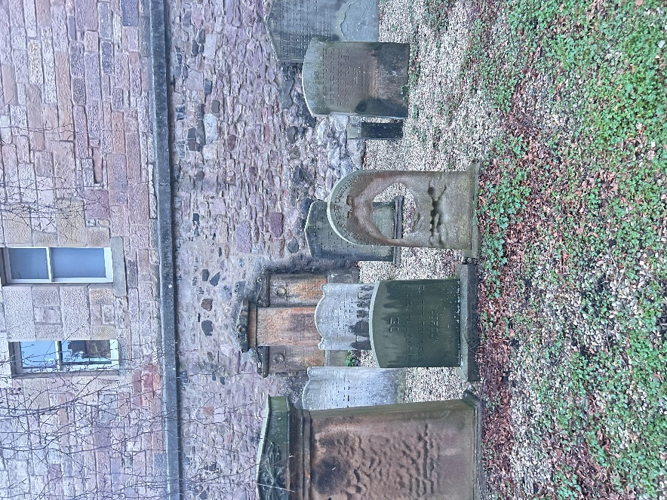

- Map

