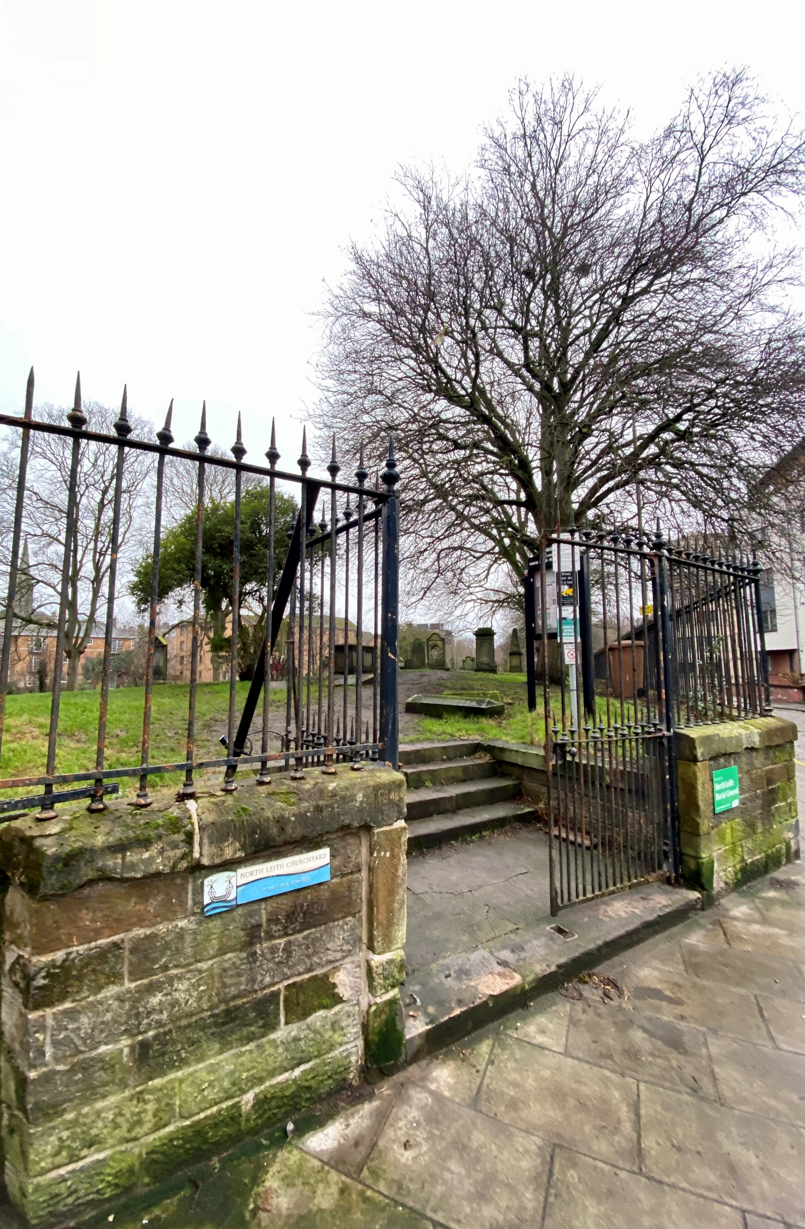


NORTH LEITH BURIAL GROUND

Version | Author(s) | Comments | Dates
V1.1 | Danielle Gartland-Quinn | Photos by Tam Magee | 25/2/2026

This document will be reviewed on an annual basis. However, a review or revision of any parts can be carried out at any time for service improvements and will be carried out following new legislation or changes to codes of practice.
This document can be viewed by the public during office hours or online.

`

Contents

- Brief history
- Site description
- Site summary
- Asset list
- Grounds maintenance and biodiversity
- Lair types and availability
- Community involvement
- Notable burials and monuments

- Brief history

North Leith Burial Ground origins are tied to the displacement of the original parishioners; after their previous burial ground at St Nicholas was built over in 1656 to create the Leith Citadel fortress, this new site on the left bank of the Water of Leith was granted in 1664. The burial ground features headstones that date as far back as 1544, and many 17th and 18th century headstones including tables tombs. A portion of the ground’s inner edge was lost in 1981 during the creation of the Water of Leith Walkway. Official records of the site are limited, and existing burial records are notably vague, covering only a short window between 1855 and 1905.

- Site description

North Leith Burial Ground is accessed via Coburg Street through traditional black iron gates set atop a small stone wall. Upon entering, three stone steps lead into the burial ground, which is securely enclosed by a low stone wall topped with black iron fencing. Along the boundaries, the perimeter is further defined by a mix of modern fencing on the side facing the Water of Leith and the rear walls of neighbouring residential properties. The burial ground itself is relatively small and unusually shaped, featuring a varied topography. While the central area is mainly flat, there are noticeable inclines and declines toward the boundary edges, adding to its historic character. From many points within the site, visitors can enjoy scenic views of the Water of Leith, which runs immediately adjacent to the graveyard. The site is densely packed with a wide variety of headstones that vary significantly in style, age, and design. These monuments range from grand, elaborate structures to more modest markers and historic table tombs, many of which date back to the 17th and 18th centuries. Despite its compact size, the well-maintained grounds offer a peaceful and visual record of Leith's maritime heritage.

- Site Summary
Name | South Leith Burial Ground
Address | 17A Coburg Street Edinburgh
Postcode | EH6 6ET
Ownership | The City of Edinburgh Council
Date site acquired | No date
Size | 0.19 hectares
Conservation area | No
Tree preservation | No
Listing | B
Access | Pedestrian
Opening hours | 24 hours

- Asset List
Asset | Location | Information
Waiting room | No
Toilets | No
CCTV | No
Signage | Cemetery gates | Signs detailing name of the cemetery, cemetery user information, safety signs
Cabinet signage | Cemetery entrance | Sign welcoming cemetery users, displaying cemetery rules, biodiversity information, other useful information
Car park | No
Disabled parking | No
Taps | No
Litter bins | Yes, throughout site see map
Benches | No
Catacombs | No
War memorials | No

- Grounds maintenance and biodiversity

The Council has revised its approach to grounds maintenance in response to the current nature emergency. This approach aims to protect and enhance existing biodiversity while encouraging the development of new habitats across the cemetery. This means less frequent grass cutting, no use of weedkiller, introduction of wildflowers, and the encouragement of natural grassland growth.

Routine maintenance activities are outlined below. A complete summary of our ground’s maintenance plans can be found in the Bereavement Services Cemeteries Management Plan.

Routine Maintenance | Frequency | Additional information
Grass cutting | Approx. every 10-12 weeks during appropriate seasons | No grass cutting during No Mow May
Strimming | Approx. every 10-12 weeks during appropriate seasons | No grass cutting during No Mow May
Sunken graves | When required
Re-turfing / grass seeding | When required | Method will depend on season
Emptying bins | When required

A biodiversity study conducted in 2021 identified that North Leith Burial Ground already supports a large range of biodiversity, including a variety of trees, grasses, animals, and insects. The council is committed to protecting these existing habitats and encouraging biodiversity across the site. A list of species found in the cemetery in 2021 are detailed below.

Species List | Details
Trees | Hawthorn, pussy willow; whitebeam
Shrubs | Buddleia; ivy
Grasses | Meadow grass (Poa pratensis) and others
Flowers | Daisy, dandelion; groundsel; ragwort; ribwort plantain; a species of speedwell
Fungi | Tar spot
Mosses | Grimmia pulvinata; Hypnum sp; Orthotrichum anomalum; Tortula muralis
Mammals | Ducks, Fox, Rat
Birds | Blackbird; carrion crow; feral pigeon; herring gull; house sparrow; magpie; starling; woodpigeon; wren
Insects | A species of snail; a species of spider

- Lair type and availability

There are no new lair’s available at North Leith Burial Ground.

- Community involvement

There are no established Friends Groups for North Leith Burial Ground.
Establishing or joining a 'Friends of' group is a meaningful way to contribute to your community while helping us protect these spaces. If you are interested in forming a new group or would like to enquire about future opportunities, please contact Bereavement Services.

- Notable burials and monuments

North Leith Burial Ground features a diverse array of memorial styles, many of which include skulls and crossbones. The memorials reflect the areas maritime history.

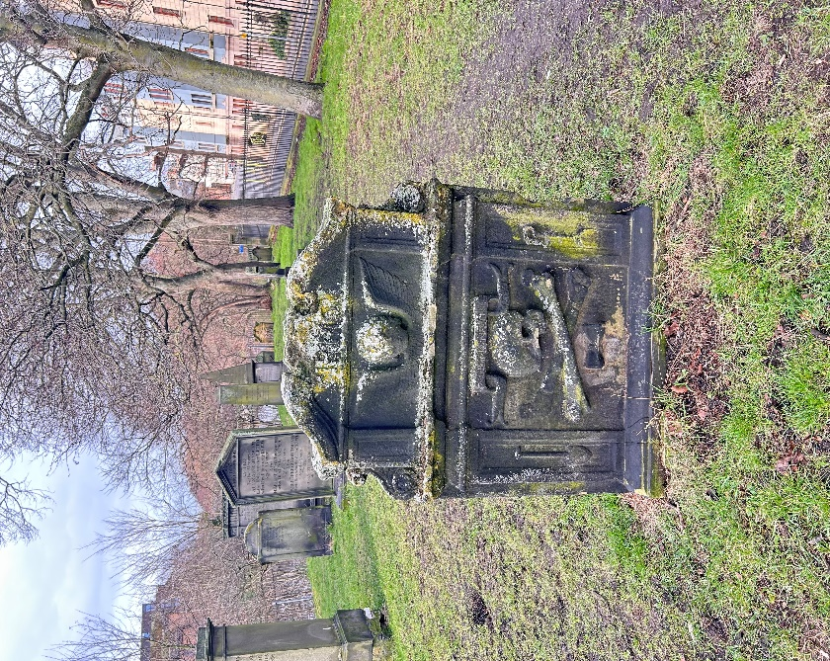

This modern memorial located at the cemetery entrance details the burial grounds notable burials, including Lady Anne Mackintosh and Reverend David Johnston.
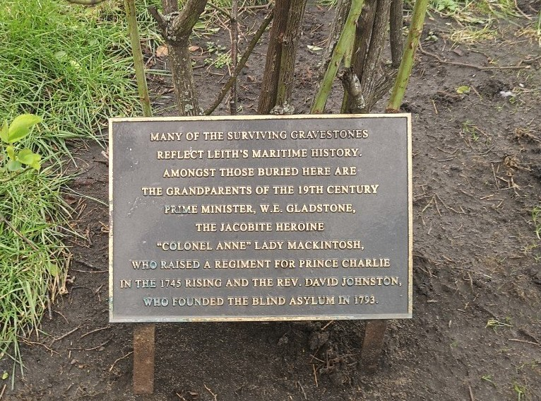

- Map

