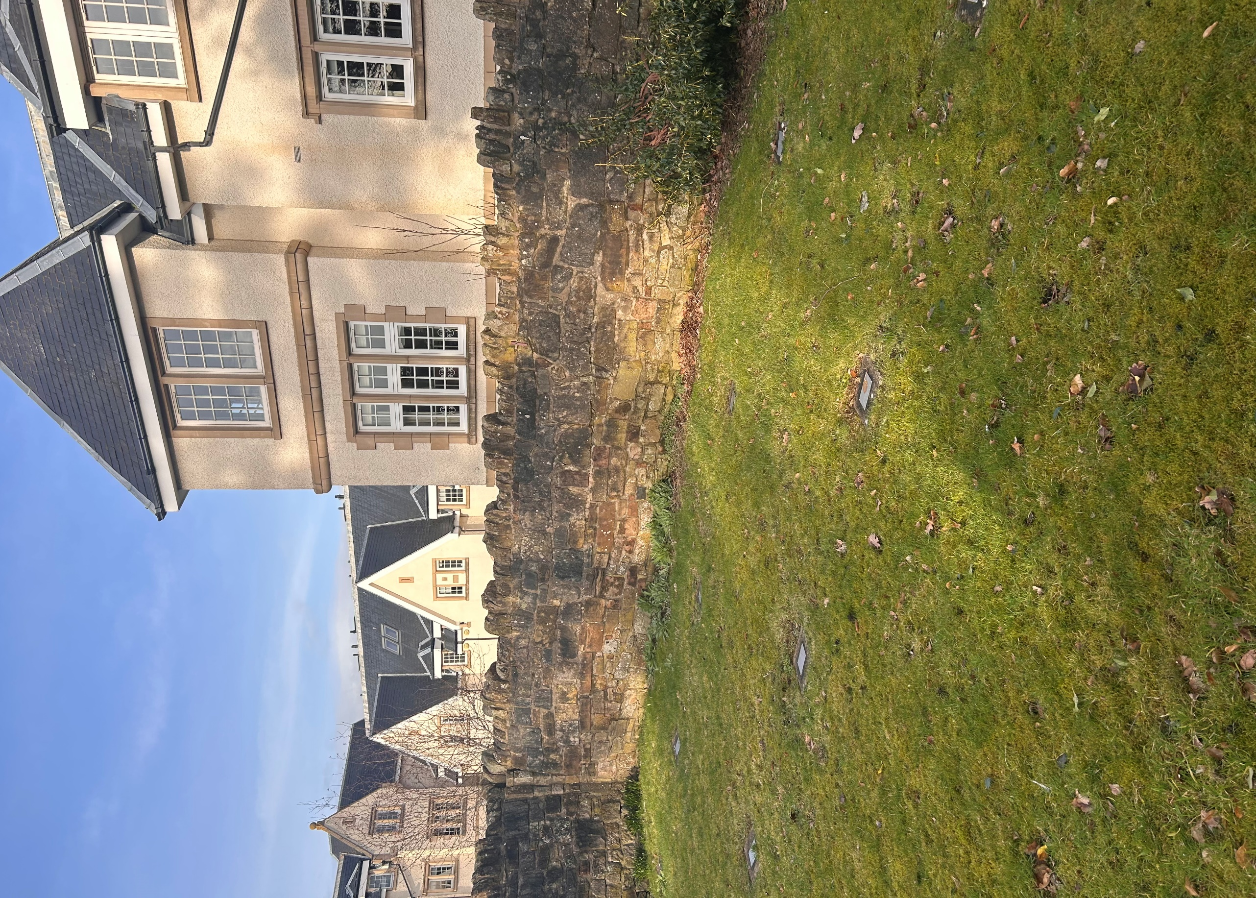


MOUNT ALVERNIA BURIAL GROUND

Version | Author(s) | Comments | Dates
V1.1 | Danielle Gartland-Quinn | Photos by Tam Magee | 25/2/2026

This document will be reviewed on an annual basis. However, a review or revision of any parts can be carried out at any time for service improvements and will be carried out following new legislation or changes to codes of practice.
This document can be viewed by the public during office hours or online.

`

Contents

- Brief history
- Site description
- Site summary
- Asset list
- Grounds maintenance and biodiversity
- Lair types and availability
- Community involvement
- Notable burials and monuments
- Map

- Brief history

Established in August 1897 by the Poor Clares (Colettines), a branch of the Order of Saint Clare, the Mount Alvernia Convent served as a secluded religious site for nearly a century. The convent eventually closed in 1992, and the remaining 13 nuns relocated to other houses within the order. Remaining on site was a small private burial ground containing the graves of 24 nuns, following the closure, a proposal was made to disinter the remains and rebury them in the nearby Mount Vernon Catholic Cemetery. This required a legal warrant, leading to a public appeal in newspapers to locate the relatives of the deceased. However, because some relatives refused to provide consent, the warrant was not granted, and the council took ownership of the cemetery in 1994. At some point, the original headstones were removed and replaced with uniform flat plaques, which now mark the final burial place of the sisters. While burials are now infrequent, graves remain reserved for those who once lived in the convent.

- Site description

Located on Lasswade Road, Mount Alvernia Cemetery is accessed through black iron gates set into sturdy stone pillars. These gates open onto a stone-slabbed pathway that leads to a second set of black iron gates. These are set into a stone wall that fully encloses the cemetery; this wall was constructed using original stone from the convent’s boundary when the site was developed into residential housing. The burial ground itself is small, flat, and neatly grass-lawned, featuring established shrubbery and trees on-site that enhance its quiet character. In place of traditional headstones, the graves are now marked by an orderly line of silver plaques flat to the ground.

- Site Summary
Name | Mount Alvernia Burial Ground
Address | 49 Mount Vernon Road Edinburgh
Postcode | EH16 6JG
Ownership | The City of Edinburgh Council
Date site acquired | 1994
Conservation area | No
Tree preservation | No
Listing | B
Access | Pedestrian
Opening hours | By appointment only

- Asset List
Asset | Location | Information
Waiting room | No
Toilets | No
CCTV | No
Signage | Cemetery gates | Signs detailing name of the cemetery, cemetery user information, safety signs
Cabinet signage | Cemetery entrance | Sign welcoming cemetery users, displaying cemetery rules, biodiversity information, other useful information
Car park | No
Disabled parking | No
Taps | No
Litter bins | No
Benches | No
Catacombs | No
War memorials | No

- Grounds maintenance and biodiversity

The Council has revised its approach to grounds maintenance in response to the current nature emergency. This approach aims to protect and enhance existing biodiversity while encouraging the development of new habitats across the cemetery. This means less frequent grass cutting, no use of weedkiller, introduction of wildflowers, and the encouragement of natural grassland growth.

Routine maintenance activities are outlined below. A complete summary of our ground’s maintenance plans can be found in the Bereavement Services Cemeteries Management Plan.

Routine Maintenance | Frequency | Additional information
Grass cutting | Approx. every 10-12 weeks during appropriate seasons | No grass cutting during No Mow May
Strimming | Approx. every 10-12 weeks during appropriate seasons | No grass cutting during No Mow May
Leaf clearance | When required | Removal from hardstanding areas and pathways only.
Sunken graves | When required
Re-turfing / grass seeding | When required | Method will depend on season
Hedge cutting | Annually | No hedge / shrub work during bird nesting season (March-August)
Emptying bins | When required

- Lair type and availability

There are no new lair’s available at Mount Alvernia Burial Ground, burial can only be arranged in an existing lair.

- Community involvement

There are no established Friends Groups for Mount Alvernia Burial Ground.
Establishing or joining a 'Friends of' group is a meaningful way to contribute to your community while helping us protect these spaces. If you are interested in forming a new group or would like to enquire about future opportunities, please contact Bereavement Services.

- Notable burials and monuments

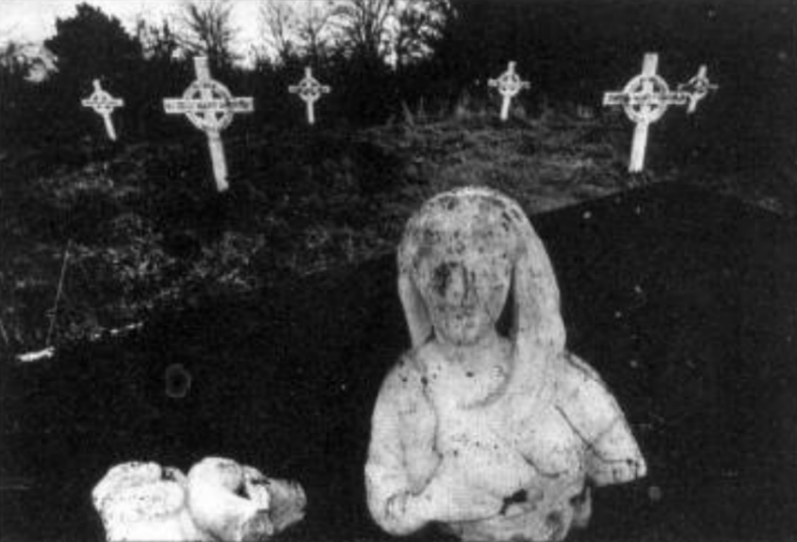

This photo published in the Edinburgh Evening News on September 23rd, 1994, shows the original headstones that marked the individual graves. It is not known why these were removed and replaced with small silver in ground plaques, as seen below.
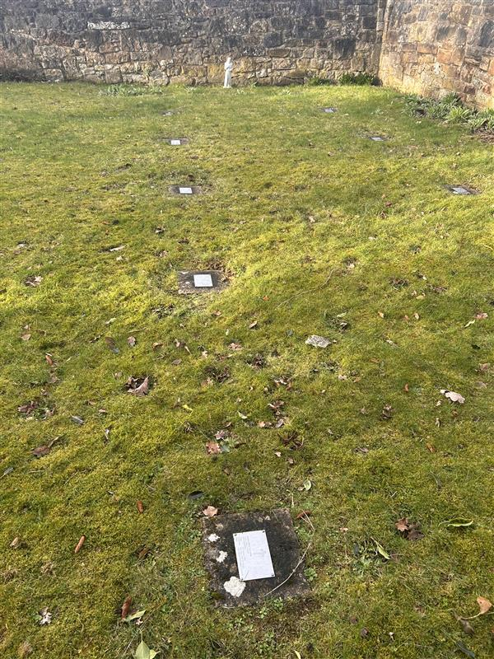

- Map

