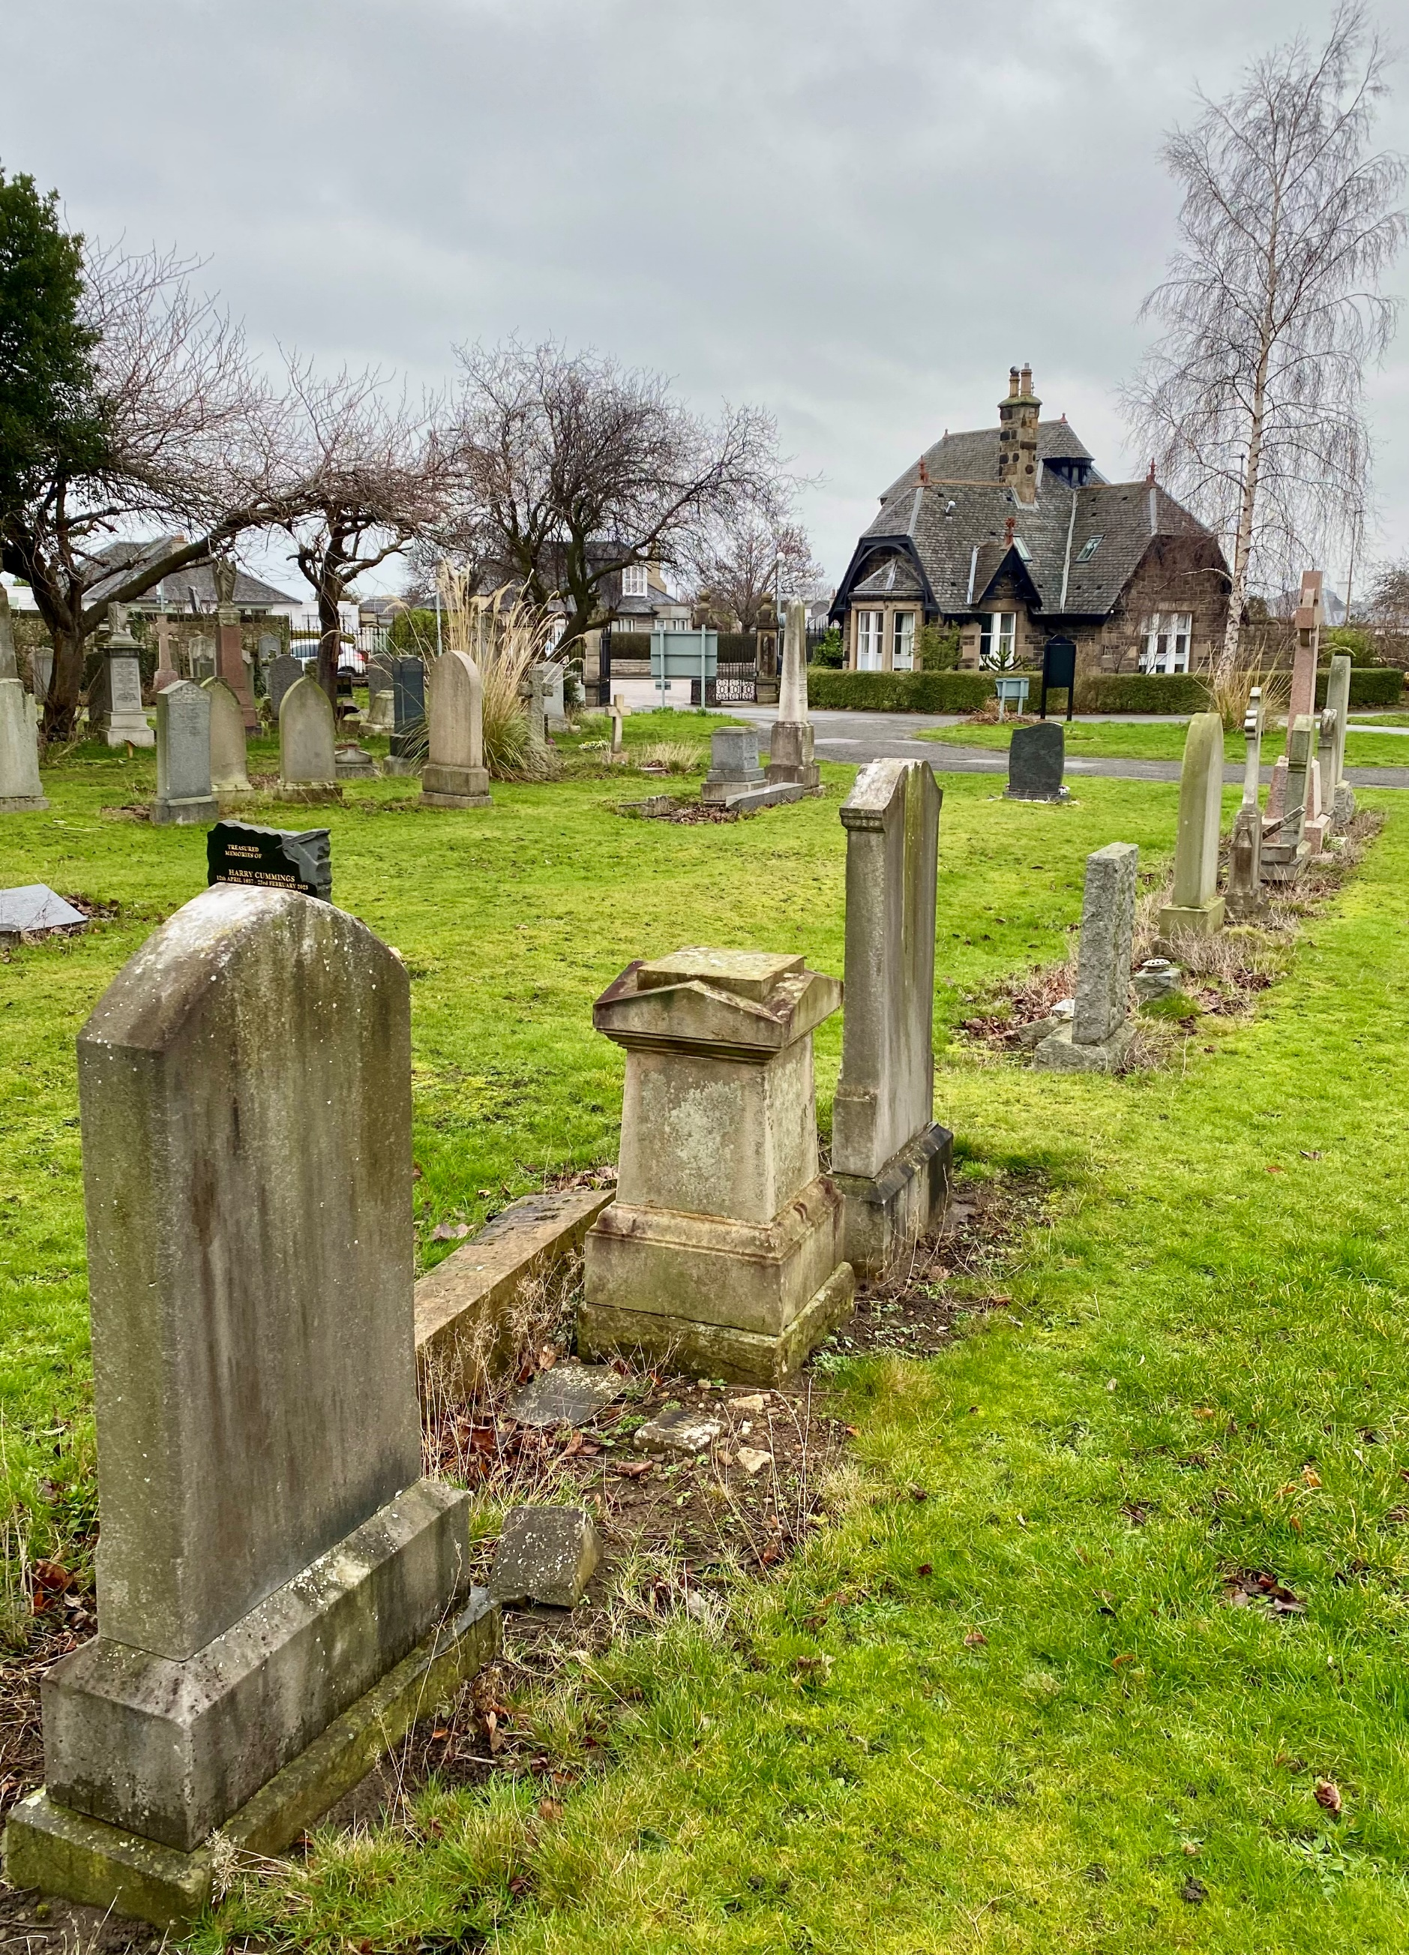
i


PORTOBELLO CEMETERY

Version | Author(s) | Comments | Dates
V1.1 | Danielle Gartland-Quinn | Photos by Tam Magee | 25/2/2026

This document will be reviewed on an annual basis. However, a review or revision of any parts can be carried out at any time for service improvements and will be carried out following new legislation or changes to codes of practice.
This document can be viewed by the public during office hours or online.

`

Contents

- Brief history
- Site description
- Site summary
- Asset list
- Grounds maintenance and biodiversity
- Lair types and availability
- Community involvement
- Notable burials and monuments
- Map

- Brief history

Portobello Cemetery was officially opened in 1877 by Provost Thomas Wood of Portobello, established during a period when nearby parish churchyards, such as Duddingston, were becoming critically overcrowded. The cemetery and its internal lodge house were designed by the notable Scottish architect Robert Paterson. While the original site spanned only three acres, the grounds have since been extended twice to meet the needs of the growing community, though specific records regarding these extensions remain vague. The first burial was conducted on 24 March 1877, marking the beginning of the site’s long history as a place of burial in the area. Designed in the popular garden cemetery style of the era, the layout is exceptionally well-planned, featuring open, spacious burial sections and a clear network of paths that provide good access throughout the entire site. This structured approach was a modern departure from the cramped conditions of older churchyards, offering a more dignified and accessible landscape for the bereaved. Despite its 19th-century origins, Portobello remains an active and vital part of the Council’s cemeteries. The grounds are well maintained, and it continues to serve the local community today with new burial lairs still available. This blend of historic Victorian architecture and continued contemporary use means that Portobello remain a significant cemetery.

- Site description

Portobello Cemetery is a well-structured and expansive burial ground accessed via a single-entry point on Milton Road East, marked by traditional iron gates set into stone pillars. Upon entry, the historic, privately owned lodge house sits immediately to the left, adjacent to a circular roadway that serves as the primary junction for the network of tarmacked roads branching through the site. These thoroughfares provide excellent access to the open, spacious burial sections that are visible from the entrance, representing a seamless blend of both historic and contemporary interments. The cemetery’s terrain begins on level ground before transitioning into a gradual slope that leads down to a lower, flat expanse. Tucked behind the lodge house are the cemetery waiting room and toilets. The site is securely enclosed by a combination of tall stone walls, dense greenery, and sections of modern fencing. Throughout the grounds, numerous established trees and shrubs contribute to a tranquil atmosphere. A section of the southern area dedicated specifically to Muslim burials offers a scenic backdrop of the Brunstane Burn. The memorials across the site vary significantly in size, material, and style, reflecting the evolving artistic trends of the Portobello community since the 19th century. From grand, imposing Victorian monuments to modest modern markers, the headstones provide a visual history of the area’s residents. This combination of a highly practical layout and a well-maintained landscape mean the grounds remain a dignified and accessible sanctuary.

- Site Summary
Name | Portobello Cemetery
Address | 198/3 Milton Road East Edinburgh
Postcode | EH15 2PD
Ownership | The City of Edinburgh Council
Date site acquired | No data
Size | 3.21 hectares
Conservation area | No
Tree preservation | No
Listing | B
Access | Vehicle and pedestrian
Opening hours | 24 hours

- Asset List
Asset | Location | Information
Waiting room | No
Toilets | Yes, see map | Opened for funerals only
CCTV | No
Signage | Cemetery gates | Signs detailing name of the cemetery, cemetery user information, safety signs
Cabinet signage | Cemetery entrance | Sign welcoming cemetery users, displaying cemetery rules, biodiversity information, other useful information
Car park | No
Disabled parking | No
Taps | No
Litter bins | Yes, throughout site see map
Benches | Yes, throughout site see map
Catacombs | No
War memorials | Yes | More information can be found on Commonwealth War Grave Commission webpage.

- Grounds maintenance and biodiversity

The Council has revised its approach to grounds maintenance in response to the current nature emergency. This approach aims to protect and enhance existing biodiversity while encouraging the development of new habitats across the cemetery. This means less frequent grass cutting, no use of weedkiller, introduction of wildflowers, and the encouragement of natural grassland growth.

Routine maintenance activities are outlined below. A complete summary of our ground’s maintenance plans can be found in the Bereavement Services Cemeteries Management Plan.

Routine Maintenance | Frequency | Additional information
Grass cutting | Approx. every 8-10 weeks during appropriate seasons | No grass cutting during No Mow May
Strimming | Approx. every 8-10 weeks during appropriate seasons | No grass cutting during No Mow May
Leaf clearance | When required | Removal from hard standing areas and pathways only.
Sunken graves | When required
Re-turfing / grass seeding | When required | Method will depend on season
Hedge cutting | Annually | No hedge / shrub work during bird nesting season (March-August)
Emptying bins | When required

A biodiversity study conducted in 2021 identified that Portobello Cemetery already supports a large range of biodiversity, including a variety of trees, grasses, animals, and insects. The council is committed to protecting these existing habitats and encouraging biodiversity across the site. A list of species found in the cemetery in 2021 are detailed below.

Species List | Details
Trees | Apple, ash, beech, birch (including downy birch, silver birch and paper birch), cherry, cypress (including Lawson cypress), elder, holly (including common holly and variegated holly), horse chestnut, laburnum, palm, pear, rowan, Swedish whitebeam, weeping willow, yew
Shrubs | Bramble, cotoneaster, holly, ivy, laurel, privet, roses
Grasses | Meadow grass (Poa pratensis), Pampas grass and others
Flowers | Broad leaved willowherb, creeping buttercup, daisy, dandelion, forget me not, groundsel, snowdrop, a species of thistle, white clover plus garden plants including cyclamen, heather and primulas
Fungi
Mosses | Grimmia pulvinata, Hypnum sp, Orthotrichum anomalum, Springy Turf Moss (Rhytidiadelphus squarrosus), Wall Screw Moss (Tortula muralis),
Mammals | Otters are likely to visit given the proximity of the river
Birds | Blackbird, blue tit, bullfinch, buzzard, chaffinch, carrion crow, coal tit, fieldfare, goldfinch, great tit, herring gull, jackdaw, long tailed tit, magpie, mistle thrush, robin, rook, woodpigeon
Insects

As part of our ongoing biodiversity work, the Council may place nature cameras in the cemetery to monitor the wildlife. Although a cemeteries primary purpose is as a place of remembrance and reflection wildlife are often attracted to cemeteries due to their quiet unchanging environment.

- Lair type and availability

Lair type | Availability | Details
Non-denomination Coffin Lairs | Yes | 2 coffin burials and 6 cremated remains urn burials
Catholic Lairs | No
Green Burial | No
Cremated remains | Yes | 6 cremated remains urn burials
Baby | No
Muslim | No
Muslim baby | No
Above ground vault | No

- Community involvement

We’ve been working with S4 students from Portobello High School, teaching them the importance of our cemetery spaces and what they mean to people. The students have been learning about faith burials and the significance of different sections within the grounds.
Alongside lessons on biodiversity and tool safety, they’ve gained a deeper respect for these spaces and are already putting their skills to work. They have made fantastic progress in clearing overgrowth and improving the cemetery.
There are no established Friends Groups for this cemetery. Establishing or joining a 'Friends of' group is a meaningful way to contribute to your community while helping us protect these spaces. If you are interested in forming a new group or would like to enquire about future opportunities, please contact Bereavement Services.

- Notable burials and monuments

Born in Edinburgh, Ian Charleson (1949–1990) rose from a printer’s son to a global star through his definitive portrayal of Olympic champion Eric Liddell in the 1981 Best Picture winner, Chariots of Fire. Though he graced other major films like Gandhi. His headstone is inscribed with Horatio's poignant farewell from Hamlet: "Good night sweet prince. And flights of angels sing thee to thy rest".

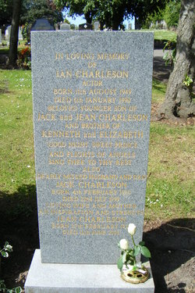

- Map

