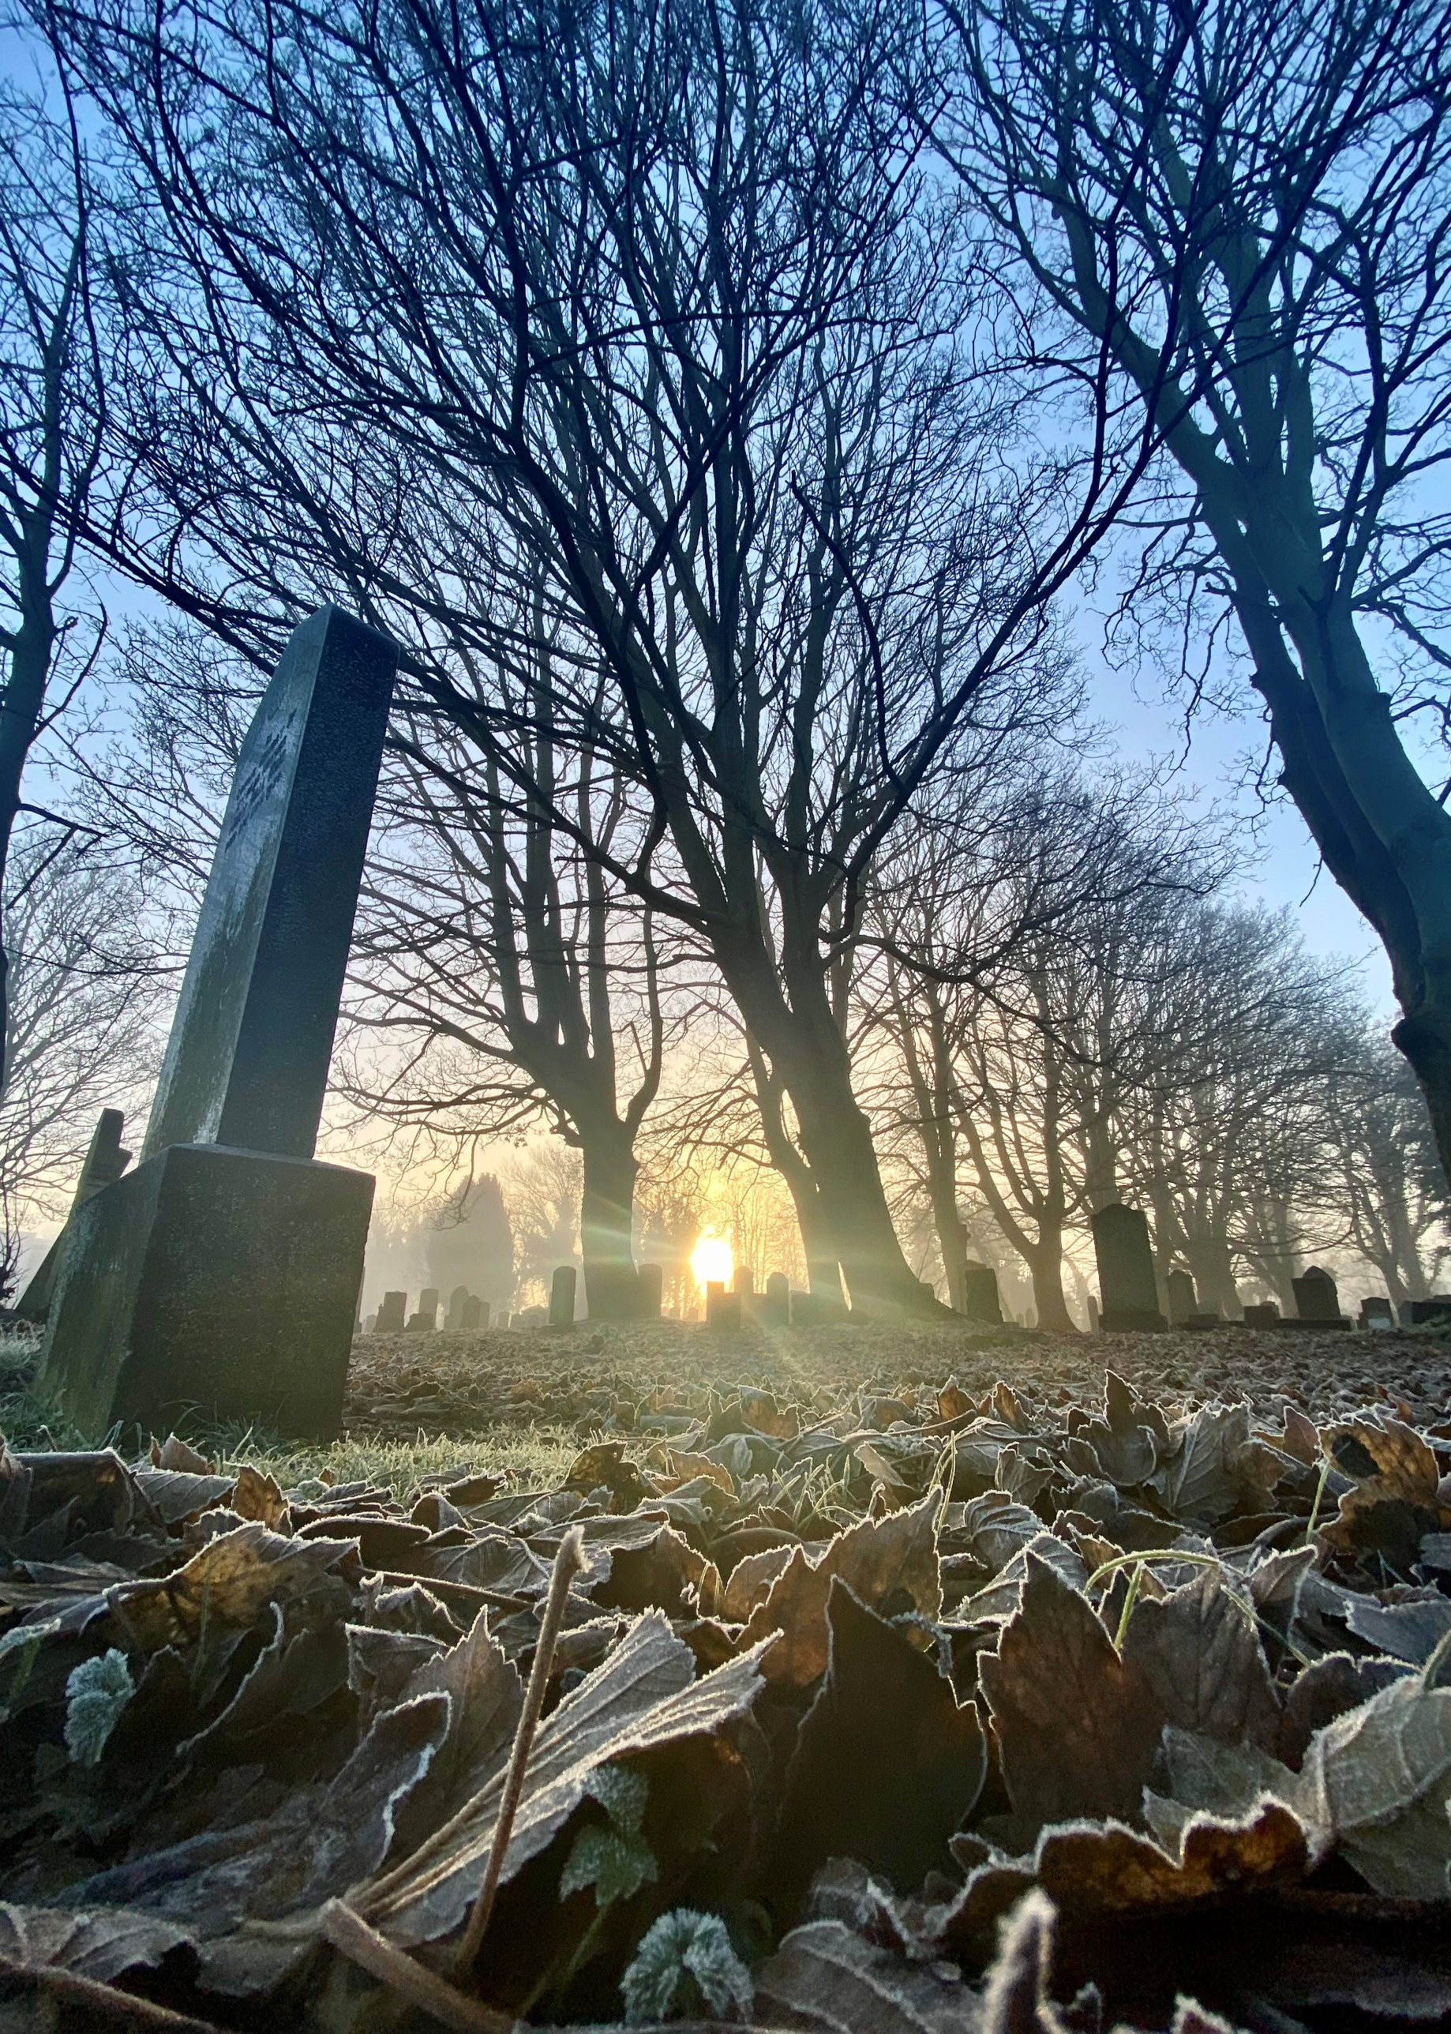


SAUGHTON CEMETERY

Version | Author(s) | Comments | Dates
V1.1 | Danielle Gartland-Quinn | Photos by Tam Magee | 20/02/2026

This document will be reviewed on an annual basis. However, a review or revision of any parts can be carried out at any time for service improvements and will be carried out following new legislation or changes to codes of practice.
This document can be viewed by the public during office hours or online.

`

Contents

- Brief history
- Site description
- Site summary
- Asset list
- Grounds maintenance and biodiversity
- Lair types and availability
- Community involvement
- Notable burials and monuments
- Map

- Brief history

Saughton Cemetery was opened in 1919 by the Edinburgh Cemetery Company, established at a time when the city needed new burial grounds to meet growing demand. The first burial was conducted on 14 June 1919, marking the beginning of its service for decades. Although historical records regarding its specific architect or formal opening are limited, the site was clearly designed with a focus on functionality and order, resulting in a well-laid out, spacious, and simple landscape that was notably different from the more ornamental cemetery designs of the previous century. In later years, the cemetery’s history was marked by a period of severe decline; the grounds fell into a state of disrepair and were significantly impacted by vandalism. When a private company purchased Saughton alongside several other Edinburgh cemeteries and suggested that the land could be repurposed for development, a dedicated Cemeteries Action Group intervened. Working alongside the City of Edinburgh Council, they successfully campaigned to protect the site from redevelopment, leading the Council to execute a compulsory purchase of the cemetery in 1994. Following the compulsory purchase, intense maintenance works by the Council made the cemetery accessible once again, and it remains a well-maintained and respectful site today. Saughton Cemetery is still as active site, with new burial lairs still available.

- Site description

Saughton Cemetery is a practical and well-considered burial ground, accessed via a single-entry point on Chesser Loan through black iron gates set into stone pillars. Upon entry, the driveway branches in two opposite directions, following the perimeter of the cemetery and providing clear access to all burial sections. Nestled within a quiet residential area, the site’s western boundary is defined by established trees and shrubbery that separate the grounds from the neighbouring Saughton Allotments. The remaining boundaries are secured by modern fencing, with the southern edge offering a particularly scenic backdrop of the Water of Leith and its adjacent public footpath. The landscape is primarily level, maintaining a mainly flat ground except for one slightly elevated burial section. True to its functional design, the grounds are open, spacious, and well-maintained. The landscape is dotted with established trees and shrubbery; while many are distributed individually throughout the site, others are clustered together in the southern portion to form a peaceful natural canopy. Though the cemetery is defined by its simplicity and practical layout, the memorials reflect a rich history of use. These monuments vary significantly in size, material, and style, illustrating the artistic shifts of the last century. Alongside traditional markers, many modern granite headstones represent the cemetery’s most recent burials. This combination of an orderly, accessible layout and a tranquil natural setting mean Saughton Cemetery remains a respected and functional cemetery.

- Site Summary
Name | Saughton Cemetery
Address | 18A Chesser Loan Edinburgh
Postcode | EH14 1SY
Ownership | The City of Edinburgh Council
Date site acquired | 1994
Size | 2.75 hectares
Conservation area | No
Tree preservation | Yes
Listing | None
Access | Vehicle and pedestrian
Opening hours | 24 hours

- Asset List
Asset | Location | Information
Waiting room | No
Toilets | No
CCTV | No
Signage | Cemetery gates | Signs detailing name of the cemetery, cemetery user information, safety signs
Cabinet signage | Cemetery entrance | Sign welcoming cemetery users, displaying cemetery rules, biodiversity information, other useful information
Car park | No
Disabled parking | No
Taps | No
Litter bins | Yes, throughout site see map
Benches | Yes, throughout site see map
Catacombs | No
War memorials | Yes, throughout the cemetery | More information can be found on Commonwealth War Grave Commission webpage.

- Grounds maintenance and biodiversity

The Council has revised its approach to grounds maintenance in response to the current nature emergency. This approach aims to protect and enhance existing biodiversity while encouraging the development of new habitats across the cemetery. This means less frequent grass cutting, no use of weedkiller, introduction of wildflowers, and the encouragement of natural grassland growth.

Routine maintenance activities are outlined below. A complete summary of our ground’s maintenance plans can be found in the Bereavement Services Cemeteries Management Plan.

Routine Maintenance | Frequency | Additional information
Grass cutting | Approx. every 8-10 weeks during appropriate seasons | No grass cutting during No Mow May
Strimming | Approx. every 8-10 weeks during appropriate seasons | No grass cutting during No Mow May
Leaf clearance | When required | Removal from hard standing areas and pathways only.
Sunken graves | When required
Re-turfing / grass seeding | When required | Method will depend on season
Hedge cutting | Annually | No hedge / shrub work during bird nesting season (March-August)
Emptying bins | When required

A biodiversity study conducted in 2021 identified that Saughton Cemetery already supports a large range of biodiversity, including a variety of trees, grasses, animals, and insects. The council is committed to protecting these existing habitats and encouraging biodiversity across the site. A list of species found in the cemetery in 2021 are detailed below.

Species List | Details
Trees | Apple, ash, beech, black poplar, cypress, holly, horse chestnut, laburnum, lime, oak, rowan, silver birch, sycamore, whitebeam
Shrubs | Buddleia, cotoneaster, elder, hawthorn, holly, privet, rose
Grasses | Perennial rye grass, meadow grass
Flowers | Dandelion, doves foot cranesbill, groundsel, lavender, nettle, prickly, sowthistle, ribwort plantain, rosebay willowherb, germander speedwell
Fungi | Deceiver, yellow wax cap, yellow stagshorn
Mosses | Bryum capillara, grimmia pulvinata,hypnum sp.
Mammals | Grey squirrel
Birds | Blackbird, blue tit, carrion crow, goldcrest, goldfinch, grey wagtail, herring gull, long tailed tit, magpie, redwing, robin, woodpigeon.
Insects | Ladybirds, cream-spot ladybird, harlequin laybird, larch ladybird, orange ladybird, pine ladybird, birch sheildbug, hawthorn sheildbug, parent bug, red legged sheildbug, common wasp, leafhopper

- Lair type and availability

Lair type | Availability | Details
Non-denomination Coffin Lairs | Yes | 2 coffin burials and 6 cremated remains urn burials
Catholic Lairs | No
Green Burial | No
Cremated remains | Yes | 6 cremated remains urn burials
Baby | No
Muslim | No
Muslim baby | No
Above ground vault | No

- Community involvement

There are currently no established Friends Groups for Saughton Cemetery.
Establishing or joining a 'Friends of' group is a meaningful way to contribute to your community while helping us protect these spaces. If you are interested in forming a new group or would like to enquire about future opportunities, please contact Bereavement Services.

- Notable burials and monuments

Cemetery in Edinburgh features a diverse collection of family memorials that reflect the local history and community through their varying designs and ages. Among these, the Commonwealth War Graves Commission maintains over 40 official headstones dedicated to service members from both World Wars, more information can be found on their webpage.

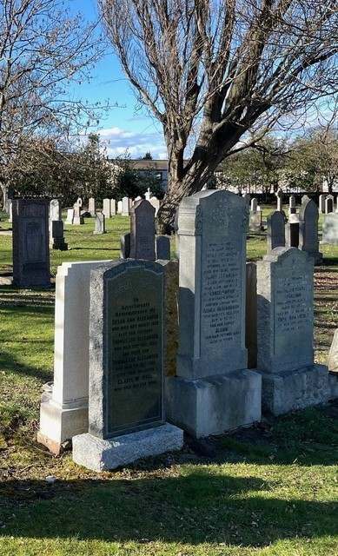

- Map
