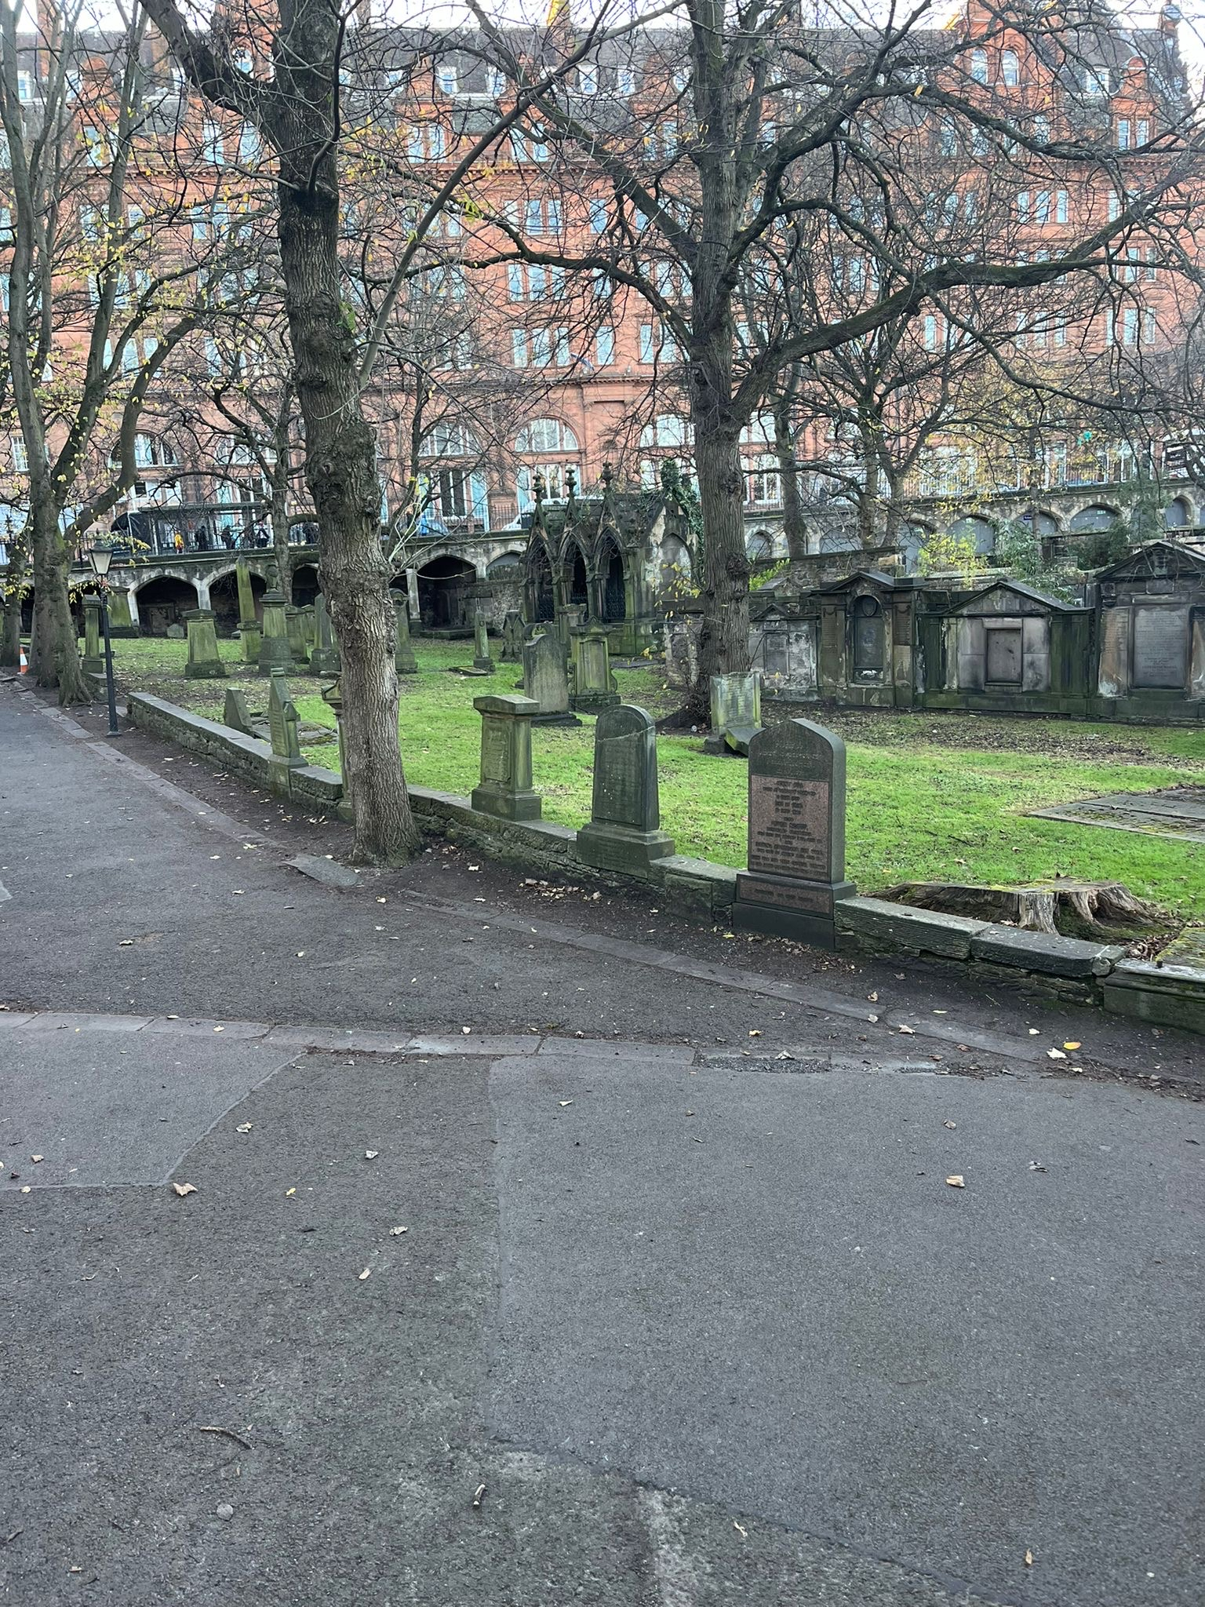


ST CUTHBERTS CHURCHYARD

Version | Author(s) | Comments | Dates
V1.1 | Danielle Gartland-Quinn | Photos by Tam Magee | 25/2/2026

This document will be reviewed on an annual basis. However, a review or revision of any parts can be carried out at any time for service improvements and will be carried out following new legislation or changes to codes of practice.
This document can be viewed by the public during office hours or online.

`

Contents

- Brief history
- Site description
- Site summary
- Asset list
- Grounds maintenance and biodiversity
- Lair types and availability
- Community involvement
- Notable burials and monuments
- Map

- Brief history

St Cuthbert’s Parish Church and churchyard is one of the most historic sites in Edinburgh, placed in the shadow of the Castle Rock. Although the current building was designed by architect Hippolyte Blanc and completed in 1894, it stands on the foundations of several earlier churches, with religious worship on this spot potentially dating back to the 7th century AD. The churchyard is one of the largest and most densely packed in the city, serving as an outdoor museum of Edinburgh's history. As it was the primary burial ground for the expansive parish of West St Cuthbert's, space was at a premium for centuries, leading to the creation of several tiered sections. The perimeter walls were raised to eight feet in 1738, and in 1827, a circular two-storey Watchtower was constructed to house armed guards, to deter body snatchers which was a common threat at the time. The tower still stands today as a unique office space. By the mid-19th century, the grounds faced a severe health crisis due to overcrowding. In 1863, the Medical Officer of Health declared the churchyard "completely full," yet the church initially refused to stop burials as they were a significant source of income. This led to a rare legal battle in 1873, where the church was taken to court for permitting a "nuisance" injurious to health. The churchyard was eventually closed to new burials in 1875, except for exceptional circumstances. The memorials within the grounds span over four hundred years, offering a visual timeline of changing artistic and social values. The oldest surviving stone dates back to 1606, though burial records are only available from 1833 onwards.

- Site description

Access to St Cuthbert’s Churchyard is available via several city-centre entry points, including King’s Stables Road, Princes Street, Lothian Road, and Princes Street Gardens. All entrances are marked by traditional iron gates, with the access from Lothian Road and Princes Street featuring stone steps that lead down into the historic grounds. A defining feature at the Lothian Road entrance is the historic two-storey Watchtower. At the King’s Stables Road entrance, the boundary is marked by a privately owned cottage that sits adjacent to the gateway. A network of tarmac roads guides visitors to the church in the middle, which is surrounded by the churchyard. The churchyard is uniquely structured into tiered burial sections, defined by small internal stone walls that act as boundaries between the different levels. While the tarmac roads provide access to the church and general areas, there are no formal paths within the burial sections themselves. The terrain includes slightly sloped areas that offer some of the most scenic views of Edinburgh Castle and the dramatic volcanic rock that looms directly above. The entire perimeter is securely enclosed by a boundary of stone walls and iron fencing, creating a peaceful, protected space in the heart of the busy West End. The grounds house a vast collection of historic stones, ranging from modest markers to grand, neoclassical monuments. These memorials reflect over four hundred years of history and include a variety of styles, such as flat memorials set into the grass and large table tombs. Some of these enclosed tombs remain grand and prominent, while others are open and accessible across the lawned areas. The combination of historic stonework and the striking backdrop of the castle makes it one of the most visually impressive historical landscapes in the city. A virtual tour of the cemetery can be viewed here.

- Site Summary
Name | St Cuthberts Churchyard
Address | 7 Lothian Road Edinburgh
Postcode | EH6 5BB
Ownership | The City of Edinburgh Council
Date site acquired | 1855
Size | 0.97 hectares
Conservation area | Yes
Tree preservation | No
Listing | Cemetery - A  Watch tower - B
Access | Pedestrian
Opening hours | 24 hours

- Asset List
Asset | Location | Information
Waiting room | No
Toilets | No
CCTV | No
Signage | Cemetery gates | Signs detailing name of the cemetery, cemetery user information, safety signs, notable burial sign entrance
Cabinet signage | Cemetery entrance | Sign welcoming cemetery users, displaying cemetery rules, biodiversity information, other useful information
Car park | No
Disabled parking | No
Taps | No
Litter bins | Yes, throughout site see map
Benches | Yes, throughout site see map
Catacombs | No
War memorials | No

- Grounds maintenance and biodiversity

The Council has revised its approach to grounds maintenance in response to the current nature emergency. This approach aims to protect and enhance existing biodiversity while encouraging the development of new habitats across the cemetery. This means less frequent grass cutting, no use of weedkiller, introduction of wildflowers, and the encouragement of natural grassland growth.

Routine maintenance activities are outlined below. A complete summary of our ground’s maintenance plans can be found in the Bereavement Services Cemeteries Management Plan.

Routine Maintenance | Frequency | Additional information
Grass Cutting | Approximately every 10–12 weeks during appropriate seasons | Grass may be left at a longer length to support conservation practices. St Cuthbert’s Churchyard, some areas are not cut during No Mow May to encourage pollinators
Strimming | Approximately every 10–12 weeks | Areas around memorials may be left unstrimmed and with  longer grass to prevent damage
Leaf Clearance | As required | Leaves are removed as required, with focus on hard-standing areas only and stairs
Sunken Graves | As required | Works are assessed based on safety and site conditions
Re-Turfing / Grass Seeding | As required, particularly where damage has occurred | Methods depend on the season and the severity of damage, especially from footfall. Areas may be temporarily fenced off during works
Hedge Cutting | Annually | No hedge cutting or shrub removal during bird nesting season (March–August), except for invasive species
Emptying Bins & Litter Removal | Three times per week, with additional collections during busy periods | A specialist cleaning team visits every two weeks to remove litter and biohazards at St Cuthbert’s Churchyard

A biodiversity study conducted in 2021 identified that St Cuthberts Churchyard already supports a large range of biodiversity, including a variety of trees, grasses, animals, and insects. The council is committed to protecting these existing habitats and encouraging biodiversity across the site. A list of species found in the cemetery in 2021 are detailed below.

Species List | Details
Trees | Cherry, hawthorn, rowan, whitebeam
Shrubs | Buddleia, cotoneaster, ivy, rose, Virginia Creeper
Fungi | Orange Mosscap (Rickenella fibula)
Ferns | Hart's tongue, Male fern, Maidenhair spleenwort, Wall rue
Grasses | Meadow grass (Poa pratensis) and others
Flowers | Broad leaved willowherb, daisy, dandelion, dock, feverfew, fuchsia, Geranium sp, groundsel, heathers, nettle, prickly sow thistle, procumbent pearlwort, ragwort, ribwort plantain, rosebay willowherb, white clover, yarrow. Plus a small vetch
Mosses | Grimmia pulvinata, Hypnum sp, and others
Mammals | Grey squirrel
Birds | Carrion crow, herring gull, magpie, robin, woodpigeon.
Insects | Two species of craneflies (probably Tipula oleracea and Tipula confusa) 2 species of spider including a lace weaver spider (Amaurobius sp); leopard slug

- Lair type and availability

There are no new lair’s available at St Cuthberts Churchyard.

- Community involvement

There are no established Friends Groups for St Cuthbert’s Churchyard.
Establishing or joining a 'Friends of' group is a meaningful way to contribute to your community while helping us protect these spaces. If you are interested in forming a new group or would like to enquire about future opportunities, please contact Bereavement Services.

- Notable burials and monuments

In the southern section of St Cuthbert’s Kirkyard, beneath the historic ramparts of Edinburgh Castle, lies the final resting place of William Home Lizars (1788–1859). A towering figure in the golden age of Scottish engraving, Lizars is best remembered for his pivotal role in natural history illustration; he was the first engraver to collaborate with John James Audubon, producing the opening ten plates for the monumental Birds of America. His grave is situated in an area of the kirkyard dedicated to the city's 19th-century intellectual elite, reflecting his status as one of Edinburgh's premier artistic innovators. Marked by a traditional upright headstone, the burial plot commemorates a man who successfully evolved his family’s engraving firm into a leading force in the publishing world. While his technical skill brought Audubon's visions to life, Lizars was also a celebrated "genre" painter, renowned for his detailed and sympathetic depictions of everyday Scottish life. Today, his memorial at St Cuthbert’s stands as a quiet tribute to his dual legacy as an artist and craftsman, located only a short distance from the National Galleries of Scotland, where many of his original works are still held in the national collection.
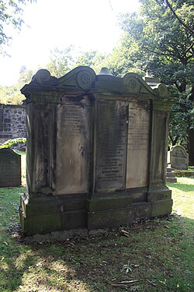

- Map

