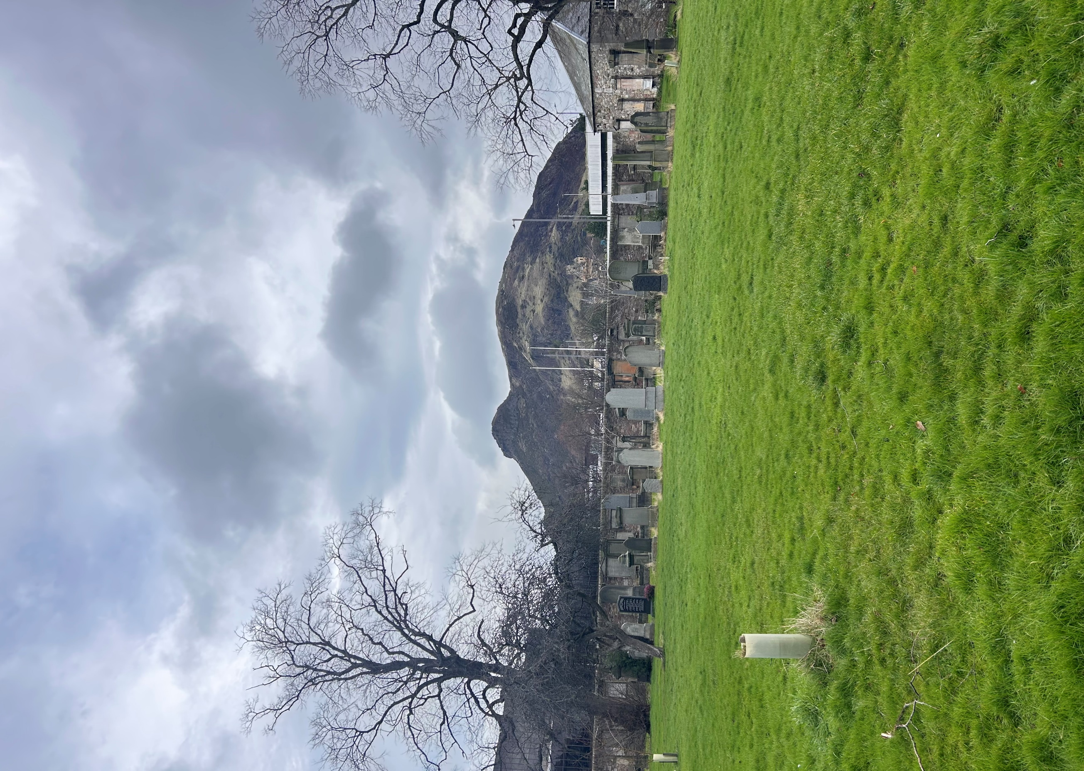


EAST PRESTON STREET CEMETERY

Version | Author(s) | Comments | Dates
V1.1 | Danielle Gartland-Quinn | Photos by Tam Magee | 24/2/2026

This document will be reviewed on an annual basis. However, a review or revision of any parts can be carried out at any time for service improvements and will be carried out following new legislation or changes to codes of practice.
This document can be viewed by the public during office hours or online.

`

Contents

- Brief history
- Site description
- Site summary
- Asset list
- Grounds maintenance and biodiversity
- Lair types and availability
- Community involvement
- Notable burials and monuments
- Map

- Brief history

The East Preston Street Cemetery was opened on 4 December 1820 to serve as an "overflow" site for the nearby Buccleuch Cemetery, which had become severely overcrowded during Edinburgh's southern urban expansion. Originally named Newington Burial Ground, the site was renamed in 1848 following the opening of the much larger Newington Cemetery nearby. Uniquely, the burial ground was established without any associated churches on the site, operating as a functional space rather than a traditional parish kirkyard. Reflecting the social anxieties of the early 19th century, the cemetery features a prominent two-storey, circular watchtower built in 1820. This tower was specifically designed to provide an elevated, complete view of the entire grounds, allowing guards to protect freshly used graves from the threat of body snatching, a common threat at the time. This security was further reinforced by high stone walls that enclose the perimeter, as well as the use of mortsafes, heavy iron cages placed over coffins and enclosed tombs. Although the site's importance declined with the opening of more grand Victorian garden cemeteries in the mid-1840s, it remains a protected historic space.

- Site description

Enclosed by tall stone walls and sections of iron fencing, the East Preston Street Cemetery is accessed via East Preston Street through black iron gates set into stone pillars. While the main vehicle gates remain locked, a pedestrian gate to the right provides pedestrian entry. Once inside, a tarmac driveway leads straight toward the centre of the cemetery, complemented by a pedestrian path branching to the left. On first appearance, the site seems modest in size, but it unfolds into an unusually shaped, expansive area with well-maintained open lawns and a scattering of mature trees. The burial sections are notably open, with a surprisingly small number of memorials that are primarily situated on the outskirts of each section. Tombs are prominently positioned against an internal stone wall, boundary wall and along the borders of the main driveway, becoming immediately visible upon entry. In the middle of the cemetery stands its most striking feature: a historic watchtower, which serves as a central focal point for the entire site. A scenic view of Arthur’s Seat can be seen from the cemetery. The open layout gives the burial ground a sense of space and tranquillity despite its location in a dense urban environment.

- Site Summary
Name | East Preston Street Cemetery
Address | 31 East Preston Street Edinburgh
Postcode | EH8 9QE
Ownership | The City of Edinburgh Council
Date site acquired | No data
Size | 0.99 hectares
Conservation area | Yes
Tree preservation | No
Listing | B
Access | Pedestrian
Opening hours | 24 hours

- Asset List
Asset | Location | Information
Waiting room | No
Toilets | No
CCTV | No
Signage | Cemetery gates | Sign detailing name of the cemetery, cemetery user information signs, safety signs
Cabinet signage | Cemetery entrance | Sign welcoming cemetery users to the cemetery, displaying cemetery rules, biodiversity information, other useful information for cemetery users
Car park | No
Disabled parking | No
Taps | No
Litter bins | No
Benches | No
Catacombs | No
War memorials | Yes, | More information can be found on the Commonwealth War Graves Commission webpage.

- Grounds maintenance and biodiversity

The Council has revised its approach to grounds maintenance in response to the current nature emergency. This approach aims to protect and enhance existing biodiversity while encouraging the development of new habitats across the cemetery. This means less frequent grass cutting, no use of weedkiller, introduction of wildflowers, and the encouragement of natural grassland growth.

Routine maintenance activities are outlined below. A complete summary of our ground’s maintenance plans can be found in the Bereavement Services Burial Management Plan.

Routine Maintenance | Frequency | Additional information
Grass cutting | Approx. every 10-12 weeks during appropriate seasons | No grass cutting during No Mow May
Strimming | Approx. every 10-12 weeks during appropriate seasons | No grass cutting during No Mow May
Leaf clearance | No
Sunken graves | When required
Re-turfing / grass seeding | When required | Method will depend on season
Hedge cutting | Not required
Emptying bins | When required

A biodiversity study conducted in 2021 identified that East Preston Street Cemetery already supports a small range of biodiversity, including a variety of ferns and birds. The council is committed to protecting these existing habitats and encouraging biodiversity across the site. A list of species found in the cemetery in 2021 are detailed below.

Species List | Details
Trees | Apple, ash, cherry, downy birch, false acacia, Norway maple, silver birch, whitebeam
Shrubs | Bramble, buddleia, cotoneaster, elder, holly, ivy, laurel, privet, rose
Grasses | Meadow grass
Flowers | Broad leaved willowherb, creeping buttercup, daisy, dandelion, groundsel, heather, rosebay willowherb, a species of thistle, wild strawberry
Fungi | Tar spot, turkey tail
Mosses | Anonalous bristle moss (Orthitrichum anonalum), Grimmia pulvinata, Hypnum sp.
Birds | Blue tit, carrion crow, great tit, magpie, robin, woodpigeon
Ferns | Male fern

- Lair type and availability

There are no new lair’s available at this cemetery.

- Community involvement
There are no established Friends Group for this cemetery.
Establishing or joining a 'Friends of' group is a meaningful way to contribute to your community while helping us protect these spaces. If you are interested in forming a new group or would like to enquire about future opportunities, please contact Bereavement Services.

- Notable burials and monuments

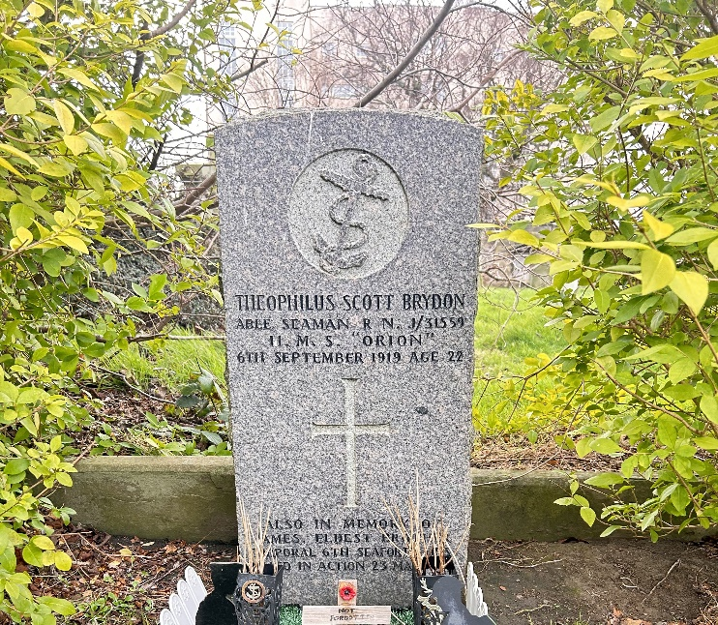
A singular military presence: Able Seaman Theophilus Scott Brydon (J/31559). An Edinburgh native, Brydon served aboard the dreadnought HMS Orion during the Battle of Jutland. Although he survived the war's major naval engagements, he died aged 22 on 6 September 1919, nearly a year after the Armistice. His final burial place is now officially maintained by the Commonwealth War Graves Commission.

Built in 1820, the Category B-listed Watch Tower at East Preston Street is a rare, two-storey hexagonal structure designed to deter body snatchers.

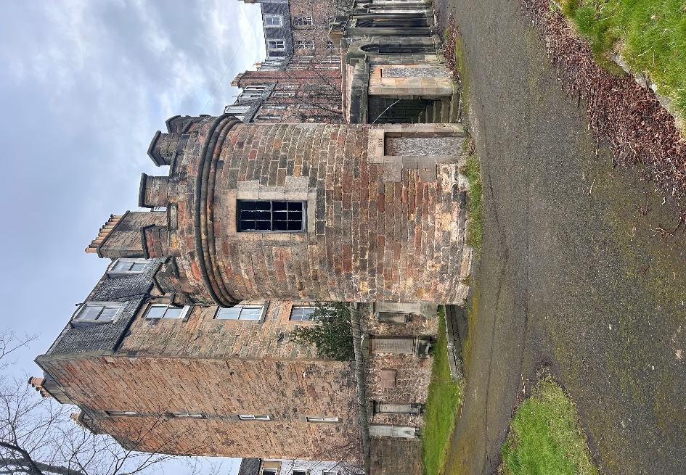

- Map

