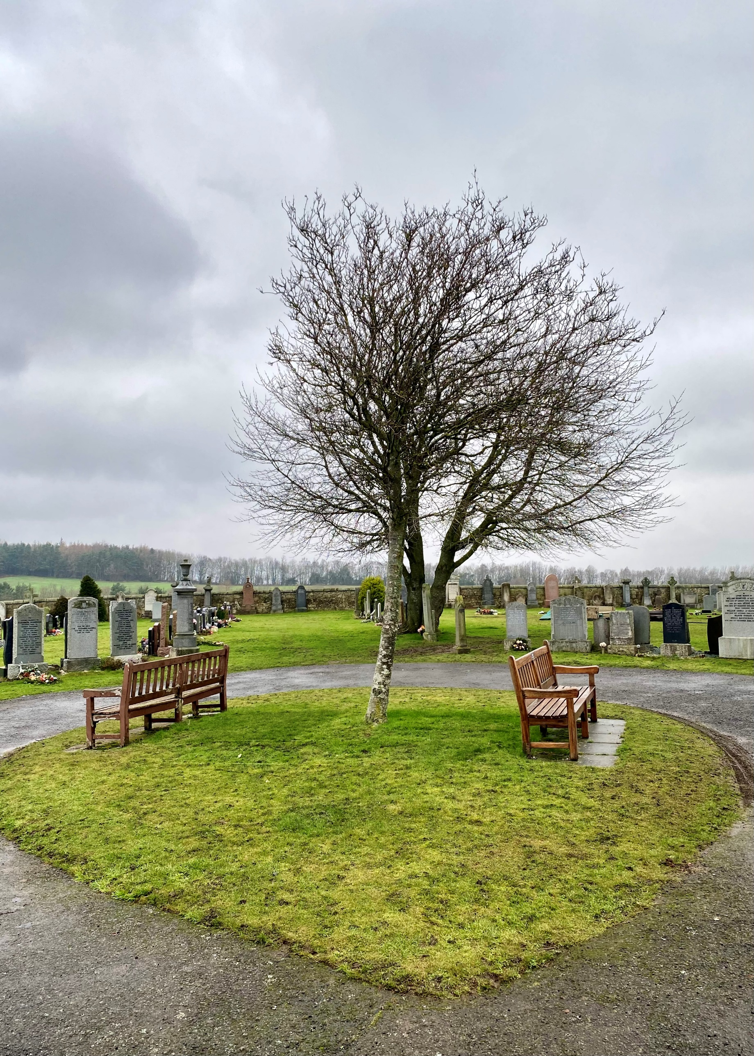


RATHO CEMETERY

Version | Author(s) | Comments | Dates
V1.1 | Danielle Gartland-Quinn | Photos by Tam Magee | 25/2/2026

This document will be reviewed on an annual basis. However, a review or revision of any parts can be carried out at any time for service improvements and will be carried out following new legislation or changes to codes of practice.
This document can be viewed by the public during office hours or online.

`

Contents

- Brief history
- Site description
- Site summary
- Asset list
- Grounds maintenance and biodiversity
- Lair types and availability
- Community involvement
- Notable burials and monuments
- Map

- Brief history

Ratho Cemetery was opened in 1899 to address the critical lack of space in the ancient Ratho Churchyard, which had served the parish for centuries. Although historical records detailing its original design and layout are limited, the site is the result of careful planning, featuring a structured and well-organised landscape. The cemetery officially began its service to the community with the first burial on 17 July 1899, and it continues to serve as an active site today with new graves still available. To accommodate the diverse needs of the modern community, the grounds now include a dedicated Muslim faith section. Furthermore, the site serves as a place of military remembrance, housing three official Commonwealth war graves.

- Site description

Accessed via Freelands Road, the entrance to Ratho Cemetery is marked by iron gates set into stone pillars. A tarmac driveway, bordered by neat grass verges, leads from the road into the heart of the cemetery, which is enclosed by traditional stone walls. Though modest in size, the site is well-planned for accessibility; the landscape is notably level and flat, with the main drive leading to a central turning circle to allow for easy vehicle movement. Near the entrance, a separate road branches off toward a stone shed. The internal layout is typical of cemeteries from the late 19th century, featuring spacious and well-organised burial sections across the flat landscape. There are no formal paths between these sections; instead, they consist of large, open grass areas that give the site an airy, uncluttered feel. The memorials throughout the grounds vary significantly in size, style, and age, ranging from original 1899 headstones to modern additions. With limited trees and shrubbery, the cemetery remains an open space that benefits from its rural setting, offering a peaceful atmosphere and expansive views over the surrounding farming fields.

- Site Summary
Name | Ratho Cemetery
Address | Freelands Road Edinburgh
Postcode | EH28 8NP
Ownership | The City of Edinburgh Council
Date site acquired | 1975
Size | 0.6 hectares
Conservation area | Yes
Tree preservation | No
Listing | None
Access | Vehicle and pedestrian
Opening hours | 24 hours

- Asset List
Asset | Location | Information
Waiting room | No
Toilets | No
CCTV | No
Signage | Cemetery gates | Signs detailing name of the cemetery, cemetery user information, safety signs
Cabinet signage | Cemetery entrance | Sign welcoming cemetery users, displaying cemetery rules, biodiversity information, other useful information
Car park | No
Disabled parking | No
Taps | Yes, see map
Litter bins | Yes, throughout site see map
Benches | Yes, throughout site see map
Catacombs | No
War memorials | Yes | More information can be found on Commonwealth War Grave Commission webpage.

- Grounds maintenance and biodiversity

The Council has revised its approach to grounds maintenance in response to the current nature emergency. This approach aims to protect and enhance existing biodiversity while encouraging the development of new habitats across the cemetery. This means less frequent grass cutting, no use of weedkiller, introduction of wildflowers, and the encouragement of natural grassland growth.

Routine maintenance activities are outlined below. A complete summary of our ground’s maintenance plans can be found in the Bereavement Services Cemeteries Management Plan.

Routine Maintenance | Frequency | Additional information
Grass cutting | Approx. every 8-10 weeks during appropriate seasons | No grass cutting during No Mow May
Strimming | Approx. every 8-10 weeks during appropriate seasons | No grass cutting during No Mow May
Leaf clearance | When required | Removal from hard standing areas and pathways only.
Sunken graves | When required
Re-turfing / grass seeding | When required | Method will depend on season
Emptying bins | When required

A biodiversity study conducted in 2021 identified that Ratho Cemetery already supports a large range of biodiversity, including a variety of trees, grasses, animals, and insects. The council is committed to protecting these existing habitats and encouraging biodiversity across the site. A list of species found in the cemetery in 2021 are detailed below.

Species List | Details
Trees | Cherry; holly; rowan; a species of spruce; yew. Plus pussy willow and Scots pine overhanging the perimeter walls
Shrubs | Holly, hypericum, ivy, pieris; privet (hedge); rose
Grasses | Meadow grass (Poa pratensis) and others
Flowers | Creeping buttercup; daffodil; daisy; dandelion; groundsel; heather; herb robert; primulas; snowdrop; a species of speedwell; a species of thistle
Fungi | This site may well be rich in fungi in autumn
Mosses | Bryum capillare, Grimmia pulvinata, Hypnum sp, Marchantia polymorpha (a liverwort), Orthotrichum anomalum, Tortula muralis
Mammals | Fox
Birds | Dunnock; jackdaw; magpie, sparrowhawk, woodpigeon. Also skylarks in surrounding fields, but they're not likely to come into the cemetery
Insects | Buff tailed bumble bee

As part of our ongoing biodiversity work, the Council may place nature cameras in the cemetery to monitor the wildlife. Although a cemeteries primary purpose is as a place of remembrance and reflection wildlife are often attracted to cemeteries due to their quiet unchanging environment.

- Lair type and availability

Lair type | Availability | Details
Non-denomination Coffin Lairs | Yes | 2 coffin burials and 6 cremated remains urn burials
Catholic Lairs | No
Green Burial | No
Cremated remains | No
Baby | No
Muslim | Yes | 1 coffin burial
Muslim baby | No
Above ground vault | No

- Community involvement

There are no established Friends Groups for this cemetery.
Establishing or joining a 'Friends of' group is a meaningful way to contribute to your community while helping us protect these spaces. If you are interested in forming a new group or would like to enquire about future opportunities, please contact Bereavement Services.

- Notable burials and monuments

Ratho Cemetery features a variety of memorial designs that differ in size and material. Although the majority of these are dedicated to family lairs, the cemetery is also home to two war graves maintained by the Commonwealth War Graves Commission. Detailed records and location information for these service burials can be found on the Commonwealth War Graves Commission’s webpage.
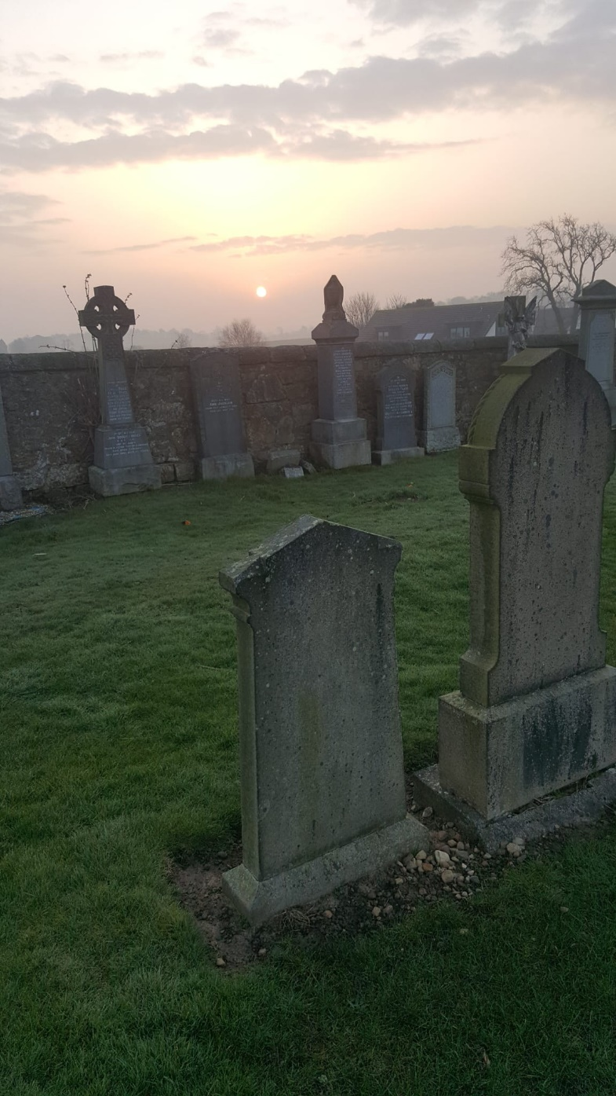

- Map
