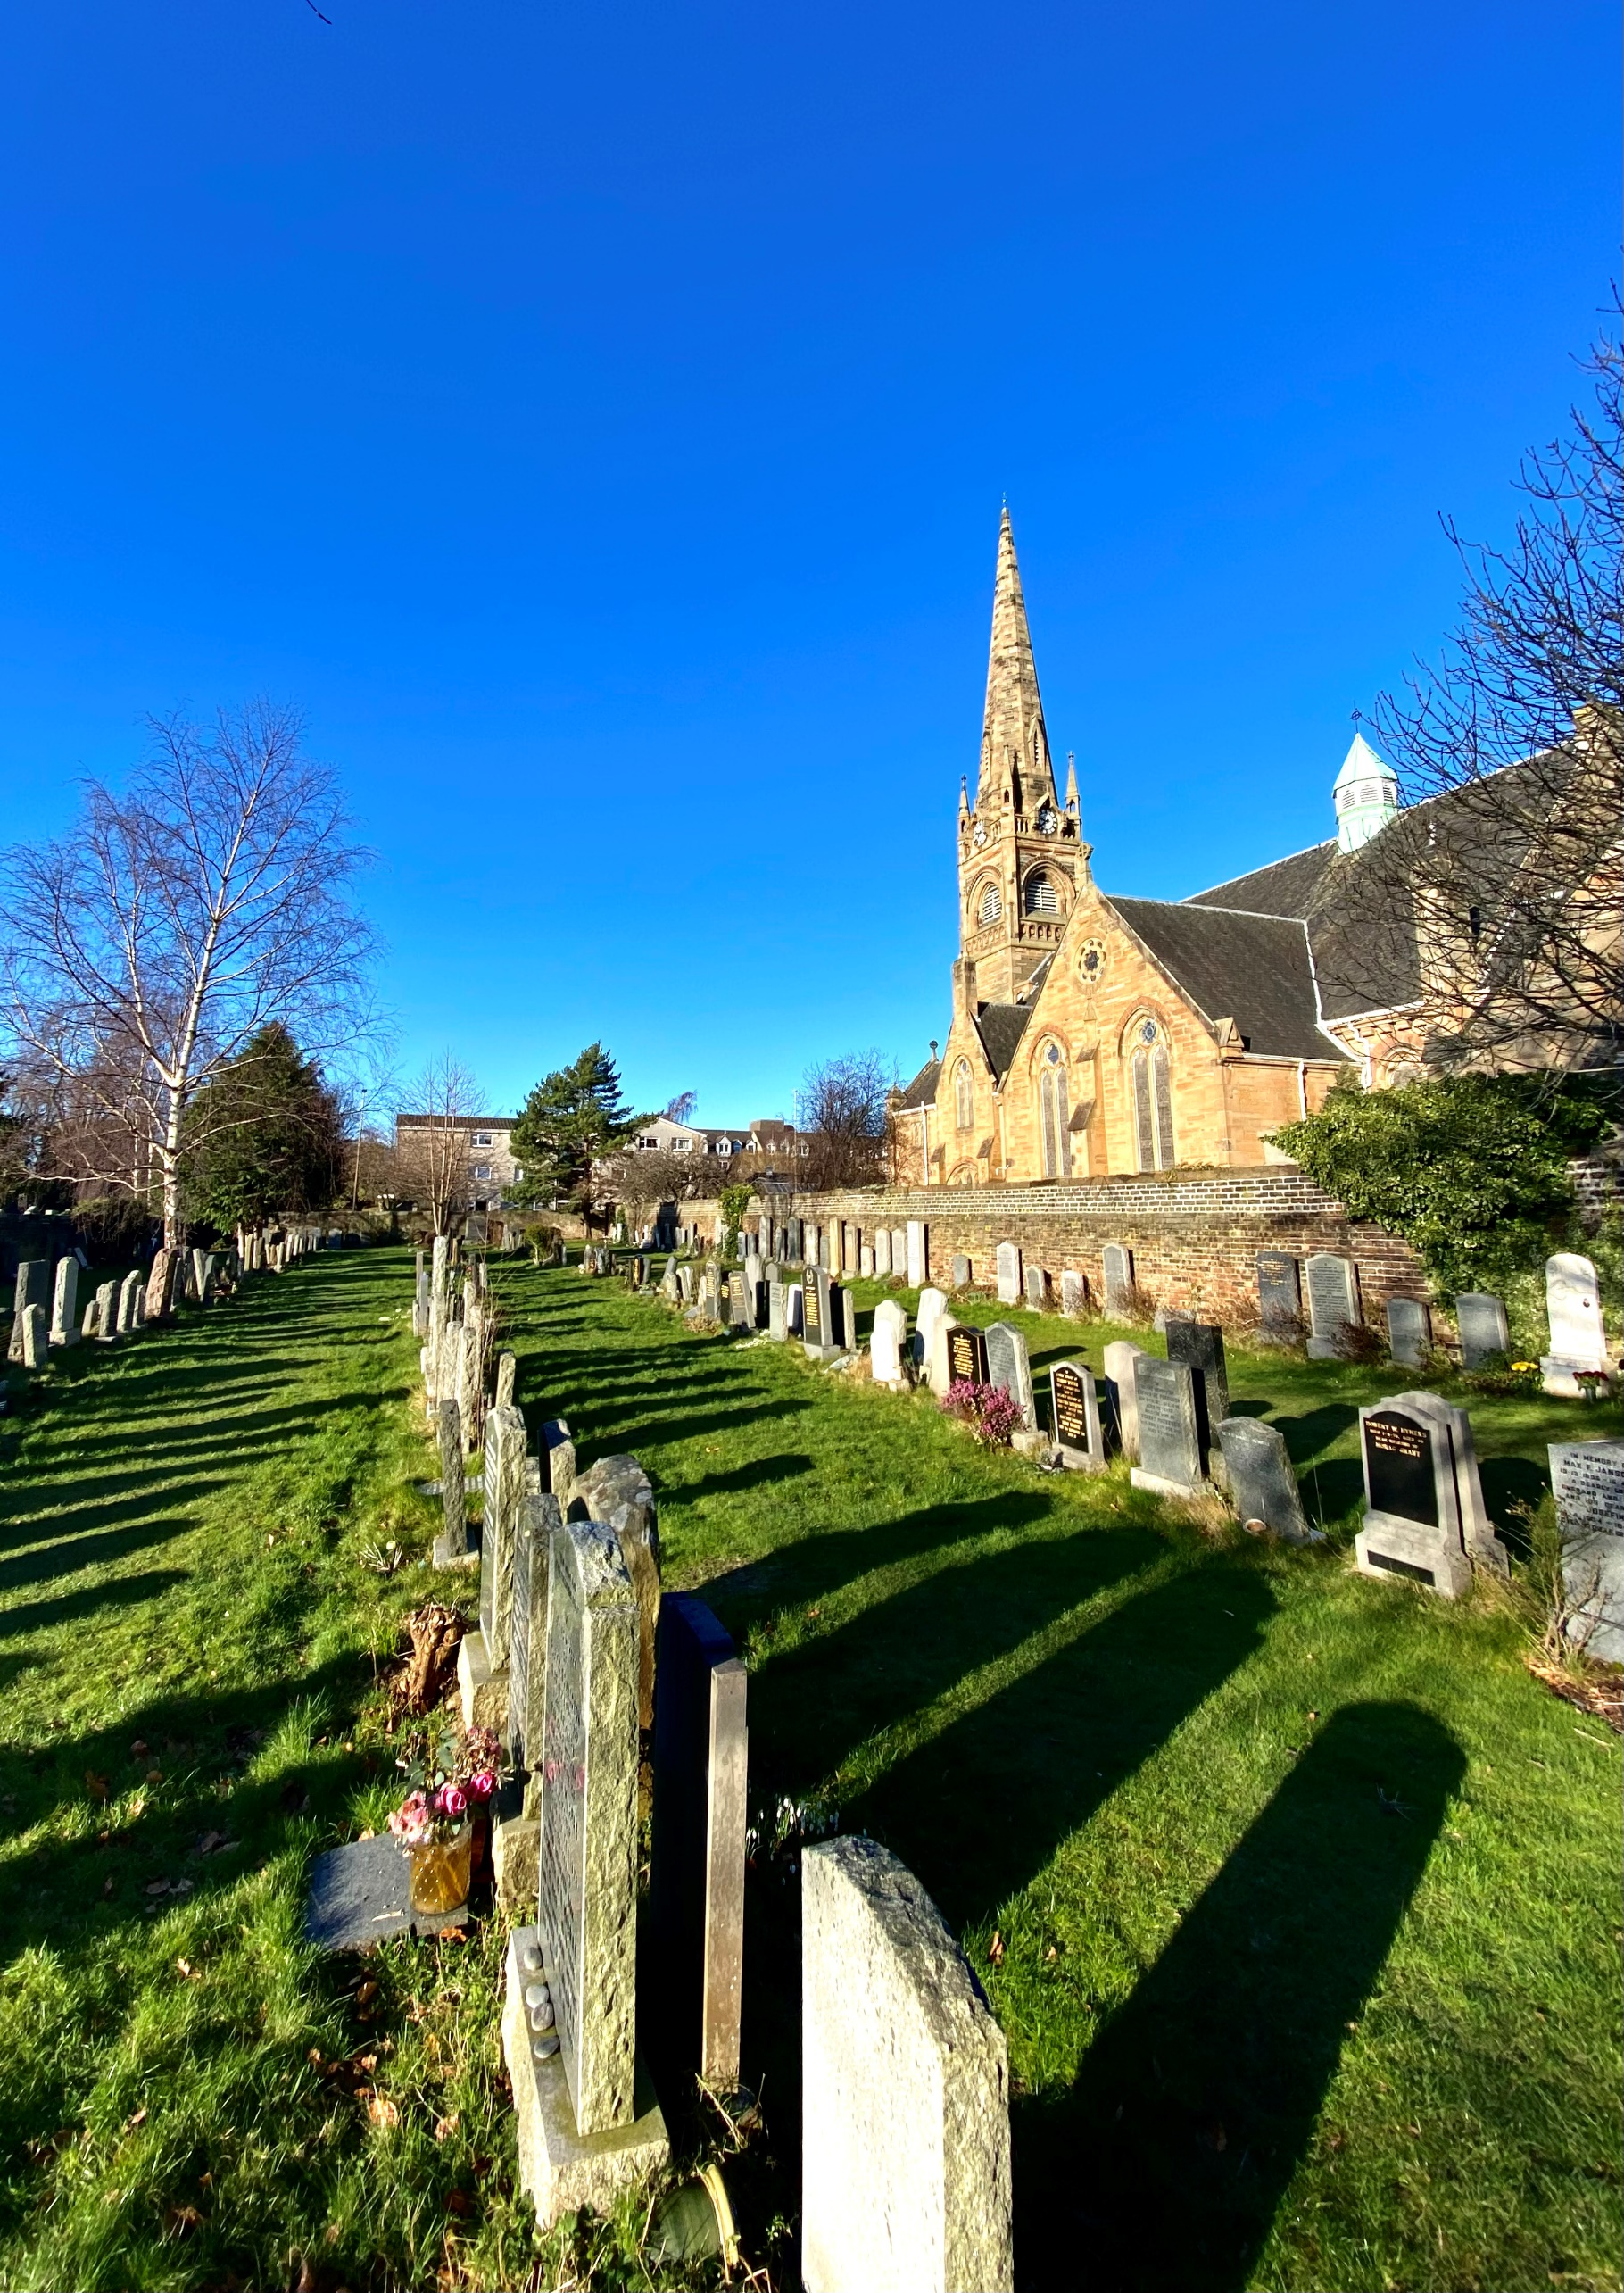


GRANGE CEMETERY

Version | Author(s) | Comments | Dates
V1.1 | Danielle Gartland-Quinn | Photos by Tam Magee | 24/2/2026

This document will be reviewed on an annual basis. However, a review or revision of any parts can be carried out at any time for service improvements and will be carried out following new legislation or changes to codes of practice.
This document can be viewed by the public during office hours or online.

`

Contents

- Brief history
- Site description
- Site summary
- Asset list
- Grounds maintenance and biodiversity
- Lair types and availability
- Community involvement
- Notable burials and monuments
- Map

- Brief history

Grange Cemetery was established in 1846 by The Southern Cemetery Company, originally opening under the name The Southern Cemetery. The land for the site was acquired from the Dick Lauder family of the surrounding Grange Estate, and the first burial was conducted shortly after on 13 June 1846. Since its inception, the grounds have served as the final burial place for over 40,000 individuals, reflecting its long-standing importance to the city’s south side. The cemetery was designed by the renowned architect David Bryce, who laid out the grounds in a formal, rectangular grid characteristic of the mid-Victorian garden cemetery style. A defining architectural feature of Bryce’s design is a monumental line of stone catacombs situated in the middle of the site. This structure includes a tunnel and an elevated terrace on top, which creates additional burial sections raised above the main level of the cemetery, providing a unique multi-tiered landscape. Bryce also designed the original lodge house at the entrance; though this was later modified by J.G. Adams in 1890, it remains a prominent feature of the site and is now a private residence. While the original ambitious plans for the cemetery included a chapel, this was never actually constructed, leaving the open, structured landscape as the primary focus. Following a period of private ownership, the Council purchased the site in 1976 to ensure its continued maintenance and preservation. Today, the Grange Cemetery remains a meticulously well-preserved example of 19th-century funerary architecture, reflecting the high social standing and history of the local community.

- Site description

Grange Cemetery is a large and prestigious burial ground accessed via two separate entry points on Beaufort Road. Both entrances feature traditional black iron gates set into stone pillars, with the primary entrance in the east of the cemetery opening directly onto the historic lodge house. These gates lead into a network of red gravel roadways that serve as the main access through the site, providing clear access to the various burial sections and the central architectural feature of the cemetery. The site is defined by its exceptionally well-organised and open layout, typical of the garden cemetery style, and is primarily enclosed by stone walls with some sections of modern fencing. While most of the grounds are flat and easily navigable, the central line of catacombs creates a unique multi-tiered landscape. This elevated terrace and its bordering burial sections can be reached via formal staircases on the catacombs or by following a slight hill on either side of the structure. Throughout the cemetery, the memorials reflect the high social standing and history of the local community, ranging from grand, imposing monuments to more modest memorials showcasing a variety of artistic styles. These are joined by modern granite headstones in the most recent burial areas, and war graves are respectfully distributed across the entire site. Two of the most contemporary sections, located in the western part of the cemetery, are distinctively walled off with stone, maintaining the site’s structured feel. The character of the grounds is further enhanced by many established trees that provide a sense of maturity and shade. Well-maintained, the Grange Cemetery remains a tranquil and peaceful sanctuary within the city, balancing its mid-Victorian heritage with continued service to the Edinburgh community.

- Site Summary
Name | Grange Cemetery
Address | 60A Grange Road Edinburgh
Postcode | EH1 2QE
Ownership | The City of Edinburgh Council
Date site acquired | 1976
Size | 4.62 hectares
Conservation area | Yes
Tree preservation | No
Listing | B
Access | Vehicle and pedestrian
Opening hours | 9am-4.30pm (access can be arranged out with these hours)

- Asset List
Asset | Location | Information
Waiting room | No
Toilets | No
CCTV | No
Signage | Cemetery gates | Signs detailing name of the cemetery, cemetery user information, safety signs
Cabinet signage | Cemetery entrance | Sign welcoming cemetery users, displaying cemetery rules, biodiversity information, other useful information, signs placed by Friends group
Car park | No
Disabled parking | No
Taps | Yes, in tunnel – see map
Litter bins | Yes, throughout site see map
Benches | Yes, throughout site see map
Catacombs | Yes, middle of cemetery
War memorials | Yes | More information can be found on Commonwealth War Grave Commission webpage.

- Grounds maintenance and biodiversity

The Council has revised its approach to grounds maintenance in response to the current nature emergency. This approach aims to protect and enhance existing biodiversity while encouraging the development of new habitats across the cemetery. This means less frequent grass cutting, no use of weedkiller, introduction of wildflowers, and the encouragement of natural grassland growth.

Routine maintenance activities are outlined below. A complete summary of our ground’s maintenance plans can be found in the Bereavement Services Cemeteries Management Plan.

Routine Maintenance | Frequency | Additional information
Grass cutting | Approx. every 8-10 weeks during appropriate seasons | No grass cutting during No Mow May
Strimming | Approx. every 8-10 weeks during appropriate seasons | No grass cutting during No Mow May
Leaf clearance | When required | Removal from hard standing areas and pathways only.
Sunken graves | When required
Re-turfing / grass seeding | When required | Method will depend on season
Emptying bins | When required

A biodiversity study conducted in 2021 identified that Grange Cemetery already supports a large range of biodiversity, including a variety of trees, grasses, animals, and insects. The council is committed to protecting these existing habitats and encouraging biodiversity across the site. A list of species found in the cemetery in 2021 are detailed below.

Species List | Details
Trees | Ash; Austrian Pine; Beech; Copper Beech; Crab Apple; Dawn Redwood; Downy Birch; Eastern White Cedar; Elder; English Oak; Field Maple; Gean (wild Cherry); Goat Willow; Hawthorn; Holly; Hornbeam; Lawson Cypress; Lime; Norway Maple; Ornamental Crab Apple; Ornamental Flowering Cherry; Pillar Apple; Rowan; Scot's Pine; Silver Birch; Silver Lime; Swedish Whitebeam; Sycamore (including a possible Corstorphine Sycamore); Whitebeam (including Vosges whitebeam); Yew.
Shrubs | Berberis; Buddleia; Camellia; Cotoneaster; hollies; Hypericum; Ivy; Pieris; roses
Grasses | Meadow Grass (Poa pratensis); Pampas Grass; Timothy Grass and others.
Flowers | Broad Leaved Willowherb; Creeping Buttercup; Daisy; Dandelion; Groundsel; Ivy Leaved Toadflax; Nettle; Periwinkle; Rosebay Willowherb; Shepherd's Purse; sowthistle (Prickly and Smooth Sowthistles); speedwells (Ivy Leaved Speedwell and at least one other species); thistles (including Spear Thistle and at least one other species); Valerian; Wall Lettuce; White Clover; Wild Strawberry; Winter Aconite; Yellow Corydalis. Plus garden flowers including Bluebells (Spanish / hybrid); Daffodils; Fuchsia; Hellebore; Hydrangea; Heathers; Pansies; Primulas; Tulips.
Fungi | a species of coral fungus
Mosses | Bryum argenteum; Bryum capillare; Grimmia pulvinata; Hypnum sp; Marchantia polymorpha (a liverwort); Orthotrichum anomalum, Rhytidiodelphus squarrosus; Tortula muralis
Mammals | Fox, rat
Birds | Blackbird; Blue Tit; Bullfinch; Carrion Crow; Chaffinch; Chiffchaff; Coal Tit; Dunnock; Goldfinch; Great Spotted Woodpecker; Great Tit; Jackdaw; Magpie; Mistle Thrush; Redwing; Robin; Sparrowhawk; Willow Warbler; Woodpigeon; Wren
Insects | Ladybirds: 2 Spot Ladybird, 10 Spot Ladybird, Cream Spot Ladybird, Eyed Ladybird, Harlequin Ladybird, Orange Ladybird, Striped Ladybird  Shield Bugs: Birch Shield Bug; Hawthorn Shield Bug; Parent Bug (Elasmucha grisea); Red Legged Shield Bug  Moths: Birch Conch (Thyraylia nana); Blastobasis vittata; Buff Footman; Common Slender Moth (Gracillaria syringella); Dingy Dowd (Blastobasis adustella); Dotted Border (Agriopis marginaria); Horse Chestnut Leaf-miner (Cameraria ohridella); Pale Brindled Beauty.  Bark flies: Ectopsocus petersi; Epicaecilius pilipennis  Bees and Wasps: Buff Tailed Bumblebee; Common Wasp;  Beetles: Exomias araneiformis (a weevil); Micrambe ulicis (a silken fungus beetle); Orchestes fagi (a flea weevil); Rabocerus gabrieli ( a small beetle)  Bugs: Anthocoris nemorum (common flower bug); Birch catkin bug (Kleidocerys resedae); Buchananiella continua (a bug, very rarely recorded in Scotland);  Flies: Aphodius (Nimbus) obliteratus (a dung fly); Drosophila suzukii (spotted wing drosophila fly); Marmalade hoverfly (Episyrphus balteatus); Syrphus sp hoverfly; Tipula pagana (a crane fly),  Other insects: Brown Lacewing; Phytomyza ilicis (holly leaf borer); a springtail (Cryptozoa sp),

As part of our ongoing biodiversity work, the Council may place nature cameras in the cemetery to monitor the wildlife. Although a cemeteries primary purpose is as a place of remembrance and reflection wildlife are often attracted to cemeteries due to their quiet unchanging environment.

- Lair type and availability

There are no new lair’s available at Grange Cemetery, burial can only be arranged in an existing lair.

- Community involvement

The Friends of Grange Cemetery established by the Grange Association. They are dedicated to caring for the heritage of the cemetery. Their involvement enhances the condition of the cemetery and contributes significantly to the improvements seen across the site. Their commitment, local knowledge and hands-on involvement have made a meaningful difference to the appearance, accessibility and historical understanding of Warriston Cemetery. Members of the Friends of Warriston group have a deep interest in and knowledge of the cemetery's local history, researching the stories of those buried there and helping preserve the cemetery’s cultural heritage.

Activities carried out by the Friends group include:

- Providing information boards of notable burials
- Gardening and maintaining planted areas
- Improving paths and general access around the cemetery
- Researched many burials
- Provided benches
- Installing Notice boards
- Creating public leaflets for visitors
- Re-erect memorials
- Hosting community events and open days
- Assisting with landscape improvements alongside members of staff
- Leading guided talks and walks to share the cemetery's history
- Contributing to the ongoing management and future planning of the site

The Friends group's involvement not only supports essential maintenance but also helps visitors better understand and appreciate the site's significance.
Contact details for volunteering, supporting or becoming a member of this Friends group can be found on the friends webpage.
Establishing or joining a 'Friends of' group is a meaningful way to contribute to your community while helping us protect these spaces. If you are interested in forming a new group or would like to enquire about future opportunities, please contact Bereavement Services.

- Notable burials and monuments

The activist Elizabeth Pease Nichol (1807–1897) is buried in a family grave in section N. She was a leading 19th-century campaigner for antislavery, women’s voting rights, and political reform. More information about Elizabeth can be found here.
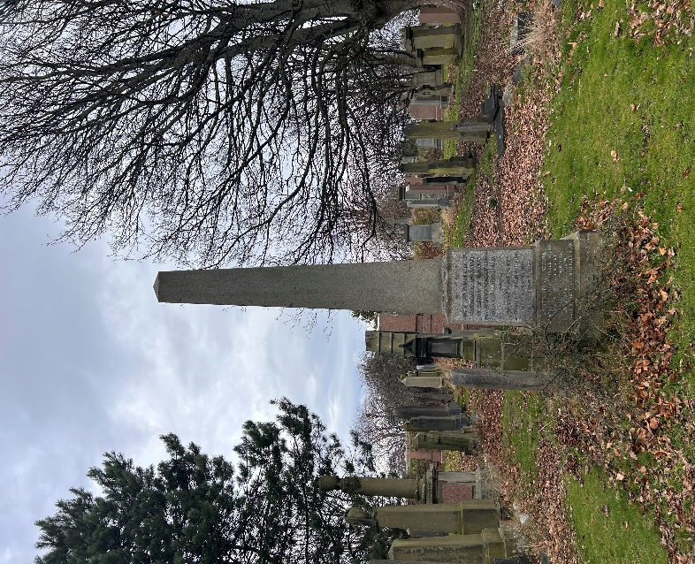

One of the most distinctive memorials in Grange Cemetery is the William Stuart Memorial. Commissioned by Stuart for his wife, Susan, the monument was sculpted by Robert Thomson and is a masterclass in Egyptian Revival masonry.

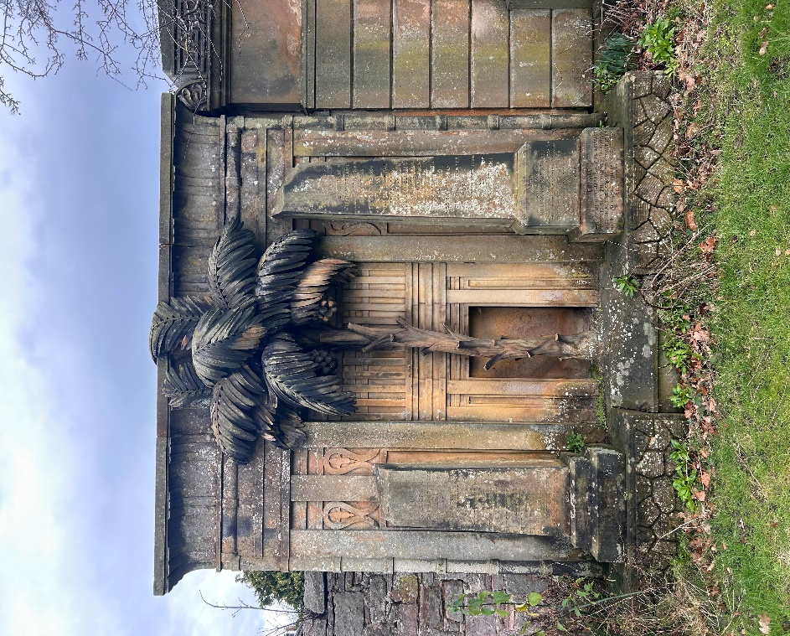

- Map

