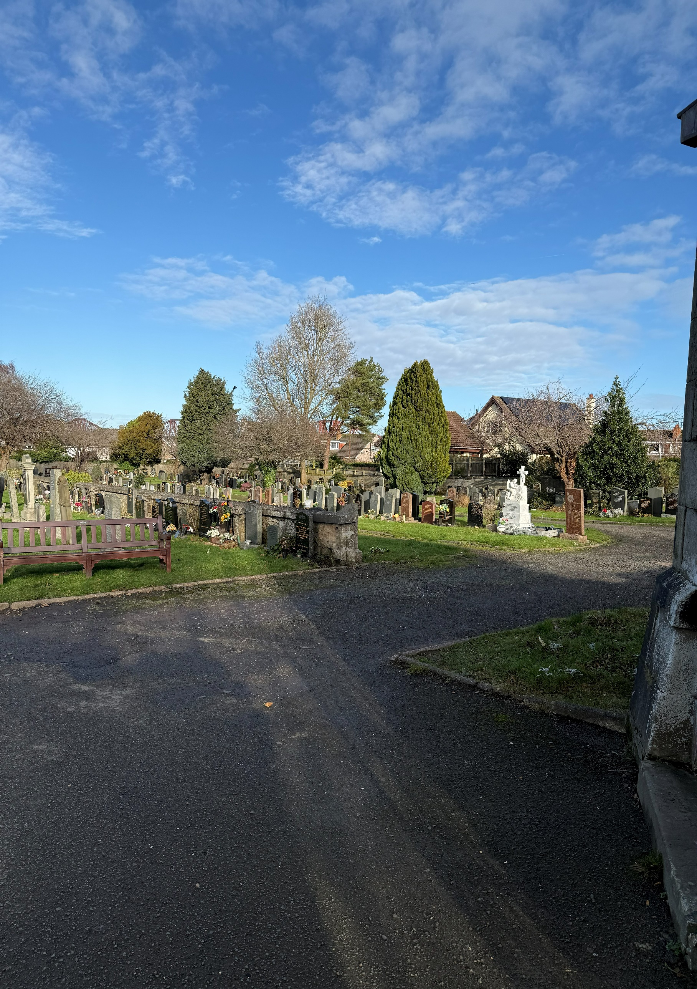


SOUTH QUEENSFERRY CEMETERY

Version | Author(s) | Comments | Dates
V1.1 | Danielle Gartland-Quinn | Photos by Tam Magee | 25/2/2026

This document will be reviewed on an annual basis. However, a review or revision of any parts can be carried out at any time for service improvements and will be carried out following new legislation or changes to codes of practice.
This document can be viewed by the public during office hours or online.

`

Contents

- Brief history
- Site description
- Site summary
- Asset list
- Grounds maintenance and biodiversity
- Lair types and availability
- Community involvement
- Notable burials and monuments
- Map

- Brief history

Established in the late 19th century, South Queensferry Cemetery is a site of significant local and military heritage. While historical records regarding its specific design and opening are limited, the cemetery’s active history began with its first burial on 28 June 1898. Since then, it has become the final burial place for over 4,000 individuals, including local families, and it continues to serve the community today with graves still available. The cemetery is notably defined by its strong ties to naval history and wartime sacrifice. Including a dedicated war memorial and serves as the burial place for 188 war burials. This includes 8 burials from World War II and 180 from World War I, almost all of whom were naval personnel. Many of these individuals are buried far from their homes, having died in service while stationed nearby or following naval engagements.

- Site description

Accessed via Ferrymuir Lane, South Queensferry Cemetery is reached by a long, shrub-lined driveway that leads to grand stone pillars and black iron gates. The cemetery is notably flat and features a spacious, well-ordered lawn layout typical of its era. The landscape is enhanced by many mature trees and shrubbery dotted throughout the grounds, providing a peaceful and established atmosphere. Movement through the site is facilitated by a tarmac roadway that transitions into a central circular road for vehicle access, with a dedicated pedestrian path to the right accessing some of the burial sections. The grounds are enclosed by stone walls of varying heights and private residential properties. Public toilets are located just before the entrance, with staff buildings situated immediately inside the gate. A small internal stone wall divides two sections of the cemetery, while the north-west corner holds the war memorial and naval graves. Across the burial sections, a mixture of modest and large monuments, ranging from historic Victorian markers to modern designs, reflects the cemetery's long history and the diverse artistic styles of the families and service members buried there.

- Site Summary
Name | South Queensferry Cemetery
Address | 12 Ferrymuir Lane Edinburgh
Postcode | EH30 9PA
Ownership | The City of Edinburgh Council
Date site acquired | 1975
Size | 0.97 hectares
Conservation area | No
Tree preservation | No
Listing | None
Access | Vehicle and pedestrian
Opening hours | 24 hours

- Asset List
Asset | Location | Information
Waiting room | No
Toilets | Yes, see map | Open for funerals only
CCTV | No
Signage | Cemetery gates | Signs detailing name of the cemetery, cemetery user information, safety signs
Cabinet signage | Cemetery entrance | Sign welcoming cemetery users, displaying cemetery rules, biodiversity information, other useful information
Car park | No
Disabled parking | No
Taps | Yes, see map
Litter bins | Yes, throughout site see map
Benches | Yes, throughout site see map
Catacombs | No
War memorials | Yes | More information can be found on Commonwealth War Grave Commission webpage.

- Grounds maintenance and biodiversity

The Council has revised its approach to grounds maintenance in response to the current nature emergency. This approach aims to protect and enhance existing biodiversity while encouraging the development of new habitats across the cemetery. This means less frequent grass cutting, no use of weedkiller, introduction of wildflowers, and the encouragement of natural grassland growth.

Routine maintenance activities are outlined below. A complete summary of our ground’s maintenance plans can be found in the Bereavement Services Cemeteries Management Plan.

Routine Maintenance | Frequency | Additional information
Grass cutting | Approx. every 8-10 weeks during appropriate seasons | No grass cutting during No Mow May
Strimming | Approx. every 8-10 weeks during appropriate seasons | No grass cutting during No Mow May
Leaf clearance | When required | Removal from hard standing areas and pathways only.
Sunken graves | When required
Re-turfing / grass seeding | When required | Method will depend on season
Emptying bins | When required

A biodiversity study conducted in 2021 identified that South Queensferry Cemetery already supports a large range of biodiversity, including a variety of trees, grasses, animals, and insects. The council is committed to protecting these existing habitats and encouraging biodiversity across the site. A list of species found in the cemetery in 2021 are detailed below.

Species List | Details
Trees | Cherry, cypress, holly, hawthorn, laburnum, pine, rowan, silver birch, yew
Shrubs | Buddleia, cotoneaster, elder, holly, ivy, laurel, rose, snowberry
Grasses | Meadow grass
Flowers | Broad leaved willowherb, creeping buttercup, daisy, dandelion, groundsel, heather, lavender, prickly sowthistle, ribwort plantain, rosebay willowherb, shepherd's purse, a species of speedwell, tansy, a species of thistle, a species of violet, white clover. Plus garden flowers
Fungi | Candlesnuff, common ink cap, sulphur tuft, tar spot, turkey tail and others including a species of waxcap
Mosses | Bryum capillare, Grimmia pulvinata, Hypnum sp, Orthotrichum anomalum, Tortula muralis. Marchantia polymorpha (a liverwort).
Mammals | Hedgehog
Birds | Blackbird, chaffinch, carrion crow, goldfinch, herring gull, jackdaw, magpie, robin, woodpigeon
Insects

As part of our ongoing biodiversity work, the Council may place nature cameras in the cemetery to monitor the wildlife. Although a cemeteries primary purpose is as a place of remembrance and reflection wildlife are often attracted to cemeteries due to their quiet unchanging environment.

- Lair type and availability

Lair type | Availability | Details
Non-denomination Coffin Lairs | Yes | 2 coffin burials and 6 cremated remains urn burials
Catholic Lairs | No
Green Burial | No
Cremated remains | No
Baby | No
Muslim | Yes | 1 coffin burial
Muslim baby | No
Above ground vault | No

- Community involvement

The Friends of South Queensferry Cemetery are dedicated to caring for the heritage and biodiversity of the cemetery. Their involvement enhances the condition of the cemetery and contributes significantly to the improvements seen across the site. Their commitment, local knowledge and hands-on involvement have made a meaningful difference to the appearance, accessibility and historical understanding of South Queensferry Cemetery. Members of the group have a deep interest in and knowledge of the cemetery's local history, researching the stories of those buried there and helping preserve the cemetery’s cultural heritage.

Activities carried out by the Friends group include:

- Tree planting and habitat creation
- Gardening and maintaining planted areas
- Improving paths and general access around the cemetery
- Creating and maintaining wildflower meadows
- Providing homes for birds, bats and other wildlife
- Assisting with landscape improvements alongside Council staff
- Leading guided talks and walks to share the cemetery’s history
- Contributing to the ongoing management and future planning of the site

The Friends group's involvement not only supports essential maintenance but also helps visitors better understand and appreciate the site's significance.
For information about volunteering, supporting or becoming a member of this Friends Group please contact Bereavement Services.
Establishing or joining a 'Friends of' group is a meaningful way to contribute to your community while helping us protect these spaces. If you are interested in forming a new group or would like to enquire about future opportunities, please contact Bereavement Services.

- Notable burials and monuments

South Queensferry Cemetery features a wide array of memorials that vary in size, material, and style, with many dedicated to family lairs. A defining feature of the grounds is the Admiralty Naval Memorial, a tall stone cross that overlooks the cemetery. This monument was erected to honour the sailors and marines of the Grand Fleet who lost their lives during the First World War. The cemetery holds over 160 war burials, a significant number that reflects the intense naval activity in the Firth of Forth at the time. Many of those interred here were casualties of the Battle of Jutland in 1916 or died from illness and accidents while stationed nearby. Detailed records and location information for these service burials can be found on the Commonwealth War Graves Commission’s webpage.

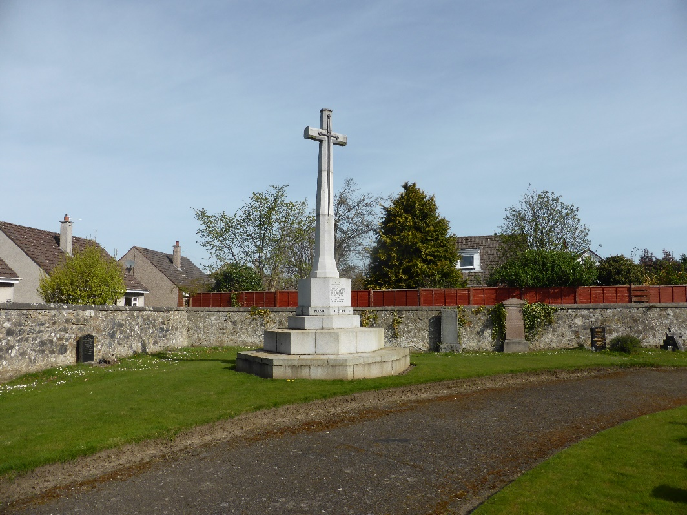

- Map
