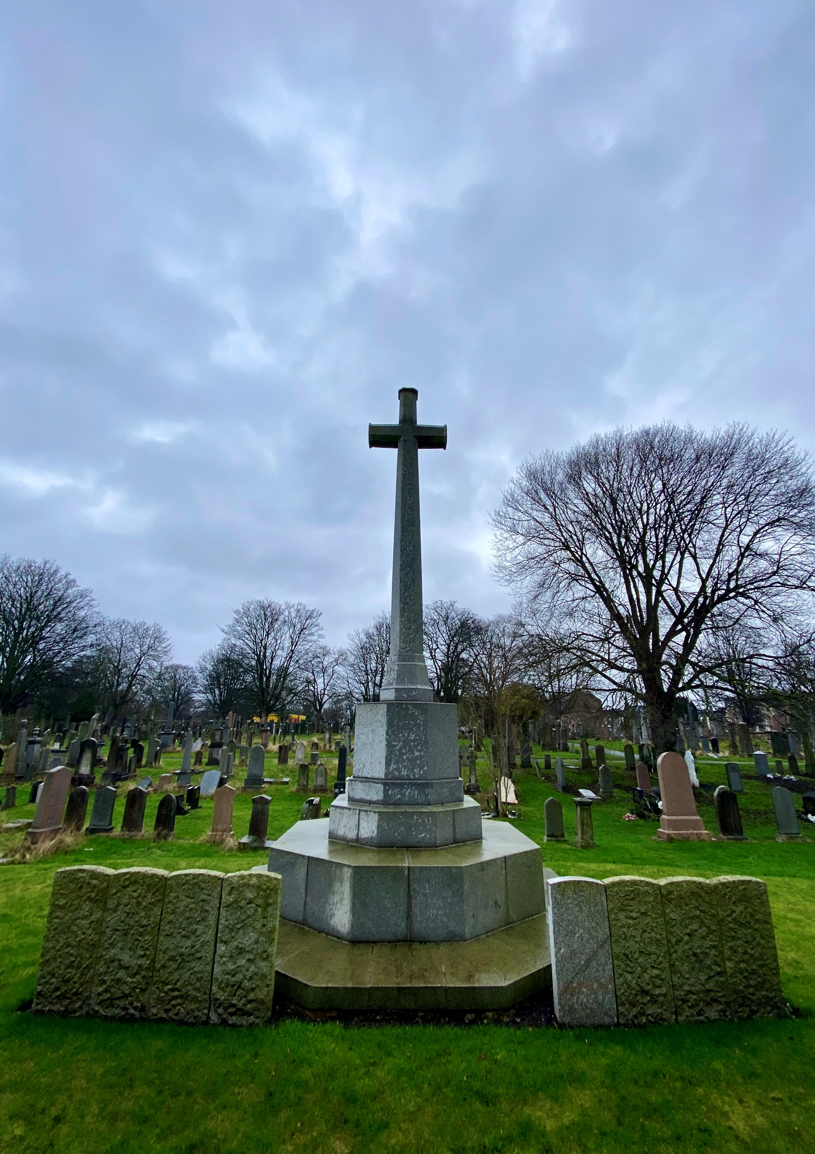


ROSEBANK CEMETERY

Version | Author(s) | Comments | Dates
V1.1 | Danielle Gartland-Quinn | Photos by Tam Magee | 25/2/2026

This document will be reviewed on an annual basis. However, a review or revision of any parts can be carried out at any time for service improvements and will be carried out following new legislation or changes to codes of practice.
This document can be viewed by the public during office hours or online.

`

Contents

- Brief history
- Site description
- Site summary
- Asset list
- Grounds maintenance and biodiversity
- Lair types and availability
- Community involvement
- Notable burials and monuments
- Map

- Brief history

Rosebank Cemetery was opened in 1846 by the Edinburgh & Leith Cemetery Company and was originally named The Edinburgh & Leith Cemetery. The site was designed by the acclaimed architect David Cousin, and while it remains a significant Victorian landscape, it is notably more compact in scale compared to his other expansive cemetery commissions across the city. The first burial was conducted on 9 September 1846, and in the years since, the grounds have become the final burial place for over XX,000 individuals. To accommodate the growing needs of the local population, the cemetery was extended eastwards in 1880, creating the broader footprint seen today. The primary entrance was originally situated on Broughton Road, and this historic access point remains a prominent feature of the cemetery’s boundary. Although now sealed and not accessible, the original grand iron gates and stone pillars remain in situ as a testament to the site’s 19th-century architectural heritage. Historically, the grounds also featured a dedicated cemetery lodge house, though details regarding its specific design are limited; the structure was eventually demolished by the 1970s. The cemetery serves as the site for the Gretna Rail Disaster memorial, which commemorates the Quintinshill rail crash of 1915, the deadliest in UK history, where over 200 soldiers from the Royal Scots were interred in a mass grave. Alongside this, the cemetery houses various other war memorials, ensuring the Rosebank grounds remain a vital place of remembrance for the Edinburgh and Leith communities.

- Site description

Rosebank Cemetery is accessed via an entrance on Pilrig Street, marked by traditional stone pillars and black iron gates. This entry opens onto a concrete driveway that transitions into a network of gravel roadways, with staff buildings situated immediately to the right. Upon entering, the open burial sections are immediately visible, served by a central driveway that facilitates access throughout the site. The grounds are fully enclosed by a substantial stone wall, with the original, now-sealed iron gates on Broughton Road remaining a prominent feature in the boundary. The layout of the cemetery is defined by its densely populated burial sections, which have expanded over time as pathways were utilised for additional graves. To the left of the main entrance lies a dedicated Muslim section, close is a separate walled-off burial area that includes a poignant memorial for babies interred in a shared space. A small terrace and stairway, surrounded by rows of headstones, forms a central focal point within the grounds. The memorials throughout the site reflect a broad social history, ranging from large, grand Victorian monuments to modest markers and contemporary granite headstones, showcasing a diverse array of materials and artistic styles under a canopy of many mature trees. Rosebank is a site of significant national remembrance, housing two major commemorative landmarks. Along the northern boundary wall stands the Gretna Rail Disaster Memorial, which marks the mass grave of over 200 soldiers from the Royal Scots who perished in the 1915 Quintinshill rail crash. Opposite, in the southern part of the cemetery, a dedicated war memorial further honours those who served. These historic features, combined with the well-maintained landscape, ensure that the cemetery remains a vital and respectful cemetery.

- Site Summary
Name | Rosebank Cemetery
Address | 104 Pilrig Street Edinburgh
Postcode | EH7 6LF
Ownership | The City of Edinburgh Council
Date site acquired | 1973
Size | 4.5 hectares
Conservation area | Yes
Tree preservation | No
Listing | C
Access | Vehicle and pedestrian
Opening hours | 24 hours

- Asset List
Asset | Location | Information
Waiting room | No
Toilets | No
CCTV | No
Signage | Cemetery gates | Signs detailing name of the cemetery, cemetery user information, safety signs
Cabinet signage | Cemetery entrance | Sign welcoming cemetery users, displaying cemetery rules, biodiversity information, other useful information
Car park | Yes, cemetery entrance | Open space inside cemetery gates
Disabled parking | No
Taps | Yes, cemetery entrance, see map
Litter bins | Yes, cemetery entrance see map
Benches | Yes, throughout site see map
Catacombs | No
War memorials | Yes | More information can be found on Commonwealth War Grave Commission webpage.

- Grounds maintenance and biodiversity

The Council has revised its approach to grounds maintenance in response to the current nature emergency. This approach aims to protect and enhance existing biodiversity while encouraging the development of new habitats across the cemetery. This means less frequent grass cutting, no use of weedkiller, introduction of wildflowers, and the encouragement of natural grassland growth.

Routine maintenance activities are outlined below. A complete summary of our ground’s maintenance plans can be found in the Bereavement Services Cemeteries Management Plan.

Routine Maintenance | Frequency | Additional information
Grass cutting | Approx. every 8-10 weeks during appropriate seasons | No grass cutting during No Mow May
Strimming | Approx. every 8-10 weeks during appropriate seasons | No grass cutting during No Mow May
Leaf clearance | When required | Removal from hard standing areas and pathways only.
Sunken graves | When required
Re-turfing / grass seeding | When required | Method will depend on season
Emptying bins | When required

A biodiversity study conducted in 2021 identified that Rosebank Cemetery already supports a large range of biodiversity, including a variety of trees, grasses, animals, and insects. The council is committed to protecting these existing habitats and encouraging biodiversity across the site. A list of species found in the cemetery in 2021 are detailed below.

Species List | Details
Trees | Ash, beech, cherry, cypress, holly, horse chestnut, lime, silver birch, sycamore, yew
Shrubs | Bramble, ivy, rose
Grasses | Meadow grass
Flowers | Broad leaved willowherb, creeping buttercup, daisy, dandelion, dock, groundsel, herb robert, nettle, ribwort plantain, rosebay willowherb, smooth sowthistle, white clover, yarrow
Fungi | Birch polypore, candle snuff, common puffballs, parrot waxcaps
Mosses | Grimma pulvinate, hypnum sp
Mammals | Grey squirrel
Birds | Blue tit, bullfinch, magpie, mistle thrush, robin, wren
Insects | Ladybirds, cream spot ladybird, birch sheild bug, cranefly

As part of our ongoing biodiversity work, the Council may place nature cameras in the cemetery to monitor the wildlife. Although a cemeteries primary purpose is as a place of remembrance and reflection wildlife are often attracted to cemeteries due to their quiet unchanging environment.

- Lair type and availability

There are no new lair’s available at Rosebank Cemetery, burial can only be arranged in an existing lair.

- Community involvement

There are no established Friends Groups for Rosebank Cemetery.
Establishing or joining a 'Friends of' group is a meaningful way to contribute to your community while helping us protect these spaces. If you are interested in forming a new group or would like to enquire about future opportunities, please contact Bereavement Services.

- Notable burials and monuments

Located at the furthest point from the Pilrig Street entrance, leaning against the Broughton Road wall near North Pilrig Heights, stands a significant memorial marking the mass grave of the Quintinshill Disaster. This site commemorates the 215 soldiers of the 1st/7th Battalion, The Royal Scots, who tragically lost their lives in the UK’s deadliest rail crash on 22 May 1915. Most of these men were Leith locals, caught in the disaster while travelling to Liverpool to embark for the Gallipoli battlefront. The few survivors were sent onwards to the front the very next day, while the bodies of the fallen were returned to Leith. On 24 May, they were buried with full military honours, with the 15th and 16th battalions of the Royal Scots serving as a guard of honour. In addition to the Quintinshill memorial, the cemetery serves the Pilrig community as the site of the local War Memorial, which features a distinctive white 'Great War Cross' designed by the renowned architect Sir Edwin Lutyens. Beyond these major collective monuments, several individual Commonwealth war graves are situated throughout the grounds. These headstones mark the final resting places of service members who succumbed to wounds or disease after returning home from both World Wars. More information can be found on the Commonwealth War Graves Commission webpage.

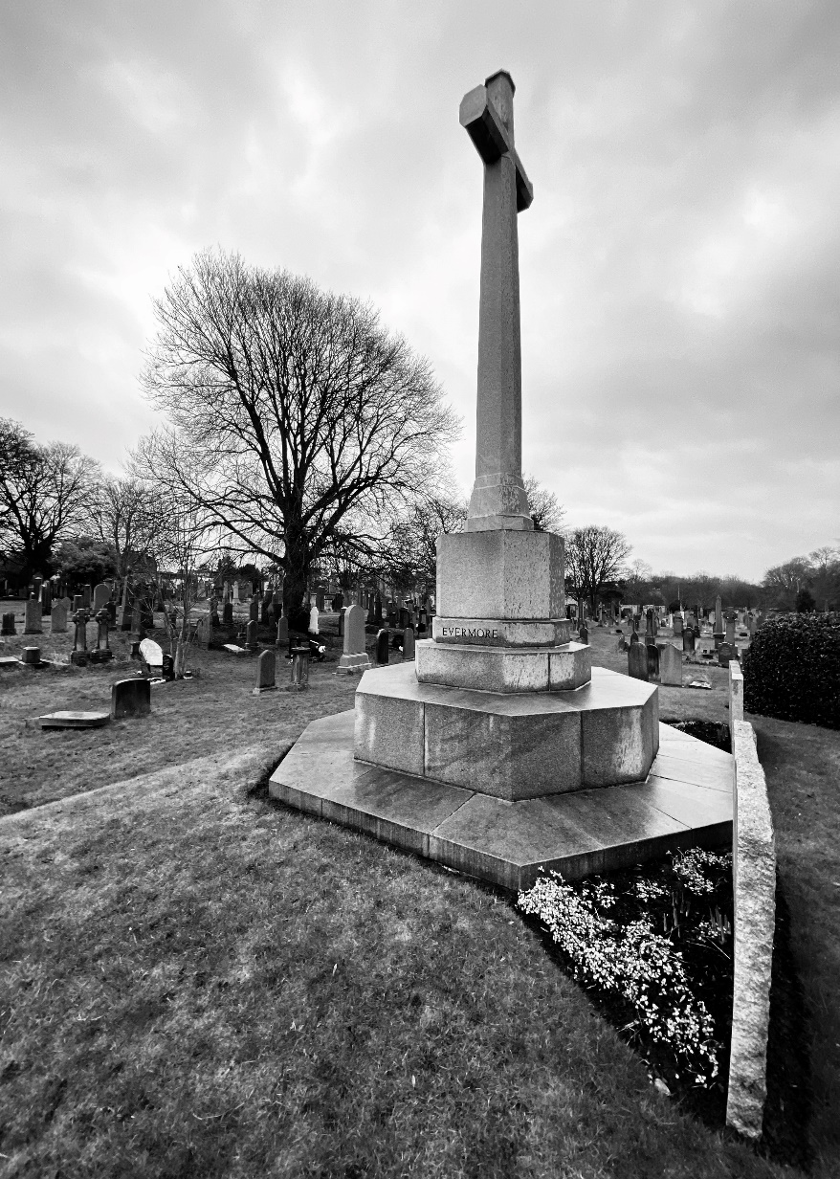


- Map
