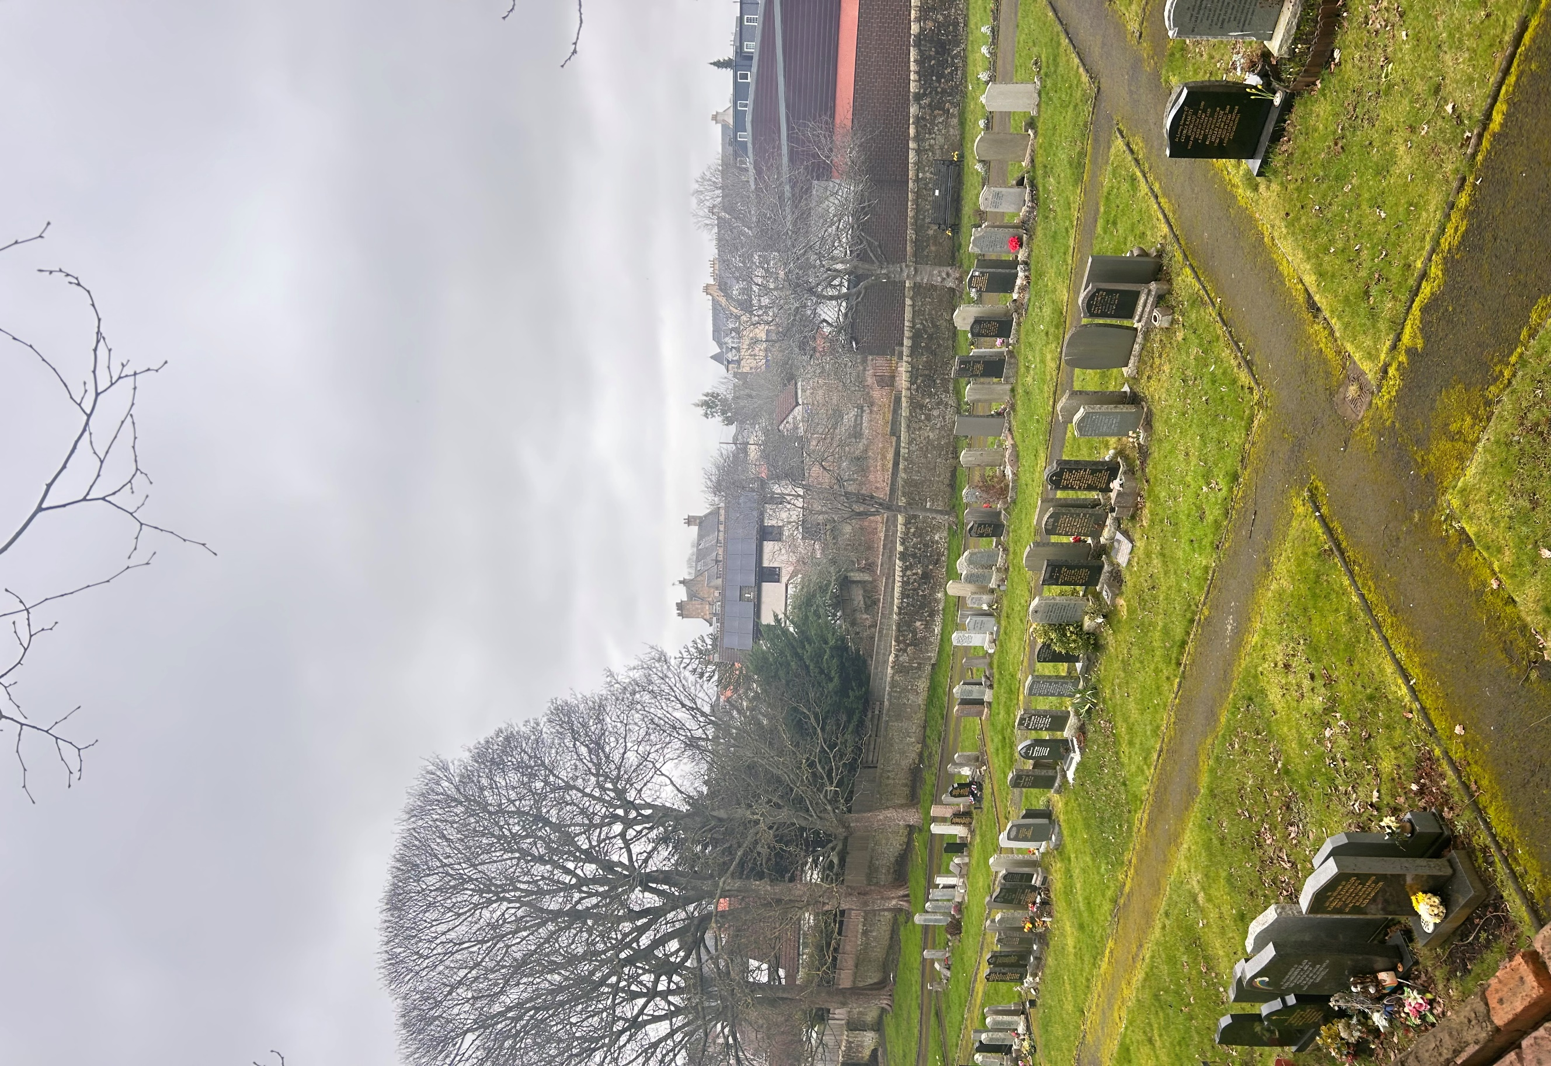


KIRKLISTON KIRKYARD AND CEMETERY

Version | Author(s) | Comments | Dates
V1.1 | Danielle Gartland-Quinn | Photos by Tam Magee | 24/2/2026

This document will be reviewed on an annual basis. However, a review or revision of any parts can be carried out at any time for service improvements and will be carried out following new legislation or changes to codes of practice.
This document can be viewed by the public during office hours or online.

`

Contents

- Brief history
- Site description
- Site summary
- Asset list
- Grounds maintenance and biodiversity
- Lair types and availability
- Community involvement
- Notable burials and monuments
- Map

- Brief history

Kirkliston Parish Church has served the community for centuries, with the building itself being one of the finest examples of Norman architecture in Scotland. While a church has stood on this site since at least the 12th century, it was significantly restored and altered in 1883 by the architect Hippolyte Blanc, who preserved the ancient Romanesque tower while updating the nave to serve the growing Victorian parish. The original churchyard surrounds the kirk, records for the earliest burials are limited, the headstones themselves provide the most reliable history, with a wide range of memorials dating from the 17th century onwards. As the population of Kirkliston expanded in the 19th century, the original churchyard became full, a common issue for historic parishes at the time. To address this, a large cemetery extension was added to the south and west. This newer section is well-laid out with open lawn areas and contains several Commonwealth War Graves from both World Wars, the cemetery remains in use today with graves still available.

- Site description

Kirkliston Churchyard is primarily accessed from The Square through double black iron gates set into stone pillars, with four stone steps leading up into the elevated grounds. Upon entry, the historic kirk building stands to the right, while a traditional stone building is situated to the left. The burial sections are immediately visible, and a tarmac footpath guides visitors toward and around the church. These original sections consist of open lawn areas with no formal pathways between the individual rows, showcasing a wide variety of old memorials that vary in size and style. To the rear of the church, the grounds transition into the cemetery extension, a stone wall and set of steps separate the two. The tarmac path continues into the cemetery, separating the two burial sections and leading to the second pedestrian entrance on Manse Road. Like the older churchyard, these sections are well-ordered open lawn areas without internal paths between the graves. The entire site is securely enclosed by stone walls of varying heights, maintaining a clear boundary for the historic parish grounds. Many headstones of varying sizes and styles, including many 17th and 18th-century stones and modern memorials.
The newest part of the cemetery is situated on a slight slope and is conveniently accessed from The Square, just outside the main churchyard boundary. A tarmac path leads from the churchyard back into the square, where a separate set of double iron gates set into stone pillars marks the entrance to this modern section. This area is well organised and laid out, featuring tarmac paths between the sections that provide easy access for visitors. The memorials in this newest addition are predominantly modern granite headstones. The entire site remains securely enclosed by stone walls of varying heights, maintaining the protected character of the parish grounds.

- Site Summary
Name | Kirkliston Churchyard and Cemetery
Address | 7B The Square Edinburgh
Postcode | EH29 9AX
Ownership | The City of Edinburgh Council
Date site acquired | 1855
Size | 0.88 hectares in total
Conservation area | Yes
Tree preservation | No
Listing | A
Access | Pedestrian
Opening hours | 24 hours

- Asset List
Asset | Location | Information
Waiting room | No
Toilets | No
CCTV | No
Signage | Cemetery and Churchyard gates | Signs detailing name of the cemetery, cemetery user information, safety signs
Cabinet signage | Cemetery and Churchyard entrances | Sign welcoming cemetery users, displaying cemetery rules, biodiversity information, other useful information
Car park | No
Disabled parking | No
Taps | No
Litter bins | Yes, throughout site see map
Benches | Yes, throughout site see map
Catacombs | No
War memorials | Yes | More information can be found on the Commonwealth War Graves Commisson webpage.

- Grounds maintenance and biodiversity

The Council has revised its approach to grounds maintenance in response to the current nature emergency. This approach aims to protect and enhance existing biodiversity while encouraging the development of new habitats across the cemetery. This means less frequent grass cutting, no use of weedkiller, introduction of wildflowers, and the encouragement of natural grassland growth.

Routine maintenance activities are outlined below. A complete summary of our ground’s maintenance plans can be found in the Bereavement Services Cemeteries Management Plan.

Routine Maintenance | Frequency | Additional information
Grass cutting | Approx. every 10-12 weeks during appropriate seasons | No grass cutting during No Mow May
Strimming | Approx. every 10-12 weeks during appropriate seasons | No grass cutting during No Mow May
Leaf clearance | When required | Removal from hard standing areas and pathways only.
Sunken graves | When required
Re-turfing / grass seeding | When required | Method will depend on season
Emptying bins | When required

A biodiversity study conducted in 2021 identified that Kirkliston Cemetery and Kirkyard already supports a large range of biodiversity, including a variety of trees, grasses, animals, and insects. The council is committed to protecting these existing habitats and encouraging biodiversity across the site. A list of species found in the cemetery in 2021 are detailed below.

Species List | Details
Trees | Cherry; a species of fir; Scot's pine; silver birch; sycamore; whitebeam.
Shrubs | Ivy, rose, azalea, brambles, buddleia; cotoneaster, elder; flowering currant; holly, ivy, laurel; rose,
Grasses | Meadow grass (Poa pratensis) and others.
Flowers | Broad leaved willowherb, creeping buttercup, crocus; daffodil; daisy, dandelion, groundsel, hellebore; ivy leaved toadflax; pansy, shepherd's purse; smooth sow thistle, snowdrop; speedwell sp, thistle sp, wall lettuce; winter aconite; yarrow.
Fungi | None visible but this might be a good place for fungi in the autumn.
Mosses | Hypnum sp; Springy Turf Moss (Rhytidiadelphus squarrosus)
Mammals
Birds | Blackbird, blue tit, carrion crow, chaffinch; coal tit; collared dove; dunnock; great tit; herring gull; house sparrow; jackdaw, lesser black backed gull; magpie, robin, rook, starling; woodpigeon, wren.
Insects | A species of funnel web spider

As part of our ongoing biodiversity work, the Council may place nature cameras the cemetery to monitor the wildlife. Although a cemeteries primary purpose is as a place of remembrance and reflection wildlife are often attracted to cemeteries due to their quiet unchanging environment.

- Lair type and availability

Lair type | Availability | Details
Non-denomination Coffin Lairs | Yes | 2 coffin burials and 6 cremated remains urn burials
Catholic Lairs | No
Green Burial | No
Cremated remains | No
Baby | No
Muslim | No
Muslim baby | No
Above ground vault | No

- Community involvement

There is no established Friends Group for this cemetery.
Establishing or joining a 'Friends of' group is a meaningful way to contribute to your community while helping us protect these spaces. If you are interested in forming a new group or would like to enquire about future opportunities, please contact Bereavement Services.

- Notable burials and monuments

Numerous 18th-century monuments throughout the yard feature classic memento mori imagery, including skulls and hourglasses, reflecting the funerary art of the period. In contrast, the more recent sections of the cemetery are characterised by contemporary granite headstones, which offer a more uniform and modern appearance compared to the older, carved markers.

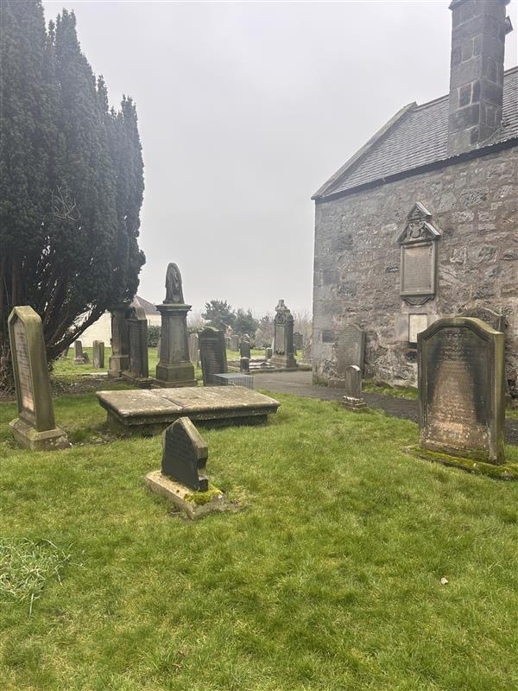

- Map
