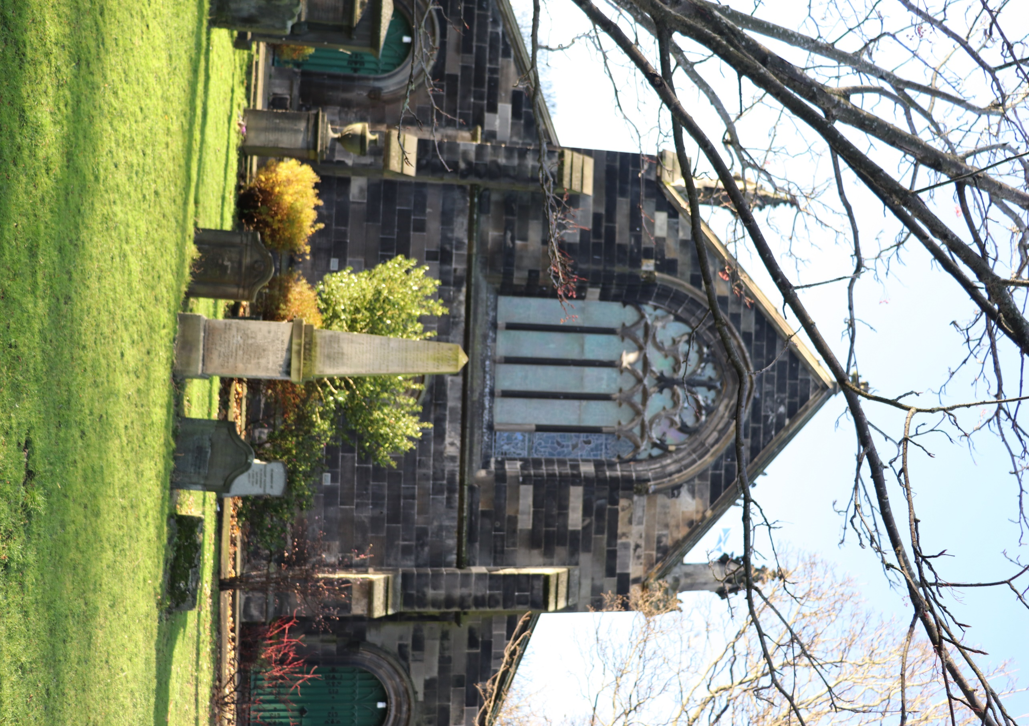


SOUTH LEITH CHURCHYARD

Version | Author(s) | Comments | Dates
V1.1 | Danielle Gartland-Quinn | Photos by Tam Magee | 25/2/2026

This document will be reviewed on an annual basis. However, a review or revision of any parts can be carried out at any time for service improvements and will be carried out following new legislation or changes to codes of practice.
This document can be viewed by the public during office hours or online.

`

Contents

- Brief history
- Site description
- Site summary
- Asset list
- Grounds maintenance and biodiversity
- Lair types and availability
- Community involvement
- Notable burials and monuments
- Map

- Brief history

For centuries, South Leith Parish Church has stood as the historic "Kirk of Our Lady," serving as the focal point of the community since the late 15th century. Originally founded around 1483, the church survived the Siege of Leith in 1560 and Oliver Cromwell’s occupation in the 1650s, during which it was used as a storehouse. While the building underwent a significant restoration in 1848 by architect Thomas Hamilton and it remains a vital part of the Kirkgate. The grounds contain a diverse range of memorials that vary in age, design, and material, including grand structures and historic table tombs. The churchyard serves as an extensive record of Leith’s past, though space eventually became so limited that the Rosebank Cemetery was opened in the 19th century to accommodate the growing population.

- Site description

South Leith Churchyard is accessible through two main points: the Kirkgate entrance and the Constitution Street entrance. The Kirkgate entrance features traditional black iron gates set into stone pillars, with steps leading down into the grounds alongside a disabled access ramp that brings visitors directly to the church doors. A tarmac roadway circles the building, leading through the site to the Constitution Street gate, which is also marked by iron gates and stone pillars. While much of the site is enclosed by a stone wall with iron fencing, a modern wall boundary has been installed on the Constitution Street side following recent tram works. The burial sections are immediately visible and uniquely positioned, as they are raised above the roadway and bordered by a small stone wall with steps and a slight grass incline. Although the churchyard appears relatively small from both street entrances, it opens up into large, open burial sections that include a small walled-off area. The grounds are well-maintained, featuring established plant beds, decorative shrubbery, and several mature trees that provide a sense of scale to the urban space. Once inside the raised burial sections, the ground is notably flat and contains a vast array of memorial types, ranging from modest markers to grand monuments and historic table tombs. Of particular note is a prominent row of tombs situated in the north, with additional tombs located to the east and north of the church building. There are no formal paths between the individual burial rows, allowing the grass to flow continuously around the stones. This layout, combined with the history found on many of the markers, creates a tranquil and well-ordered environment in the heart of Leith.

- Site Summary
Name | South Leith Churchyard
Address | Kirkgate Edinburgh
Postcode | EH6 6BJ
Ownership | The City of Edinburgh Council
Date site acquired | 1855
Size | 0.93 hectares
Conservation area | No
Tree preservation | No
Listing | A
Access | Pedestrian
Opening hours | 24 hours

- Asset List
Asset | Location | Information
Waiting room | No
Toilets | No
CCTV | No
Signage | Cemetery gates | Signs detailing name of the cemetery, cemetery user information, safety signs
Cabinet signage | Cemetery entrance | Sign welcoming cemetery users, displaying cemetery rules, biodiversity information, other useful information
Car park | No
Disabled parking | No
Taps | No
Litter bins | Yes, throughout site see map
Benches | Yes, throughout site see map
Catacombs | No
War memorials | Yes, throughout site | More information can be found on Commonwealth War Grave Commission webpage.

- Grounds maintenance and biodiversity

The Council has revised its approach to grounds maintenance in response to the current nature emergency. This approach aims to protect and enhance existing biodiversity while encouraging the development of new habitats across the cemetery. This means less frequent grass cutting, no use of weedkiller, introduction of wildflowers, and the encouragement of natural grassland growth.

Routine maintenance activities are outlined below. A complete summary of our ground’s maintenance plans can be found in the Bereavement Services Cemeteries Management Plan.

Routine Maintenance | Frequency | Additional information
Grass cutting | Approx. every 10-12 weeks during appropriate seasons – pathways through burial sections only | No grass cutting during No Mow May
Strimming | Approx. every 10-12 weeks during appropriate seasons – pathways through burial sections only | No grass cutting during No Mow May
Leaf clearance | When required | Clearance from hard standing areas only
Sunken graves | When required
Re-turfing / grass seeding | When required | Method will depend on season
Emptying bins | When required

A biodiversity study conducted in 2021 identified that South Leith Churchyard already supports a large range of biodiversity, including a variety of trees, grasses, animals, and insects. The council is committed to protecting these existing habitats and encouraging biodiversity across the site. A list of species found in the cemetery in 2021 are detailed below.

Species List | Details
Trees | Ash, holly, Norway maple, silver birch, sycamore, yew
Shrubs | Buddleia, cotoneaster, fuchsia, hydrangea, ivy, laurel, rhododendron (probably Rhododendron ponticum), rose.
Grasses | Meadow grass (Poa pratensis) and others
Flowers | broad leaved willowherb, creeping buttercup, daisy, dandelion, groundsel, ragwort, ribwort plantain, rosebay willowherb, shepherd's purse, a species of thistle, white clover. Plus garden flowers and shrubs
Fungi | tar spot
Mosses | Bryum capillare, Grimmia pulvinata, Hypnum sp, Orthotrichum anomalum, Tortula muralis.
Mammals | Grey squirrel
Birds | black headed gull, carrion crow, feral pigeon, herring gull, jackdaw, magpie, pied wagtail, woodpigeon.
Insects | 2 spot ladybird, 10 spot ladybird, cream spot ladybird, Harlequin ladybird, orange ladybird, pine ladybird. birch shield bug.  Other insects: common wasp, Syrphus sp hoverfly (larva),

As part of our ongoing biodiversity work, the Council may place nature cameras in the cemetery to monitor the wildlife. Although a cemeteries primary purpose is as a place of remembrance and reflection wildlife are often attracted to cemeteries due to their quiet unchanging environment.

- Lair type and availability

There are no new lair’s available at South Leith Churchyard.

- Community involvement

The Friends of South Leith Churchyard are dedicated to caring for the heritage and biodiversity of the cemetery, they to preserve, restore and educate. Their involvement enhances the condition of the cemetery and contributes significantly to the improvements seen across the site. Their commitment, local knowledge and hands-on involvement have made a meaningful difference to the appearance, accessibility and historical understanding of the churchyard. Some members of the group are a part of the church congregation, and others a local to the area.

Activities carried out by the Friends group include:
- Tree planting
- Shrub planting
- Gardening and maintaining planted areas
- Providing homes for birds, bats and other wildlife
- Assisting with landscape improvements alongside Council staff
- Contributing to the ongoing management and future planning of the site
- Minor churchyard maintainence
The Friends group's involvement not only supports essential maintenance but also helps visitors better understand and appreciate the site's significance.
For information about volunteering, supporting or becoming a member of this Friends group please email FriendsNSLPChurchyard@gmail.com.
Establishing or joining a 'Friends of' group is a meaningful way to contribute to your community while helping us protect these spaces. If you are interested in forming a new group or would like to enquire about future opportunities, please contact Bereavement Services.

- Notable burials and monuments

There are 9 First World War burials located within South Leith Parish Churchyard, all of which are under the care of the Commonwealth War Graves Commission. Among those laid to rest here is James Greenhill, a Driver for the Royal Field Artillery, who passed away in 1920. More information about these graves and memorials can be found on the Commonwealth War Graves Commission webpage.
Memorials in the churchyard vary in size, style, and design; there are tombs with iron gates and prominent headstones, as well as more modest markers and weathered memorials that reflect centuries of the area's local history.

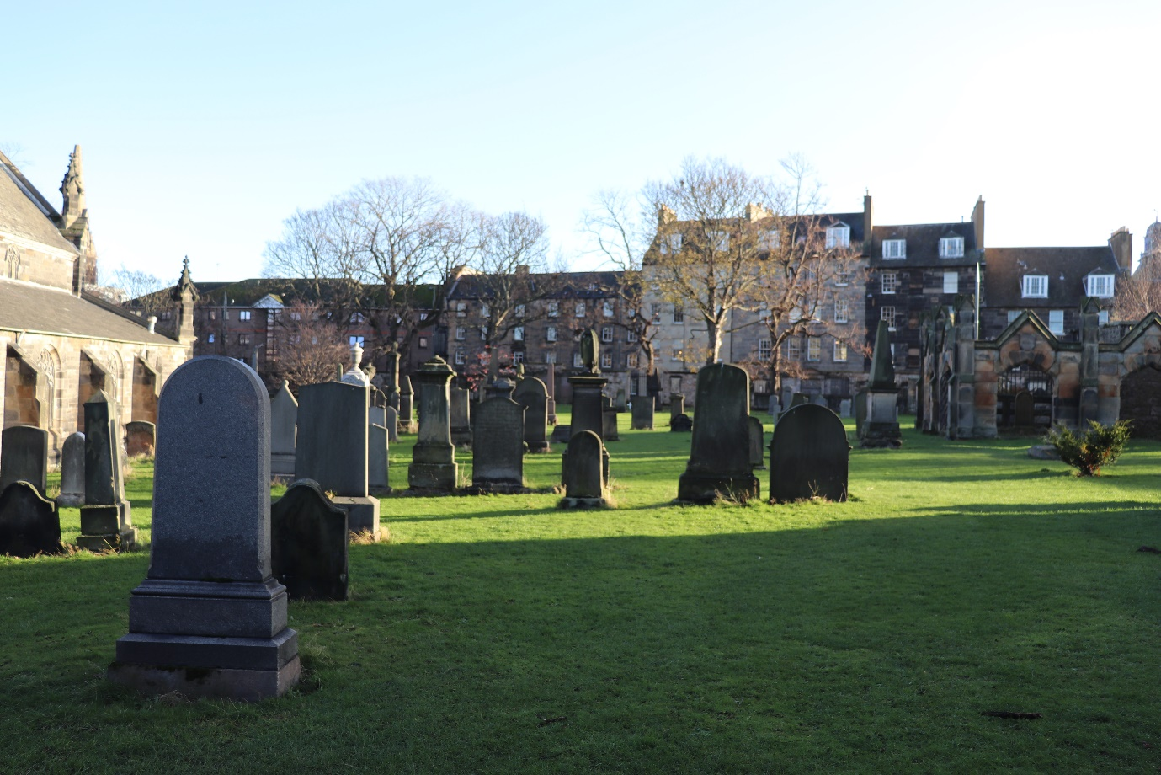

- Map
