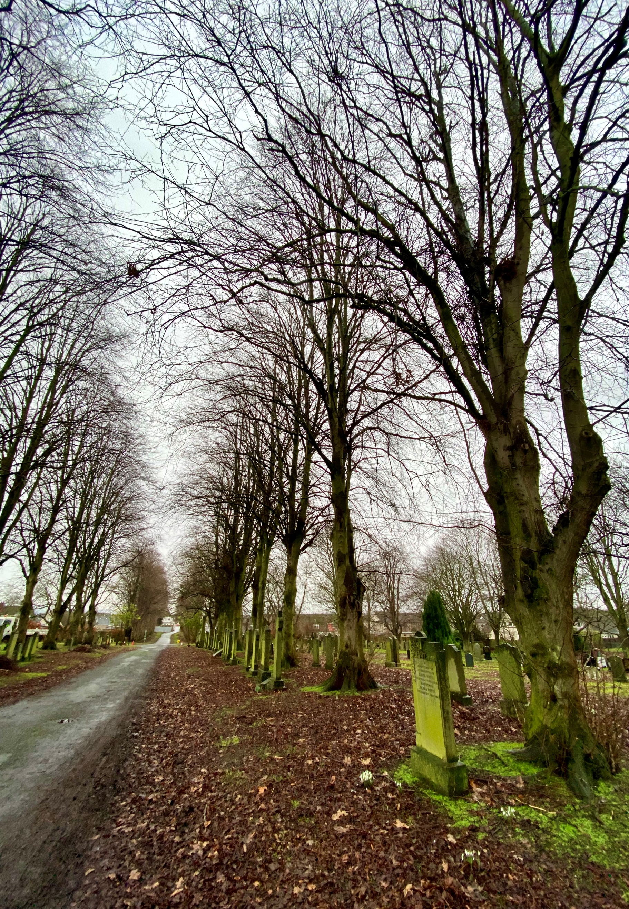


CORSTORPHINE HILL CEMETERY

Version | Author(s) | Comments | Dates
V1.1 | Danielle Gartland-Quinn | Tam Magee | 24/2/2026

This document will be reviewed on an annual basis. However, a review or revision of any parts can be carried out at any time for service improvements and will be carried out following new legislation or changes to codes of practice.
This document can be viewed by the public during office hours or online.

`

Contents

- Brief history
- Site description
- Site summary
- Asset list
- Grounds maintenance and biodiversity
- Lair types and availability
- Community involvement
- Notable burials and monuments
- Map

- Brief history

Corstorphine Hill Cemetery was opened in 1928 by The Edinburgh Cemetery Company, established during a period of increasing demand for modern burial space in the city's western suburbs. The first burial was conducted on 29 October 1928, and the site remains an active burial ground today with new graves still available. While we have no records to confirm the specific architect or designer, the cemetery was clearly designed with a focus on practicality, featuring well-organised burial sections and a highly accessible layout. The site is notable for its diverse commemorative areas, reflecting the changing cultural and social landscape of Edinburgh. It houses significant war memorials, including a dedicated section containing 165 Polish war graves, which serves as a poignant link to the city's wartime history. Additionally, the grounds include a Muslim section and hold the distinction of being the site of Edinburgh’s first woodland burial section, offering a natural and environmentally conscious alternative to traditional interment. Following a period of private ownership, the cemetery fell into a severe state of disrepair alongside several other sites in the city. To ensure its preservation and restoration, the Council compulsory purchased the cemetery in 1994. Today, Corstorphine Hill Cemetery is managed as a welcoming and inclusive sanctuary, balancing its role as a place of international remembrance with its biodiversity importance.

- Site description

Corstorphine Hill Cemetery is accessed via a single-entry point on Drum Brae South. The entrance consists of a long, tree-lined driveway nestled between residential properties and garages, which eventually transitions from a tarmac road into an earth track. The road branches in two directions, encircling the perimeter and providing clear access to and between the various burial sections. The site is fully enclosed by a diverse boundary of modern fencing, and the wooden fences and stone walls of neighbouring private properties. The landscape is flat, featuring open grass burial sections that are spacious and well-organised. A defining feature of the landscape is the woodland burial section located in the eastern part of the cemetery. Here, individual graves are marked by a group of slender silver birch trees, with a central pathway bordered by natural boulder-style memorials. Situated directly behind this area is the Commonwealth War Graves section, which contains uniformed memorials, including the notable Polish war graves, maintained in a dedicated and orderly space. Throughout the grounds, the memorials reflect the cemetery's long history, varying significantly in age, size, and style. These range from traditional stone monuments to contemporary granite and slate memorials associated with more recent interments. The abundance of established trees across the site creates the immersive feel of a wooded area, offering a sheltered and tranquil atmosphere away from the busy city surroundings.

- Site Summary
Name | Corstorphine Hill Cemetery
Address | 28A Drum Brae South Edinburgh
Postcode | EH12 8SZ
Ownership | The City of Edinburgh Council
Date site acquired | 1994
Size | 3.37 hectares
Conservation area | Yes
Tree preservation | Yes
Listing | None
Access | Vehicle and pedestrian
Opening hours | 24 hours

- Asset List
Asset | Location | Information
Waiting room | No
Toilets | No
CCTV | No
Signage | Cemetery gates | Signs detailing name of the cemetery, cemetery user information, safety signs
Cabinet signage | Cemetery entrance | Sign welcoming cemetery users, displaying cemetery rules, biodiversity information, other useful information
Car park | No
Disabled parking | No
Taps | No
Litter bins | Yes, throughout site see map
Benches | Yes, throughout site see map
Catacombs | No
War memorials | Yes, memorial and individual graves throughout site | More information can be found on Commonwealth War Grave Commission webpage.

- Grounds maintenance and biodiversity

The Council has revised its approach to grounds maintenance in response to the current nature emergency. This approach aims to protect and enhance existing biodiversity while encouraging the development of new habitats across the cemetery. This means less frequent grass cutting, no use of weedkiller, introduction of wildflowers, and the encouragement of natural grassland growth.

The woodland burial section is managed with minimal intervention to encourage biodiversity. This low-maintenance approach allows natural flora to flourish, fulfilling the original vision for this ecological space.

Routine maintenance activities are outlined below. A complete summary of our ground’s maintenance plans can be found in the Bereavement Services Cemeteries Management Plan.

Routine Maintenance | Frequency | Additional information
Grass cutting | Approx. every 8-10 weeks during appropriate seasons | No grass cutting during No Mow May
Strimming | Approx. every 8-10 weeks during appropriate seasons | No grass cutting during No Mow May
Leaf clearance | When required | Removal from hard standing areas and pathways only.
Sunken graves | When required
Re-turfing / grass seeding | When required | Method will depend on season
Hedge cutting | Annually | No hedge / shrub work during bird nesting season (March-August)
Emptying bins | When required

A biodiversity study conducted in 2021 identified that Corstorphine Hill Cemetery already supports a large range of biodiversity, including a variety of trees, grasses, animals, and insects. The council is committed to protecting these existing habitats and encouraging biodiversity across the site. A list of species found in the cemetery in 2021 are detailed below.

Species List | Details
Trees | Ash, beech, black poplar, cherry, hawthorn, horse chestnut, laburnum, lime, Norway maple, pedunculate oak, rowan, silver birch, sweet chestnut, sycamore, whitebeam, wych elm, yew
Shrubs | Beech jedges, bramble, cotoneaster, holly, hypericum, ivy, rose, snowberry, whin
Flowers | Blue comfrey, broadleaved willowherb, creeping buttercup, daosy, dandelion, dock, doves-foot cranesbill, groundsel, Michaelmas daisy, nettle, ox eye daisy, purple loosestrife, red campion, sweet pea, tansy, thistle, white clover, wood avens, garden plants
Fungi | Turkey tail
Mammals | Grey squirrel, foxes and possibly badgers
Birds | Blue tit, carrion crow, great tit, jackdaw, magpie, robin, stock dove, woodpigeon, wren
Insects | Banded hoverfly, craneflies, honey bee, pine ladybird

As part of our ongoing biodiversity work, the Council may place nature the cemetery to monitor wildlife. Although a cemeteries primary purpose is as a place of remembrance and reflection wildlife are often attracted to cemeteries due to their quiet unchanging environment.

- Lair type and availability

Lair type | Availability | Details
Non-denomination Coffin Lairs | Yes | 2 coffin burials and 6 cremated remains urn burials
Catholic Lairs | No
Woodland lair | No
Green Burial | No
Cremated remains | Yes | 6 cremated remains urn burials
Baby | No
Muslim | No
Muslim baby | No
Above ground vault | No

- Community involvement

There are no established Friends Group for this cemetery.
Establishing or joining a 'Friends of' group is a meaningful way to contribute to your community while helping us protect these spaces. If you are interested in forming a new group or would like to enquire about future opportunities, please contact Bereavement Services.

- Notable burials and monuments

Corstorphine Hill Cemetery contains the second-highest number of Polish war graves in Scotland, serving as a major site of remembrance for Polish forces who were stationed in camps near Edinburgh during World War II. In addition to the notable Polish section, Corstorphine Hill Cemetery contains a significant number of other military burials and memorials maintained by the Commonwealth War Graves Commission. More information about those who are buried here and their memorials can be found on the Commonwealth War Graves Commission’s webpage.

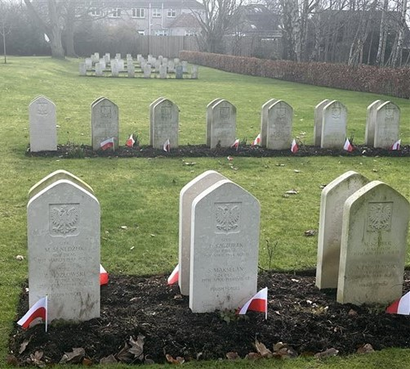

- Map

