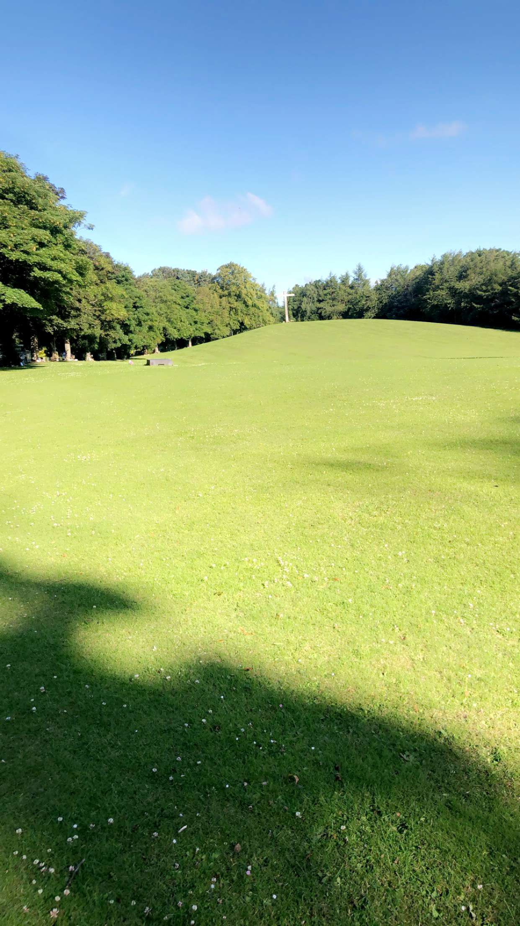


MORTONHALL CEMETERY

Version | Author(s) | Comments | Dates
V1.1 | Danielle Gartland-Quinn | Photos by Tam Magee | 25/2/2026

This document will be reviewed on an annual basis. However, a review or revision of any parts can be carried out at any time for service improvements and will be carried out following new legislation or changes to codes of practice.
This document can be viewed by the public during office hours or online.

`

Contents

- Brief history
- Site description
- Site summary
- Asset list
- Grounds maintenance and biodiversity
- Lair types and availability
- Community involvement
- Notable burials and monuments
- Map

- Brief history

Mortonhall Cemetery represents a significant milestone in Edinburgh’s civic development, as it was the first burial ground to be both established and opened directly by the Council. Purchased in 1958 to address a post-war shortage of burial space, the cemetery was designed as a modern, spacious alternative to the dense Victorian graveyards of the city’s past. The grounds officially opened in the summer of 1960, with the first burial recorded on 9 August 1960. This new design approach focused on a park-like atmosphere, utilising flat memorials and wide-open sections to maintain a sense of tranquillity and order across the landscape. The cemetery is integrated with shared grounds designed by the celebrated architect Sir Basil Spence, who employed an modernist/brutalise design style to create a serene environment. This architectural movement sought to evoke emotional and spiritual responses through bold, sculptural forms and a dramatic use of natural light, moving away from traditional, heavy masonry. Spence’s vision for the site was heavily influenced by Scandinavian Modernism, specifically the pioneering Woodland Cemetery in Stockholm. This Nordic inspiration is evident in the "woodland" philosophy of the layout, where the burial sections are secondary to the natural environment, using the existing forest to create a journey of reflection for the bereaved. A central feature of this reflective landscape is the Garden of Remembrance; a tranquil space specifically designed for the interment of ashes and quiet contemplation. Overlooking the grounds from a nearby hillock is a striking monumental cross, which serves as a spiritual anchor for the site. While it functions as a Christian symbol, the cross is designed with a distinct, non-traditional shape and unconventional dimensions that reflect the Expressionist spirit of the wider project. Rather than following standard proportions, the cross features a unique, elongated verticality and minimalist geometry in white concrete, designed to stand out as a bold, modern silhouette against the surrounding green canopy and sky. Since its opening, the cemetery has had over 10,000 burials, serving the local community for over six decades and lairs are still reopened and utilised today.

- Site description

Mortonhall Cemetery is a modern and expansive burial ground accessed via a single point of entry on Howdenhall Road, where white concrete pillars and black iron gates open onto a long driveway sheltered by a dense canopy of mature trees. This impressive approach leads past the crematorium building to the formal start of the cemetery grounds, which features a dedicated waiting area, complete with a burial office and public toilets. From this point, an immediate view of the open burial sections unfolds, defined by an orderly landscape of flat granite memorials, marking the individual graves, that vary in size and style while maintaining a clean aesthetic. The site is carefully organised, with modern roadways dividing the various burial sections to provide easy vehicle and pedestrian access throughout the grounds. The entire cemetery is an enclosed site, secured by modern fencing and softened by established shrubbery that borders the perimeter. Along the road rows, mature trees frame the approach to the Garden of Remembrance, where visitors can look across to the monumental cross. The ground is exceptionally well-maintained, consisting primarily of level ground with some sections that rise into gentle, graduated slopes. Mature trees are distributed across the entire site, contributing to its tranquil and established character. At the rear of the cemetery, a modern Baby Garden of Remembrance is situated alongside an established wooded area, providing a secluded and peaceful sanctuary for reflection. This dedicated space features its own beautifully planted garden and seating area, offering a quiet corner for contemplation amidst the natural landscape. The seamless blend of modern design and mature landscape ensures that Mortonhall remains a peaceful, and easily navigable space for all visitors. A virtual tour of the cemetery can be viewed here.

- Site Summary
Name | Mortonhall Cemetery
Address | 30A Howdenhall Road Edinburgh
Postcode | EH16 6TX
Ownership | The City of Edinburgh Council
Date site acquired | 1958
Size | 5.01 hectares
Conservation area | No
Tree preservation | Yes
Listing | None
Access | Vehicle and pedestrian
Opening hours | 8am-6pm

- Asset List
Asset | Location | Information
Waiting room | Yes
Toilets | Yes | Cemetery entrance
CCTV | Yes | Buildings only
Signage | Cemetery gates | Signs detailing name of the cemetery, cemetery user information, safety signs, throughout site regarding parking
Cabinet signage | Cemetery entrance | Sign welcoming cemetery users, displaying cemetery rules, biodiversity information, other useful information
Car park | Yes | Entrance of grounds
Disabled parking | Yes | Crematorium building
Taps | Yes, throughout site see map
Litter bins | Yes, throughout site see map
Benches | Yes, throughout site see map
Catacombs | No
War memorials | No

- Grounds maintenance and biodiversity

The Council has revised its approach to grounds maintenance in response to the current nature emergency. This approach aims to protect and enhance existing biodiversity while encouraging the development of new habitats across the cemetery. This means less frequent grass cutting, no use of weedkiller, introduction of wildflowers, and the encouragement of natural grassland growth.

Routine maintenance activities are outlined below. A complete summary of our ground’s maintenance plans can be found in the Bereavement Services Cemeteries Management Plan.

Routine Maintenance | Frequency | Additional information
Grass cutting | Approx. every 8-10 weeks during appropriate seasons | No grass cutting during No Mow May
Strimming | Approx. every 8-10 weeks during appropriate seasons | No grass cutting during No Mow May
Leaf clearance | When required | Removal from hard standing areas and pathways only.
Sunken graves | When required
Re-turfing / grass seeding | When required | Method will depend on season
Hedge cutting | Annually | No hedge / shrub work during bird nesting season (March-August)
Emptying bins | When required

A biodiversity study conducted in 2021 identified that Mortonhall Cemetery already supports a large range of biodiversity, including a variety of trees, grasses, animals, and insects. The council is committed to protecting these existing habitats and encouraging biodiversity across the site. A list of species found in the cemetery in 2021 are detailed below.

Species List | Details
Trees | Ash, beech, cherry, crab apple, cypress, elder, hawthorn, hornbeam, horse chestnut, lime, Norway maple, oak, rowan, scots pine, silver birch, sweet chestnut, sycamore, weeping willow, wych elm, yew
Shrubs | Bramble, cotoneaster, holly, hypericum, ivy, laurel, rose, snowberry
Flowers | Broad leaved willowherb, creeping buttercup, daffodil, daisy, dandelion, dock, doves-foot, cranesbill, feverfew, groundsel, Michaelmas daisy, nettle, red campion, white clover, wood avens, yarrow, various garden plants.
Fungi | A bonnet fungus, a brittlegill, giant polypore, jelly ear, a knight fungus, meadow waxcap
Mammals | Badger, deer, fox, grey squirrel
Birds | Black headed gull, blue tit, buzzard, carrion crow, coal tit, goldcrest, great tit, herring gull, jackdaw, long tailed tit, magpie, mallard ducks, mistle thrush, robin, woodpecker, wood pigeon, wren
Insects | Hoverflies, banded hoverfly, drone fly, footballer hoverfly, common wasp, common calder bumble bee, peacock butterfly

As part of our ongoing biodiversity work, the Council may place nature cameras to monitor the wildlife. Although a cemeteries primary purpose is as a place of remembrance and reflection wildlife are often attracted to cemeteries due to their quiet unchanging environment.

- Lair type and availability

There are no new lair’s available at Mortonhall Cemetery, burial can only be arranged in an existing lair.

- Community involvement

There are no established Friends Groups for Mortonhall Cemetery.
Establishing or joining a 'Friends of' group is a meaningful way to contribute to your community while helping us protect these spaces. If you are interested in forming a new group or would like to enquire about future opportunities, please contact Bereavement Services.

- Notable burials and monuments

As a prominent landmark within the grounds, the Mortonhall cross stands on the highest point of the landscape, making it visible from almost every area of the cemetery. It was designed by the renowned architect Sir Basil Spence who drew creative inspiration from the minimalist aesthetic of Erik Gunnar Asplund’s famous Forest Cemetery in Stockholm. Although the structure takes the form of a cross, it was intended as a secular sculptural element rather than a religious icon.


The Baby Rose Garden located along the southern boundary of the Mortonhall Cemetery grounds, contains memorials donated by various charities. Notable contributors include Sands (the stillbirth and neonatal death charity), whose Lothians branch is now known as Held In Our Hearts, as well as the charity SiMBA. These organisations have worked in partnership with the City of Edinburgh Council to establish this tranquil space.
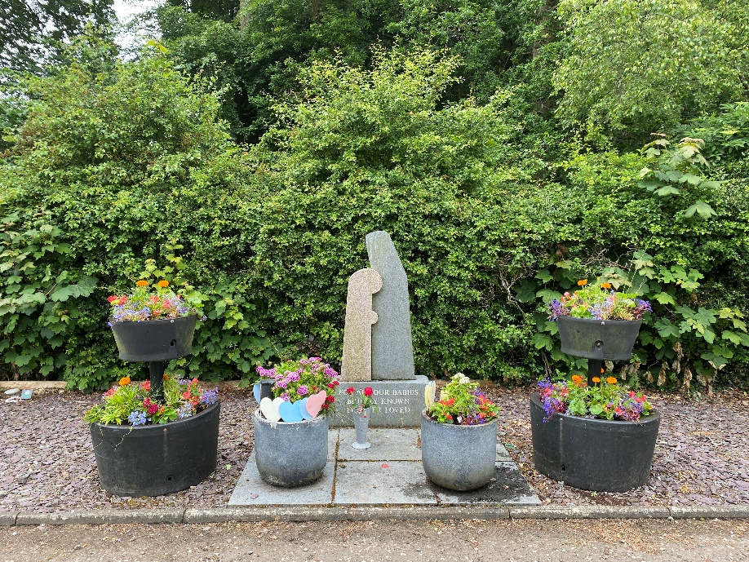

- Map
