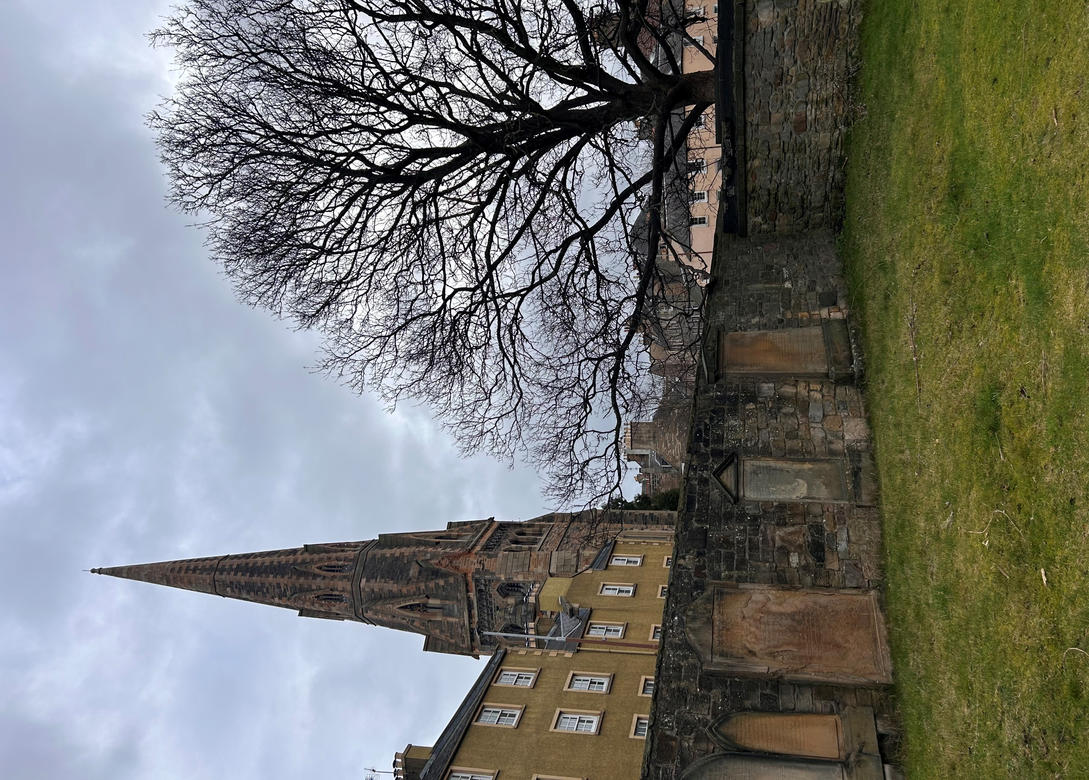


BUCCLEUCH CHURCHYARD

Version | Author(s) | Comments | Dates
V1.1 | Danielle Gartland-Quinn | Photos by Tam Magee | 24/2/2026

This document will be reviewed on an annual basis. However, a review or revision of any parts can be carried out at any time for service improvements and will be carried out following new legislation or changes to codes of practice.
This document can be viewed by the public during office hours or online.

`

Contents

- Brief history
- Site description
- Site summary
- Asset list
- Grounds maintenance and biodiversity
- Lair types and availability
- Community involvement
- Notable burials and monuments
- Map

- Brief history

Buccleuch Church was opened around 1763 (rebuilt in 1866) as a chapel-of-ease of St Cuthberts Parish. Historically, the grounds included a windmill which served the local communities water supply. The burial ground was opened around 1763 and was closed for new lairs by 1820. We do not hold burial records for this burial ground therefore it is not possible to confirm dates or details of burials with complete accuracy. The church in the grounds is now owned by the Orthodox Community of St Andrew in Edinburgh, Parish of the Archdiocese of Thyateira and Great Britain, which is part of the Ecumenical Patriarchate.

- Site description

Buccleuch Churchyard is a small, enclosed site accessed from Chapel Street through black iron gates upon a stone wall, positioned at the entrance of the church. The churchyard surrounds the church building on all sides and is a mainly flat open lawn area with stone chips in the centre. There are little fauna and flora on site, with a single ash tree and a small number of shrubs. The site is enclosed by tall stone boundary walls, with five built tombs on the eastern boundary. Headstones are mounted along the inner faces of the boundary walls throughout; they represent a range of periods and artistic style. Many sandstone headstones have experienced significant weathering, with some inscriptions now fully eroded and no longer legible. Stone slabs have been laid to form a pathway to a section of the grounds which is enclosed by fencing. The purpose and function of this area is unknown, as it is managed by the church.

- Site Summary
Name | Buccleuch Churchyard
Address | 2C Buccleuch Street Edinburgh
Postcode | EH8 9JR
Ownership | The City of Edinburgh Council
Date site acquired | 1855
Size | 0.24 hectares
Conservation area | Yes
Tree preservation | No
Listing | None
Access | Pedestrian
Opening hours | 24 hours

- Asset List
Asset | Location | Information
Waiting room | No
Toilets | No
CCTV | No
Signage | Cemetery gates | Sign detailing name of the cemetery, cemetery user information signs, safety signs
Cabinet signage | Cemetery entrance | Sign welcoming cemetery users to the cemetery, displaying cemetery rules, biodiversity information, other useful information for cemetery users
Car park | No
Disabled parking | No
Taps | No
Litter bins | No
Benches | No
Catacombs | No
War memorials | No

- Grounds maintenance and biodiversity

The Council has revised its approach to grounds maintenance in response to the current nature emergency. This approach aims to protect and enhance existing biodiversity while encouraging the development of new habitats across the cemetery. This means less frequent grass cutting, no use of weedkiller, introduction of wildflowers, and the encouragement of natural grassland growth.

Routine maintenance activities are outlined below. A complete summary of our ground’s maintenance plans can be found in the Bereavement Services Burial Management Plan.

Routine Maintenance | Frequency | Additional information
Grass cutting | Approx. every 10-12 weeks during appropriate seasons | No grass cutting during No Mow May
Strimming | Approx. every 10-12 weeks during appropriate seasons | No grass cutting during No Mow May
Leaf clearance | No
Sunken graves | When required
Re-turfing / grass seeding | When required | Method will depend on season
Hedge cutting | Not required
Emptying bins | Not required

A biodiversity study conducted in 2021 identified that Buccleuch Churchyard already supports a small range of biodiversity, including a variety of ferns and birds. The council is committed to protecting these existing habitats and encouraging biodiversity across the site. A list of species found in the cemetery in 2021 are detailed below.

Species List | Details
Trees | Ash
Shrubs | Buddleia, cotoneaster, ivy
Grasses | Meadow grass
Flowers | Creeping buttercup, daisy, dandelion, fox and cubs, groundsel, nettle, ribwort plantain, rosebay willowherb, smooth sow thistle, sneezewort, thistle, white clover, wood avens, garden flowers and shrubs
Fungi | Tar spot, turkey tail
Mosses | Hypnum sp.
Birds | Blue tit, carrion crow, herring gull, magpie, pied wagtail, robin, woodpigeon.
Ferns | Hart’s tongue, maidenhair spleenwort, male fern, wall rue

- Lair type and availability

There are no new lair’s available at Buccleuch Churchyard.

- Community involvement
There are no established Friends Group for Buccleuch Churchyard.
Establishing or joining a 'Friends of' group is a meaningful way to contribute to your community while helping us protect these spaces. If you are interested in forming a new group or would like to enquire about future opportunities, please contact Bereavement Services.

- Notable burials and monuments

Deacon Brodie the notorious cabinetmaker whose double life inspired the story of Dr Jekyll and Mr Hyde, is believed to be buried in an unmarked lair against the north wall of the churchyard.
Dr Andrew Duncan a pioneering physician and founder of the Royal Edinburgh Hospital, is interred in a family tomb within Buccleuch Churchyard. Notably, Charles Darwin (1758–1778), one of Andrew Duncan’s students and the uncle and namesake of the famous naturalist is also buried in the Duncan family tomb.

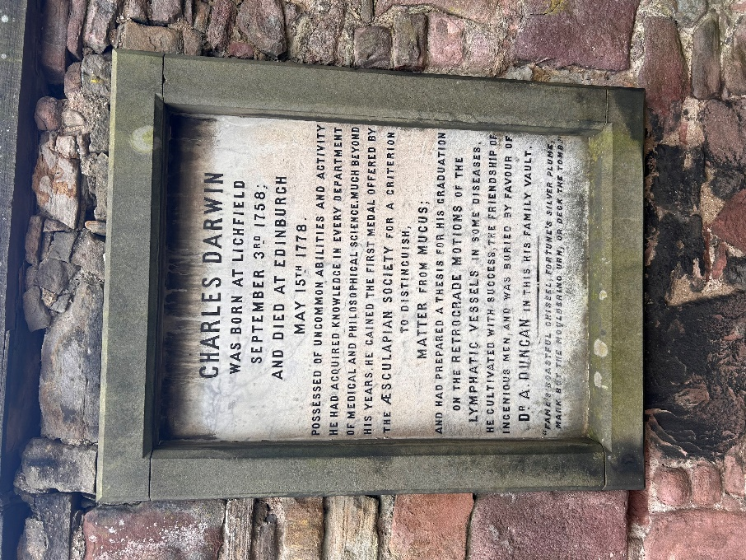
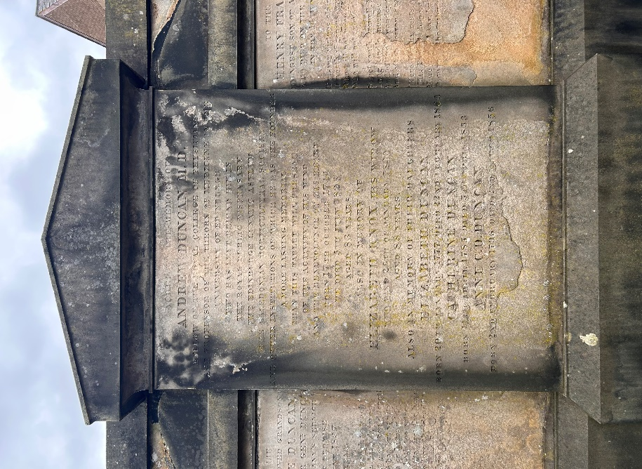

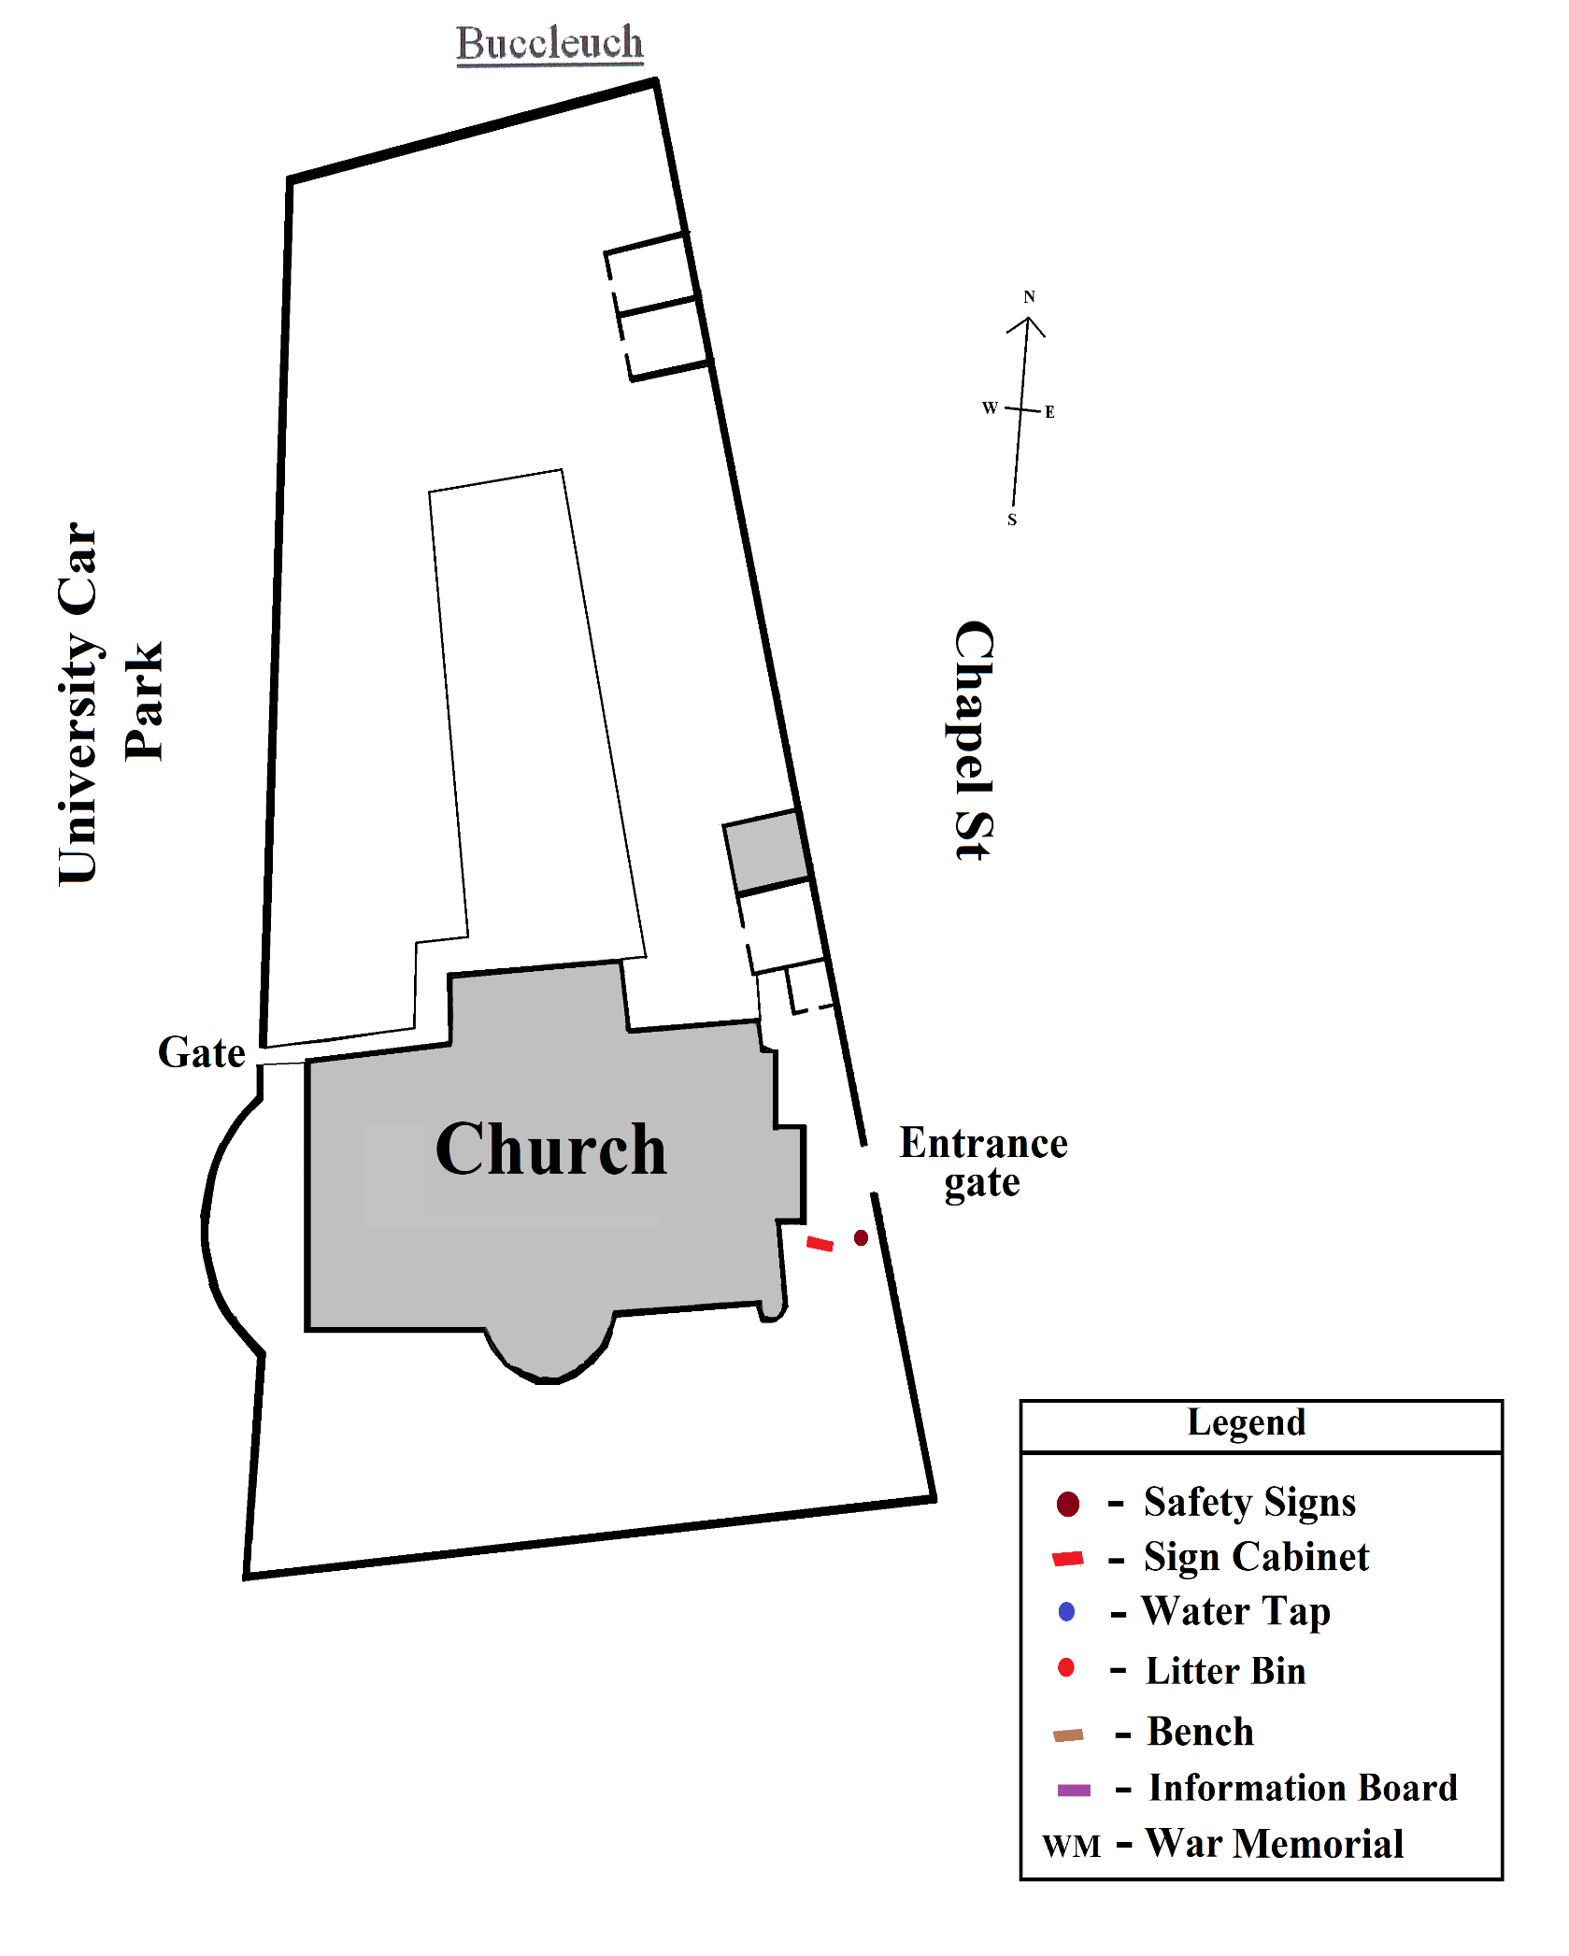
- Map

