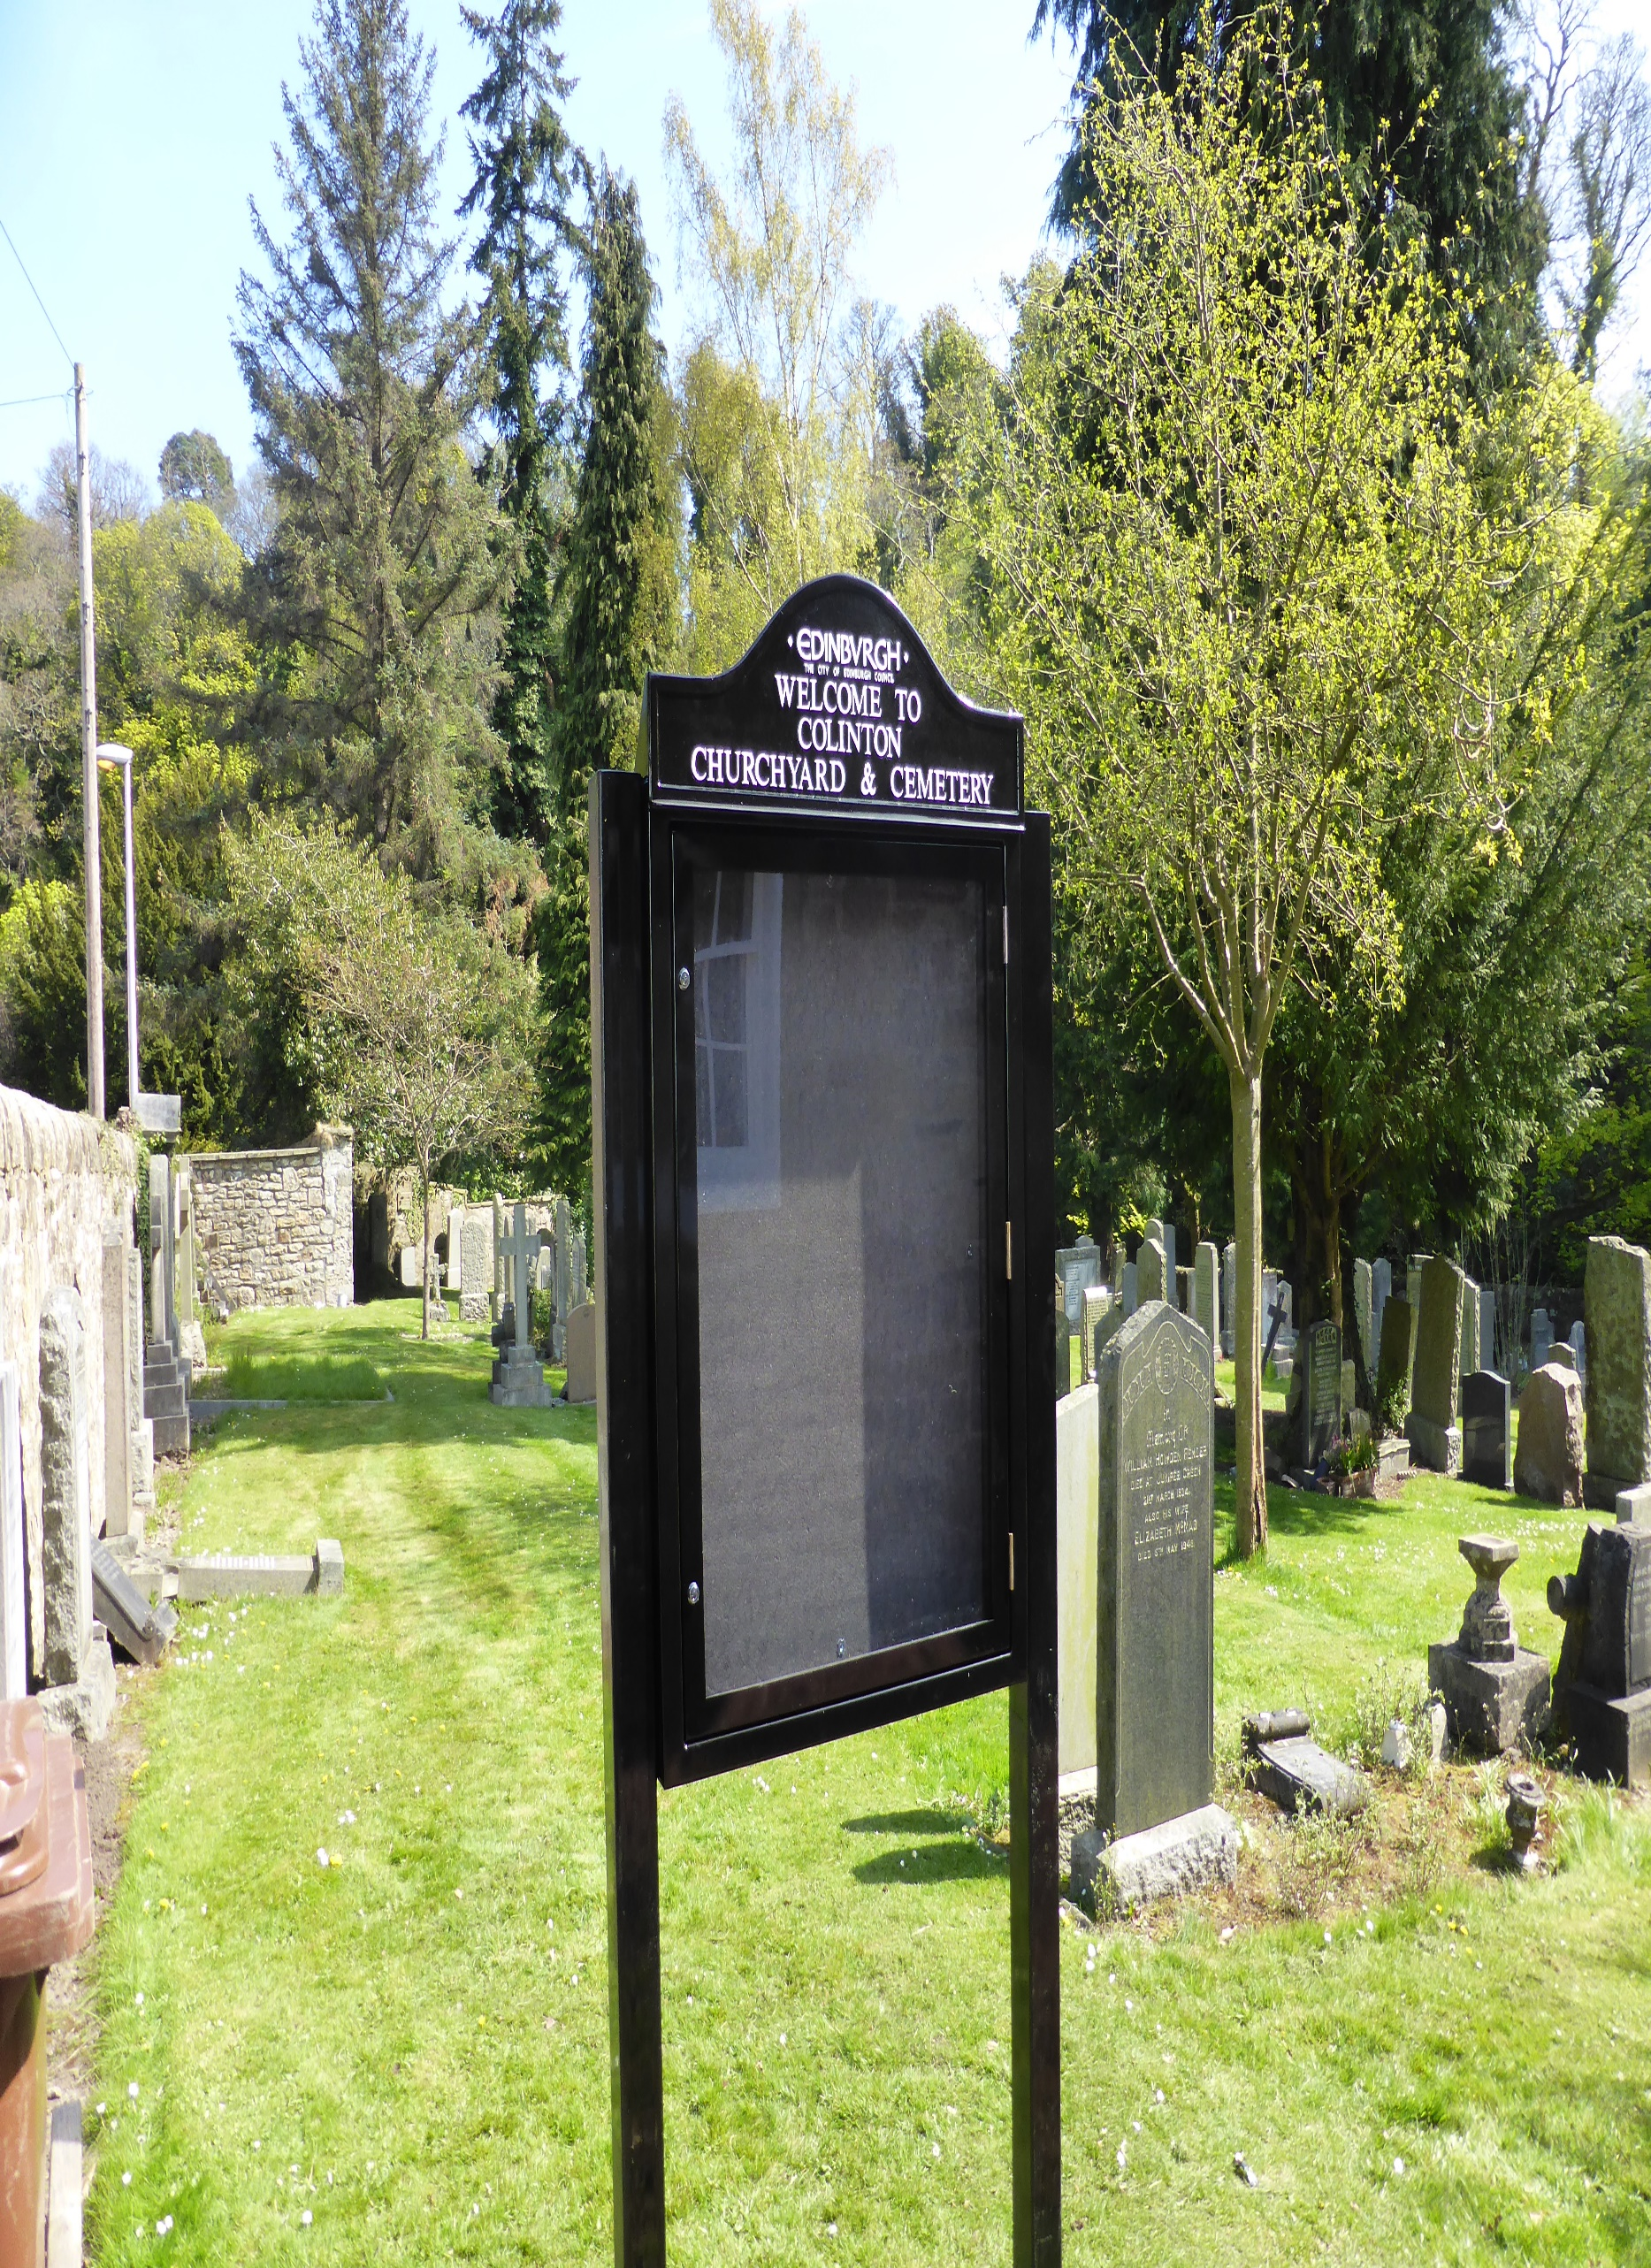


COLINTON CEMETERY

Version | Author(s) | Comments | Dates
V1.1 | Danielle Gartland-Quinn | Photos by Tam Magee | 24/2/26

This document will be reviewed on an annual basis. However, a review or revision of any parts can be carried out at any time for service improvements and will be carried out following new legislation or changes to codes of practice.
This document can be viewed by the public during office hours or online.

`

Contents

- Brief history
- Site description
- Site summary
- Asset list
- Grounds maintenance and biodiversity
- Lair types and availability
- Community involvement
- Notable burials and monuments
- Map

- Brief history

For centuries, Colinton Parish Church has served as the spiritual and communal heart of the village, with its sacred origins stretching back as far as 1095. While the site has hosted diverse structures for nearly a millennium, the current church building was largely transformed between 1907 and 1908 by the architect Sydney Mitchell, who introduced a distinctive Neo-Byzantine style featuring pink sandstone columns. Despite this modern reimagining, the structure still incorporates the prominent 1837 bell tower designed by the renowned architect David Bryce. As the village expanded, the original churchyard eventually reached capacity, a common challenge for historic Scottish parishes. To meet the community's growing needs, a larger cemetery extension was added to the south in the late 19th century, roughly around the 1880s, providing a well-laid-out landscape of spacious, lawned areas. The grounds of Colinton Church and Cemetery serve as a physical chronicle of local history, with burial records dating back to 1716 and surviving monuments from as early as 1593. The older churchyard preserves remarkable relics such as heavy iron mortsafes from the 1820s, which were used to protect graves from "resurrectionists" or body snatchers. In contrast, the newer southern extension is home to the village’s grand War Memorial, designed by sculptor Pilkington Jackson, which stands as a solemn tribute to those who fell in the World Wars. Today, the combined grounds represent a unique bridge between Colinton's medieval roots and the present day, with more than 3,400 recorded interments in the parish registers alone.

- Site description

Accessed via Dell Road, entry to Colinton Cemetery is gained through traditional iron gates set into a stone wall, which open onto a stone-chip pathway. This path leads directly into the cemetery and surrounds the village’s grand War Memorial, which serves as a solemn focal point for reflection. Upon arrival, the site reveals open lawn burial sections, bordered to the right by private property. The landscape is defined by its gentle slope descending toward the Water of Leith, which provides a picturesque and tranquil backdrop to the grounds. This natural setting is populated by mature trees and shrubs that enhance the peaceful atmosphere, while the entire site remains secluded behind stone walls of varying heights and dense greenery. The memorials display a diverse range of sizes, materials, and styles. While the main stone-chip path serves the site’s entrance and the memorial area, there are no formal pathways between the individual burial sections, which consist of simple, open greenery. Notably, there is no direct access to the historic Colinton Parish Churchyard from here, as the two sites are physically separated by the road leading to the Manse.

- Site Summary
Name | Colinton Cemetery and Churchyard
Address | 9 Dell Road Edinburgh
Postcode | EH4 2DL
Ownership | The City of Edinburgh Council
Date site acquired | 1855
Size | 0.24 hectares
Conservation area | Yes
Tree preservation | No
Listing | B
Access | Pedestrian
Opening hours | 24 hours

- Asset List
Asset | Location | Information
Waiting room | No
Toilets | No
CCTV | No
Signage | Cemetery and Churchyard gates | Signs detailing name of the cemetery, cemetery user information, safety signs
Cabinet signage | Cemetery and Churchyard entrances | Sign welcoming cemetery users, displaying cemetery rules, biodiversity information, other useful information
Car park | No
Disabled parking | No
Taps | No
Litter bins | Yes, throughout site see map
Benches | No
Catacombs | No
War memorials | Yes | More information can be found on the Commonwealth War Graves Commission webpage.

- Grounds maintenance and biodiversity

The Council has revised its approach to grounds maintenance in response to the current nature emergency. This approach aims to protect and enhance existing biodiversity while encouraging the development of new habitats across the cemetery. This means less frequent grass cutting, no use of weedkiller, introduction of wildflowers, and the encouragement of natural grassland growth.

Routine maintenance activities are outlined below. A complete summary of our ground’s maintenance plans can be found in the Bereavement Services Cemeteries Management Plan.

Routine Maintenance | Frequency | Additional information
Grass cutting | Approx. every 10-12 weeks during appropriate seasons | No grass cutting during No Mow May
Strimming | Approx. every 10-12 weeks during appropriate seasons | No grass cutting during No Mow May
Leaf clearance | When required | Removal from hard standing areas and pathways only.
Sunken graves | When required
Re-turfing / grass seeding | When required | Method will depend on season
Emptying bins | When required

A biodiversity study conducted in 2021 identified that Colinton Cemetery and Churchyard already supports a large range of biodiversity, including a variety of trees, grasses, animals, and insects. The council is committed to protecting these existing habitats and encouraging biodiversity across the site. A list of species found in the cemetery in 2021 are detailed below.

Species List | Details
Trees | Ash, cherry, cypress, laburnum, laurel, rowan, silver birch
Shrubs | Bramble, cotoneaster, ivy, rose
Grasses | Meadow grass
Flowers | Creeping buttercup, daisy, dandelion, groundsel, heather,rosebay willowherb
Fungi | Some present including tar spot on sycamore leaves
Mosses | Grimmia pulvinata, Marchantia polymorpha (a liverwort), Hypnum sp.
Mammals | Grey squirrel, rabbit, roe deer are often seen in the area and probably visit the cemetery
Birds | Blackbird, blue tit, buzzard, carrion crow, chaffinch, coal tit, goldcrest, great tit, jackdaw, long tailed tit, magpie, robin, rook, song thrush, sparrowhawk, woodpigeon, wren

- Lair type and availability

There are no new lairs available at the churchyard.

- Community involvement

There is no established Friends Group for this churchyard.
Establishing or joining a 'Friends of' group is a meaningful way to contribute to your community while helping us protect these spaces. If you are interested in forming a new group or would like to enquire about future opportunities, please contact Bereavement Services

- Notable burials and monuments

Standing as a solemn focal point within the cemetery’s southern extension, the Colinton War Memorial is a poignant tribute to the local servicemen who lost their lives in the World Wars. Designed by the celebrated sculptor Charles Pilkington Jackson, the memorial is crafted from sandstone and features a dignified Celtic cross set upon a tiered pedestal.

- Map

