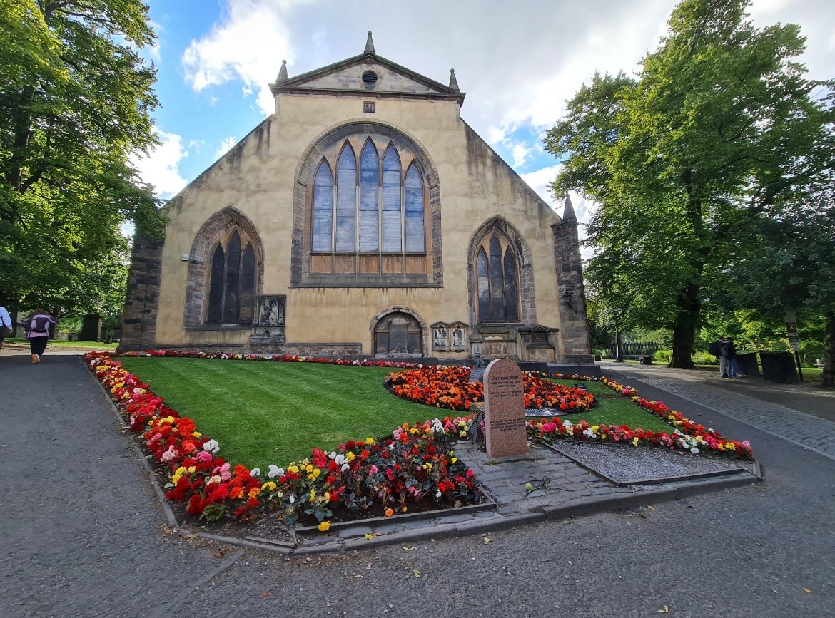


GREYFRIARS KIRKYARD

Version | Author(s) | Comments | Dates
V1.1 | Danielle Gartland-Quinn | Photos by Tam Magee | 24/2/2026

This document will be reviewed on an annual basis. However, a review or revision of any parts can be carried out at any time for service improvements and will be carried out following new legislation or changes to codes of practice.
This document can be viewed by the public during office hours or online.

`

Contents

- Brief history
- Site description
- Site summary
- Asset list
- Grounds maintenance and biodiversity
- Lair types and availability
- Community involvement
- Notable burials and monuments
- Map

- Brief history
Established in 1562 on the site of a former Franciscan monastery, Greyfriars Kirkyard was a direct response to the overcrowding of the small graveyard at St Giles’ Cathedral, with Mary, Queen of Scots granting the land to the town council for use as a new public cemetery. Greyfriars Kirk was constructed later with work starting in 1601 with the Kirk opening in 1620. Over the centuries, it has evolved into a site of profound national importance, serving as the setting for the signing of the National Covenant in 1638 and later as the Covenanters' Prison in 1679, where hundreds of religious dissidents were held in brutal conditions. The kirkyard has an impressive collection of 17th and 18th-century architecture, representing some of the finest masonry of the Scottish Enlightenment. Because it was the final resting place for Edinburgh’s elite, the boundary walls are lined with grand, Baroque-style mural monuments and gated family vaults. These memorials are famous for their intricate "memento mori" carvings, such as winged souls, skeletons, and hourglasses, designed to remind viewers of the brevity of life. A defining structural feature of the grounds is the Flodden Wall; a massive stone fortification built in the early 16th century to protect Edinburgh after the catastrophic Scottish defeat at the Battle of Flodden. This historic wall forms the southern and western boundaries of the kirkyard, and several of the most elaborate 17th-century burial vaults were built directly into its fabric. The presence of the wall not only provided security during the city's more turbulent years but also created a prestigious "mural" space for the city’s wealthiest families to display their status through highly decorative stonework. The grounds also famously include the Greyfriars Bobby headstone, commemorating the loyal Skye Terrier who supposedly guarded his master's grave for 14 years. Beyond its historical and religious significance, the kirkyard has become a site of global literary interest. It contains the graves of influential figures, but in recent years, it has gained fame for its connection to Harry Potter. Today, the Category A-listed site remains one of Edinburgh's most visited locations.
- Site description
The top entrance to Greyfriars Kirkyard is uniquely nestled between traditional historic buildings that form a significant part of the site’s boundary. These structures reflect the character of the Old Town, consisting of a mix of residential properties and commercial businesses that look directly onto the burial grounds. This main gateway at the top of Candlemaker Row features traditional stone setts and a distinctive stone bothy, a vibrant flower bed and a granite memorial bearing the Edinburgh Council logo, and a granite statue of Greyfriars Bobby, welcoming visitors to the historic grounds. The site is notably sloped, with the ancient stone setts transitioning into more modern paths that circle the church and provide a smoother route through the cemetery. While there are no formal paths within the burial sections themselves, there are many paths throughout the site, mainly running around the borders to provide access to all sections. This layout offers visitors impressive views of Edinburgh's Flodden Wall, which separates the main grounds from the West Yard. The perimeter is securely enclosed by a combination of high stone walls, iron fencing, and the rear of neighbouring buildings. The Covenanters’ Prison, located at the southern end of the kirkyard, remains one of the site's most sombre areas and is accessed through a set of locked iron gates. The burial sections are densely packed with architecturally significant memorials, ranging from grand monuments built into the city walls to modest headstones and large table tombs. These open grass areas are well-maintained and include mature trees and shrubbery, blending ancient stonework with the surrounding historic city skyline. A virtual tour of the cemetery can be viewed here.

- Site Summary
Name | Greyfriars Kirkyard
Address | 26A Candlemaker Row Edinburgh
Postcode | EH1 2QE
Ownership | The City of Edinburgh Council
Date site acquired | 1562
Size | 2.13 hectares
Conservation area | Yes
Tree preservation | No
Listing | A
Access | Pedestrian
Opening hours | 24 hours

- Asset List
Asset | Location | Information
Waiting room | No
Toilets | No
CCTV | No
Signage | Cemetery gates, throughout site | Signs detailing name of the cemetery, cemetery user information, safety signs, notable burial sign entrance, information plaques on notable tombs
Cabinet signage | Cemetery entrance | Sign welcoming cemetery users, displaying cemetery rules, biodiversity information, other useful information
Car park | No
Disabled parking | No
Taps | Yes | Outside bothy
Litter bins | Yes, throughout site see map
Benches | Yes, throughout site see map
Catacombs | No
War memorials | No

- Grounds maintenance and biodiversity

The Council has revised its approach to grounds maintenance in response to the current nature emergency. This approach aims to protect and enhance existing biodiversity while encouraging the development of new habitats across the cemetery. This means less frequent grass cutting, no use of weedkiller, introduction of wildflowers, and the encouragement of natural grassland growth.

Routine maintenance activities are outlined below. A complete summary of our ground’s maintenance plans can be found in the Bereavement Services Cemeteries Management Plan.

Routine Maintenance | Frequency | Additional information
Grass Cutting | Approximately every 10–12 weeks during appropriate seasons. | Grass may be left at a longer length to support conservation practices. Some areas of Greyfriars Kirkyard are not cut during No Mow May to encourage pollinators.
Strimming | Approximately every 10–12 weeks. | Areas around memorials may be left unstrimmed and with longer grass to prevent damage.
Leaf Clearance | As required. | Leaves are removed as required with focus on removal from hard-standing areas only.
Sunken Graves | As required. | Works are assessed based on safety and site conditions.
Re-Turfing / Grass Seeding | As required, particularly where damage has occurred. | Methods depend on the season and the severity of damage, especially from footfall. Areas may be temporarily fenced off during works.
Hedge Cutting | Annually. | No hedge cutting or shrub removal during bird nesting season (March–August), except for invasive species.
Emptying Bins & Litter Removal | Three times per week, with additional collections during busy periods. | A specialist cleaning team attends every two weeks to remove litter and biohazards in Greyfriars Kirkyard.

A biodiversity study conducted in 2021 identified that Greyfriars Kirkyard already supports a large range of biodiversity, including a variety of trees, grasses, animals, and insects. The council is committed to protecting these existing habitats and encouraging biodiversity across the site. A list of species found in the cemetery in 2021 are detailed below.

Species List | Details
Trees | Black elder, cherry, hawthorn, holly, horse chestnut, laburnum, lime, Norway maple, oak, rowan, sycamore, whitebeam, wych elm, yew
Shrubs | Bay, bramble, currant, hops, ivy, privet, raspberries
Grasses
Flowers | Balm of Gilead, bergamot, betony, bistort, blue comfrey, borage, broad leaved willowherb, bugle, burdock, creeping buttercup, daisy, dandelion, dock, evening primrose, feverfew, forget me not, foxglove, garlic mustard, green alkanet, groundsel, herb robert, hyssop, ivy leaved toadflax, knapweed, ladies' mantle, lemon balm, lovage, marjoram, michaelmas daisy, mugwort, musk mallow, nettle, oregano, perforated St John's wort, pineapple sage, purple loosestrife, red campion, ribwort plantain, rosebay willowherb, scabious, soapwort, tansy, teasel, thistle sp, valerian, water mint, white clover, wild strawberry, woad, wood avens, woundwort, yarrow.
Mosses | Grimmia pulvinata, Hypnum sp, and others
Mammals | Grey squirrel
Birds | Blue tit, carrion crow, magpie, robin, treecreeper, woodpigeon
Insects | 2 spot ladybird, 7 spot ladybird, pine ladybird, Harlequin ladybird, ten spot ladybird, cream spot ladybird and a possible hieroglyphic ladybird, Large White butterfly, Speckled wood butterfly, Banded hoverfly (Syrphus sp), a species of cranefly, garden snail and other snails; common carder bee, honey bee, common wasp, a harvestman (Leiobunum rotundum), devil's coach horse beetle, hawthorn shield bug, birch shield bug, at least two species of spider. At least 3 species of leafhoppers (including probably Alnetoidea alneti and Ribautiana ulmi ), a flower bug (Anthocoris nemorum).

- Lair type and availability

There are no new lair’s available at Greyfriars Kirkyard.
- Community involvement

The Friends of Greyfriars Kirkyard are dedicated to caring for the heritage and conservation of the cemetery. Their involvement enhances the condition of the cemetery and contributes significantly to the improvements seen across the site. Their commitment, knowledge and hands-on involvement have made a meaningful difference to the appearance, accessibility and historical understanding of the kirkyard. Members of the friends group have a deep interest in and knowledge of the cemetery's history, researching the stories of those buried there and helping preserve the cemetery’s cultural heritage.

Activities carried out by the Friends group include:

• Conservation focused.
• Assists with events within churchyards
• Litter Picks
• Recording details and monitoring historical monuments.
• Gardening and maintaining planted areas.
• Improving paths and general access around the cemetery.
• Fundraising to support conservation projects.
• Hosting community events and open days.
• Assisting with landscape improvements alongside members of staff.
• Leading guided talks and walks to share the churchyard's history.
• Contributing to the ongoing management and future planning of the site.

The Friends group's involvement not only supports essential maintenance but also helps visitors better understand and appreciate the site's significance.
Contact details for volunteering, supporting or becoming a member of this Friends group can be found on the friends webpage.
Establishing or joining a 'Friends of' group is a meaningful way to contribute to your community while helping us protect these spaces. If you are interested in forming a new group or would like to enquire about future opportunities, please contact Bereavement Services.

- Notable burials and monuments

Duncan Ban MacIntyre (Donnchadh Bàn Mac an t-Saoir) is one of the most significant sites for Gaelic literature in Scotland. Often referred to as the "Burns of the Highlands," MacIntyre was a celebrated 18th-century poet who, despite being illiterate, composed intricate and beautiful nature poetry, most notably Moladh Beinn Dòbhrain (Praise of Ben Dorain). His final burial place is marked by a large, ornate Neo-Classical monument made of white sandstone, which stands in the southern section of the kirkyard. The memorial was erected by public subscription in 1859, nearly 50 years after his death in 1812, reflecting his enduring legacy. It features a tall, tiered pedestal topped with a draped urn and bears an inscription in both Gaelic and English, honouring his contribution to the language and culture of the Highlands.

- Map
