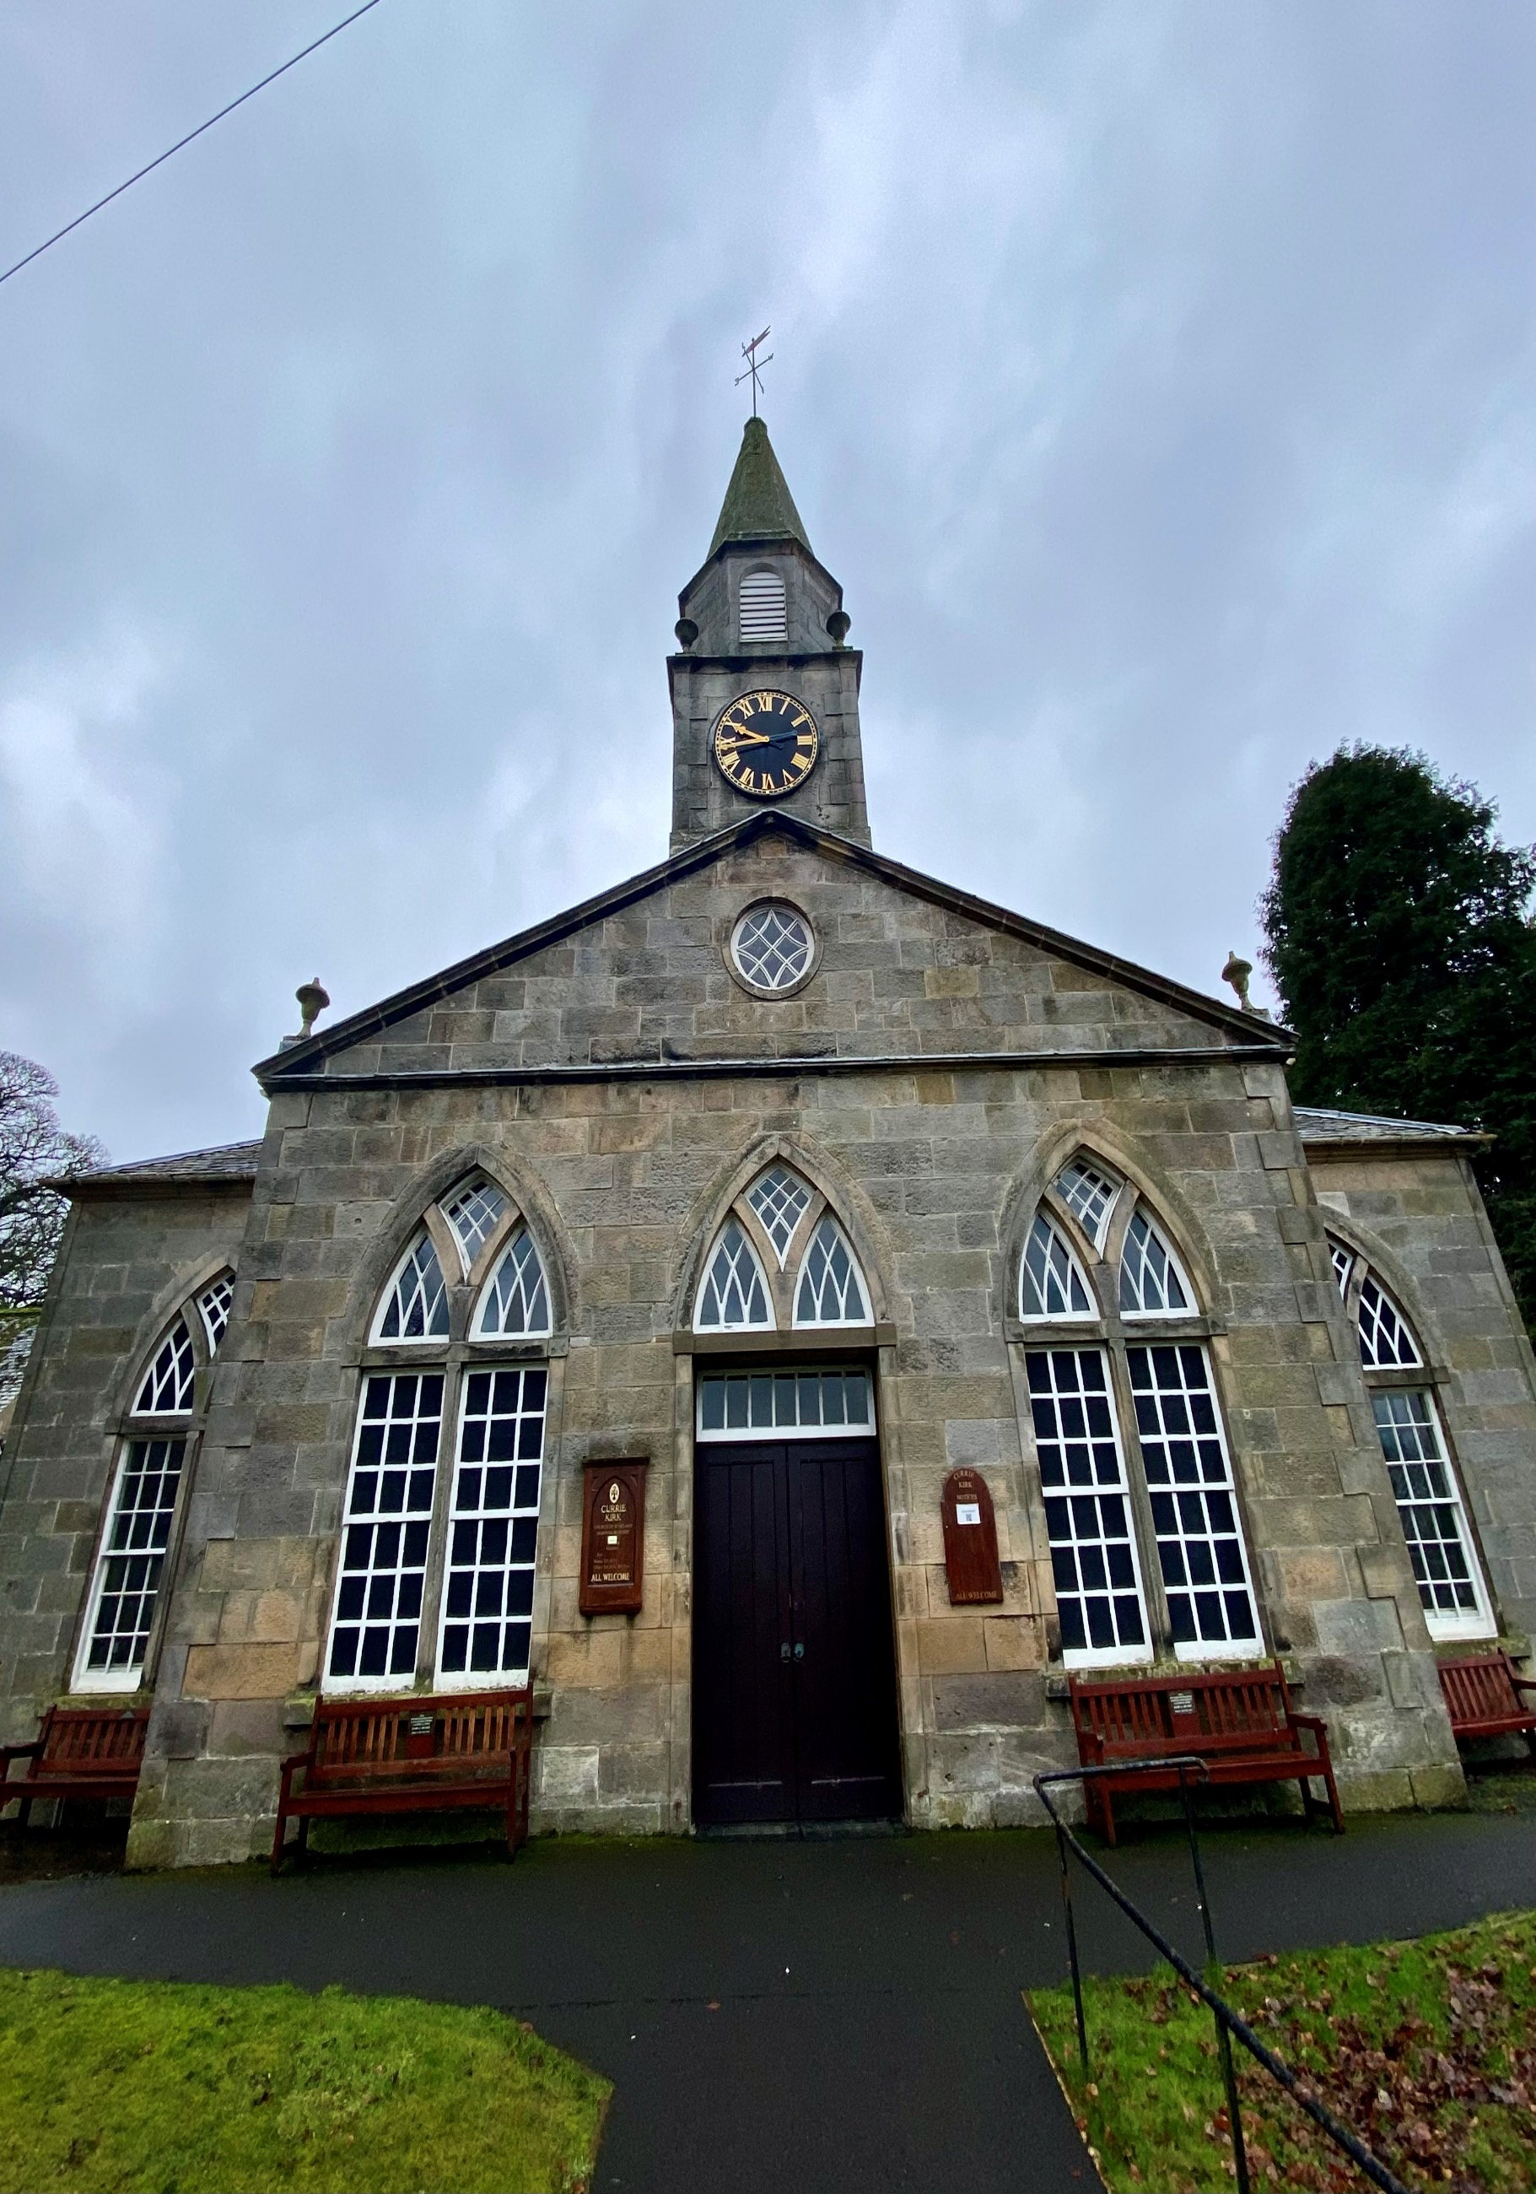


CURRIE KIRKYARD

Version | Author(s) | Comments | Dates
V1.1 | Danielle Gartland-Quinn | Photos by Tam Magee | 24/2/2026

This document will be reviewed on an annual basis. However, a review or revision of any parts can be carried out at any time for service improvements and will be carried out following new legislation or changes to codes of practice.
This document can be viewed by the public during office hours or online.

`

Contents

- Brief history
- Site description
- Site summary
- Asset list
- Grounds maintenance and biodiversity
- Lair types and availability
- Community involvement
- Notable burials and monuments
- Map

- Brief history

Currie Parish Church has served its community for centuries, with the present building dating back to 1784. This structure, designed by James Thomson, was built upon the foundations of a much older church. The original kirkyard surrounds the kirk and acts as a physical record of the people who lived in the area. The grounds contain a vast collection of headstones, with many dating back to the 17th and 18th centuries, among these historic markers is a particularly notable stone carved coffin dated 1751. Although official written records regarding the early burials are limited, the variety of monuments across the grounds shows how the site has served the local community for generations. As the local population grew, the original churchyard eventually became full, a challenge faced by many parishes. To address the need for burial space, the cemetery was extended, allowing the church to continue providing a final resting place for its residents. The site also serves as a place of remembrance for those who dies in the wars, containing several Commonwealth War Graves from both the First and Second World Wars.

- Site description

Currie Kirkyard is a historic burial ground defined by its atmospheric setting on a raised ridge overlooking the Water of Leith. Access to the grounds is primarily through the traditional stone gates at the foot of Kirkgate, with additional pedestrian links connecting the site to the newer cemetery extension to the south. The landscape consists of level, well-maintained grassed areas with mature trees and shrubbery, though the perimeter is marked by a dramatic drop-off and high retaining wall that offers views toward the surrounding hills. An internal stone wall separates the modern cemetery from the historic kirkyard, with a pedestrian opening allowing for seamless movement between the two. The memorials within the kirkyard represent a significant span of Scottish history, ranging from weathered 17th-century markers to more elaborate 19th-century monuments. Unlike the polished granite of the modern cemetery, these older stones are crafted from local sandstone and showcase a rich variety of styles, including upright slabs, flat ledgers, and elevated table tombs. The collection is particularly notable for its traditional folk art, with many stones featuring memento mori imagery such as skulls, crossbones, and hourglasses, alongside symbols of trade and mortality that reflect the heritage of the local parish.

- Site Summary
Name | Currie Cemetery and Kirkyard
Address | Kirkgate Currie
Postcode | EH14 6AL
Ownership | The City of Edinburgh Council
Date site acquired | 1855
Size | 0.68 hectares
Conservation area | Yes
Tree preservation | No
Listing | A
Access | Pedestrian
Opening hours | 24 hours

- Asset List
Asset | Location | Information
Waiting room | No
Toilets | No
CCTV | No
Signage | Cemetery gates | Signs detailing name of the cemetery, cemetery user information, safety signs, church signage
Cabinet signage | Cemetery entrance | Sign welcoming cemetery users, displaying cemetery rules, biodiversity information, other useful information
Car park | No
Disabled parking | No
Taps | No
Litter bins | Yes, throughout site see map
Benches | Yes, throughout site see map
Catacombs | No
War memorials | Yes, throughout site | More information can be found on Commonwealth War Grave Commission webpage.

- Grounds maintenance and biodiversity

The Council has revised its approach to grounds maintenance in response to the current nature emergency. This approach aims to protect and enhance existing biodiversity while encouraging the development of new habitats across the cemetery. This means less frequent grass cutting, no use of weedkiller, introduction of wildflowers, and the encouragement of natural grassland growth.

Routine maintenance activities are outlined below. A complete summary of our ground’s maintenance plans can be found in the Bereavement Services Cemeteries Management Plan.

Routine Maintenance | Frequency | Additional information
Grass cutting | Approx. every 8-10 weeks during appropriate seasons | No grass cutting during No Mow May
Strimming | Approx. every 8-10 weeks during appropriate seasons | No grass cutting during No Mow May
Leaf clearance | When required | Removal from hardstanding areas and pathways only.
Sunken graves | When required
Re-turfing / grass seeding | When required | Method will depend on season
Hedge cutting | Annually | No hedge / shrub work during bird nesting season (March-August)
Emptying bins | When required

A biodiversity study conducted in 2021 identified that Currie Kirkyard already supports a large range of biodiversity, including a variety of trees, grasses, animals, and insects. The council is committed to protecting these existing habitats and encouraging biodiversity across the site. A list of species found in the cemetery in 2021 are detailed below.

Species List | Details
Trees | Beech; cherry; Cypress (including Lawson cypress); holly (including common holly and variegated holly); spruce (including Norway Spruce); sycamore.
Shrubs | Bramble; buddleia; holly, hydrangea; ivy, laurel; rhododendron.
Grasses | Meadow grass (Poa pratensis) and others
Flowers | Creeping buttercup; daisy; dandelion; feverfew; groundsel; heather; primulas; snowdrop; a species of speedwell; white clover
Fungi | Tar spot on fallen leaves. This site may well be rich in fungi in autumn.
Mosses | Bryum capillare, Grimmia pulvinata, Hypnum sp, Marchantia polymorpha (a liverwort), Orthotrichum anomalum, Tortula muralis.
Mammals
Birds | Blue tit; bullfinch; carrion crow; chaffinch; coal tit; jackdaw; magpie, mistle thrush; pied wagtail; robin, woodpigeon.

- Lair type and availability

There are no new lair’s available at Currie Kirkyard, burial can only be arranged in an existing lair.

- Community involvement

There are currently no established Friends Groups for this kirkyard.
Establishing or joining a 'Friends of' group is a meaningful way to contribute to your community while helping us protect these spaces. If you are interested in forming a new group or would like to enquire about future opportunities, please contact Bereavement Services.

- Notable burials and monuments

Currie Kirkyard in Edinburgh contains a wide range of memorials that reflect centuries of local history and varying artistic styles. The Currie War Memorial also known as the Currie Parish Cross, is a prominent landmark located in the historic churchyard, positioned to the left of the main entrance in front of Currie Kirk. In addition to the central memorial cross, Currie Parish Churchyard is the final burial place for seven individual military casualties. Recognised by the Commonwealth War Graves Commission, these graves are separate from the collective memorial and are located throughout the cemetery. More information about the individuals and their memorials can be found on the Commonwealth War Graves Commission’s webpage.

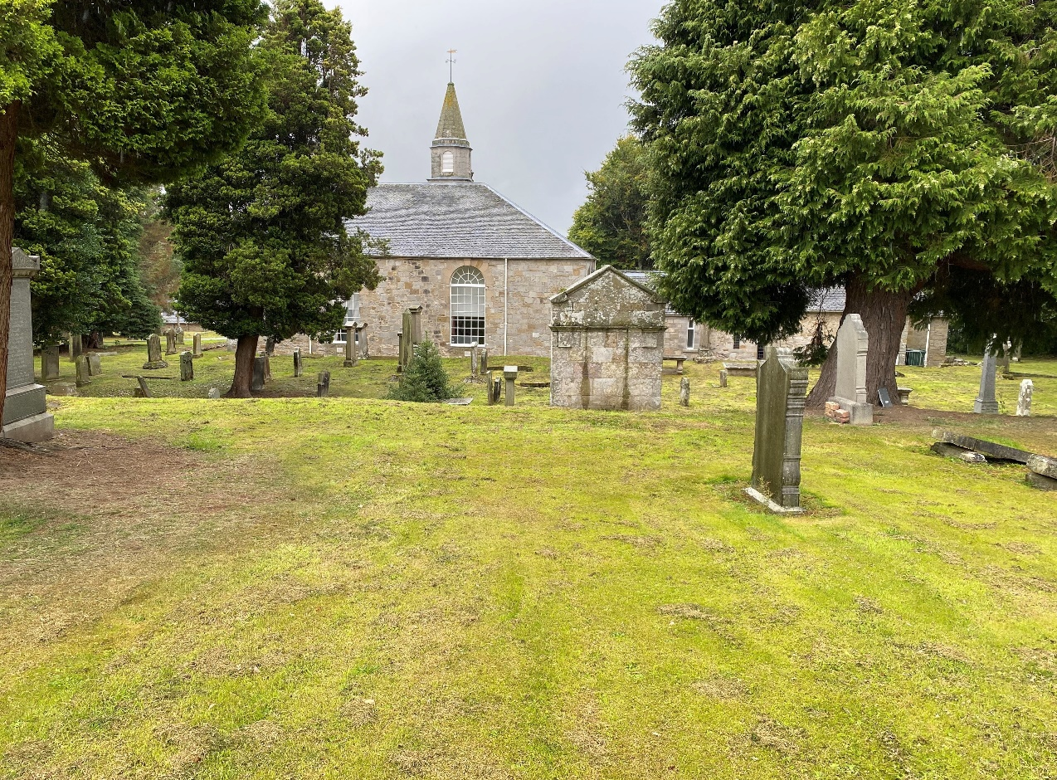

- Map
