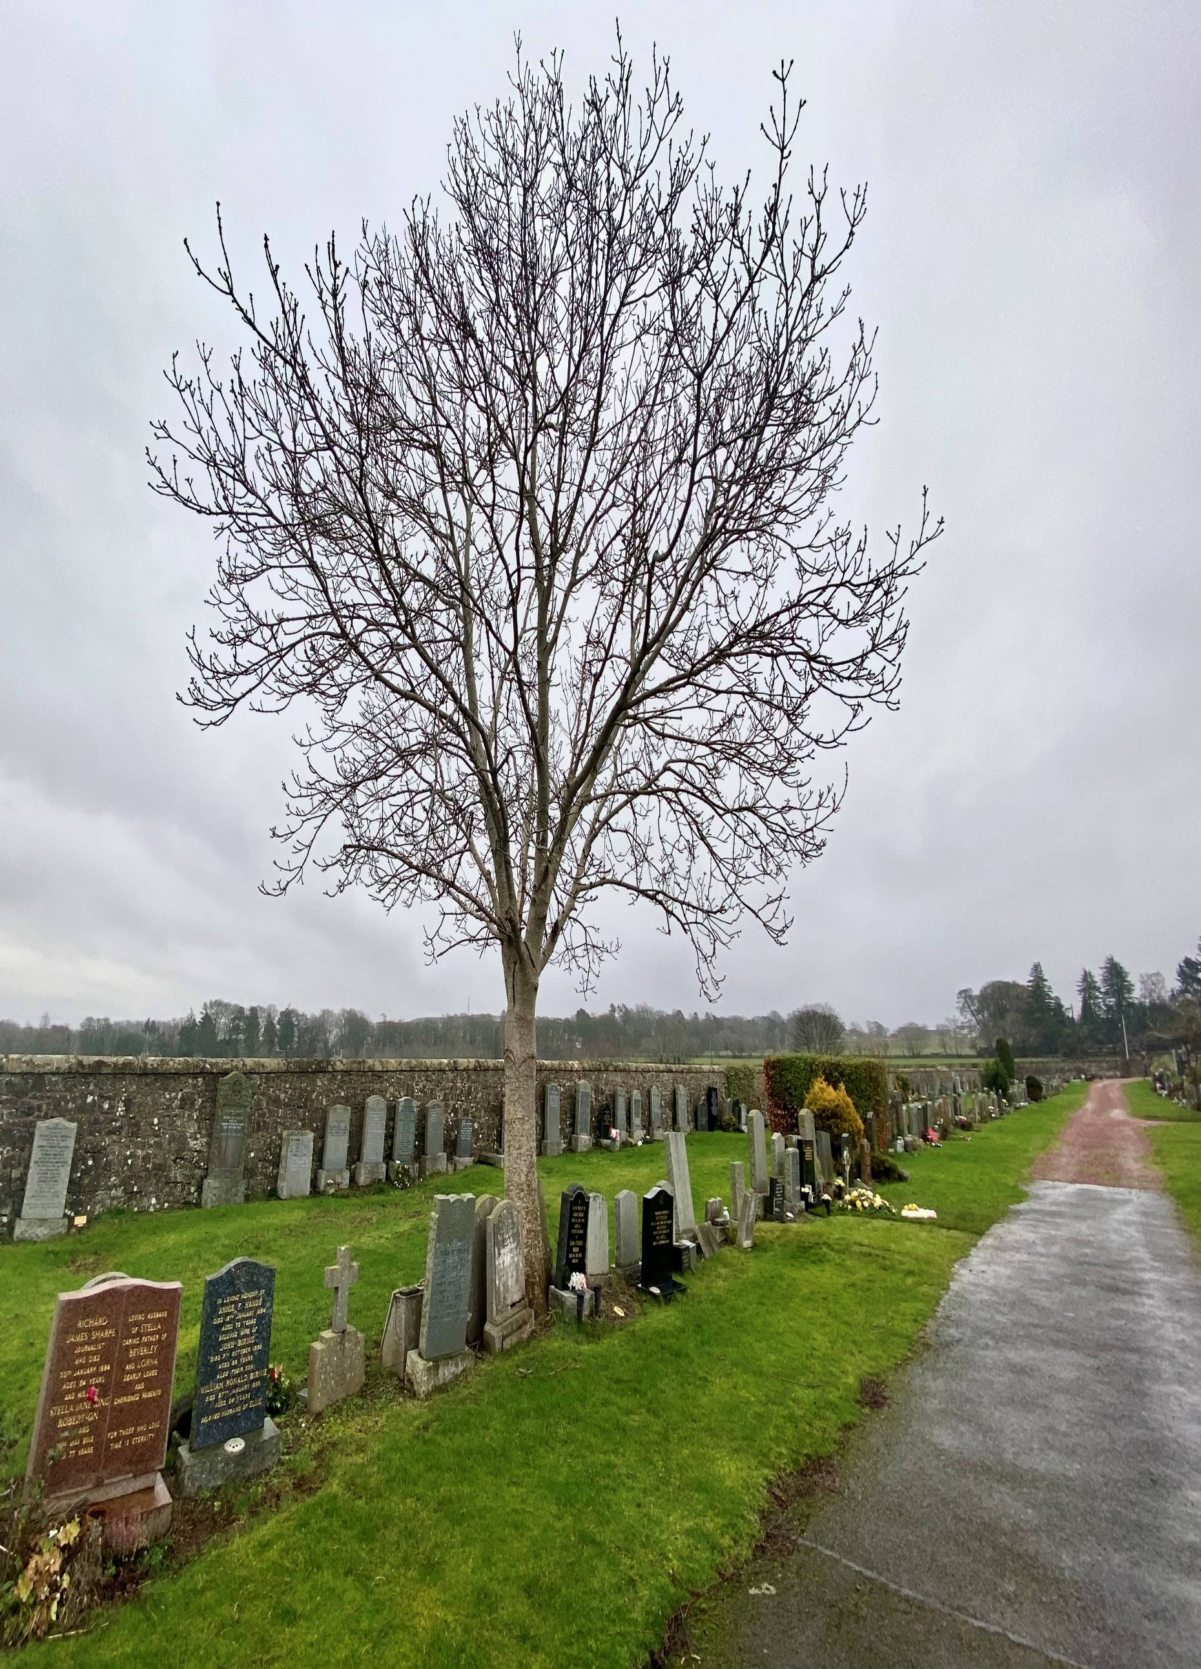


CURRIE CEMETERY

Version | Author(s) | Comments | Dates
V1.1 | Danielle Gartland-Quinn | Photos by Tam Magee | 24/2/2026

This document will be reviewed on an annual basis. However, a review or revision of any parts can be carried out at any time for service improvements and will be carried out following new legislation or changes to codes of practice.
This document can be viewed by the public during office hours or online.

`

Contents

- Brief history
- Site description
- Site summary
- Asset list
- Grounds maintenance and biodiversity
- Lair types and availability
- Community involvement
- Notable burials and monuments
- Map

- Brief history

Currie Cemetery was established as a necessary extension to the original Currie Kirkyard to meet the growing demand for burial space within the parish. While historical records regarding its specific architect or the initial design methods are relatively vague, the site was clearly developed as a well-designed, laid-out, and spacious burial ground. The first burial was conducted on 12 January 1927, marking its formal opening as a secondary place of burial for the local community. The cemetery’s unusual shape is the result of a later extension to the grounds, although specific archival details regarding the dates or planning of this addition remain limited. Despite the lack of formal records, the expansion was integrated into the existing site to maintain a clear and practical layout for visitors. Although the cemetery has now reached its capacity and no new lairs are currently available, it remains important to the community with continued burials in existing family lairs. This ongoing use ensures that the Currie grounds remain an important cemetery.
- Site description

Currie Cemetery is a unique shaped burial ground, offering a peaceful place for reflection with scenic views of the Forth Rail and Road Bridges. The site is primarily surrounded by open farming fields, enhancing its quiet, rural character. It is accessed via three distinct points: two pedestrian gates on Kirkgate and the primary vehicle and pedestrian entrance on Blinkbonny Road, situated at the cemetery's highest point. These main iron gates are set into stone pillars and open onto a red chip driveway that leads immediately to the most recent burial sections. The internal layout is defined by a circular driveway that loops around a central grassed burial section, providing clear access to the surrounding plots. While a traditional stone boundary wall encloses most of the site, a row of cottages on Kirkgate forms the western boundary. An internal stone wall separates the modern cemetery from the historic Currie Kirkyard, with a pedestrian opening allowing for seamless movement between the two. The landscape consists of open grass sections that follow a slight slope descending from the Blinkbonny Road entrance toward the kirk. The landscape is characterised by established shrubbery and hedges but lacks mature trees. The memorials are predominantly of a modern style, varying in size, material, and artistic design, reflecting the cemetery's 20th-century origins. Most recently, a line of modern above-ground burial vaults has been positioned in the middle of the cemetery. This blend of functional design and a quiet, scenic setting ensure the Currie grounds remain a dignified and peaceful place.

- Site Summary
Name | Currie Cemetery and Kirkyard
Address | Kirkgate Currie
Postcode | EH14 6AL
Ownership | The City of Edinburgh Council
Date site acquired | 1855
Size | 0.92 hectares
Conservation area | Yes
Tree preservation | Yes
Listing | A
Access | Vehicle and pedestrian
Opening hours | 24 hours

- Asset List
Asset | Location | Information
Waiting room | No
Toilets | No
CCTV | No
Signage | Cemetery gates | Signs detailing name of the cemetery, cemetery user information, safety signs
Cabinet signage | Cemetery entrance | Sign welcoming cemetery users, displaying cemetery rules, biodiversity information, other useful information
Car park | No
Disabled parking | No
Taps | No
Litter bins | Yes, throughout site see map
Benches | Yes, throughout site see map
Catacombs | No
War memorials | Yes, throughout site | More information can be found on Commonwealth War Grave Commission webpage.

- Grounds maintenance and biodiversity

The Council has revised its approach to grounds maintenance in response to the current nature emergency. This approach aims to protect and enhance existing biodiversity while encouraging the development of new habitats across the cemetery. This means less frequent grass cutting, no use of weedkiller, introduction of wildflowers, and the encouragement of natural grassland growth.

Routine maintenance activities are outlined below. A complete summary of our ground’s maintenance plans can be found in the Bereavement Services Cemeteries Management Plan.

Routine Maintenance | Frequency | Additional information
Grass cutting | Approx. every 8-10 weeks during appropriate seasons | No grass cutting during No Mow May
Strimming | Approx. every 8-10 weeks during appropriate seasons | No grass cutting during No Mow May
Leaf clearance | When required | Removal from hard standing areas and pathways only.
Sunken graves | When required
Re-turfing / grass seeding | When required | Method will depend on season
Hedge cutting | Annually | No hedge / shrub work during bird nesting season (March-August)
Emptying bins | When required

A biodiversity study conducted in 2021 identified that Currie Cemetery already supports a large range of biodiversity, including a variety of trees, grasses, animals, and insects. The council is committed to protecting these existing habitats and encouraging biodiversity across the site. A list of species found in the cemetery in 2021 are detailed below.

Species List | Details
Trees | Ash; cherry; Cypress; hawthorn; rowan
Shrubs | Beech (hedge); cotoneaster; holly, ivy, privet (hedge); rose.
Grasses | Meadow grass (Poa pratensis) and others
Flowers | Creeping buttercup; daisy; dandelion; groundsel; heather; herb robert; lavender; primulas; snowdrop; a species of speedwell; white clover
Fungi | Tar spot on fallen leaves. This site may well be rich in fungi in autumn.
Mosses | Bryum capillare, Grimmia pulvinata, Hypnum sp, Marchantia polymorpha (a liverwort), Orthotrichum anomalum, Tortula muralis.
Mammals
Birds | Blue tit; bullfinch; carrion crow; chaffinch; coal tit; jackdaw; magpie, mistle thrush; pied wagtail; robin, woodpigeon.
Insects

As part of our ongoing biodiversity work, the Council may place nature cameras in the cemetery to monitor the wildlife. Although a cemeteries primary purpose is as a place of remembrance and reflection wildlife are often attracted to cemeteries due to their quiet unchanging environment.

- Lair type and availability

There are no new lair’s available at Currie Cemetery, burial can only be arranged in an existing lair.
Above ground interment vaults are available.

- Community involvement

There is no established Friends Group for Currie Cemetery.
Establishing or joining a 'Friends of' group is a meaningful way to contribute to your community while helping us protect these spaces. If you are interested in forming a new group or would like to enquire about future opportunities, please contact Bereavement Services.

- Notable burials and monuments

Reflecting the changing trends in commemoration, the memorials here range from simple, classic markers to more elaborate custom designs. Throughout the cemetery, the transition to modern granite is evident; these durable, polished stones have become the standard material, offering a spectrum of colours that mark the site’s 20th and 21st-century heritage.
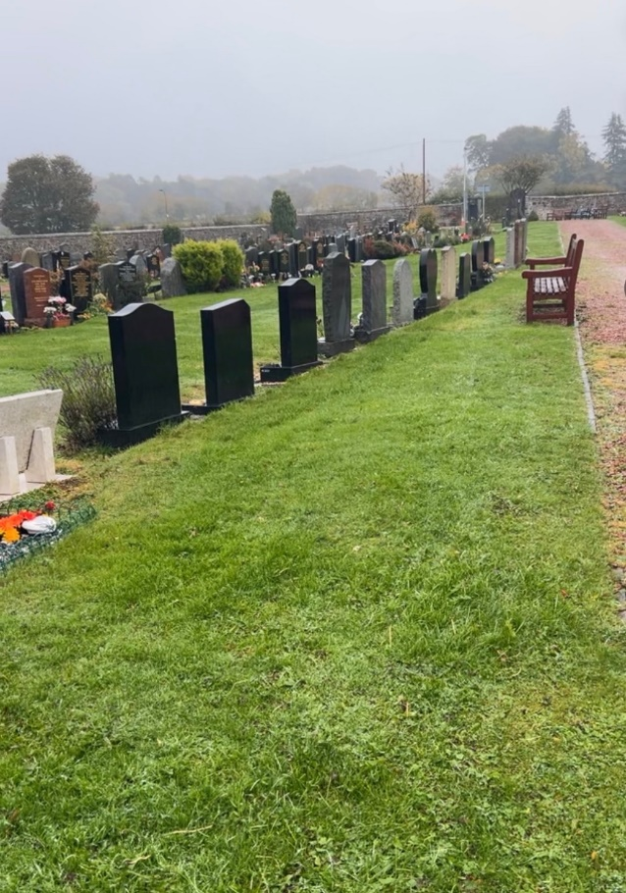

- Map
