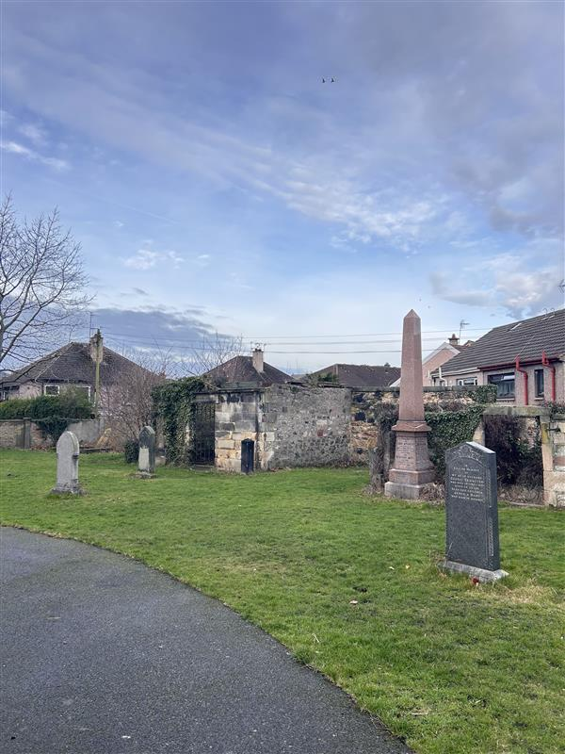

RESTALRIG CHURCHYARD



Version | Author(s) | Comments | Dates
V1.1 | Danielle Gartland-Quinn | Photos by Tam Magee | 25/2/2026

This document will be reviewed on an annual basis. However, a review or revision of any parts can be carried out at any time for service improvements and will be carried out following new legislation or changes to codes of practice.
This document can be viewed by the public during office hours or online.

`

Contents

- Brief history
- Site description
- Site summary
- Asset list
- Grounds maintenance and biodiversity
- Lair types and availability
- Community involvement
- Notable burials and monuments
- Map

- Brief history

Restalrig Parish Church (St Triduana’s) has been a site of profound historical and religious significance. It became a major centre of pilgrimage due to the shrine of St Triduana, a legendary saint associated with the healing of eyesight. The church was partially restored in the 19th century and fully rebuilt in the early 20th century. The surrounding churchyard serves as an extensive record of the area's history, though official records for the earliest periods are limited. The grounds feature numerous 17th and 18th-century memorials, including classical headstones and table tombs. Among the most remarkable features within the grounds is the St Triduana’s Aisle, a rare and beautiful hexagonal chapel dating back to the late 15th century. Originally built as a royal chapel for King James III, it later served as a burial vault for the Logan family. Attached to an incomplete 17th-century gateway in the southeast boundary wall is a pair of jougs, an iron neck collar formerly used for public punishment.

- Site description

Access to Restalrig Churchyard is available via Restalrig Road South, with the main entrance featuring large double iron gates set into stone pillars. This entrance opens onto a tarmac pathway that serves as the primary route through the grounds, leading directly to the church building and the historic St Triduana’s Chapel. Upon entering through the main gates, burial sections are immediately visible, while the boundary to the right is formed by private property. The central tarmac path continues through the cemetery with burial sections situated on either side. While the main path provides clear navigation, there are no formal pathways between the individual burial rows. These sections consist of open grass and flat ground, which are well-maintained and includes mature trees and shrubbery that add to the site's peaceful atmosphere. The churchyard is securely enclosed by stone walls of varying heights, with the rear of neighbouring properties forming part of the perimeter in some areas. The grounds house a diverse range of memorial styles, reflecting the long history of the parish. These include grand tombs, historic table tombs, and traditional headstones, all of which are easily accessible across the open lawn areas.

- Site Summary
Name | Restalrig Churchyard
Address | 27 Restalrig Road South Edinburgh
Postcode | EH7 6LF
Ownership | The City of Edinburgh Council
Date site acquired | 1855
Size | 0.4 hectares
Conservation area | Yes
Tree preservation | No
Listing | A
Access | Pedestrian
Opening hours | 24 hours

- Asset List
Asset | Location | Information
Waiting room | No
Toilets | No
CCTV | No
Signage | Cemetery gates | Signs detailing name of the cemetery, cemetery user information, safety signs, signage by St Triduana’s chapel
Cabinet signage | Cemetery entrance | Sign welcoming cemetery users, displaying cemetery rules, biodiversity information, other useful information
Car park | No
Disabled parking | No
Taps | No
Litter bins | No
Benches | No
Catacombs | No
War memorials | Yes | More information can be found on the Commonwealth War Graves Commission webpage.

- Grounds maintenance and biodiversity

The Council has revised its approach to grounds maintenance in response to the current nature emergency. This approach aims to protect and enhance existing biodiversity while encouraging the development of new habitats across the cemetery. This means less frequent grass cutting, no use of weedkiller, introduction of wildflowers, and the encouragement of natural grassland growth.

Routine maintenance activities are outlined below. A complete summary of our ground’s maintenance plans can be found in the Bereavement Services Cemeteries Management Plan.

Routine Maintenance | Frequency | Additional information
Grass cutting | Approx. every 10-12 weeks during appropriate seasons | No grass cutting during No Mow May
Strimming | Approx. every 10-12 weeks during appropriate seasons | No grass cutting during No Mow May
Leaf clearance | When required | Clearance from hard standing areas only
Sunken graves | When required
Re-turfing / grass seeding | When required | Method will depend on season

A biodiversity study conducted in 2021 identified that Restalrig Churchyard already supports a large range of biodiversity, including a variety of trees, grasses, animals, and insects. The council is committed to protecting these existing habitats and encouraging biodiversity across the site. A list of species found in the cemetery in 2021 are detailed below.

Species List | Details
Trees | Apple, ash, cherry, field maple, laburnum, oak, red oak, rowan, sycamore, yew
Shrubs | Buddleia, cotoneaster, hydrangea, ivy, laurel, rose
Flowers | Broad leaved willowherb, creeping buttercup, daisy, dandelion, dove's foot cranesbill, groundsel, herb robert, primrose, ribwort plantain, rosebay willowherb, smooth sowthistle, a species of speedwell, yarrow. Plus garden flowers and shrubs.
Mosses | Bryum capillare, Grimmia pulvinata, Hypnum sp, Orthotrichum anomalum, Tortula muralis.
Fungi | Turkey tail
Birds | Carrion crow, herring gull, jackdaw, magpie
Grasses | Meadow grass (Poa pratensis) and others

- Lair type and availability

There are no new lairs available.

- Community involvement

There are no established Friends Group for this cemetery.
Establishing or joining a 'Friends of' group is a meaningful way to contribute to your community while helping us protect these spaces. If you are interested in forming a new group or would like to enquire about future opportunities, please contact Bereavement Services.

- Notable burials and monuments

The most prominent monument on site is St Triduana’s Chapel, dedicated to the 4th-century Pictish saint who, according to legend, blinded herself to repel the unwanted advances of a king. During the Middle Ages, her shrine became a renowned pilgrimage site for those seeking cures for blindness and eye ailments. Nearby, the churchyard contains several ancient headstones featuring weathered 'memento mori' carvings of skulls and crossbones, many of which have seen their inscriptions completely erased by time.
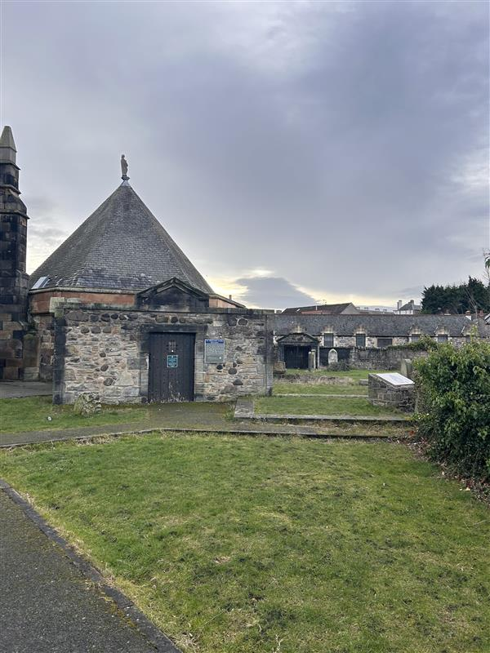

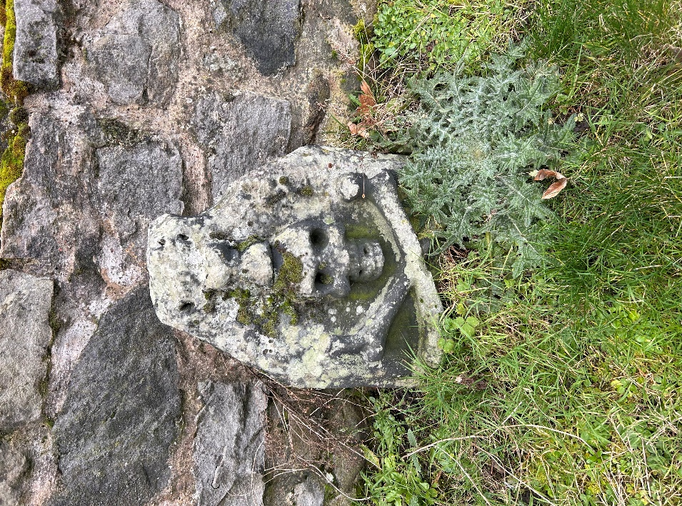

- Map
