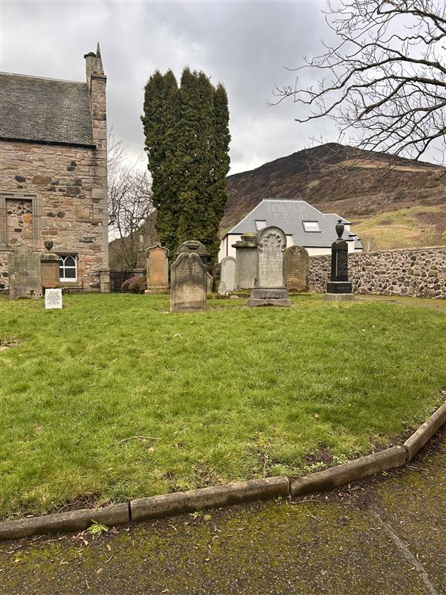


DUDDINGSTON KIRKYARD

Version | Author(s) | Comments | Dates
V1.1 | Danielle Gartland-Quinn | Photos by Tam Magee | 24/2/2026

This document will be reviewed on an annual basis. However, a review or revision of any parts can be carried out at any time for service improvements and will be carried out following new legislation or changes to codes of practice.
This document can be viewed by the public during office hours or online.

`

Contents

- Brief history
- Site description
- Site summary
- Asset list
- Grounds maintenance
- Lair types and availability
- Community involvement
- Notable burials and monuments
- Map

- Brief history

Located on the southeast slope of Arthur's Seat, Duddingston Kirk is a historic landmark whose architecture dates the original structure back to the 12th century. As one of the oldest churches still in active use in the east of Scotland, the building has been developed and rebuilt across the centuries. A significant feature of the grounds is the octagonal gatehouse, which was added in 1824 and designed by the architect Robert Brown. This structure was purposefully built and used as a watch tower during the early 19th century. During this period, relatives and church elders would guard recent graves for a period of three weeks to deter body snatchers, which was a common threat at the time. The kirkyard surrounds the kirk, though official records regarding its earliest origins are limited, making it difficult to confirm exactly when the site was first established as a burial ground. Despite this, physical evidence remains in the form of headstone inscriptions dating back to the early 18th century, while formal burial records for the site officially began in 1855.

- Site description

Accessed via black iron gates set into a traditional stone wall on Old Chapel Lane, the Duddingston Kirkyard is a modest-sized and well-maintained burial ground that surrounds the kirk. To the left of the entrance stands the historic octagonal gatehouse. Situated on the south-eastern slope of Arthur’s Seat, the cemetery itself remains notably flat and level despite its hillside location, offering a scenic view toward Duddingston Loch. Upon entering through the gates, a modern tarmac path winds around the kirk, providing clear access to the burial sections. The grounds are enclosed by a mix of traditional stone walls and iron railings, with the lawn featuring a dense collection of prominent tombs and headstones. These markers vary in age and artistic style, ranging from ornate table tombs to modern granite memorials. The site is softened by mature trees and self-sown wildflowers, creating a secluded, atmospheric space that feels removed from the surrounding city.

- Site Summary
Name | Duddingston Kirkyard
Address | 9 Old Church Lane Edinburgh
Postcode | EH15 3PX
Ownership | The City of Edinburgh Council
Date site acquired | 1855
Size | 0.18 hectares
Conservation area | Yes
Tree preservation | No
Listing | A
Access | Pedestrian
Opening hours | 24 hours

- Asset List
Asset | Location | Information
Waiting room | No
Toilets | No
CCTV | No
Signage | Cemetery gates | Signs detailing name of the cemetery, cemetery user information, safety signs
Cabinet signage | Cemetery entrance | Sign welcoming cemetery users, displaying cemetery rules, biodiversity information, other useful information
Car park | No
Disabled parking | No
Taps | No
Litter bins | No
Benches | No
Catacombs | No
War memorials | Yes | More information can be found on Commonwealth War Grave Commission webpage.

- Grounds maintenance and biodiversity

The Council has revised its approach to grounds maintenance in response to the current nature emergency. This approach aims to protect and enhance existing biodiversity while encouraging the development of new habitats across the cemetery. This means less frequent grass cutting, no use of weedkiller, introduction of wildflowers, and the encouragement of natural grassland growth.

Routine maintenance activities are outlined below. A complete summary of our ground’s maintenance plans can be found in the Bereavement Services Cemeteries Management Plan.

Routine Maintenance | Frequency | Additional information
Grass cutting | Approx. every 10-12 weeks during appropriate seasons | No grass cutting during No Mow May
Strimming | Approx. every 10-12 weeks during appropriate seasons | No grass cutting during No Mow May
Leaf clearance | When required | Clearance from hard standing areas only
Sunken graves | When required
Re-turfing / grass seeding | When required | Method will depend on season

A biodiversity study conducted in 2021 identified that Duddingston Kirkyard already supports a large range of biodiversity, including a variety of trees, grasses, animals, and insects. The council is committed to protecting these existing habitats and encouraging biodiversity across the site. A list of species found in the cemetery in 2021 are detailed below.

Species List | Details
Trees | Cypress, elm, whitebeam
Shrubs | Bramble, cotoneaster, ivy, rose
Flowers | Broad leaved willowherb, cleavers, creeping buttercup, daisy, dandelion, groundsel, heathers, herb robert, prickly sow thistle, ribwort plantain, rosebay willowherb, wild strawberry. Plus garden plants
Fungi
Mosses | Bryum capillare, Grimmia pulvinata, Hypnum sp, Tortula muralis
Birds | Blue tit, carrion crow, herring gull, jackdaw, robin, woodpigeon
Grasses | Meadow grass (Poa pratensis) and others

- Lair type and availability

There are no new lairs available.

- Community involvement

There are no established Friends Group for this cemetery.
Establishing or joining a 'Friends of' group is a meaningful way to contribute to your community while helping us protect these spaces. If you are interested in forming a new group or would like to enquire about future opportunities, please contact Bereavement Services.

- Notable burials and monuments

Lt. Col. William Henry Dick-Cunyngham VC (1851–1900), a recipient of the Victoria Cross for his bravery during the Second Afghan War. He was mortally wounded during the Siege of Ladysmith in the Second Boer War. His memorial is located on the north wall of the kirkyard.

The churchyard holds a diverse range of memorials. These vary from contemporary granite obelisks, stone table tombs, and family tombs. Another notable item at the kirkyard is the jougs on the outside of the kirkyard wall, used from 16th to 18th centuries as a form public punishment.

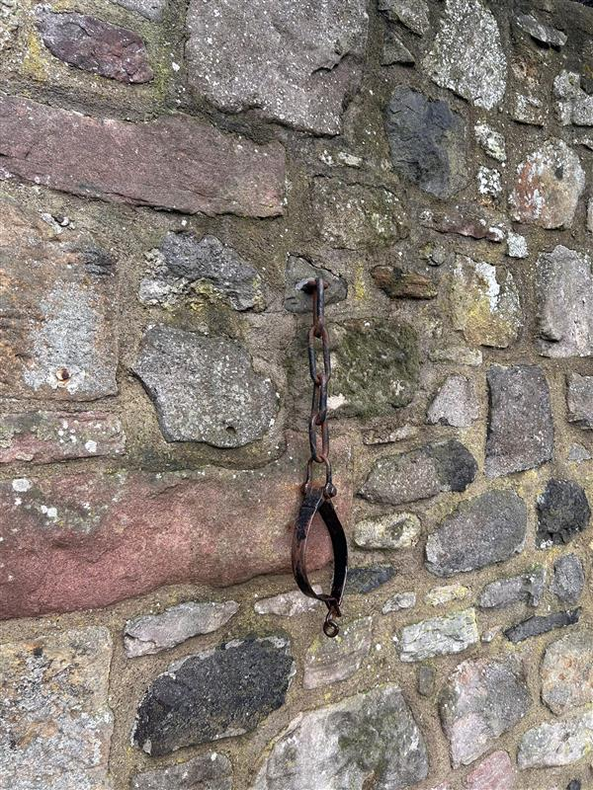
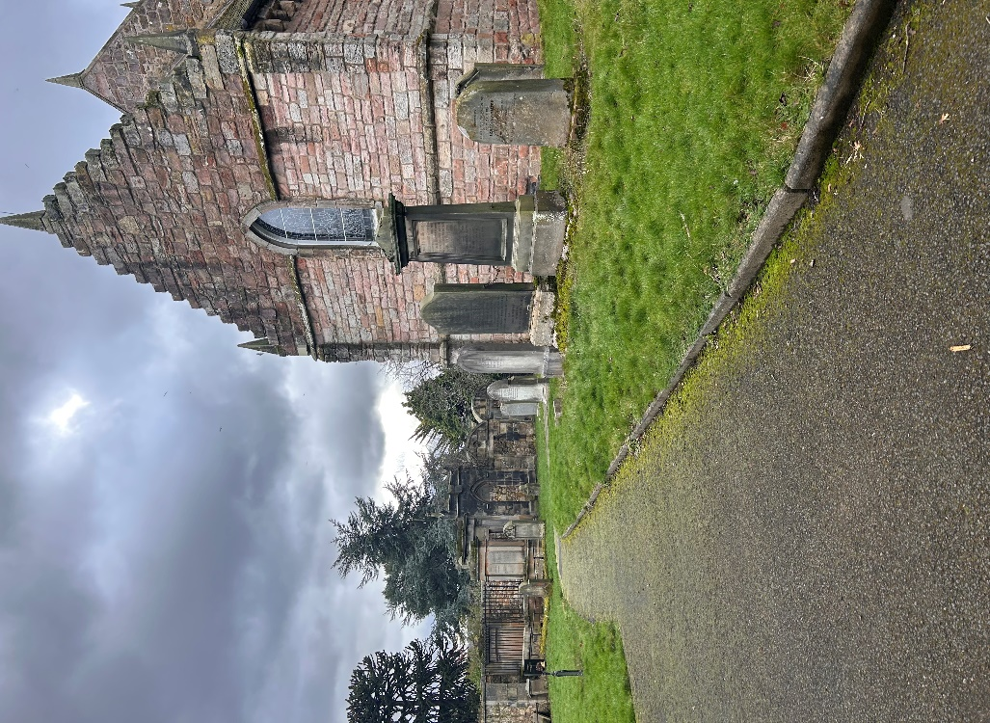

- Map
