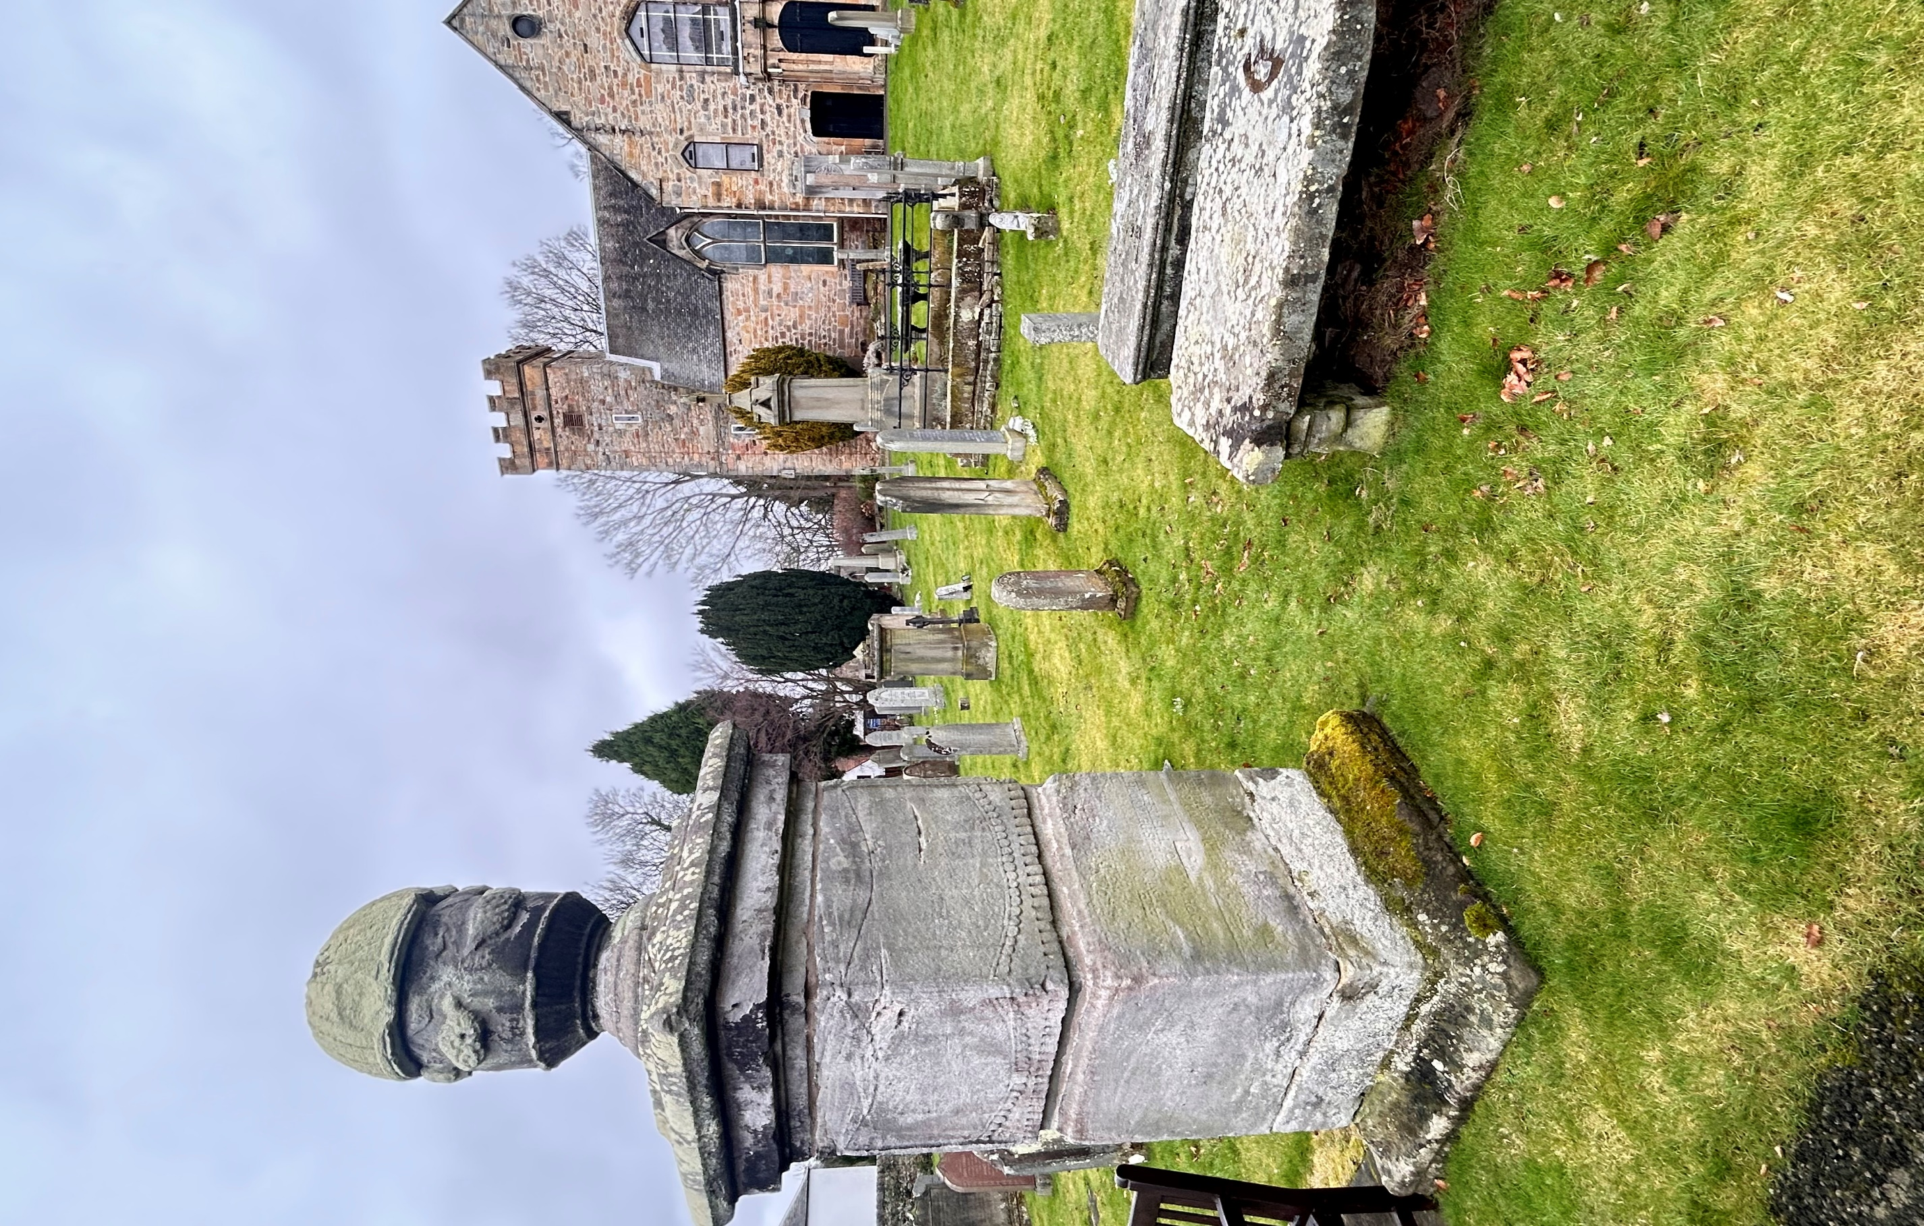


CRAMOND KIRKYARD

Version | Author(s) | Comments | Dates
V1.1 | Danielle Gartland-Quinn | Tam Magee | 24/2/2026

This document will be reviewed on an annual basis. However, a review or revision of any parts can be carried out at any time for service improvements and will be carried out following new legislation or changes to codes of practice.
This document can be viewed by the public during office hours or online.

Contents

- Brief history
- Site description
- Site summary
- Asset list
- Grounds maintenance and biodiversity
- Lair types and availability
- Community involvement
- Map
- Brief history
Built on the site of an ancient Roman Fort, Cramond Kirk has been a central part of the community for centuries. The building has seen several major structural changes to keep up with the needs of the parish, including a significant remodelling in 1828 by the Edinburgh architect William Burn. This was followed by further work in 1851 by the renowned David Bryce. A notable modern addition is the "little gatehouse," which was designed by the celebrated architect Sir Basil Spence while he was still a student. The surrounding kirkyard provides a physical record of the area's history, featuring a wide range of memorials dating from the 17th century onwards. Although official written records for the kirkyard are limited, the variety of monuments across the grounds shows how the site has served the local community for generations.
- Site description
Access to Cramond Kirkyard is available via two points: the main entrance on Cramond Glebe Road, featuring a pedestrian iron gate set in stone pillars, and a second pedestrian access point through Cramond Kirk Hall on Kirk Cramond. Entering from Cramond Glebe Road leads onto a modern footpath with the "little gatehouse" situated to the right, where paths branch off toward the kirk and the surrounding burial sections. Open lawn burial areas are immediately visible, encircling both sides and the front of the kirk building. The grounds are well-maintained and predominantly flat, with a slight uphill incline to reach the kirk and burial sections. The entrance from Cramond Kirk Hall consists of a modern stone path that uniquely passes by the Severan Roman Fort before leading into the open cemetery areas. This section of the graveyard feels open and airy, as there are limited established trees within the boundary, which is defined by stone walls of varying heights. The memorials throughout the site reflect a wide range of history, varying greatly in age, design, and material. While many historic headstones are scattered across the lawns, there are also newer shared memorials placed against the boundary wall. This mixture of old and new styles showcases how the site serves as a functional and historic space for the community.
- Site Summary
Name | Cramond Kirkyard
Address | Glebe Road Edinburgh
Postcode | EH4 6NS
Ownership | The City of Edinburgh Council
Date site acquired | 1855
Size | 0.44 hectares
Conservation area | Yes
Tree preservation | No
Listing | A
Access | Pedestrian
Opening hours | 24 hours

- Asset List
Asset | Location | Information
Waiting room | No
Toilets | No
CCTV | No
Signage | Cemetery gates | Signs detailing name of the cemetery, cemetery user information, safety signs, church signage
Cabinet signage | Cemetery entrance | Sign welcoming cemetery users, displaying cemetery rules, biodiversity information, other useful information
Car park | No
Disabled parking | No
Taps | No
Litter bins | Yes, throughout site see map
Benches | Yes, throughout site see map
Catacombs | Yes, middle of cemetery
War memorials | Yes, throughout site | More information can be found on Commonwealth War Grave Commission webpage.

- Grounds maintenance and biodiversity

The Council has revised its approach to grounds maintenance in response to the current nature emergency. This approach aims to protect and enhance existing biodiversity while encouraging the development of new habitats across the cemetery. This means less frequent grass cutting, no use of weedkiller, introduction of wildflowers, and the encouragement of natural grassland growth.

Routine maintenance activities are outlined below. A complete summary of our ground’s maintenance plans can be found in the Bereavement Services Cemeteries Management Plan.

Routine Maintenance | Frequency | Additional information
Grass cutting | Approx. every 10-12 weeks during appropriate seasons | No grass cutting during No Mow May
Strimming | Approx. every 10-12 weeks during appropriate seasons | No grass cutting during No Mow May
Leaf clearance | When required | Removal from hard standing areas and pathways only.
Sunken graves | When required
Re-turfing / grass seeding | When required | Method will depend on season
Hedge cutting | Not required
Emptying bins | When required

A biodiversity study conducted in 2021 identified that Cramond Kirkyard already supports a large range of biodiversity, including a variety of trees, grasses, animals, and insects. The council is committed to protecting these existing habitats and encouraging biodiversity across the site. A list of species found in the cemetery in 2021 are detailed below.

Species List | Details
Trees | Common beech, cypress, Highclere holly, Japanese maple, yew
Shrubs | Bramble, buddleia, cotoneaster, forsythia, holly, honesty, hydrangea, hypericum, ivy, laurel, rose
Grasses | Meadow grass (Poa pratensis) and others.
Flowers | Broad leaved willowherb, creeping buttercup, daisy, groundsel, heather, ivy leaved toadflax, rosebay willowherb, snowdrop, winter aconite. Also garden flowers including primulas.
Fungi | Tar spot on sycamore leaves (this fungus does not damage the trees) and others.
Mosses | Anomolous bristle moss (Orthotrichum anomolum). Capillary thread moss (Bryum capillare), Grimmia pulvinata, Hypnum sp, Marchantia polymorpha (a liverwort).
Mammals | Grey squirrel, a species of vole.
Birds | Blackbird, blue tit, buzzard, carrion crow, great tit, grey wagtail, herring gull, jackdaw, long tailed tit, robin.
Insects | Hawthorn shield bug, a wood gnat (Sylvicola sp

- Lair type and availability

There are no new lair’s available at Cramond Kirkyard, burial can only be arranged in an existing lair.

- Community involvement

There are currently no established Friends of Cramond Kirkyard.
Establishing or joining a 'Friends of' group is a meaningful way to contribute to your community while helping us protect these spaces. If you are interested in forming a new group or would like to enquire about future opportunities, please contact Bereavement Services.

- Map
