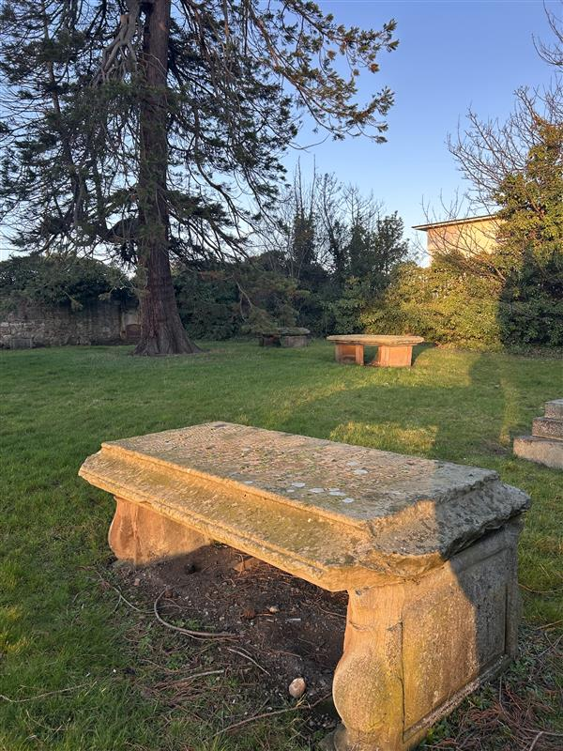


WAUCHOPE BURIAL GROUND

Version | Author(s) | Comments | Dates
V1.1 | Danielle Gartland-Quinn | Photos by Tam Magee | 25/2/2026

This document will be reviewed on an annual basis. However, a review or revision of any parts can be carried out at any time for service improvements and will be carried out following new legislation or changes to codes of practice.
This document can be viewed by the public during office hours or online.

`

Contents

- Brief history
- Site description
- Site summary
- Asset list
- Grounds maintenance
- Lair types and availability
- Community involvement
- Notable burials and monuments
- Map

- Brief history

Originally part of the expansive private estate owned by the Wauchope family, the area of Niddrie was once defined by a grand manor house and its accompanying grounds. This historic estate featured a private family burial ground and a dedicated mausoleum for the Wauchope lineage. Following the death of Lady Jane Wauchope, who died with no heirs, the land was acquired by the council through a combination of donation and purchase. While most of the former estate has since been developed into residential housing, the cemetery remains as a preserved landmark containing the graves of the Wauchope family members and members from the local community. Because the site is now situated within this built-up residential area, the management of the mausoleum falls under the jurisdiction of housing services, rather than the cemetery management team.

- Site description

Wauchope Cemetery is a small site accessed through modern black iron gates on Greendykes Road. The grounds are fully enclosed by a combination of traditional stone walls and modern iron fencing, creating a sense of boundary within the surrounding development. Inside, the burial ground is a flat lawn with no formal roadways or paths, the boundary of the burial ground is raised, including a small stone wall. A small number of headstones in varying sizes and styles are dotted across the site without a specific order of placement. The perimeter is lined with mature trees and shrubbery, which give the area a secluded and private atmosphere despite its location. With several established trees also growing within the lawn area, the cemetery remains a quiet, green space dedicated to the memory of the Wauchope family.

- Site Summary
Name | Wauchope Burial Ground
Address | 162 Greendykes Road Edinburgh
Postcode | EH16 4ES
Ownership | The City of Edinburgh Council
Date site acquired | 1951
Size | 0.14 hectares
Conservation area | No
Tree preservation | No
Listing | None
Access | Pedestrian
Opening hours | By appointment

- Asset List
Asset | Location | Information
Waiting room | No
Toilets | No
CCTV | No
Signage | Cemetery gates | Signs detailing name of the cemetery, cemetery user information, safety signs
Cabinet signage | Cemetery entrance | Sign welcoming cemetery users, displaying cemetery rules, biodiversity information, other useful information
Car park | No
Disabled parking | No
Taps | No
Litter bins | No
Benches | No
Catacombs | No
War memorials | Yes | More information can be found on Commonwealth War Grave Commission webpage.

- Grounds maintenance

The Council has revised its approach to grounds maintenance in response to the current nature emergency. This approach aims to protect and enhance existing biodiversity while encouraging the development of new habitats across the cemetery. This means less frequent grass cutting, no use of weedkiller, introduction of wildflowers, and the encouragement of natural grassland growth.

Routine maintenance activities are outlined below. A complete summary of our ground’s maintenance plans can be found in the Bereavement Services Cemeteries Management Plan.

Routine Maintenance | Frequency | Additional information
Grass cutting | Approx. every 10-12 weeks during appropriate seasons | No grass cutting during No Mow May
Strimming | Approx. every 10-12 weeks during appropriate seasons | No grass cutting during No Mow May
Leaf clearance | When required | Removal from hard standing areas and pathways only.
Sunken graves | When required
Re-turfing / grass seeding | When required | Method will depend on season

- Lair type and availability

There are no new lair’s available at Wauchope Burial Ground.

- Community involvement

There are no established Friends Groups for Wauchope Burial Ground.
Establishing or joining a 'Friends of' group is a meaningful way to contribute to your community while helping us protect these spaces. If you are interested in forming a new group or would like to enquire about future opportunities, please contact Bereavement Services.

- Notable burials and monuments

While memorials are few at Wauchope Burial Ground, they reflect the close-knit history of the area. Alongside members of the Wauchope family, there are headstones for local residents who lived and worked on the grounds. Two of the most prominent memorials include:
- Major General Andrew Gilbert Wauchope: a celebrated commander of the Black Watch and Laird of Niddrie, who became a national figure after his death leading the Highland Brigade during the Boer War.
- Pte. Charles Egan: a musician with the Black Watch whose presence in this private burial ground highlights the deep bond and mutual respect between the Wauchope family and those who served alongside them.
Together, these graves tell the story of a shared military legacy and a dedicated local community.

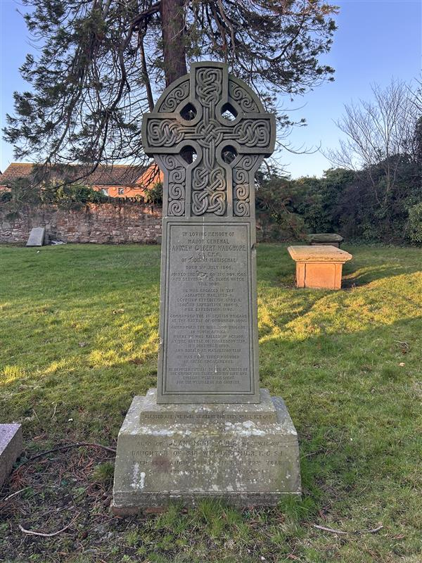

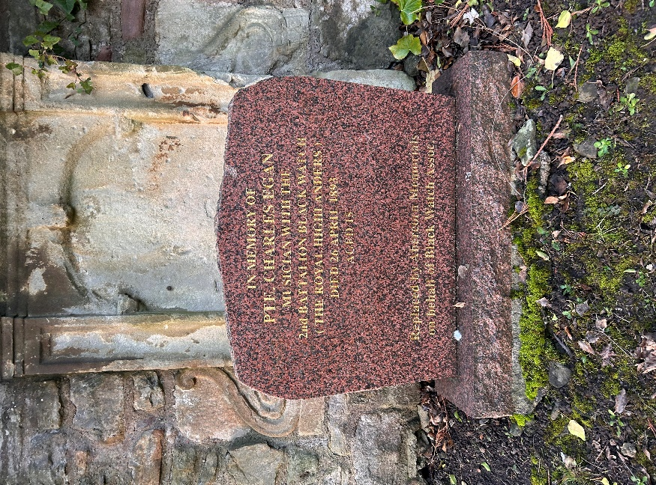

- Map

