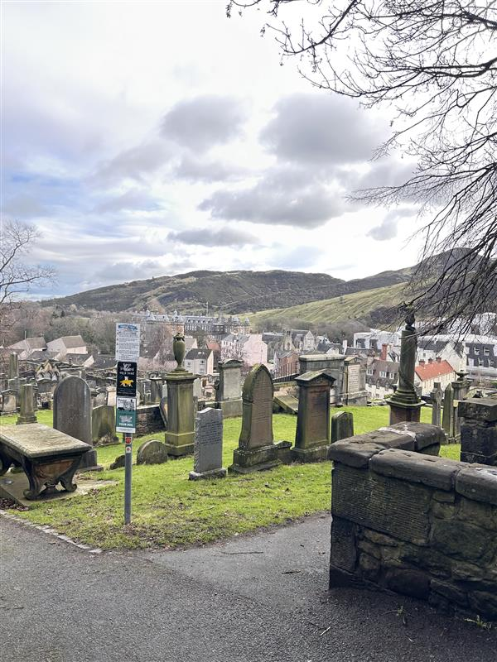


NEW CALTON BURIAL GROUND

Version | Author(s) | Comments | Dates
V1.1 | Danielle Gartland-Quinn | Photos by Tam Magee | 25/2/2026

This document will be reviewed on an annual basis. However, a review or revision of any parts can be carried out at any time for service improvements and will be carried out following new legislation or changes to codes of practice.
This document can be viewed by the public during office hours or online.

`

Contents

- Brief history
- Site description
- Site summary
- Asset list
- Grounds maintenance and biodiversity
- Lair types and availability
- Community involvement
- Notable burials and monuments
- Map

- Brief history

The creation of the New Calton Burial Ground was primarily driven by the ambitious urban engineering of the early 19th century. When the construction of Waterloo Place cut directly through the original Old Calton Burial Ground, the city was faced with the immediate need to re-inter the affected remains. This unusual exercise took place between 1817 and 1820, during which bodies were carefully identified and moved alongside their original headstones. As a result, several monuments within the grounds predate the cemetery’s establishment, serving as authentic markers for those whose rest was disturbed by the city's expansion. The site was designed by Thomas Bonnar, with the layout later refined and completed by Thomas Brown. Far exceeding the size of the original graveyard, the new grounds were intentionally spacious to accommodate the rapidly rising mortality rates associated with Edinburgh’s growth. By providing a more open and convenient alternative to the cramped city-centre kirkyards, the New Calton Burial Ground became a vital part of the city’s landscape, bridging the gap between the historic necessity of the past and the logistical demands of a burgeoning 19th-century capital.

- Site description

New Calton Burial Ground is accessible via two distinct entry points: the primary entrance on Regent Road and a lower entrance on Calton Road. Both entrances are marked by traditional iron gates, and the entire site is secured by an enclosure of stone walls that vary in height, with some sections rising quite tall to frame the landscape. From the Regent Road entrance, the ground slopes down toward the gates, revealing a cemetery divided into three distinct tiers. Immediately upon entering from the top, visitors are met by a prominent watchtower on the right-hand side. Constructed in the 1820s, this tower served as a vital security measure to deter "body snatchers". The internal layout is defined by a network of modern-style tarmac pathways that provide clear access across the sloping landscape. Two of these paths run directly across the cemetery, while another two cut through the centre, with one extending all the way down to the Calton Road exit. Navigating the steep hillside is made possible by several sets of stone steps located throughout the site and pathways, which allow visitors to move between the different tiers and access the various burial sections. These routes are occasionally bordered by small stone-walled sections, creating a sense of formal structure among a vast array of memorials. The grounds feature a diverse collection of monuments that vary significantly in size, material, and style, ranging from modest, weathered headstones to grand, ornate tombs. Perhaps the most striking feature of the burial ground is its dramatic elevation, which affords magnificent, unobstructed views up to Arthur’s Seat and across to Holyrood Palace. This combination of varied architectural styles, the tiered landscape, and its picturesque hillside setting makes the New Calton Burial Ground one of the most scenic and historically significant sites in the city. A virtual tour of the cemetery can be viewed here.

- Site Summary
Name | New Calton Burial Ground
Address | 10 Regent Street Edinburgh
Postcode | EH7 5BL
Ownership | The City of Edinburgh Council
Date site acquired | 1856
Size | 1.23 hectares
Conservation area | Yes
Tree preservation | No
Listing | None
Access | Pedestrian
Opening hours | 9am-5pm

- Asset List
Asset | Location | Information
Waiting room | No
Toilets | No
CCTV | No
Signage | Cemetery gates, throughout site | Signs detailing name of the cemetery, cemetery user information, safety signs, notable burial sign entrance, information about notable burials.
Cabinet signage | Cemetery entrances | Sign welcoming cemetery users, displaying cemetery rules, biodiversity information, other useful information
Car park | No
Disabled parking | No
Taps | No
Litter bins | Yes, cemetery gates
Benches | No
Catacombs | No
War memorials | No

- Grounds maintenance and biodiversity

The Council has revised its approach to grounds maintenance in response to the current nature emergency. This approach aims to protect and enhance existing biodiversity while encouraging the development of new habitats across the cemetery. This means less frequent grass cutting, no use of weedkiller, introduction of wildflowers, and the encouragement of natural grassland growth.

Routine maintenance activities are outlined below. A complete summary of our ground’s maintenance plans can be found in the Bereavement Services Cemeteries Management Plan.

Routine Maintenance | Frequency | Additional information
Grass Cutting | Approximately every 10–12 weeks during appropriate seasons. | Grass may be left at a longer length to support conservation practices. New Calton Cemetery is not cut during No Mow May to encourage pollinators.
Strimming | Approximately every 10–12 weeks. | Areas around memorials may be left unstrimmed and with  longer grass to prevent damage.
Leaf Clearance | As required. | Leaves are removed from hard-standing areas only.
Sunken Graves | As required. | Works are assessed based on safety and site conditions.
Re-Turfing / Grass Seeding | As required, particularly where damage has occurred. | Methods depend on the season and the severity of damage, especially from footfall. Areas may be temporarily fenced off during works.
Hedge Cutting | Annually. | No hedge cutting or shrub removal during bird nesting season (March–August), except for invasive species.
Emptying Bins & Litter Removal | Three times per week, with additional collections during busy periods. | A specialist cleaning team visits every two weeks to remove litter and biohazards at New Calton Cemetery.

A biodiversity study conducted in 2021 identified that New Calton Burial Ground already supports a large range of biodiversity, including a variety of trees, grasses, animals, and insects. The council is committed to protecting these existing habitats and encouraging biodiversity across the site. A list of species found in the cemetery in 2021 are detailed below.

Species List | Details
Trees | Ash, ash, lime, sycamore, wych elm
Shrubs | buddleia, holly, Hypericum; ivy, laurel, Solomon's Seal and other garden species.
Ferns | Hart's tongue, Male fern, Maidenhair spleenwort, Wall rue
Grasses | Meadow grass (Poa pratensis) and others
Flowers | creeping buttercup, daisy, dandelion, dock, groundsel, ragwort, ribwort plantain, rosebay willowherb, white clover, yarrow. Plus several garden species.
Mosses | Bryum capillare, Grimmia pulvinata, Hypnum sp; Orthotrichum sp; Tortula muralis
Birds | Magpie, robin, woodpigeon
Insects | Ladybirds: Harlequin, pine ladybird. Other Insects: elm leafhopper (Ribautiana ulmi) and at least one other species of leafhopper

- Lair type and availability

There are no new lair’s available at New Calton Burial Ground.

- Community involvement

The Friends of the New Calton and Old Calton Burial Grounds is a community group dedicated to the conservation and promotion of these two historic Edinburgh graveyards.
Establishing or joining a 'Friends of' group is a meaningful way to contribute to your community while helping us protect these spaces. If you are interested in forming a new group or would like to enquire about future opportunities, please contact Bereavement Services.

- Notable burials and monuments

David Bryce a visionary architect who defined much of Scotland's 19th-century aesthetic, is buried in the New Calton Burial Ground. Although he designed the layout for the Grange Cemetery in 1847, his own final burial place is located on the southern slopes of Calton Hill.
His grave is shared with his nephew and business partner, John Bryce who also worked as an architect and oversaw the completion of several of David's projects following his death in 1876.

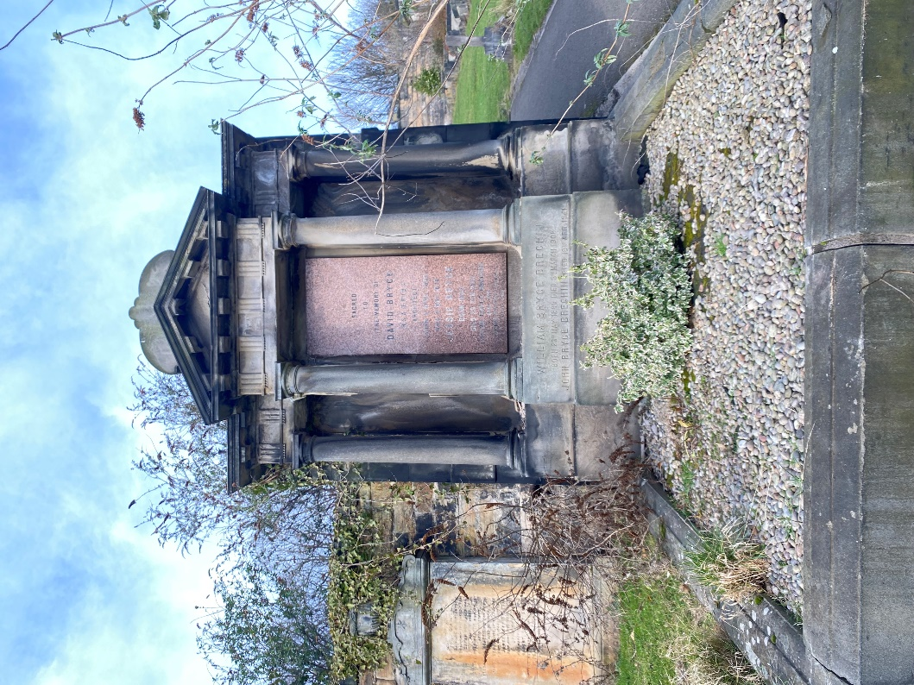

- Map
