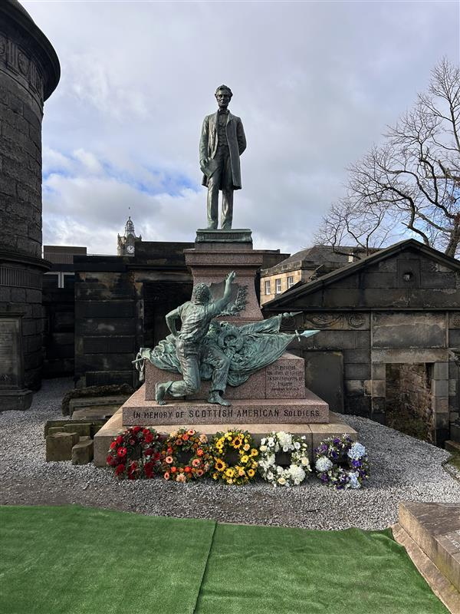


OLD CALTON BURIAL GROUND

Version | Author(s) | Comments | Dates
V1.1 | Danielle Gartland-Quinn | Photos by Tam Magee | 25/2/2026

This document will be reviewed on an annual basis. However, a review or revision of any parts can be carried out at any time for service improvements and will be carried out following new legislation or changes to codes of practice.
This document can be viewed by the public during office hours or online.

`

Contents

- Brief history
- Site description
- Site summary
- Asset list
- Grounds maintenance and biodiversity
- Lair types and availability
- Community involvement
- Notable burials and monuments
- Map

- Brief history

Established in 1718, the Old Calton Burial Ground is one of Edinburgh’s most architecturally significant and atmospheric graveyards, situated on the steep slopes of Calton Hill. Originally created to serve the tradesmen of the Calton district, the site was dramatically altered in 1819 when the construction of Waterloo Place cut through the grounds, necessitating the relocation of hundreds of bodies to the nearby New Calton Burial Ground. This major engineering project left the cemetery divided; while the larger, more prominent section remains to the south, a smaller, isolated portion sits directly opposite on the street named Calton Hill. Despite this physical separation, the site remains a crowded and dramatic landscape of stone, enclosed by high walls and dominated by several massive, high-profile monuments, such as David Hume's mausoleum and the Political Martyrs' Monument, that reflect Edinburgh’s Enlightenment history.

- Site description

The Old Calton Burial Ground is accessed from Waterloo Place through iron gates set into towering stone walls, which open onto a steep flight of stone stairs leading uphill. As visitors ascend, the cemetery gradually reveals itself, with open burial sections either side of the steps and modern pathways guiding the way. These burial areas are slightly raised and accessed via smaller sets of steps. While the site may initially appear compact, the true scale of the cemetery is cleverly disguised by a dense arrangement of prominent tombs and high walls that extend back into deep rows of monuments, served by a stone-chip pathway. Alongside these impressive, large-scale tombs, the grounds are home to many individual headstones showcasing a diverse range of historical styles, from traditional 18th-century trade symbols to more ornate Victorian designs. From this elevated position, the grounds offer spectacular scenic views across Edinburgh, including a clear vantage point over the smaller, divided portion of the cemetery located on the street named Calton Hill.The northern section of the cemetery, situated on the Calton Hill side, is accessed through a separate set of iron gates nestled between two commercial properties. Here, another set of steps leads upward into a smaller, more intimate space containing a select number of tombs and memorials. This detached area offers its own unique views of the city skyline and allows visitors to look back toward the main southern section. Both sides of the cemetery are physically separated by Waterloo Place below, which remains visible from the heights of both grounds. Unlike the main site, the Calton Hill side features no formal pathways, consisting instead of a simple, open lawn area that preserves a quiet and secluded atmosphere. A virtual tour of the cemetery can be viewed here.

- Site Summary
Name | Old Calton Burial Ground
Address | 27 Walterloo Place Edinburgh
Postcode | EH1 3BQ
Ownership | The City of Edinburgh Council
Date site acquired | 1856
Size | 0.2 hectares
Conservation area | Yes
Tree preservation | No
Listing | None
Access | Pedestrian
Opening hours | 9am-5pm

- Asset List
Asset | Location | Information
Waiting room | No
Toilets | No
CCTV | No
Signage | Cemetery gates, throughout site | Signs detailing name of the cemetery, cemetery user information, safety signs, notable burial sign entrance, information about notable burials.
Cabinet signage | Top of stairs | Sign welcoming cemetery users, displaying cemetery rules, biodiversity information, other useful information
Car park | No
Disabled parking | No
Taps | No
Litter bins | Yes, cemetery gates
Benches | No
Catacombs | No
War memorials | No

- Grounds maintenance and biodiversity

The Council has revised its approach to grounds maintenance in response to the current nature emergency. This approach aims to protect and enhance existing biodiversity while encouraging the development of new habitats across the cemetery. This means less frequent grass cutting, no use of weedkiller, introduction of wildflowers, and the encouragement of natural grassland growth.

Routine maintenance activities are outlined below. A complete summary of our ground’s maintenance plans can be found in the Bereavement Services Cemeteries Management Plan.

Routine Maintenance | Frequency | Additional information
Grass Cutting | Approximately every 10–12 weeks during appropriate seasons. | Grass may be left at a longer length to support conservation practices. Old Calton Burial Ground is not cut during No Mow May to encourage pollinators.
Strimming | Approximately every 10–12 weeks. | Areas around memorials may be left unstrimmed and with  longer grass to prevent damage.
Leaf Clearance | As required. | Leaves are removed from hard-standing areas only.
Sunken Graves | As required. | Works are assessed based on safety and site conditions.
Re-Turfing / Grass Seeding | As required, particularly where damage has occurred. | Methods depend on the season and the severity of damage, especially from footfall. Areas may be temporarily fenced off during works.
Hedge Cutting | Annually. | No hedge cutting or shrub removal during bird nesting season (March–August), except for invasive species.
Emptying Bins & Litter Removal | Three times per week, with additional collections during busy periods. | A specialist cleaning team visits every two weeks to remove litter and biohazards at Old Calton Burial Ground.

A biodiversity study conducted in 2021 identified that Old Calton Burial Ground already supports a large range of biodiversity, including a variety of trees, grasses, animals, and insects. The council is committed to protecting these existing habitats and encouraging biodiversity across the site. A list of species found in the cemetery in 2021 are detailed below.

Species List | Details
Trees | Ash, ash, lime, sycamore
Shrubs | Buddleia, cotoneaster, fuchsia, holly, ivy, laurel, rhododendron sp and garden species
Ferns | Common polypody, Hart's tongue, Male fern, Maidenhair spleenwort, Wall rue.
Grasses | Meadow grass (Poa pratensis) and others
Flowers | Broad leaved willowherb, chickweed; creeping buttercup, daisy, dandelion, groundsel, lavender; potato; purple loosestrife; ragwort, ribwort plantain, rosebay willowherb, white clover, yarrow. Plus several garden species.
Mosses | Atrichum undulatum; Bryum capillare, Grimmia pulvinata, Hypnum sp; Marchantia polymorpha (a liverwort), Orthotrichum sp; Tortula muralis
Birds | Carrion crow, magpie, pied wagtail, wren
Insects | Ladybirds: 2 spot, Harlequin, pine ladybird. Other Insects: common carder bumble bee; craneflies (not identified to species level), a leafhopper; Phytocoris tilliae (a Mirid bug); a stonefly

- Lair type and availability

There are no new lair’s available at Old Calton Burial Ground.

- Community involvement

The Friends of the New Calton and Old Calton Burial Grounds is a community group dedicated to the conservation and promotion of these two historic Edinburgh graveyards.
Establishing or joining a 'Friends of' group is a meaningful way to contribute to your community while helping us protect these spaces. If you are interested in forming a new group or would like to enquire about future opportunities, please contact Bereavement Services.
- Notable burials and monuments

The David Hume Mausoleum is a 1777 neo-classical structure designed by Robert Adam, featuring a minimalist design holding the remains of the Scottish philosopher. Due to his reputation, the tomb required an eight-day guard after his burial to prevent potential desecration.

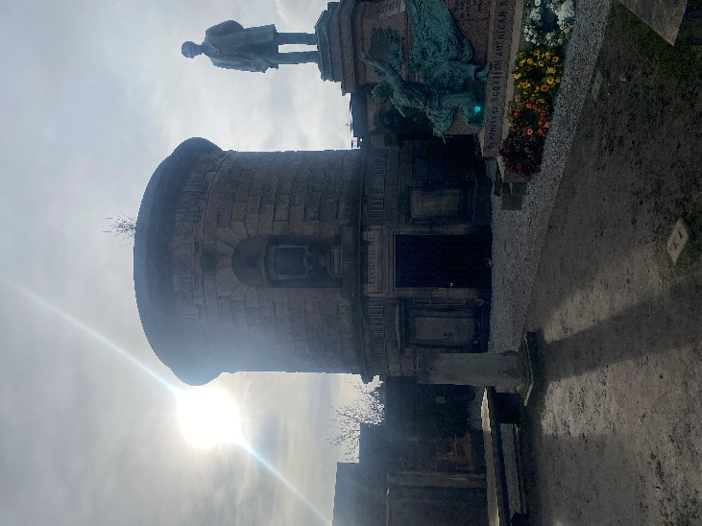

The Political Martyrs' Monument, a 90-foot Egyptian obelisk erected in 1844, honours five 18th-century reformers who were transported for advocating parliamentary reform.

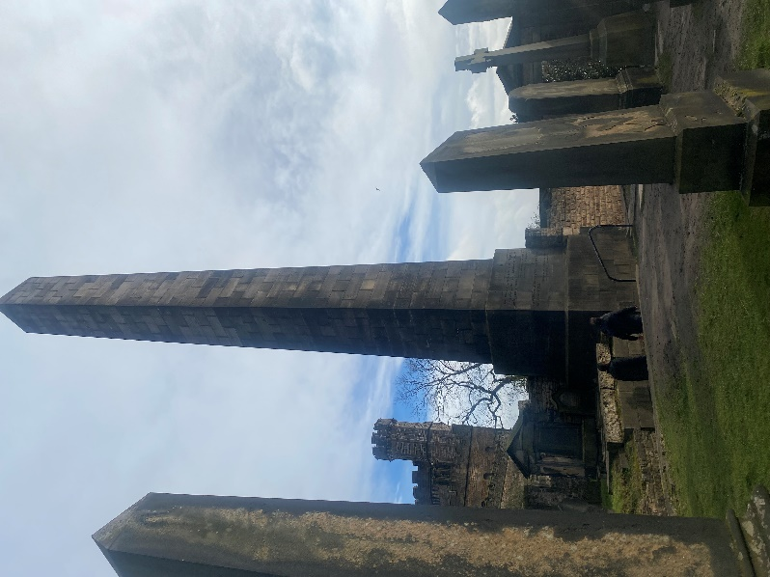

- Map

