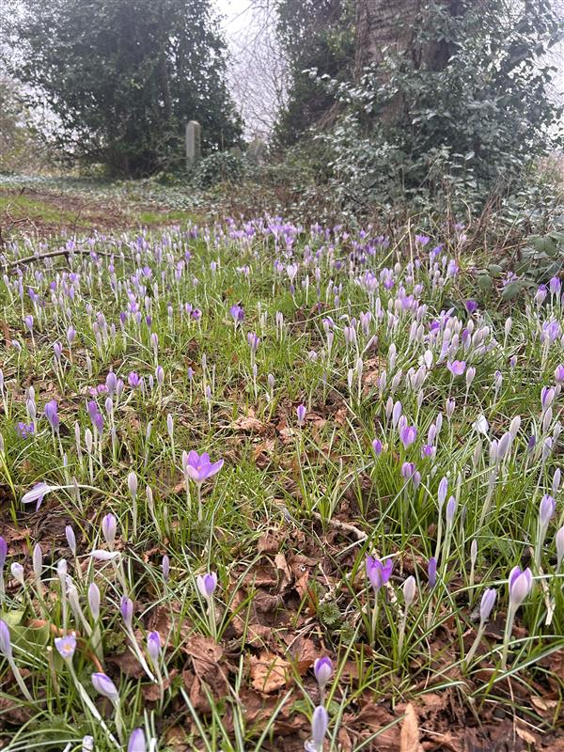


NORTH MERCHISTON CEMETERY

Version | Author(s) | Comments | Dates
V1.1 | Danielle Gartland-Quinn | Photos by Tam Magee | 25/2/2026

This document will be reviewed on an annual basis. However, a review or revision of any parts can be carried out at any time for service improvements and will be carried out following new legislation or changes to codes of practice.
This document can be viewed by the public during office hours or online.

`

Contents

- Brief history
- Site description
- Site summary
- Asset list
- Grounds maintenance and biodiversity
- Lair types and availability
- Community involvement
- Notable burials and monuments
- Map

- Brief history

North Merchiston Cemetery, originally established as New Dalry Cemetery, was opened in 1874 by The Edinburgh Cemetery Company. It was planned primarily as an "overflow" site to meet the surging demand for burial space as the nearby Dalry Cemetery rapidly approached capacity. The first burial was conducted on 23 June 1874, and the grounds have since become the final burial place for over 9,000 individuals. While archival records regarding a specific architect are limited, the layout reflects the 19th-century garden cemetery movement, with early advertisements highlighting a structured design of well-organised burial sections and extensive shrub planting. The cemetery’s entrance is marked by a traditional lodge house, which remains a prominent architectural feature and is now a private residence. Notably, North Merchiston departed from some grander Victorian trends by excluding catacombs from its design, focusing instead on an open-air, landscape-driven approach. The site holds significant military history, containing several war graves and serving as the burial place for two Victoria Cross recipients. Despite its historical importance, the cemetery eventually fell into a state of serious disrepair and was compulsory purchased by the Council in 1994, along with five other abandoned cemeteries. Today, the management of the grounds has shifted to prioritise biodiversity. Current maintenance strategies focus on protecting and enhancing the site's natural heritage, balancing its role as a place of remembrance with its status as a flourishing urban habitat.

- Site description

North Merchiston Cemetery is a secluded urban sanctuary accessed via a single entrance at the junction of Slateford Road and Ardmillan Terrace. Entry is gained through green iron gates set within stone pillars, directly to the right is the historic lodge house, which is now a private residence enclosed by its own boundary fencing. From the entrance, an earth roadway offers two openings in opposite directions, serving as the primary routes into the rest of the cemetery grounds. The landscape is primarily level, providing a mainly flat ground that is fully enclosed by a combination of traditional stone walls and modern fencing, particularly along the northern boundary which runs parallel to the adjacent railway line. The cemetery is defined by a sense of wild, dense overgrowth, where mature trees, natural grasses, and established shrubbery have been allowed to flourish. While most of the grounds are heavily wooded, a small number of mounded burial areas remain clear of trees, providing a brief opening in the canopy. Throughout the site, the memorials vary significantly in size, style, and colour, offering a visual history of those interred and the evolving artistic trends throughout years of active use. Positioned in the heart of the grounds is a dedicated war memorial, complemented by numerous individual war graves across the entire site. Access through the burial sections is provided by mown pathways that wind through the foliage, creating the atmosphere of a natural woodland walkway with monuments emerging from the greenery on either side. This largely undisturbed environment receives minimal maintenance, a deliberate strategy that contributes to the cemetery’s status as an Important Local Nature Conservation Site. By balancing its role as a place of remembrance with its function as a vital urban green space, North Merchiston provides a unique and biodiverse habitat within the city.

- Site Summary
Name | North Merchiston Cemetery
Address | 4 Slateford Road Edinburgh
Postcode | EH11 2LF
Ownership | The City of Edinburgh Council
Date site acquired | 1994
Size | 3.78 hectares
Conservation area | No
Tree preservation | Yes
Listing | C
Access | Vehicle and pedestrian
Opening hours | 24 hours

- Asset List
Asset | Location | Information
Waiting room | No
Toilets | No
CCTV | No
Signage | Cemetery gates and throughout cemetery | Signs detailing name of the cemetery, cemetery user information, safety signs, signs placed by Friends and Maroon Mile
Cabinet signage | Cemetery entrance | Sign welcoming cemetery users, displaying cemetery rules, biodiversity information, other useful information, biodiversity signs placed by Friends
Car park | No
Disabled parking | No
Taps | No
Litter bins | Yes, throughout site see map
Benches | Yes, throughout site see map
Catacombs | No
War memorials | Yes, throughout site | More information can be found on Commonwealth War Grave Commission webpage.

- Grounds maintenance and biodiversity

The Council has revised its approach to grounds maintenance in response to the current nature emergency. This approach aims to protect and enhance existing biodiversity while encouraging the development of new habitats across the cemetery. This means less frequent grass cutting, no use of weedkiller, introduction of wildflowers, and the encouragement of natural grassland growth.

North Merchiston is managed with a low-intervention approach to prioritize biodiversity and the flourishing of local wildlife. By intentionally limiting formal grounds maintenance, the site serves as a protected habitat where native flora and fauna can thrive undisturbed. This sustainable management strategy transforms the cemetery into a vibrant urban ecosystem, balancing its role as a place of remembrance with a commitment to ecological conservation

Routine maintenance activities are outlined below. A complete summary of our ground’s maintenance plans can be found in the Bereavement Services Cemeteries Management Plan.

Routine Maintenance | Frequency | Additional information
Grass cutting | Approx. every 10-12 weeks during appropriate seasons – pathways through burial sections only | No grass cutting during No Mow May
Strimming | None
Leaf clearance | None
Sunken graves | When required
Re-turfing / grass seeding | When required | Method will depend on season
Emptying bins | When required

A biodiversity study conducted in 2021 identified that North Merchiston Cemetery already supports a large range of biodiversity, including a variety of trees, grasses, animals, and insects. The council is committed to protecting these existing habitats and encouraging biodiversity across the site. A list of species found in the cemetery in 2021 are detailed below.

Species List | Details
Trees | Alder, ash, weeping ash, buddleia, elder, elm, hawthorn, horse chestnut, hollies, laburnum, lime, pussy willow, silver birch, sycamore, whitebeam
Shrubs | Brambles, Buddleia, Cotoneaster
Grasses | Cocksfoot, meadow grass, Yorkshire Fog, Timothy grass, perennial rye-grass, Common Whitlowgrass and others
Flowers | Bittersweet (woody nightshade), cow parsley, crocus, daffodil, dandelion, lawn daisy, red campion, meadow buttercup, Spanish and hybrid bluebells, white dead-nettle, red dead nettle, common sorrel, ivy, brambles, stinging nettles, herb robert, prickly sow thistle, smooth sow thistle, spear thistle (and one other thistle species), Germander speedwell, wall speedwell, garlic mustard, cuckoo flower, few flowered leek, groundsel, wood avens (herb bennet), pink purslane, dock, ground elder, cleavers, white clover, rosebay willowherb, broad leaved willowherb, common hogweed, ground elder, common chickweed, ribwort plantain, doves foot cranesbill, nipplewort, yarrow, snowdrops, wild garlic, Dutch Hyacinth, Glory of the Snows, fox and cubs,
Fungi | Jelly Ear fungus, coral spot fungus, earthstars, candle snuff, stagshorn, Hairy Bracket (Trametes hirsuta). Turkey Tail, and others.
Butterflies | Comma, peacock, orange tip, red admiral, small tortoiseshell, small white, speckled wood.
Mammals | Fox, grey squirrel, albino squirrel, stoat, weasel
Birds | Blackbird, blackcap, blue tit, bullfinch, buzzard, carrion crow, chaffinch, chiffchaff, coal tit, dunnock, fieldfare, goldcrest, goldfinch, great spotted woodpecker, great tit, greenfinch, jackdaw, long-tailed tit, magpie, mistle thrush, pheasant, redwing, robin, song thrush, sparrowhawk, treecreeper, willow warbler, wood pigeon, woodcock (not seen, but feathers found), wren.
Insects | Broad Centurion fly (Chloromyia formosa), Click beetle (Athous haemorrhoidalis), Common flower bug (Anthocoris nemorum), hawthorn shield bug, house fly, Deraeocoris lutescens (shield bug), green bottle fly, St Marks fly, soldier beetle, Elipsocus hyalinus (a barkfly), Graphopsocus cruciatus (another barkfly) picture wing fly (Xyphosia miliaria ), nettle weevil, crane fly, common wasp and at least two other species of wasp, ground beetle (Nebria brevicollis), Sepsis sp (an ant mimic fly), dark edged bee fly (Bombylius major).
Hoverflies | Marmalade hoverfly (Episyrphus balteatus), footballer hoverfly (Helophilus pendulus and H. hybridus), Narcissus bulb fly (Meredon equestris), batman hoverfly (Myathropa florea), pellucid hoverfly (Volucella pellucens), plus those with only scientific names: Baccha elongata, Cheilosia sp, Dasysyrphus albostriatus, Dasysyrphus venustus, Eristalis intricaria, Eristalis pertinax, Eupeoides latifasciatus, Eupeoides sp, Epistrophe eligans, Epistrophe grossulariae, Leucozona lucorum, Meliscaeva auricollis, Melangyna lasiophthalma, Melanostoma scalare, Parasyrphus punctulatus, Pipiza sp, Platycheirus albimanus, Platycheirus sp, Sphaerophoria sp. Syrphus sp, Xylota segnis,

- Lair type and availability

There are no new lair’s available at North Merchiston Cemetery, burial can only be arranged in an existing lair.

- Community involvement

The Friends of North Merchiston Cemetery and are dedicated to caring for the heritage and biodiversity of the cemetery, some of thier aims are to preserve, restore and educate. Their involvement enhances the condition of the cemetery and contributes significantly to the improvements seen across the site. Their commitment, local knowledge and hands-on involvement have made a meaningful difference to the appearance, accessibility and historical understanding of North Merchiston Cemetery. Members of the group have a deep interest in and knowledge of the cemetery's local history, researching the stories of those buried there and helping preserve the cemetery’s cultural heritage.

Activities carried out by the Friends group include:

- Tree planting and habitat creation
- Gardening and maintaining planted areas
- Improving paths and general access around the cemetery
- Creating and maintaining wildflower meadows
- Providing homes for birds, bats and other wildlife
- Assisting with landscape improvements alongside Council staff
- Leading guided talks and walks to share the cemetery’s history
- Contributing to the ongoing management and future planning of the site
- Weekly litterpick
- Placing signage across the cemetery with Maroon Mile
- Biodiversity focused work

The Friends group's involvement not only supports essential maintenance but also helps visitors better understand and appreciate the site's significance.
Contact details for volunteering, supporting or becoming a member of this Friends group can be found on the friends webpage.
Establishing or joining a 'Friends of' group is a meaningful way to contribute to your community while helping us protect these spaces. If you are interested in forming a new group or would like to enquire about future opportunities, please contact Bereavement Services.

- Notable burials and monuments

North Merchiston Cemetery serves as the final burial place for two distinguished Scottish recipients of the Victoria Cross:
- Charles Thomas Kennedy (1873–1807), a member of the Highland Light Infantry, earned the highest award for gallantry during the Boer War for carrying a wounded comrade to safety under heavy fire.
- James Davis (1835–1893) of the Black Watch was decorated for his "duty of danger and affection" during the Indian Mutiny at Fort Ruhya.
For over a century, both men lay in unmarked graves until dedicated memorials were erected, ensuring their extraordinary bravery is permanently honoured within the grounds.
Beyond these two heroes, the cemetery is a significant site of remembrance, containing over 140 Commonwealth war graves from both the First and Second World Wars, alongside various regimental memorials that pay tribute to Edinburgh's military history.
More information about these graves and memorials can be found on the Commonwealth War Graves Commission webpage.

- Map
