RATHO CHURCHYARD



Version | Author(s) | Comments | Dates
V1.1 | Danielle Gartland-Quinn | Photos by Tam Magee | 25/2/2026

This document will be reviewed on an annual basis. However, a review or revision of any parts can be carried out at any time for service improvements and will be carried out following new legislation or changes to codes of practice.
This document can be viewed by the public during office hours or online.

`

Contents

- Brief history
- Site description
- Site summary
- Asset list
- Grounds maintenance and biodiversity
- Lair types and availability
- Community involvement
- Notable burials and monuments
- Map

- Brief history

The history of Ratho Churchyard is linked to the ancient site of St Mary’s Parish Church, where records of a religious presence date back as far as 1243. The surrounding churchyard serves as a physical timeline of this long heritage, preserving many features of the parish's past. While early burial records for the site are limited, the surviving memorials provide a physical link to the 17th century, with the oldest headstones dating back to 1679. The churchyard is noted for its distinctive memorials, including unusual monuments such as a uniquely stone-carved coffin. By the late 19th century, the churchyard had reached its capacity, leading to the opening of the adjacent Ratho Cemetery in 1899 to accommodate the growing needs of the village.

- Site description

Ratho Churchyard is accessed via black iron gates set into traditional stone pillars on Baird Road. Upon entering, a prominent stone gatehouse sits to the left, while a modern pathway leads directly to the church entrance. The burial grounds immediately surrounding the kirk are laid out in flat grass sections; while the main approach is tarmaced, there are no formal paths within the burial section themselves, allowing for an unobstructed view of the varied monuments. The churchyard surrounds the church building and includes a diverse range of memorials that vary significantly in age, style, and scale. These span from weathered 17th and 18th-century headstones to more substantial monuments dedicated to local lairds and ministers.

- Site Summary
Name | Ratho Churchyard
Address | 47/1 Baird Road Edinburgh
Postcode | EH28 8NP
Ownership | The City of Edinburgh Council
Date site acquired | 1975
Size | 0.26 hectares
Conservation area | Yes
Tree preservation | No
Listing | A
Access | Pedestrian
Opening hours | 24 hours

- Asset List
Asset | Location | Information
Waiting room | No
Toilets | No
CCTV | No
Signage | Cemetery gates | Signs detailing name of the cemetery, cemetery user information, safety signs
Cabinet signage | Cemetery entrance | Sign welcoming cemetery users, displaying cemetery rules, biodiversity information, other useful information
Car park | No
Disabled parking | No
Taps | No
Litter bins | No
Benches | No
Catacombs | No
War memorials | No

- Grounds maintenance and biodiversity

The Council has revised its approach to grounds maintenance in response to the current nature emergency. This approach aims to protect and enhance existing biodiversity while encouraging the development of new habitats across the cemetery. This means less frequent grass cutting, no use of weedkiller, introduction of wildflowers, and the encouragement of natural grassland growth.

Routine maintenance activities are outlined below. A complete summary of our ground’s maintenance plans can be found in the Bereavement Services Cemeteries Management Plan.

Routine Maintenance | Frequency | Additional information
Grass cutting | Approx. every 10-12 weeks during appropriate seasons | No grass cutting during No Mow May
Strimming | Approx. every 10-12 weeks during appropriate seasons | No grass cutting during No Mow May
Leaf clearance | When required | Clearance from hard standing areas only
Sunken graves | When required
Re-turfing / grass seeding | When required | Method will depend on season

A biodiversity study conducted in 2021 identified that Ratho Churchyard already supports a range of biodiversity, including a variety of trees, grasses, animals, and insects. The council is committed to protecting these existing habitats and encouraging biodiversity across the site. A list of species found in the cemetery in 2021 are detailed below.

Species List | Details
Trees | Cherry, rowan
Shrubs | Bramble, elder, forsythia, ivy
Flowers | Broad leaved willowherb, creeping buttercup, daffodil, daisy, dandelion, groundsel, ivy leaved toadflax, nettle, snowdrop, a species of speedwell, a species of thistle, wall lettuce
Mammals | Rabbit
Birds | Jackdaw, woodpigeon
Grasses | Meadow grass (Poa pratensis) and others

- Lair type and availability

There are no new lairs available.

- Community involvement

There are no established Friends Group for this cemetery.
Establishing or joining a 'Friends of' group is a meaningful way to contribute to your community while helping us protect these spaces. If you are interested in forming a new group or would like to enquire about future opportunities, please contact Bereavement Services.

- Notable burials and monuments

Ratho Churchyard has an exceptional collection of 17th and 18th-century graves, including grand monuments dedicated to local lairds and ministers. Among its most remarkable features is a unique, coffin-shaped headstone carved for John Mitchell in 1749, as well as a rare 13th-century memorial preserved within the south porch of the Ratho Kirk.
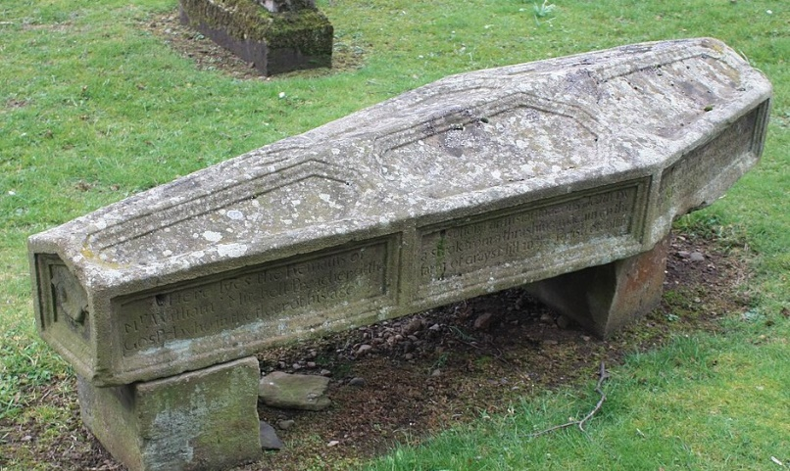

- Map
