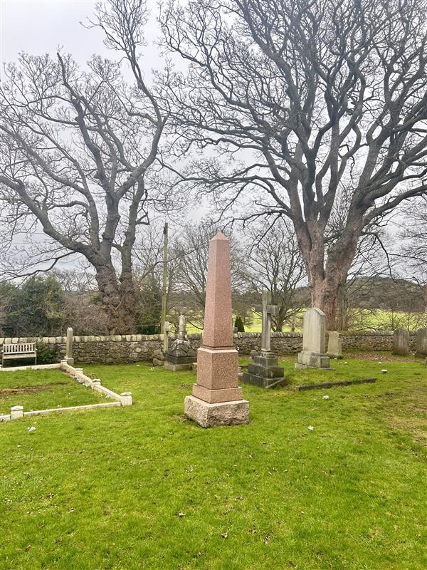

DALMENY CHURCHYARD



Version | Author(s) | Comments | Dates
V1.1 | Danielle Gartland-Quinn | Tam Magee | 24/2/2026

This document will be reviewed on an annual basis. However, a review or revision of any parts can be carried out at any time for service improvements and will be carried out following new legislation or changes to codes of practice.
This document can be viewed by the public during office hours or online.

`

Contents

- Brief history
- Site description
- Site summary
- Asset list
- Grounds maintenance
- Lair types and availability
- Community involvement
- Notable burials and monuments
- Map

- Brief history

Dalmeny Churchyard surrounds the church building widely considered to be the best-preserved Norman Romanesque church in Scotland. While the current structure dates back to the 12th century, the site’s history extends much further into the past; physical evidence on the grounds, such as a 7th-century stone coffin, suggests that the area has served the local community as a sacred space for over a millennium. The church building itself has seen significant changes over time, most notably the loss of its original western tower, which was eventually rebuilt in 1937. The churchyard acts as a diverse record of the parish, containing a wide range of memorial styles that reflect the shifting social history of the area. These include grand monuments, modest headstones, and historic table tombs, with the oldest surviving stone marker dating back to 1669. Although official written records regarding the early years of the churchyard are limited, the variety of designs and ages of the stones evidences its continuous role in serving the residents across many generations. One of the most significant architectural features within the grounds is the Rosebery burial vault, the final resting place for members of the Primrose family, the Earls of Rosebery. This vault, along with the numerous highly decorative headstones makes the churchyard a vital site for understanding the heritage of the area.

- Site description

Access to Dalmeny Churchyard is gained from Main Street through a set of traditional black iron gates set into stone pillars. The entrance is nestled between a kirk building and a row of privately owned cottages. Upon entering, a modern pedestrian path leads straight ahead, providing direct access to the church and its entry points, with a branching path to the left specifically for reaching the additional church building. The burial grounds consist of open lawn sections that are immediately visible upon arrival. While the main paths guide visitors toward the architecture, there are no formal pathways between the individual burial rows, allowing the grass to flow continuously around the monuments. The site is securely enclosed by stone walls, with the rear of the neighbouring cottages forming part of the boundary line. The grounds are well-maintained and largely flat, though there are slight slopes in certain areas of the burial site, and the landscape features limited trees and shrubbery. A scenic view from the churchyard offers a rural feel. The memorials are in good order for a historic churchyard, featuring a diverse range of styles including prominent table tombs scattered across the open lawns.

- Site Summary
Name | Dalmeny Churchyard
Address | 22/2 Main Street Edinburgh
Postcode | EH30 9TU
Ownership | The City of Edinburgh Council
Date site acquired | 1975
Size | 0.34 acres
Conservation area | Yes
Tree preservation | No
Listing | A
Access | Pedestrian
Opening hours | 24 hours

- Asset List
Asset | Location | Information
Waiting room | No
Toilets | No
CCTV | No
Signage | Cemetery gates | Signs detailing name of the cemetery, cemetery user information, safety signs
Cabinet signage | Cemetery entrance | Sign welcoming cemetery users, displaying cemetery rules, biodiversity information, other useful information
Car park | No
Disabled parking | No
Taps | No
Litter bins | No
Benches | No
Catacombs | No
War memorials | No

- Grounds maintenance and biodiversity

The Council has revised its approach to grounds maintenance in response to the current nature emergency. This approach aims to protect and enhance existing biodiversity while encouraging the development of new habitats across the cemetery. This means less frequent grass cutting, no use of weedkiller, introduction of wildflowers, and the encouragement of natural grassland growth.

Routine maintenance activities are outlined below. A complete summary of our ground’s maintenance plans can be found in the Bereavement Services Cemeteries Management Plan.

Routine Maintenance | Frequency | Additional information
Grass cutting | Approx. every 10-12 weeks during appropriate seasons | No grass cutting during No Mow May
Strimming | Approx. every 10-12 weeks during appropriate seasons | No grass cutting during No Mow May
Leaf clearance | When required | Clearance from hard standing areas only
Sunken graves | When required
Re-turfing / grass seeding | When required | Method will depend on season

A biodiversity study conducted in 2021 identified that Dalmeny Churchyard already supports a large range of biodiversity, including a variety of trees, grasses, animals, and insects. The council is committed to protecting these existing habitats and encouraging biodiversity across the site. A list of species found in the cemetery in 2021 are detailed below.

Species List | Details
Trees | Ash (with signs of dieback), cypress, hawthorn, holly, rowan, yew. Plus overlooking cemetery: elder, silver birch, sycamore
Shrubs | bramble, buddleia (growing from neighbouring garden), cotoneaster, ivy, rose, Virginia Creeper
Grasses | Meadow grass (Poa pratensis) and others
Flowers | broad leaved willowherb, creeping buttercup, daisy, dandelion, dock, groundsel, ivy leaved toadflax, nettle, ribwort plantain, a species of speedwell, white clover, yarrow
Birds | carrion crow, goldfinch, jackdaw, magpie, mistle thrush, robin, rook, woodpigeon, wren
Insects | A cranefly (probably Tipula confusa), Syrphus sp hoverfly, at least one species of spider, garden snail and at least one other species of snail.

As part of our ongoing biodiversity work, the Council may place nature cameras in the cemetery to monitor the wildlife. Although a cemeteries primary purpose is as a place of remembrance and reflection wildlife are often attracted to cemeteries due to their quiet unchanging environment.

- Lair type and availability

There are no new lairs available.

- Community involvement

There are no established Friends Group for this cemetery.
Establishing or joining a 'Friends of' group is a meaningful way to contribute to your community while helping us protect these spaces. If you are interested in forming a new group or would like to enquire about future opportunities, please contact Bereavement Services.
- Notable burials and monuments

The churchyard holds a diverse range of memorials spanning several centuries. These vary from contemporary granite obelisks, stone tabletombs and some dating back as far as 1775 and some featuring traditional 'memento mori' carvings of skulls and crossbones.

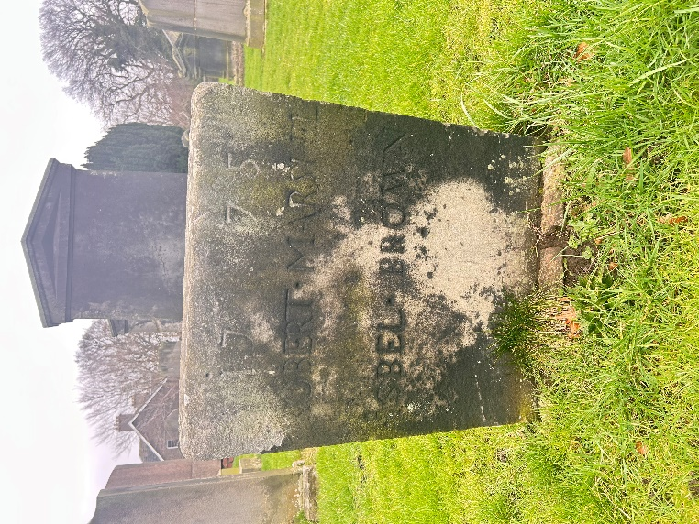
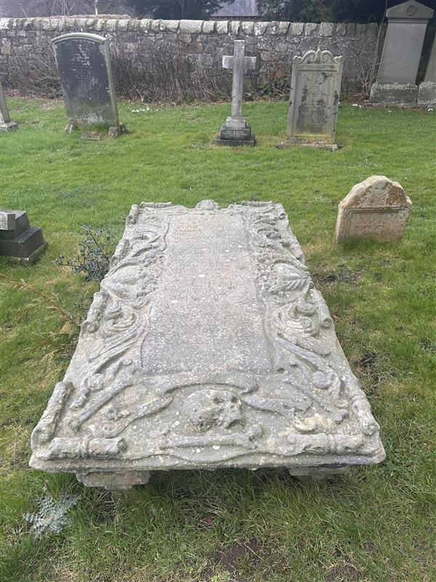
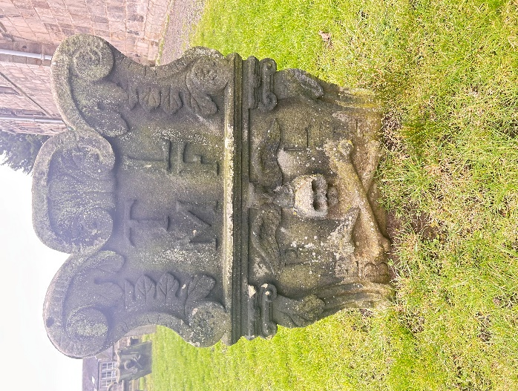

- Map

