
COMELY BANK CEMETERY

Version | Author(s) | Comments | Dates
V1.1 | Danielle Gartland-Quinn | Photos by Tam Magee | 24/2/2026

This document will be reviewed on an annual basis. However, a review or revision of any parts can be carried out at any time for service improvements and will be carried out following new legislation or changes to codes of practice.
This document can be viewed by the public during office hours or online.

`

Contents

- Brief history
- Site description
- Site summary
- Asset list
- Grounds maintenance and biodiversity
- Lair types and availability
- Community involvement
- Notable burials and monuments
- Map

- Brief history

Comely Bank Cemetery was formally opened in 1896 by The Edinburgh Cemetery Company, designed as a garden cemetery by architect George Washington Browne. Although the first recorded burial took place on 29 November 1869, the formal establishment of the grounds was intended to be far more extensive than the site seen today. Much of the land originally earmarked for the cemetery was subsequently sold and developed for residential housing; the original entrance gates and pillars still stand in situ on Crewe Road South. Since its beginning, the cemetery has served as the final burial place for over 15,000 individuals. While it is renowned for its military history, containing the graves of over 300 service personnel due to its proximity to wartime hospitals and battalion headquarters, it primarily serves as a burial place for the local community. Alongside these servicemen and a variety of notable figures, generations of local families are interred here, with their memorials reflecting the diverse cultural and artistic trends of Edinburgh across the centuries. Despite its architectural and historical importance, the cemetery eventually fell into a state of serious disrepair. In 1994, the Council compulsory purchased the cemetery along with five other abandoned cemeteries to ensure their long-term preservation. Today, the cemetery is once again a well-tended and active site, continuing to serve the local community with new lairs still available for burial.

- Site description

Comely Bank Cemetery is a modest yet elegantly composed burial ground, fully enclosed and accessed via a single point of entry on Craigleith Road. Here, black iron gates set into stone pillars open onto a monoblock driveway that serves as the site's primary thoroughfare, bordered by well-tended burial sections. From this central drive, a network of former gravel carriage ways branches out to provide access to the rest of the grounds. True to the garden cemetery style, the layout is well-planned and spacious, set within a structured landscape framework that remains well-maintained. The cemetery’s terrain is generally flat, though punctuated by subtly raised areas that add depth to the landscape. Its character is defined by a lush variety of established trees and carefully placed shrubbery distributed across the site, which together create a distinct and tranquil woodland atmosphere. This greenery backdrop complements an impressive collection of memorials that vary in size, design, and style, reflecting a broad range of historical periods and the evolving artistic approaches of those buried. A particularly unusual feature of Comely Bank is its war graves memorials, where the granite headstones lie flat, a unique design choice by the Imperial War Graves Commission architect and Edinburgh native, Sir Robert Lorimer. Positioned prominently within the cemetery, the Second World War plot contains more than half of the cemetery's 76 graves from that era. Adding to the site's historical significance, the cemetery also houses the grave of a member of the Finnish Legion alongside two non-war service burials, all preserved within this serene urban sanctuary. A virtual tour of the cemetery can be viewed here.

- Site Summary
Name | Comely Bank Cemetery
Address | 1A Craigleith Road Edinburgh
Postcode | EH4 2DL
Ownership | The City of Edinburgh Council
Date site acquired | 1994
Size | 3.18 hectares
Conservation area | No
Tree preservation | Yes
Listing | None
Access | Vehicle and pedestrian
Opening hours | 24 hours

- Asset List
Asset | Location | Information
Waiting room | No
Toilets | No
CCTV | No
Signage | Cemetery gates, and War Graves | Signs detailing name of the cemetery, cemetery user information, safety signs, information signs by the war graves
Cabinet signage | Cemetery entrance | Sign welcoming cemetery users, displaying cemetery rules, biodiversity information, other useful information
Car park | No
Disabled parking | No
Taps | Yes, see map
Litter bins | Yes, throughout site see map
Benches | Yes, throughout site see map
Catacombs | No
War memorials | Yes, see map | More information can be found on Commonwealth War Grave Commission webpage.

- Grounds maintenance and biodiversity

The Council has revised its approach to grounds maintenance in response to the current nature emergency. This approach aims to protect and enhance existing biodiversity while encouraging the development of new habitats across the cemetery. This means less frequent grass cutting, no use of weedkiller, introduction of wildflowers, and the encouragement of natural grassland growth.

Routine maintenance activities are outlined below. A complete summary of our ground’s maintenance plans can be found in the Bereavement Services Cemeteries Management Plan.

Routine Maintenance | Frequency | Additional information
Grass cutting | Approx. every 8-10 weeks during appropriate seasons | No grass cutting during No Mow May
Strimming | Approx. every 8-10 weeks during appropriate seasons | No grass cutting during No Mow May
Leaf clearance | When required | Removal from hard standing areas and pathways only.
Sunken graves | When required
Re-turfing / grass seeding | When required | Method will depend on season
Hedge cutting
Emptying bins | When required

A biodiversity study conducted in 2021 identified that Comely Bank Cemetery already supports a large range of biodiversity, including a variety of trees, grasses, animals, and insects. The council is committed to protecting these existing habitats and encouraging biodiversity across the site. A list of species found in the cemetery in 2021 are detailed below.

Species List | Details
Trees | Ash, beech, cherry, cypress, holly, horse chestnut, lime, silver birch, sycamore, yew
Shrubs | Bramble, ivy, laurel, rhododendron, rose
Grasses | Meadow grass
Flowers | Broad leaved willowherb, creeping buttercup, daisy, dandelion, dock, groundsel, herb robert, nettle, ribwort plantain, rosebay willowherb, smooth sowthistle, white clover, yarrow
Fungi | Birch polypore, candle snuff, common puffballs, parrot waxcups
Mosses | Grimmia pulvinate, hypnum sp
Mammals | Grey squirrel
Birds | Blue tit, bullfinch, magpie, mistle thrush, robin, wren
Insects | 2 spot ladybird, cream spot ladybird, harlequin ladybird, birch sheild bug, hawthorn sheild bug

As part of our ongoing biodiversity work, we may place nature cameras in the cemetery to monitor the wildlife. Although a cemeteries primary purpose is as a place of remembrance and reflection wildlife are often attracted to cemeteries due to their quiet unchanging environment.

- Lair type and availability

Lair type | Availability | Details
Non-denomination Coffin Lairs | Yes | 2 coffin burials and 6 cremated remains urns burials
Catholic Lairs | No
Green Burial | No
Cremated remains | No
Baby | No
Muslim | No
Muslim baby | No
Above ground vault | No

- Community involvement

There is currently no community involvement in Comely Bank Cemetery.
Establishing or joining a 'Friends of' group is a meaningful way to contribute to your community while helping us protect these spaces. If you are interested in forming a new group or would like to enquire about future opportunities, please contact Bereavement Services.

- Notable burials and monuments

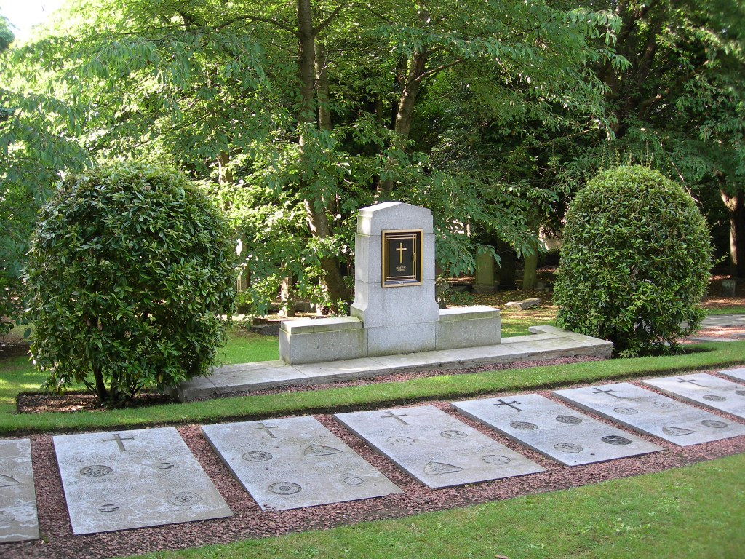
The Comely Bank Cemetery War Memorial in Edinburgh serves as a poignant tribute to over 300 Commonwealth service members. Unlike traditional upright markers, the memorial site is distinguished by unique flat granite headstones designed by the celebrated architect Sir Robert Lorimer. A central granite screen wall, designed by Ralph Hobday and unveiled in 1956, commemorates those buried in the surrounding plots. The site is perhaps most notable for being the final resting place of Reginald Earnshaw, who, at age fourteen, is recognised by the Commonwealth War Graves Commission as the youngest known British service casualty of World War II. Further information and images of the memorials can be found on the Commonwealth War Graves Commission webpage.

- Map

