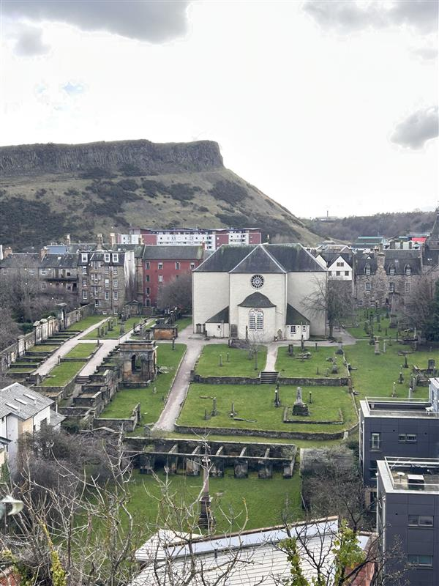


CANONGATE KIRKYARD

Version | Author(s) | Comments | Dates
V1.1 | Danielle Gartland-Quinn | Photos Tam Magee | 24/2/2026

This document will be reviewed on an annual basis. However, a review or revision of any parts can be carried out at any time for service improvements and will be carried out following new legislation or changes to codes of practice.
This document can be viewed by the public during office hours or online.

`

Contents

- Brief history
- Site description
- Site summary
- Asset list
- Grounds maintenance and biodiversity
- Lair types and availability
- Community involvement
- Notable burials and monuments
- Map

- Brief history

Canongate Kirkyard situated on the Royal Mile in Edinburgh’s Old Town, is a site of immense historical, social and archaeological significance. Located at the heart of the medieval burgh of the Canongate established in the early 12th century, the site was originally occupied by secular buildings from the 12th to late 17th century. The A-listed Kirkyard and Kirk were established in the late 1680s by James VII & II, with the Kirk built between 1688 & 1690 to a design by James Smith. The Kirkyard also includes the B-listed 16th century Burgh Cross restored in its current location in 1888. The burial ground is essentially linked to the history of the Canongate, which existed as an independent and prosperous burgh before its incorporation into the city of Edinburgh. Serving generations of residents, from the humble to the elite, the kirkyard provides a dense physical record of the district's evolution from a separate town to a central part of the capital. The grounds surround Canongate Kirk, which holds a unique status as the Royal Family’s primary place of worship in Edinburgh. This royal connection is physically woven into the landscape through commemorative tree plantings. Notable among these is a cherry tree planted by Prince Philip, Duke of Edinburgh, during his first official visit in June 1953, alongside others contributed by members of the Royal Family to mark significant state occasions. Beyond its royal ties, the kirkyard is the final burial place for some of the most influential figures of the Scottish Enlightenment. Most notably, it contains the tomb of the pioneering economist Adam Smith and the grave of the poet Robert Fergusson, marked by a headstone commissioned and paid for by Robert Burns. These monuments, alongside those of countless local tradespeople and families, ensure the kirkyard remains a vital landmark of Scottish cultural and civic history.

- Site description

Canongate Kirkyard is a historic enclosed burial ground accessed via a single point of entry through black iron gates set into stone pillars. These gates lead immediately into a traditional setted courtyard that serves as a grand approach to the impressive Kirk entrance. While the site appears relatively modest in scale from this principal entrance, most of the burial ground extends significantly to the rear of the kirk building, fully surrounding the Kirk. From the central courtyard, gravel paths branch out on either side, providing access to open grassed lawn burial sections and the Mercat Cross, a powerful symbol of civic rights within the ancient burgh. Throughout the entire site, an impressive range of memorials reflects the diverse cultural trends and social history of Edinburgh; these monuments vary significantly in size, from the modest to the grand. They showcase a wealth of different artistic styles, materials, and colours, ranging from weathered grey sandstone to granites, reflecting the status and era of those interred. The topography is further defined by a notable downward slope to the rear of the kirk, where the gravel pathways guide visitors to the lower burial sections. Elaborate tombs are positioned throughout the site, including a prominent row of wall-mounted memorials along the eastern boundary and additional significant tombs within the northern section, known as the Marchmont area. These memorials and tombs represent a broad range of historical periods and artistic styles, commemorating a diverse mix of local residents and internationally notable individuals, such as the economist Adam Smith and the poet Robert Fergusson. Reflecting the kirkyard's long-standing role in the social history of the Canongate, the grounds remain a tranquil yet historically dense landmark situated directly on Edinburgh’s Royal Mile. A virtual tour of the cemetery can be viewed here.

- Site Summary
Name | Canongate Kirkyard
Address | 155 Canongate Edinburgh
Postcode | EH8 8BN
Ownership | The City of Edinburgh Council
Date site acquired | 1855
Size | 0.85
Conservation area | Yes
Tree preservation | No
Listing | A
Access | Pedestrian
Opening hours | 24 hours

- Asset List
Asset | Location | Information
Waiting room | No
Toilets | No
CCTV | No
Signage | Cemetery gates, throughout site | Signs detailing name of the cemetery, cemetery user information, safety signs, notable burial sign entrance, information plaques on notable tombs
Cabinet signage | Cemetery entrance | Sign welcoming cemetery users, displaying cemetery rules, biodiversity information, other useful information
Car park | No
Disabled parking | No
Taps | No
Litter bins | Yes, throughout site see map
Benches | Yes, throughout site see map
Catacombs | No
War memorials | No

- Grounds maintenance and biodiversity

The Council has revised its approach to grounds maintenance in response to the current nature emergency. This approach aims to protect and enhance existing biodiversity while encouraging the development of new habitats across the cemetery. This means less frequent grass cutting, no use of weedkiller, introduction of wildflowers, and the encouragement of natural grassland growth.

Routine maintenance activities are outlined below. A complete summary of our ground’s maintenance plans can be found in the Bereavement Services Cemeteries Management Plan.

Routine Maintenance | Frequency | Additional information
Grass Cutting | Approximately every 10–12 weeks during appropriate seasons. | Grass may be left at a longer length to support conservation practices. Some areas of Canongate Kirkyard are not cut during No Mow May to encourage pollinators.
Strimming | Approximately every 10–12 weeks. | Areas around memorials may be left un strimmed and with longer grass to prevent damage.
Leaf Clearance | As required. | Leaves are removed from hard-standing areas only.
Sunken Graves | As required. | Works are assessed based on safety and site conditions.
Re-Turfing / Grass Seeding | As required, particularly where damage has occurred. | Methods depend on the season and the severity of damage, especially from footfall. Areas may be temporarily fenced off during works.
Hedge Cutting | Annually. | No hedge cutting or shrub removal during bird nesting season (March–August), except for invasive species.
Emptying Bins & Litter Removal | Three times per week, with additional collections during busy periods. | A specialist cleaning team attends every two weeks to remove litter and biohazards in Canongate Kirkyard.

A biodiversity study conducted in 2021 identified that Greyfriars Kirkyard already supports a large range of biodiversity, including a variety of trees, grasses, animals, and insects. The council is committed to protecting these existing habitats and encouraging biodiversity across the site. A list of species found in the cemetery in 2021 are detailed below.

Species List | Details
Trees | Cherry, hawthorn, rowan, whitebeam
Shrubs | Buddleia, cotoneaster, ivy, rose, Virginia Creeper
Fungi | Orange Mosscap (Rickenella fibula)
Ferns | Hart's tongue, Male fern, Maidenhair spleenwort, Wall rue
Grasses | Meadow grass (Poa pratensis) and others
Flowers | Broad leaved willowherb, daisy, dandelion, dock, feverfew, fuchsia, Geranium sp, groundsel, heathers, nettle, prickly sow thistle, procumbent pearlwort, ragwort, ribwort plantain, rosebay willowherb, white clover, yarrow. Plus a small vetch
Mosses | Grimmia pulvinata, Hypnum sp, and others
Mammals | Grey squirrel
Birds | Carrion crow, herring gull, magpie, robin, woodpigeon.
Insects | Two species of craneflies (probably Tipula oleracea and Tipula confusa) 2 species of spider including a lace weaver spider (Amaurobius sp); leopard slug

- Lair type and availability

There are no new lair’s available at Canongate Kirkyard.

- Community involvement

There are no established Friends Groups for Canongate Kirkyard.
Establishing or joining a 'Friends of' group is a meaningful way to contribute to your community while helping us protect these spaces. If you are interested in forming a new group or would like to enquire about future opportunities, please contact Bereavement Services.

- Notable burials and monuments

Buried in the Canongate Kirkyard on Edinburgh’s Royal Mile, George Chalmers (1773–1836) is celebrated as a "success story" of the city. Born into poverty, he trained as a master plumber and eventually amassed a significant fortune through his trade. He lived and worked near Weir's Close in the Canongate, where a plaque now commemorates his life. Upon his death, Chalmers left his substantial estate to found a hospital for the "sick and hurt" citizens of Edinburgh. This legacy led to the opening of Chalmers Hospital in 1864, an institution that continues to serve the community today.

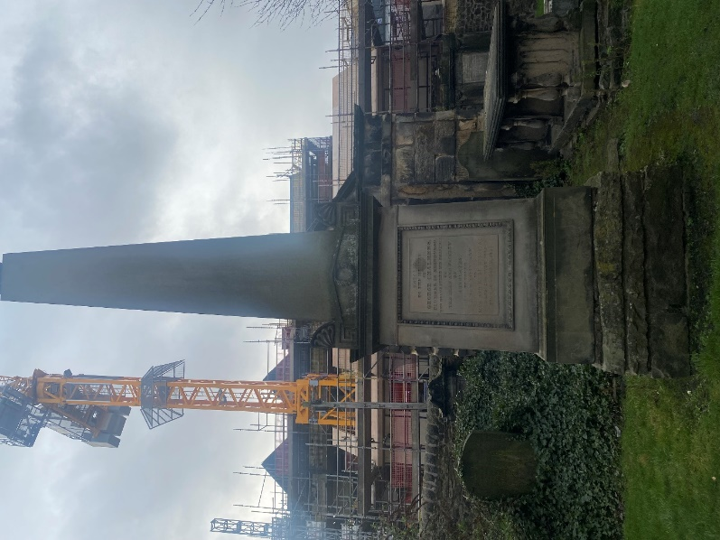

- Map
