
TO LET
Café Opportunity, Gilmerton Road, Liberton, Edinburgh, EH17 7PT
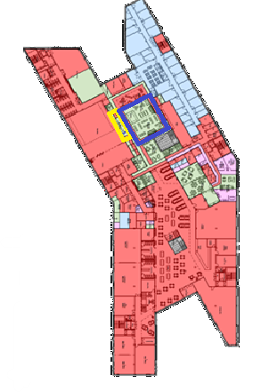
Approximate Gross Internal Area: 68.52 m² (448.05 sq.ft.) servery only
Illustrative View Indicative Allocated Area

Location

The premises are located off the A772 Gilmerton Road, within the Liberton area of Edinburgh, towards the south of the city, approximately 5km (3.1 miles) from the city centre. Liberton is bounded by Inch to the north, Moredun to the east and Alnwickhill and Gracemount to the south. To the west lies the Braid Hills. The Liberton/Gilmerton ward of the city had 37,672 inhabitants at the 2021 Census.

Description
The subject Café is situated within the ground floor of the newly built Liberton Campus which provides 1200 school places, NHS Medical Practice with 10,000 visitors per annum, together with footfalls from staff and visitors to the Library and Edinburgh Leisure Gym facilities.

The Cafe will comprise a modern servery, storage room and two vending machines with seating for 42 covers (layout shown below). Operation is likely to require 2 members of staff and is restricted to a Class 3 offering only. A turnkey start is available including furniture and fittings by negotiation.

The opening hours will be all year round from 8:30am – 8pm (Mondays and Wednesday) and 8:30am – 5pm (Tuesday, Thursday Friday and Saturday). The café will not operate on a Sunday.


You can get this document on audio CD, in Braille, large print if you ask us. Please contact Interpretation and Translation Service (ITS) on its@edinburgh.gov.uk and quote reference 25-0871.
The City of Edinburgh Council | Commercial Property | lesley.lumsden@edinburgh.gov.uk

Accommodation

We have measured the accommodation in accordance with the RICS Code of Measuring Practice (6th Edition) and we calculate the Gross Internal Area as 68.52 m² (448.05 sq. Ft), excluding WC and store.

Rateable Value
We understand that the subjects will attract a rateable value, a ratings valuation is yet to be provided. Further details on rateable value, rate poundage and rates relief can be found at www.saa.gov.uk or 0131 344 2500.

Planning
The Café opportunity is situated within the New Liberton Campus, which was granted permission under application 22/04134/FUL. Applicants must satisfy themselves as to any planning requirements or condition relating to their proposed use by contacting the Council’s Planning Department at Waverley Court, 4 East Market Street, Edinburgh, EH8 8BG. They can also be contacted by telephone on 0131 529 3550 or emailed at planning@edinburgh.gov.uk.

Terms
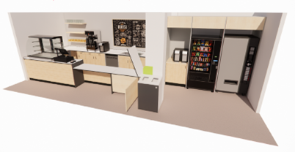
The premises will be offered on a Licence with negotiable terms and duration (minimum 12 months). The Council will insure the property, and the premium will be recovered from the tenant. The tenant will be responsible for contents and all other insurances.

The opening hours will be all year round as set out above.
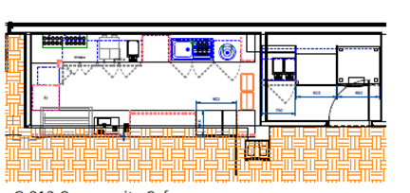
Services
Mains drainage, water and electricity are installed and all charges for such services will be sub-metered and will be the responsibility of the tenant. The tenant must satisfy themselves of the condition and suitability of the services.

Rent
Offers in excess of £8,000 per annum (inclusive of VAT, rates, buildings insurance and service charge) are invited.
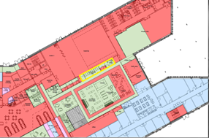
Energy Performance Certificate
Currently under assessment and available upon request.

Viewing
The unit may be viewed by appointment with Lesley Lumsden, Estates Surveyor who can be contacted on lesley.lumsden@edinburgh.gov.uk or 07864955358.

Fees
Each party will be responsible for their own fees and expenses in connection with the transaction. The ingoing tenant will be responsible for any Land and Buildings Transaction Tax and registration dues (where applicable).
Indicative Plans and View
Details for Submitting Offers

1. Notes of interest should be registered with the Council’s Surveyor using the contact details above in order that interested parties may be advised of a closing date.
2. When a closing date is set all offers must be received by 12 noon on the closing date. The Council will not accept late offers under any circumstances.
3. Offers must be submitted using an Offer to Let Form and sent by email to offers@edinburgh.gov.uk
The subject line of the email should state ‘Closing Date Offer – Liberton Café’ to ensure it is recorded as a formal offer. No emails will be read until the closing date has passed.
4. An email acknowledgement will be issued on receipt of the offer. You are responsible for confirming the offer has been safely received, and we recommend doing so a minimum of 24 hours prior to the closing date
5. Hand delivered offers and offers by post will not be accepted
6. The Council does not bind itself to accept the highest or any offer.
7. Prior to submitting an offer, you are strongly recommended to take appropriate professional advice.
8. The successful bidder will require to provide sufficient proof of identity within a reasonable timeframe prior to entering into any legal agreement in order to comply with money laundering regulations.

IMPORTANT NOTICE: The City of Edinburgh Council (CEC) give notice that: 1. They are not in a position to give any warranties in relation to the property either here or elsewhere. CEC assume no responsibility for any statement that may be made in these particulars. These particulars do not form part of any offer or contract and must not be relied upon as statements or representations of fact. 2. Any areas, measurements or distances are approximate. The text, photographs and plans are for guidance only and are not necessarily comprehensive. It should not be assumed that the property has all necessary planning, building regulation or other consents and The City of Edinburgh Council have not tested any services, equipment or facilities. Prospective tenants must satisfy themselves by inspection or otherwise. Date of publication May 2026.

