Annotated nomination papers – Scottish Parliament – individual regional candidates
- Process and forms
  - There are two documents that you must submit to make your nomination valid:
- Nomination paper
- Consent to nomination

  - You must deliver these forms by hand. The forms must be originals, not copies and anything received by email/fax will not be valid.
  - However, if you are abroad and the Regional Returning Officer (RRO) is satisfied it is not practicable for you to submit your consent to nomination in writing and deliver it by hand, you may be permitted to provide it by fax or email, and will not require a witness to sign the form.
  - You also need to pay a deposit of £500. The RRO will provide you with instructions about how this can be paid, for example in cash or by banker’s draft. This deposit must be deposited with the RRO by 16:00 23 working days before the poll. . Candidates who poll more than 5% of the total valid votes cast in the region will have their deposit returned. Candidates who poll less than, or equal to, 5% of the total valid votes cast will lose their deposit.
  - You may also submit an election agent appointment form, which does not necessarily need to be submitted at the same time as the other nomination forms. However, it does have the same deadline. If you do not submit an agent appointment form, you become your own agent by default.
  - If you appoint an election agent, your election agent may appoint sub-agents to act on their behalf. The appointment of sub-agents must be in writing to the RRO no later than two working days prior to the poll.
  - If you have any issues with completing your nomination forms, please contact the RRO at the Election Team, City of Edinburgh Council, elections@edinburgh.gov.uk or chris.highcock@edinburgh.gov.uk 0131 469 3126.
  - It is a good idea to have your nomination paperwork informally checked by the RRO before you formally submit them. This can allow you to make any corrections or complete new nomination forms if there are any mistakes.
  - Once your nomination is formally submitted you cannot amend any details. But, if you change your mind and no longer want to stand for election, you can withdraw your nomination until 16:00 23 working days before the poll (the withdrawal deadline). You may withdraw as a candidate by signing and submitting a withdrawal notice, which must be witnessed by one other person.
- Further information

Other useful guidance sources
Guidance for Candidates and Agents at Scottish Parliament elections
The Scottish Parliament (Elections etc.) Order 2015

- Annotated forms
  - These annotated forms cover areas that commonly cause confusion or difficulty, which staff can refer to when checking that a nomination paper is completed properly. Notes have been added to draw attention to the areas where candidates may have questions or made errors, and to remind staff where they need to add details.

Form 1 – nomination paper (header)
This section should be completed by RRO staff when the form is formally submitted.

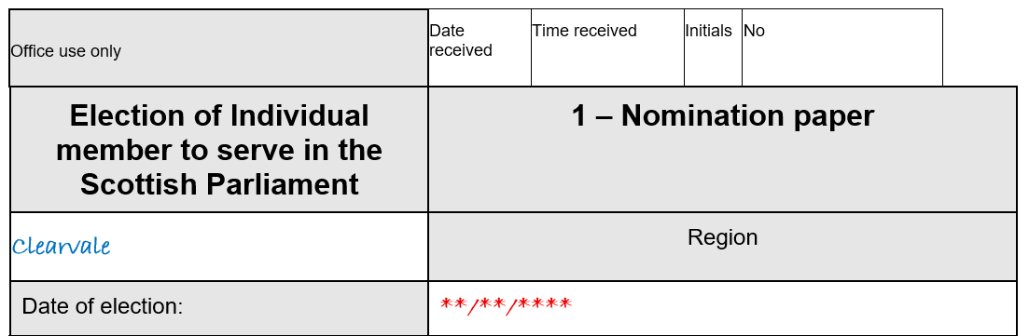
If it has not been pre-printed; the date of the election should be given.
The name of the Scottish Parliamentary region should be given here.

Form 1 – nomination paper (candidate’s details)

Full names must be added here – no initials.
Prefixes (e.g., Sir) or suffixes (e.g., Snr) must not be used.
This is optional. If you are commonly known by a different name to your actual name, this/these should be entered here.
The commonly used name will then appear on the ballot paper and the Statement of Parties and Persons Nominated instead of your actual name.
It is important to read the EC guidance if a commonly used name is used.

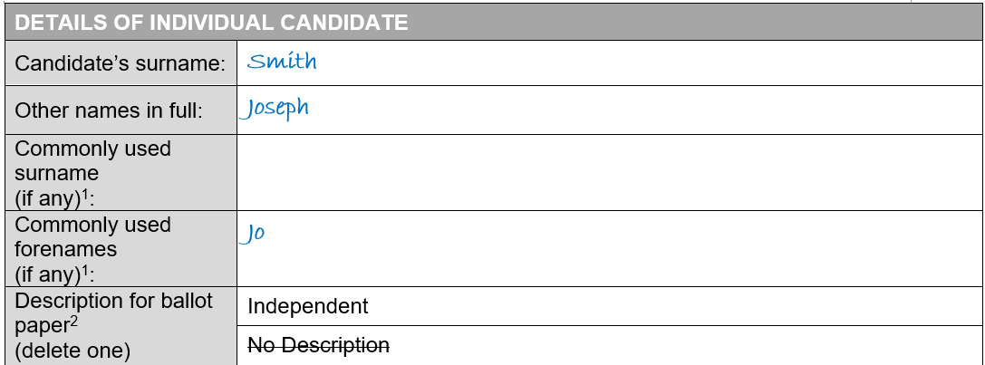
You could use the description ‘Independent’
OR the description may be left blank.
It is important to read the EC Guidance if a description is used.

Form 1 – nomination paper (candidate’s details) (cont.)
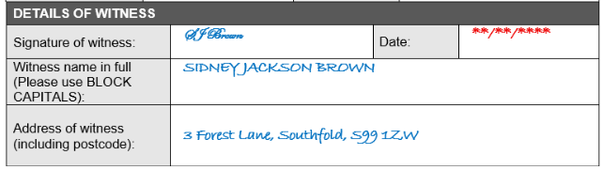
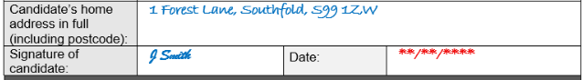
There are no restrictions on who can be a witness. Their name and address must be provided.
Your home address of the candidate must be given here:
- in full and without any abbreviations
- it must be their current home address
- it must not be a business address (unless they run a business from their home).

For further information see the EC guidance.

Form 2 – candidates consent to nomination (header)

This section should be completed by RRO staff when the form is formally submitted.

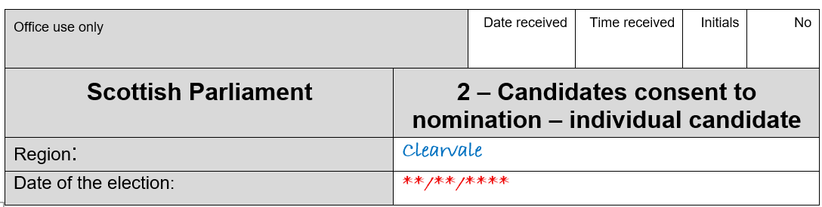
If it has not been pre-printed; the date of the election should be given.
The name of the Scottish Parliamentary region should be given here.

Form 2 – candidates consent to nomination (Section 1)

This should be your full name (rather than commonly used name) as given in Form 1.

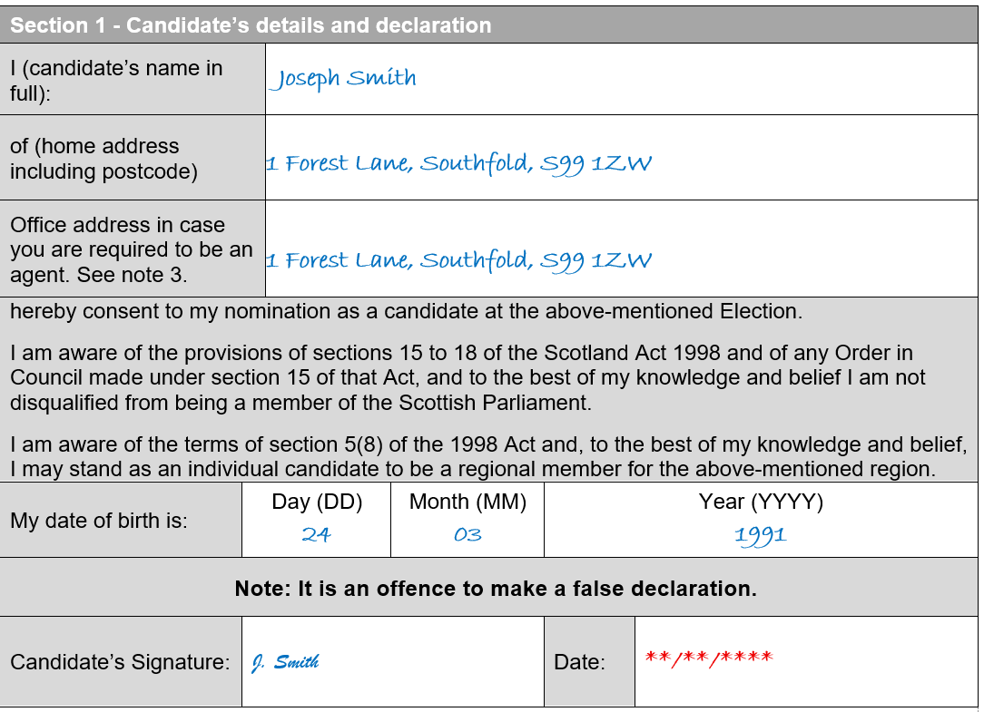

If you do not appoint an election agent by the deadline, this address will appear on the Notice of Election Agents.

You must be 18 or over on the date of submitting the nomination paper.
You must sign here, and the date should not be earlier than one month before the deadline for nominations.

Form 3 – notification of election agent

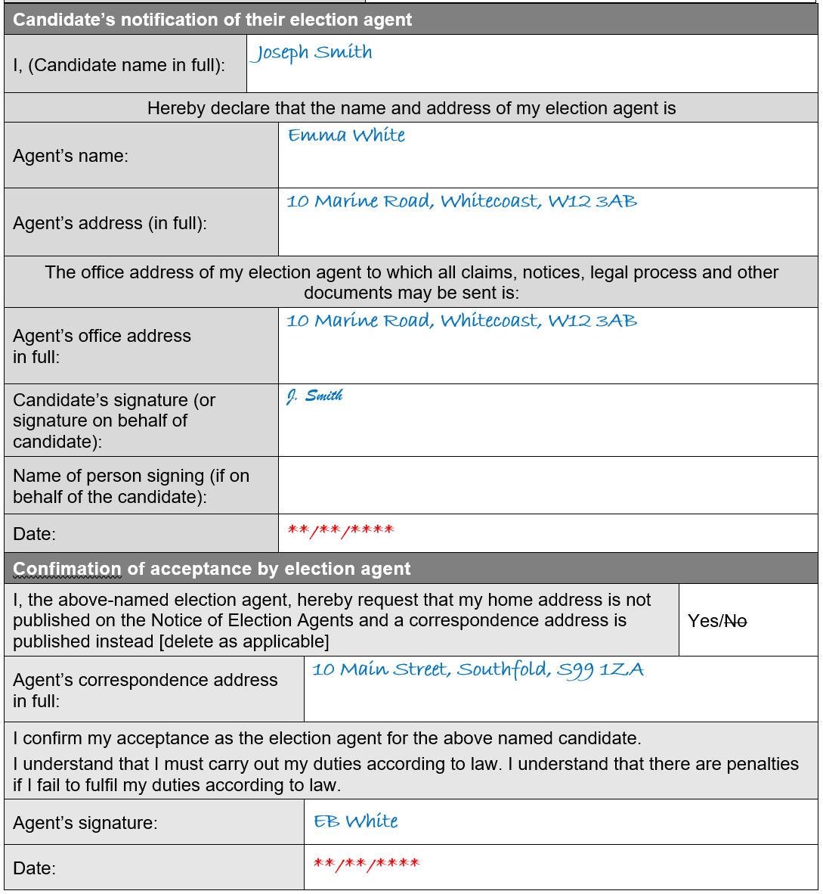
Optional – if you do not appoint an agent you will become your own agent by default.

Must be a physical address. There are no restrictions on where the office must be located.
An Election Agent can provide a correspondence address, which will be used on public notices instead of their home address.

Where you sign or someone else (other than the election agent) signs on your behalf, the election agent must sign the confirmation of acceptance.
If the election agent signs on your behalf, they do not need to also sign the acceptance.

Form 5 – notification of an election agent (cont.)
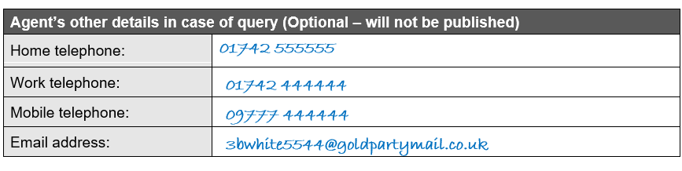
It is useful to provide this information in case of query or follow up contact.
Form 3 – notification of a sub-election agent (1)
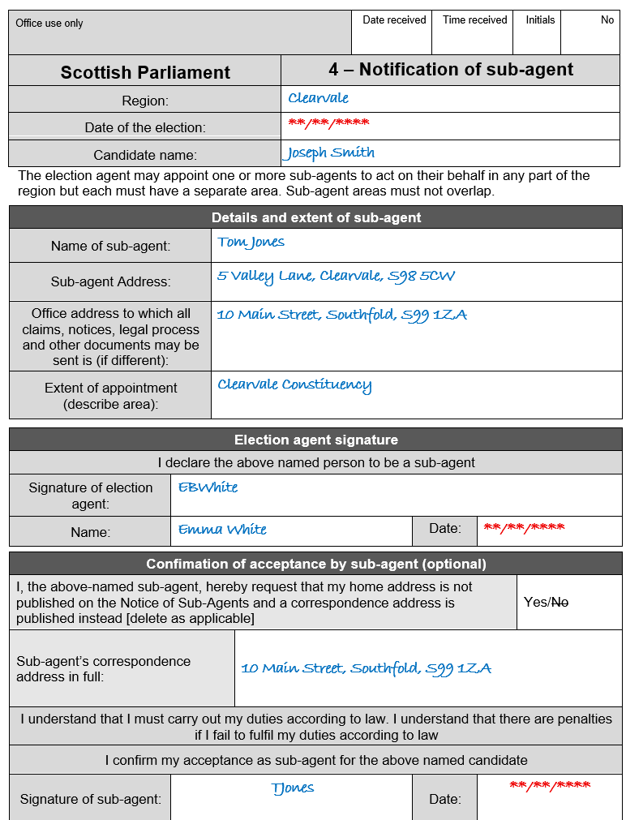
The sub-agent is not required to sign the form, but may do so.

A sub agent can provide a correspondence address, which will be used on public notices instead of their home address.

The election agent must sign the form.
Must be a physical address. There are no restrictions on where the office must be located.
Form 3 – notification of a sub-election agent (2)
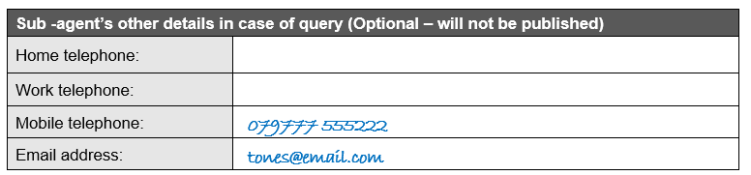
It is useful to provide this information in case of query or follow up contact.

Appendix A – Example of correctly completed nomination
