Annotated nomination papers – Scottish Parliament – regional party list
- Process and forms
  - There are three documents that you must submit to make your nomination valid:
- Nomination paper – one per party list
- a certificate of authorisation – one per party list
- An emblem request form (if they want an emblem on the ballot paper) – one per party list
- Consent to nomination – one for each candidate.

  - You must be deliver these forms by hand. They must be originals, not copies and anything received by email/fax will not be valid.
  - However, if you are abroad and the Regional Returning Officer (RRO) is satisfied it is not practicable for you to submit your consent to nomination in writing and deliver it by hand, you may be permitted to provide it by fax or email, and will not require a witness to sign the form.
  - You must also pay a deposit of £500. The RRO will have provided instructions about how this could be paid, for example in cash or by banker’s draft. This must be deposited with the RRO by 16:00, 23 working days before the poll (1 April 2026). Parties that poll more than 5% of the total valid votes cast in the region will have their deposit returned. Parties who poll less than, or equal to 5% of the total valid votes cast will lose their deposit.
  - You may also submit an election agent appointment form, which does not necessarily need to be submitted at the same time as the other nomination forms. However, it does have the same deadline.
  - Where you do not appoint an election agent, the candidate who appears first on the candidate list will be deemed to be the election agent.
  - If you have any issues with completing your nomination forms, please contact the RRO at the Election Team, City of Edinburgh Council, elections@edinburgh.gov.uk or chris.highcock@edinburgh.gov.uk 0131 469 3126.
  - It is a good idea to have your nomination paperwork informally checked by the RRO before you formally submit them. This can allow you to make any corrections or complete new nomination forms if there are any mistakes.
  - Once your party list nomination has been formally submitted, no details can be amended. If you want to withdraw your whole party list, or one or more of the candidates, you can do so until 16:00, 23 working days before the poll.
  - If a candidate changes their mind and no longer want to stand for election, they can withdraw their candidacy until 16:00, 23 working days before the poll.
- Further information

Other useful guidance sources
Guidance for Candidates and Agents at Scottish Parliament elections
The Scottish Parliament (Elections etc.) Order 2015

3. Annotated forms
3.1 These annotated forms cover areas that commonly cause confusion or difficulty, which staff can refer to when checking that a nomination paper is completed properly. Notes have been added to draw attention to the areas where candidates may have questions or made errors, and to remind staff where they need to add details.

Form 1 – nomination paper (header)
This section should be completed by RRO staff when the form is formally submitted.

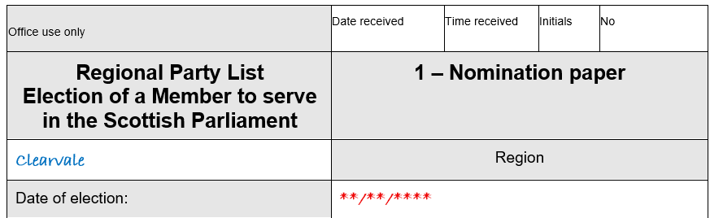

If it has not been pre-printed; the date of the election should be given.
The name of the Scottish Parliamentary region should be given here.

Form 1 – nomination paper (header)(cont.)
This must be the registered name of the political party. If the party name is not preceded by the word “Scottish”, this can be added. If the party name begins with “The” then “Scottish” can be inserted after it.
This should match exactly the name given in Form 3.

This must be the name of the political party, as registered with the Electoral Commission.

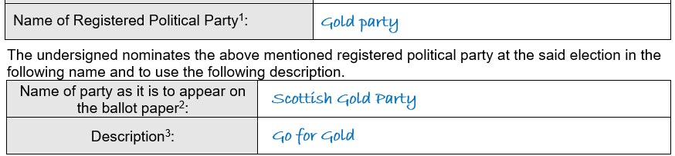
You must enter the registered party name and/or description as authorised by the party. This must be as registered with the Electoral Commission and must match EXACTLY with the description authorised in Form 3 – the certificate of authorisation.
Registered party names and descriptions can be found on the Electoral Commission website: http://search.electoralcommission.org.uk/
The party name can be preceded by the word “Scottish” if it is not already part of the name. If the party name begins with “The”, then “Scottish” can be inserted after that word.
It is important to read the EC Guidance if a description is used.

You may add a description to your party name, that will appear on the ballot paper and notices. This must be a description registered with the Electoral Commission.

Form 1 – nomination paper (candidate’s details)
You can field up to twelve candidates per region.
Full names must be added here – no initials.
Prefixes (e.g., Sir) or suffixes (e.g., Snr) must not be used.

Candidates’ full names and commonly used names (where used) must match EXACTLY with those listed on Form 2 for each candidate.

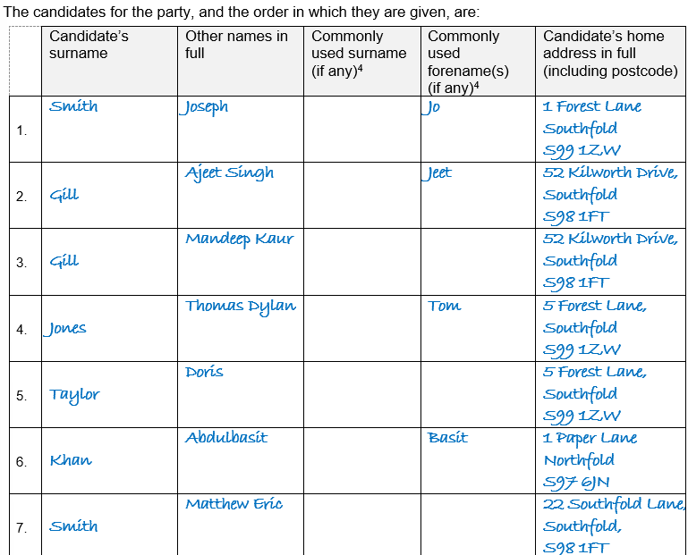
This is optional. If the candidate is commonly known by a different name to their actual name, this/these should be entered here.
The commonly used name will then appear on the ballot paper, the Statement of parties and persons nominated and the notice of election agent instead of the actual name.
Usually, you will take the commonly used name at face value, but it may be rejected if it is obscene or offensive, or its use could mislead or confuse electors. It is important to read the EC guidance if a commonly used name is used.

Form 1 – nomination paper (candidate’s details) (cont.)
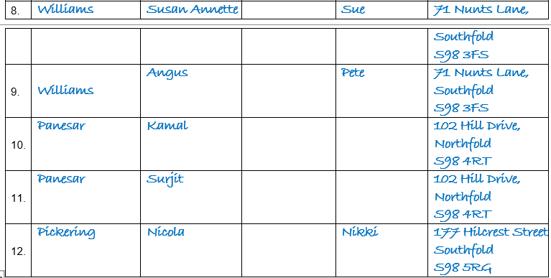
The home address of each candidate must be given here:
- in full and without any abbreviations
- it must be their current home address
- it must not be a business address (unless they run a business from their home).

For further information see the EC guidance.

Form 1 – nomination paper (authorisation)
You must sign the nomination paper. If you are not the registered Nominating Officer, you must have been authorised to do so.

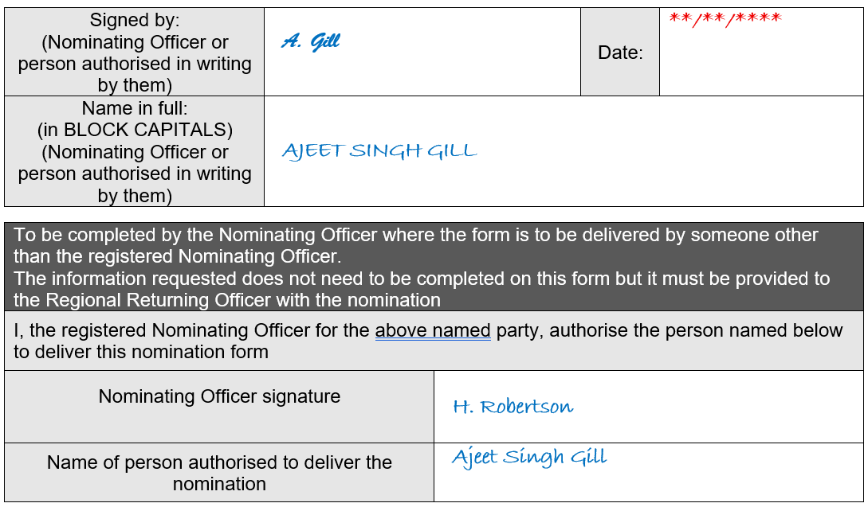
If you are not the nominating officer, the Nominating Officer may sign here to indicate you are authorised to submit the nomination.
The authorisation may be provided separately, but it must be provided to the RRO when the nomination is delivered.

Form 2 – candidates consent to nomination (header)
Each candidate must complete Form 2. The forms must be submitted at the same time as the nomination paper for the party list.

This section should be completed by RRO staff when the form is formally submitted.

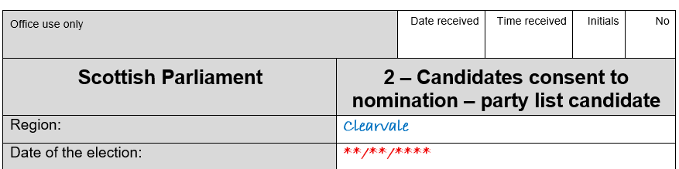
If it has not been pre-printed; the date of the election should be given.
The name of the Scottish Parliamentary region should be given here.
Check the name of the region is correct.

Form 2 – candidates consent to nomination (Section 1)
This should be your full name (rather than commonly used name) as given in Form 1.

If you become the election agent by default for example where no appointment is made, this address will be used as the office address on the Notice of Election Agents.
Every candidate must provide an address for this purpose.

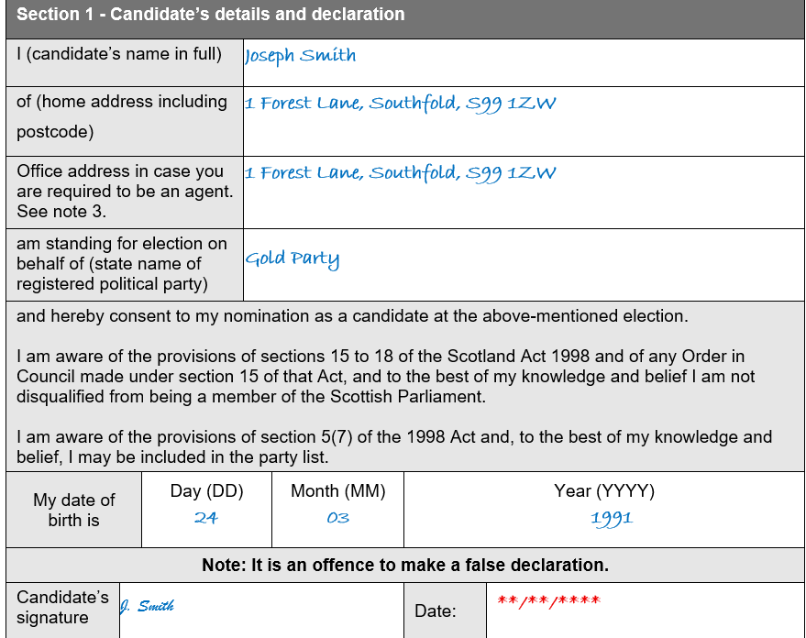

You must be 18 or over on the date of submitting the nomination paper.
You must sign here, and the date should not be earlier than one month before the deadline for nominations.

Form 2 – candidates consent to nomination (Section 2)
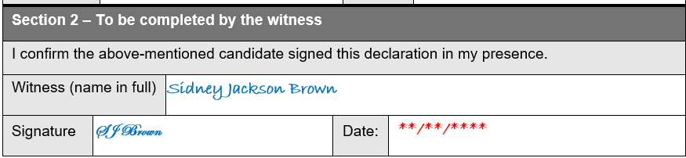
There are no restrictions on who can be a witness.

Form 3 – certificate of authorisation
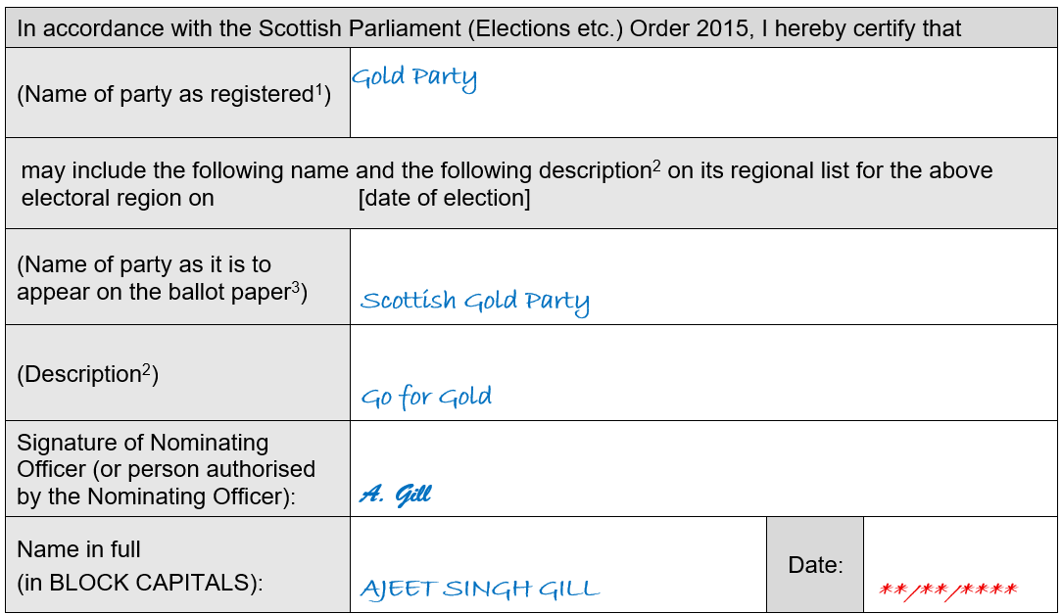
This must be the registered name of the political party. If the party name is not preceded by the word “Scottish”, this can be added. If the party name begins with “The” then “Scottish” can be inserted after it.
This should match exactly the name given in Form 1.

You must sign the certificate of authorisation. If you are not the registered Nominating Officer, you must have been authorised to do so.

The party may add a description to their party name, that will appear on the ballot paper and notices.
You must enter the registered party name and/or description as authorised by the party. This must be as registered with the Electoral Commission and must match EXACTLY with the description authorised in Form 1 – the nomination paper.
Registered party names and descriptions can be found on the Electoral Commission website: http://search.electoralcommission.org.uk/
The party name can be preceded by the word “Scottish” if it is not already part of the name. If the party name begins with “The”, then Scottish can be inserted after that word.
It is important to read the EC Guidance if a description is used.

This must be the name of the political party, as registered with the Electoral Commission.

Form 4 – request for a party emblem
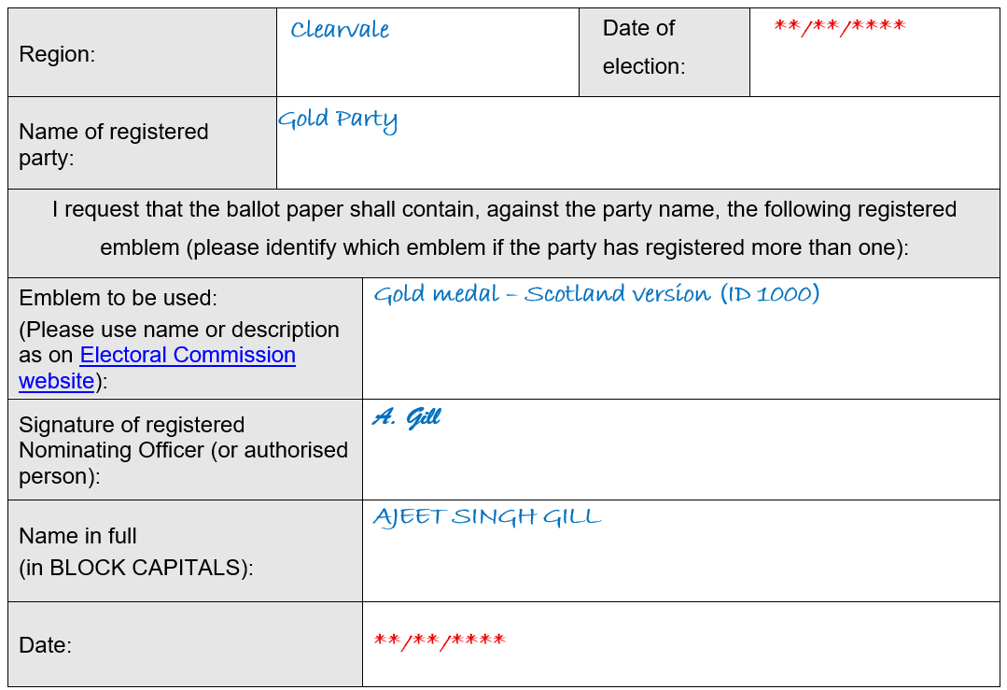
Emblems can be found on the Electoral Commission website by searching the registration details for the party and clicking for more details to view the emblems.

This should be the name as registered with the EC e.g., “Emblem for use in Scotland” or “Emblem ID 1000”.

Must be signed. If you are not the registered Nominating Officer, you must have been authorised to do so.

Form 5 – notification of election agent
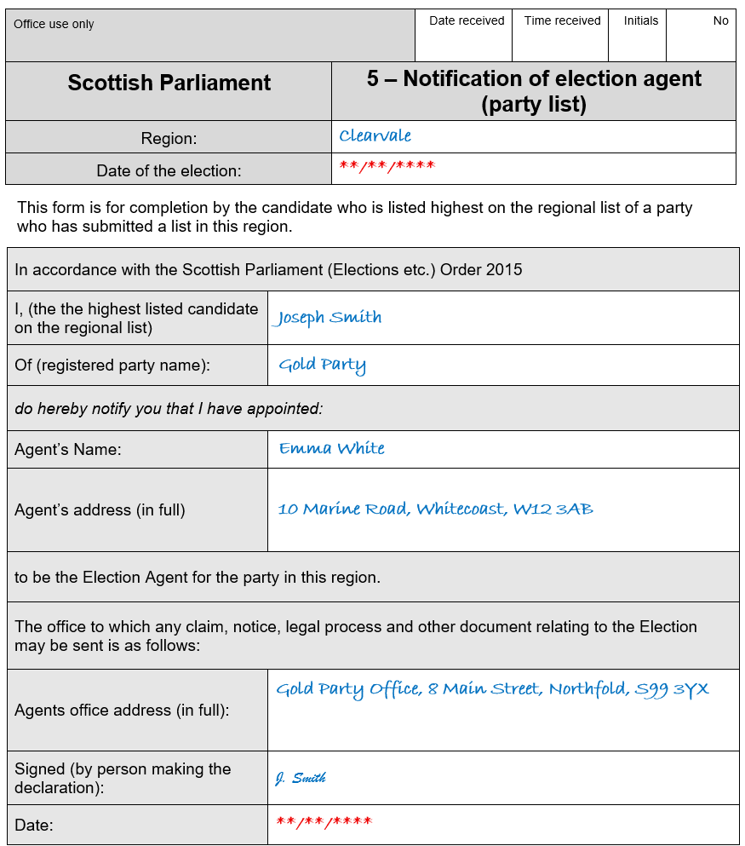
Optional – if you do not appoint an election agent, the candidate whose name appears first on the candidate list will be the agent on behalf of the party.
.

This must be the name of the political party, as registered with the Electoral Commission.

The form must be signed by the candidate whose names appears first on the candidate list.
Must be a physical address. There are no restrictions on where the office must be located.

Form 5 – notification of an election agent (cont.)
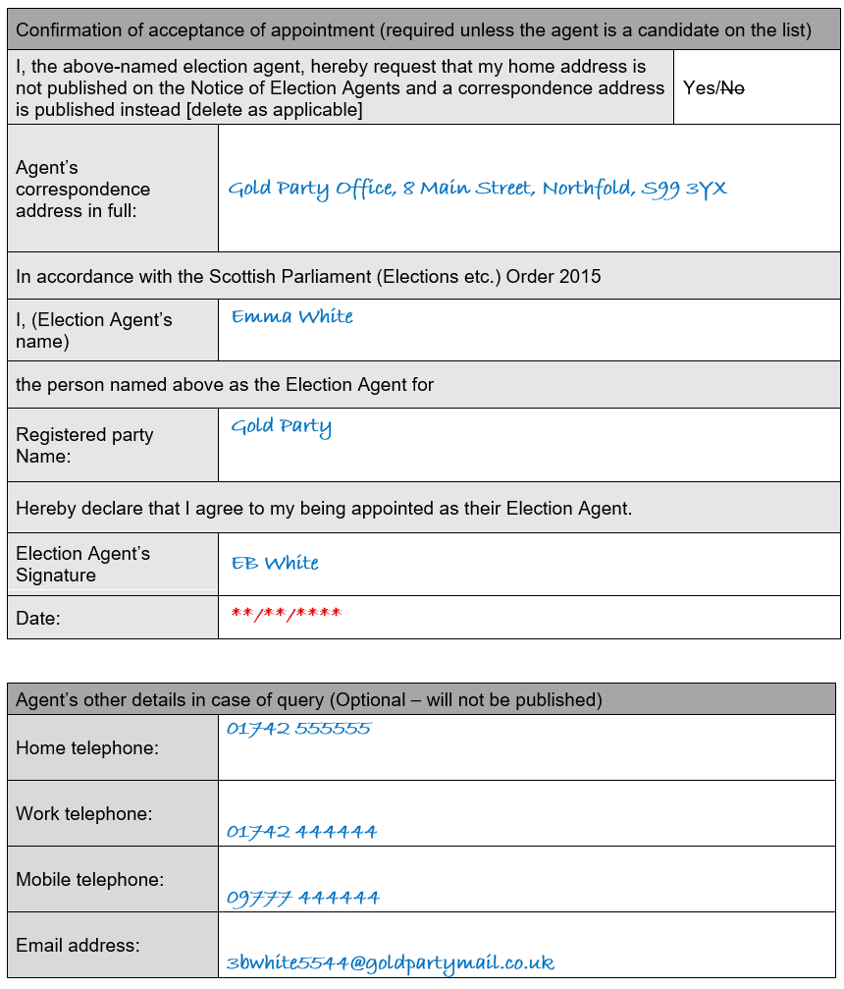
An election agent can provide a correspondence address, which will be used on public notices instead of their home address.
It is useful to provide this information in case of query or follow up contact.

The election agent must also sign the form.
Form 3 – notification of a sub-election agent
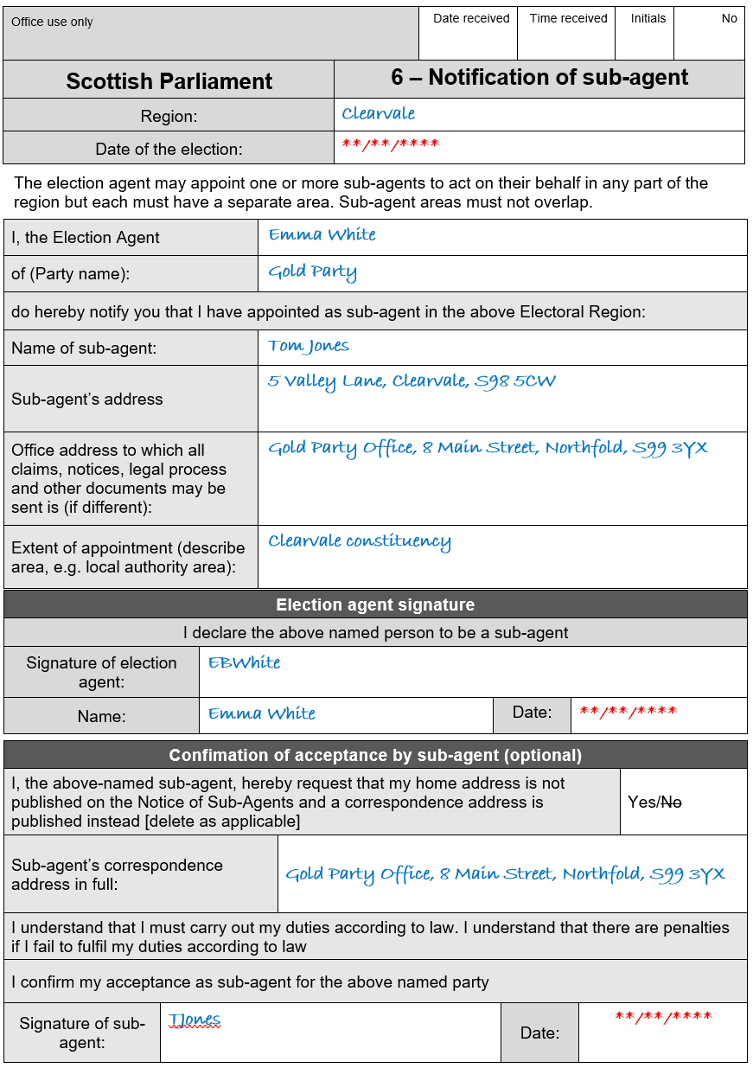
The election agent must sign the form.
The sub-agent is not required to sign the form, but may do so.

A sub agent can provide a correspondence address, which will be used on public notices instead of their home address.

Must be a physical address. There are no restrictions on where the office must be located.

Form 3 – notification of a sub-election agent (cont.)

It is useful to provide this information in case of query or follow up contact.

Appendix A – Example of correctly completed nomination
