Dealing with doubtful ballot papers
Supporting the Scottish Parliament elections

Contents
1 | Introduction
2 | Principles of adjudication
 | Want of official mark
 | Ballot papers with more than one mark
 | Writing or mark by which the voter can be identified
 | Unmarked ballot papers
 | Void for uncertainty
3 | Summary
4 | Examples
Case law references
Allowed votes
 | Rejected votes
Annex | Legislation
 | Decisions of the CRO
 | The election rules

- Introduction
  - This booklet is designed to assist Constituency Returning Officer (CROs) in adjudicating doubtful ballot papers at the Scottish Parliament elections.
This booklet should also be read in conjunction with our general guidance on managing the verification and count which can be found on our website.
  - The CRO may delegate the final decision on adjudication to one or more deputies, but this should be done explicitly in writing.
  - Because the CRO discharges a statutory function in adjudicating doubtful votes, the CRO or authorised Deputy CRO, and not any other staff employed by the CRO at the count, should carry out this function.
  - One of the aims of this booklet is to help to ensure consistency of approach across the whole of Scotland.
  - The booklet is based on existing doubtful ballot paper guidance for other elections, which has been developed in consultation with representatives from across the electoral community, including members of the Elections, Referendums and Registration Working Group on which the Electoral Management Board for Scotland is represented. The Electoral Commission is grateful for their assistance throughout this process.
  - When undertaking the adjudication of ballot papers it is important to ensure that the process is carried out in full view of all candidates and agents present at the count, as well as in the presence of any Commission representatives and accredited observers in attendance.
Managing the adjudication at Scottish Parliament elections
  - CROs should not wait until towards the end of the count before starting the adjudication process; this should be carried out regularly throughout the count in clear view of those entitled to be present.
  - Those ballot papers that have been rejected should be stamped with the word ‘rejected’ and placed in the appropriate package. All other ballot papers must be counted.
  - A statement must be prepared showing the number of ballot papers rejected under each of the following headings:
- want of official mark
- in the case of a constituency ballot paper: votes given for more than one candidate
- in the case of a regional ballot paper: votes given for more than one registered party or individual regional candidate, or for a registered party and an individual regional candidate
- writing or mark by which the voter can be identified (except the unique identifying number on the back)
- unmarked or void for uncertainty
- Principles of adjudication

  - Any doubtful ballot papers should be placed in a tray for the supervisor to take to the CRO for adjudication. The whole of the ballot paper needs to be considered when adjudicating doubtful votes in case the voter has made any marks outside of the voting boxes.
  - The CRO may only reject a ballot paper on the following grounds:
- it does not contain an official mark (not the unique identifying number)
- those that have more than one mark
- it contains a mark or writing by which the voter can be identified (except the printed ballot paper number or other unique identifying number)
- that is unmarked or void for uncertainty

  - A ballot paper must not be rejected because the vote is:
- not marked in the proper place
- marked other than by a cross
- marked by more than one mark,

  - A paper on which each of the candidates, or parties on the regional ballot paper, is marked 1, 2, 3, 4 etc instead of with a cross must not be rejected, provided the voter’s intention is otherwise clear and the voter cannot be identified. In these cases, the ballot shall be treated as a vote for the candidate (or in the case of a regional ballot paper, for the individual candidate or registered party) against whom the number “1” appears.
  - The following ballot papers will need to be passed to the CRO for adjudication:
- those that appear to have no official mark (not the unique identifying number)
- those appearing to contain more than one vote
- those with any writing or mark by which the voter may be identified
- those where there is no mark or uncertainty as to the vote

  - In addition, in order to help maintain the integrity of the election, the following ballot papers should be passed to the CRO for further consideration:
- any paper torn or damaged in any way
- any paper with anything unusual about it (for example, any paper that appears to have been altered, either with a clearly different writing instrument or with correction fluid).

  - In the case of ballot papers that appear to have been altered, CROs may consider packaging them separately in case of later challenge of investigation.
Want of official mark
  - Absence of the official mark must lead to an automatic rejection. The CRO has no discretion.
  - However, where instead of a pre-printed official mark a stamping instrument has been used, a partial piercing or embossing of the ballot paper should not in itself result in a rejection. As long as it is clear that the ballot paper has been stamped by polling station staff or postal vote issuing staff, the fact that not all the pins have stamped through the ballot paper or that the perforation is not wholly on the paper is immaterial.
Ballot papers with more than one mark
  - This is a matter for the CRO’s judgement.
  - Additional marks must not lead to a rejection if it is clear that those marks were not intended as a vote.
Writing or mark by which voter can be identified
  - There are two aspects to this:
- either any writing or mark on the ballot paper which, of itself, identifies the voter, or
- the voter can be identified by such writing or mark

  - It is important to bear in mind that the legislation states that the voter can be, not may be or might possibly be, identified (which does not include the ballot paper number and unique identifying mark on the back of the ballot paper).
Writing or mark which, of itself, identifies the voter
  - A ballot paper must be rejected if:
- the electoral number of the voter written on the ballot paper unequivocally identifies the voter
- it may reasonably be held to bear the name (or signature) or unique address of the voter on its front.

The voter can be indirectly identified by any writing or mark on the ballot paper
  - The CRO is not required to investigate the matter or require evidence to be produced to identify the writing or mark, but the CRO should consider any evidence that is given to them at the time.
  - Where there is doubt about the identity of the person who marked the ballot paper, CROs should allow rather than reject the ballot paper.
Unmarked ballot papers
  - Unmarked ballot papers must be rejected.
  - A ballot paper marked by means other than a pencil should not be rejected simply because of that.
  - Marks other than a cross, however faint, may still be valid.
Decisions of the CRO
  - The decision of the CRO is final, subject only to review on election petition.
Void for uncertainty
  - Establishing voter intention is crucial when determining doubtful ballot papers.
  - The key phrase in the Rules is: ‘A ballot paper […] shall not […] be deemed to be void if an intention that the vote shall be for one of the candidates (or in the case of a regional ballot paper, for one of the individual candidates or registered parties) clearly appears[…]’
  - Each ballot paper should be considered on its own merits and decisions should be taken on a case-by-case basis.
  - The key question a CRO should ask is whether the voter has, on the face of the paper, indicated a reasonably clear intention to vote for a candidate or party.

- Summary

  - The principles to be applied are set out above. In practical terms, the general approach can be summarised as follows:
- always be clear and consistent
- take time to ensure that a considered decision is given in every case
- determine whether the intention of the voter clearly appears on the ballot paper. As part of this, CROs will need to:
- consider the whole of the ballot paper
- consider whether the way a ballot paper has been marked means that at a constituency contest, a vote for one candidate is clearly apparent and, at a regional contest, a vote for one party or individual regional candidate is clearly apparent
- Examples

  - The examples provided here are based on previous case law or taken from the specific rules for the elections. Ultimately, the decision on any particular ballot paper, including the question as to whether an intention to vote for a particular candidate or party clearly appears, rests with the CRO.
  - To avoid repetition, the examples provided in this booklet are of the constituency ballot paper only. However, the same principles apply to regional ballot papers and the examples should be read across to any regional doubtful ballot papers you may need to adjudicate.
Case law references
  - Abbreviated case law references have been used throughout this booklet. The following table lists the full case law references.
Abbreviation Full reference
Berwick-upon-Tweed case Berwick-upon-Tweed case [1880] 3O'M&H 178
Buckrose case Buckrose case, Sykes v. McArthur[1886] 5 O'M&H 110
Cirencester case Lawson v. Chester Master [1893]
Cornwell v Marshall Cornwell v. Marshall [1977] 75 LGR 676 DC
Eley v Durant Eley v. Durant [1900] 4SJ 430
Levers v Morris Levers v. Morris [1971] 3 All ER QBD
Rowe v Cox Rowe v. Cox [2001] QBD, Case M/294/01
Ruffle v Rogers Ruffle v. Rogers [1982] QB 1220
South Newington case South Newington case, Lewis v. Shepperdson [1948] 2 All ER 503
West Bromwich case West Bromwich case, Hazel v. Viscount Lewisham [1911] 6 O'M&H 256
Woodward v Sarsons Woodward v. Sarsons [1875] LR10 CP 733

Allowed votes
The following are suggested examples of allowed votes:

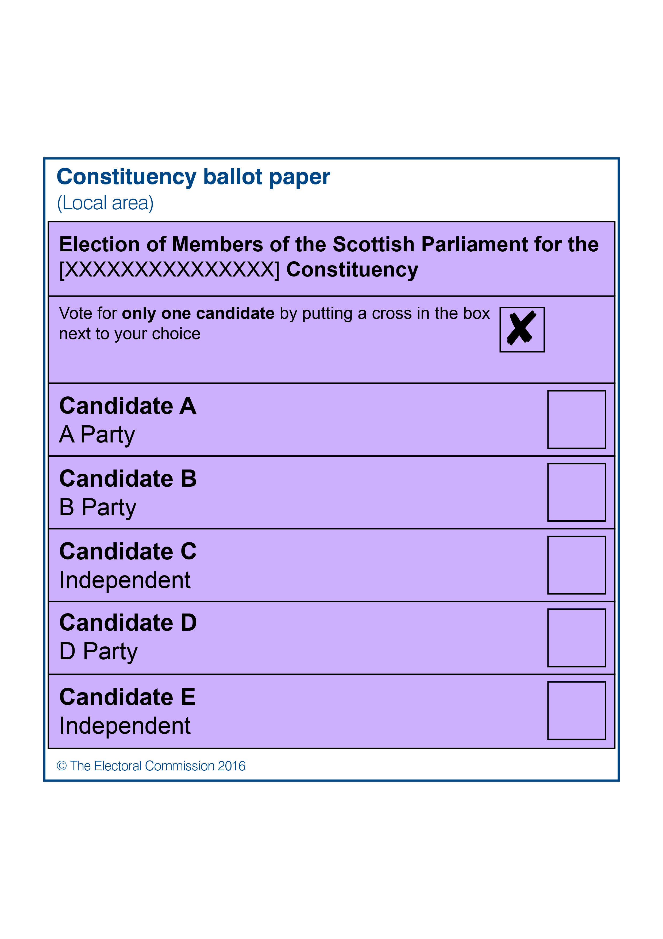
Allow for candidate C - vote marked elsewhere than in the proper place. Berwick-upon-Tweed case and Rule 58(2)(a).

Allow for candidate A - vote marked otherwise by means of a cross. Rule 58(2)(b).

Allow for candidate D – vote marked by more than one mark. Rule 58(2)(c).

Allow for candidate E – vote marked elsewhere than in the proper place. Rule 58(2)(a)

Allow for candidate E – vote marked otherwise than by means of a cross and vote marked elsewhere than in the proper place. Rule 58(2)(a) and (b).

Allow for candidate A – vote marked elsewhere than in the proper place and vote marked otherwise by means of a cross. Rule 58(2)(a) and (b).
Allow for candidate E – vote marked by more than one mark. Cirencester case, Eley v Durant and Rule 58(2)(c).

Allow for Candidate B – vote marked by more than one mark. Levers v. Morris and Rule 58(2)(c). See also Schofield’s Election Law, Volume 5, Appendix E, E20, (Shaw & Sons, 2008 as updated by supplement issue no.1).

Vote
A
Allow for candidate A - vote marked otherwise by means of a cross. Ruffle v Rogers and Rule 58 (2)(b) [provided there is no other candidate by the name of A].

Candidate A!
Allow for Candidate A - vote marked otherwise by means of a cross. Ruffle v Rogers and Rule 58(2)(b) [provided there is no other candidate by the name of A]

Allow for candidate C – vote marked other than by means of a cross. Rule 58 (2)(b).

Allow for candidate C - vote marked indicating a sequential order of preference, Rule 58 (3).

five
four
three
two
one

Allow for candidate B – vote marked other than by means of a cross vote and marked by more than one mark. Rule 58 (2)(b)and (c).

Allow for candidate B – vote marked elsewhere than in the proper place. Rule 58(2)(a).

Allow for candidate C –– vote marked other than by means of a cross vote. Rule 58(2)(b).

Allow for candidate A – vote marked elsewhere than in the proper place and otherwise than by means of a cross. Levers v Morris and Rule 58 (2)(a) and (b). See also Schofield’s Election Law, Volume 5, Appendix E, E20 (Shaw & Sons, 2008 as updated by supplement issue no.1)
Rejected votes
The following are suggested examples of rejected votes:

Reject – voted for more than one candidate. Rule 58(1)(b).

Reject – voter’s intention uncertain. Buckrose case and Rule 58(1)(e).

F. Brown
77 Poppy Drive

Reject – voter can be identified. Woodward v Sarsons, South
Newington case and Rule 58(1)(d).

Reject – voted for more than one candidate. Rule 58(1)(b).

Reject – Voting for more than one candidate. Rule 58(1)(b).
Reject – voter’s intention uncertain. Rule 58(1)(e).
None of
the above

Reject – voter’s intention uncertain. Rule 58(1)(e).

Reject – ballot paper unmarked. Rule 58(1)(e).

Annex - Legislation
Decisions of the CRO
The relevant rules on adjudicating doubtful ballot papers are contained in Schedule 2 of The Scottish Parliament (Elections etc) Order 2015 and are as follows:
Rejected ballot papers
58 (1) Any ballot paper—

(a) which does not bear the official mark and the unique identifying number;
(b) in the case of a constituency ballot paper, on which votes are given for more than one
candidate;
(c) in the case of a regional ballot paper, on which votes are given for more than one registered party or individual candidate, or for a registered party and an individual candidate;
(d) on which anything is written or marked by which the voter can be identified except the
printed number and other unique identifying mark on the back; or
(e) which is unmarked or void for uncertainty,

shall, subject to the provisions of paragraphs (2) and (3), be void and not counted.

(2) A ballot paper on which the vote is marked—

(a) elsewhere than in the proper place;
(b) otherwise than by means of a cross; or
(c) by more than one mark,

shall not for such reason be deemed to be void if an intention that the vote shall be for one of the candidates (or in the case of a regional ballot paper, for one of the individual candidates or registered parties) clearly appears, and the way the paper is marked does not of itself identify the voter and it is not shown that the voter can be identified by it.

(3) Where different numbers have been written by a voter on a ballot paper apparently as a vote in a sequential order of preference, and the ballot would otherwise be rejected under this rule, the ballot shall be treated as a vote for the candidate (or in the case of a regional ballot paper, for the individual candidate or registered party) against whom the number 1 appears.

(4) The CRO shall record, by marking the ballot paper, the rejection of any ballot paper which under this rule is not to be counted, and shall also record any objection that is made by a counting agent to the decision to reject the ballot paper.

(5) The CRO shall draw up a statement showing the number of constituency ballot papers and the number of regional ballot papers, respectively, rejected under each of sub-paragraphs (a) to (e) of paragraph (1).

Decisions on ballot papers
59 The decision of the CRO on any question arising in respect of a ballot paper shall be final, but shall be subject to review on an election petition.

Rule 58(4), Scottish Parliament (Elections etc.) Order 2015.
Rule 58(5), Scottish Parliament (Elections etc.) Order 2015.
Rule 58(2), Scottish Parliament (Elections etc.) Order 2015.
Rule 58(3), Scottish Parliament (Elections etc.) Order 2015.
Cirencester case, Lawson v. Chester-Master (1893) 4 O’M & H 194 and Newington case, Lewis v. Shepperdson (1948) 2 All ER 503.
Woodward v Sarsons (1875), LR 10, CP74 and Cirencester case (1893)
Rule 58(2), Scottish Parliament (Elections etc.) Order 2015.

