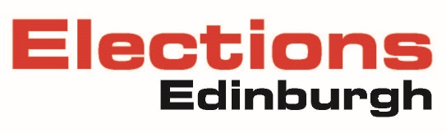

On-street advertising structures

Citywide ban on 'A' boards and other temporary adverts
On 17 May 2018, the Transport and Environment Committee approved a citywide ban on all temporary on-street advertising structures, such as advertising boards, also known as 'A' boards. This is primarily to improve pedestrian safety and accessibility.
The ban came into force on Monday 5 November 2018.

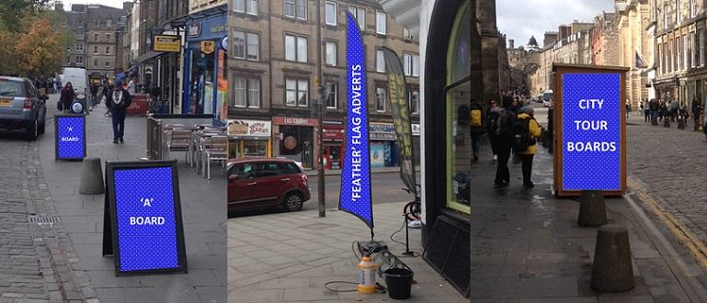
Examples of some of the types of temporary on-street advertising that are included under the ban.

Exemptions
Summer Fringe Festival
The Festival is an exceptional period in the city’s events calendar, where the city is temporarily transformed to support the huge variety of activities and events taking place. An exemption to the ban is in place during this period specifically for official Council-approved event-related signage to be displayed. This helps the Council to limit unauthorised flyposting across the city. Throughout the Festival season the Council works closely with event organisers to make sure event advertising structures meet with public safety requirements.
Elections
There is a special dispensation for the use of A-Boards associated with elections on polling days. The terms of use are:
- Use only during the hours of polling – 7am-10pm;
- Sited off the pavement whenever possible;
- Sited so as to avoid any obstruction to pedestrians; and
- Sited so as to avoid any obstruction to access to the polling place.

Public Information Sharing
From time to time, the Council and its partners need to share information about matters of wide public interest or to provide important public safety messages. In certain circumstances, information either attached to lampposts or via footpath stencils are the most effective way to share these messages.
Reporting a breach If you would like to report a breach please email aboards@edinburgh.gov.uk.

