
Lease for community use

Braidwood Centre

69 Dumbiedykes Road, Edinburgh EH8 9UT

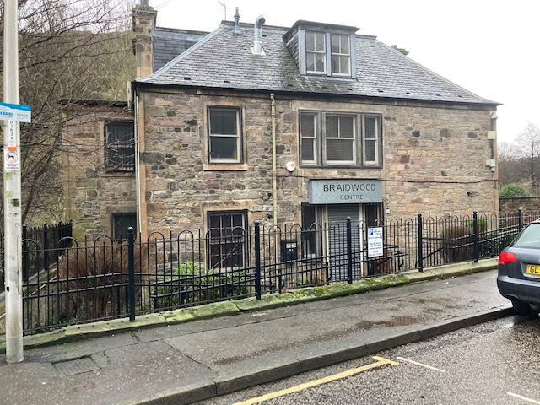

Location

Dumbiedykes is a central location within the city centre of Edinburgh, overlooking the iconic Arthur’s Seat.

The Braidwood Centre is situated within the predominantly residential area of Dumbiedykes where properties are a mix of Council rented and privately owned.
Just two minutes from the Scottish Parliament and the Royal Mile, with gorgeous views to Salisbury Crags and a courtyard with access that backs on to Holyrood Park, the Braidwood Centre’s location makes it ideal for the use by community organisations from the Southside/Royal Mile areas.

Centrally located, it is well served by public transport and bus stops close to the centre offer easy access to other parts of Edinburgh and beyond.

Description
The Braidwood Centre is a traditional stone building with a substantial area of outdoor space.
The property is over 3 floors- ground, 1st and 2nd with a small lift providing disabled access between the ground to 1st floor.

Current Position
The property has been temporarily occupied by a charity group while their own accommodation has been renovated. The group are due to return to their premises in late Spring 2026. Prior to this, the property was occupied and run by a management committee of local individuals to provide community facilities for the local community. It closed in December 2022 due to the dissolving of the existing management committee.

The Council is seeking a tenant who can ensure that the building is used for community use going forward which will include granting regular access to the local community to run activities and groups. It is anticipated that the tenant will look to run the building in the future with minimal financial and staff support from the Council. This includes the tenant being responsible for repairs and maintenance, statutory compliance, health and safety compliance, utility payments, insurance payments, cleaning and janitorial services.

Accommodation
The Gross Internal Area has been assessed as approximately 291.42 m² (3,137 ft²)

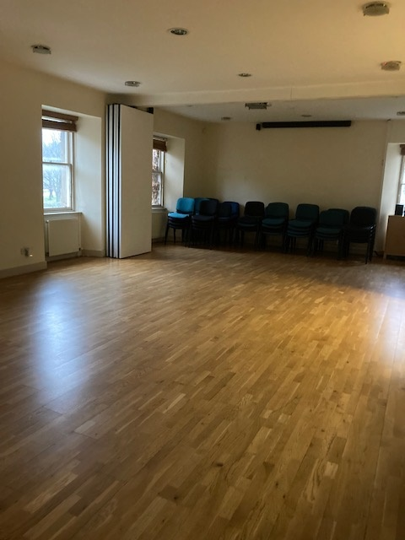

Ground
- Small office and secure reception.
- Single WC.
- Kitchen/canteen with fire exit and access to the rear garden.
- Small meeting room.
- Disabled WC.

First
- Large main hall with dividing room partition.
- Small kitchen off hall.
- Single WC.

Second
- Plant room.
- Office 1.
- Office 2.

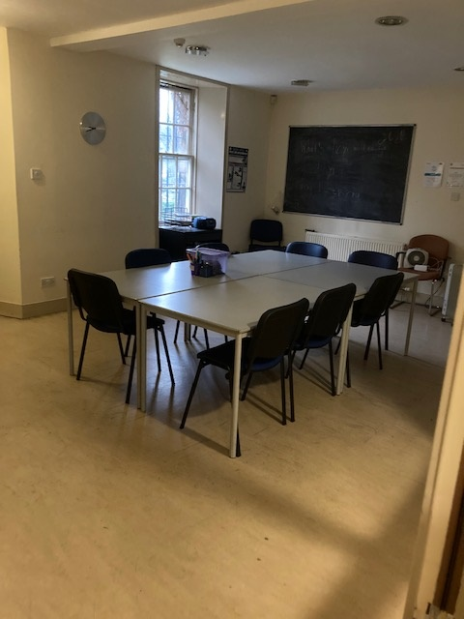

Garden Area
The Council is currently negotiating a new long lease from Historic Environment Scotland (HES) for the garden area to the rear of the building. Until that is completed, only a short term let of the garden area is possible. Please note that this garden is designated as a “scheduled monument” (due to its proximity to Holyrood Park) and there will be clear restrictions on what works, planting and general garden use can be carried out.

Rateable Value
The subjects have a current rateable value of £22,700 however this may change at the next revaluation which is due in April 2026.
Any new tenant would have six months to appeal the rateable value.
Discretionary relief may apply depending on the tenant’s status and the use to which the property will be put.
Further information on rateable value, rates charges and rates payable can be found at www.saa.gov.uk or 0131 344 2500

Planning
The property is not a listed building.
Interested parties should satisfy themselves as to any planning requirements for their proposed use by contacting the Planning Service at Waverley Court, 4 East Market Street, Edinburgh, EH8 8BG on 0131 529 3550 or planning@edinburgh.gov.uk

Condition
The building is in fair condition and currently does not require any major upgrading works.

Services
Mains gas, electricity, water and drainage are connected and all charges for such services will be the responsibility of the Tenant.

Viewing and Further Information
The property may be viewed by appointment only.
Please contact Amanda Fraser, Estates Surveyor on 07864955359, or at amanda.fraser@edinburgh.gov.uk

Expressions of Interest
Expressions of interest are invited for community use only. Please submit expressions of interest to:

Amanda Fraser
Estates Surveyor
City of Edinburgh Council
Level 1.5 Waverley Court
4 East Market St
Edinburgh EH8 8BG.
Or by email to:
amanda.fraser@edinburgh.gov.uk

By – Monday 9th February 2026
Once expressions of interest have been received – organisations, groups and interested parties will be asked to submit a project proposal.

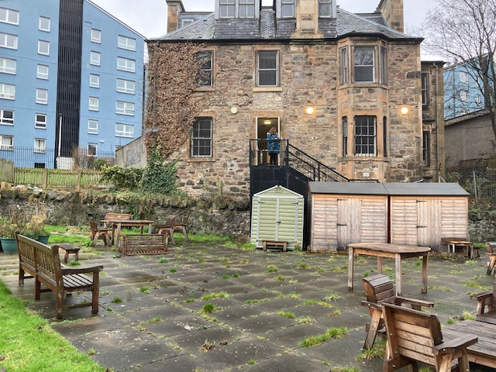

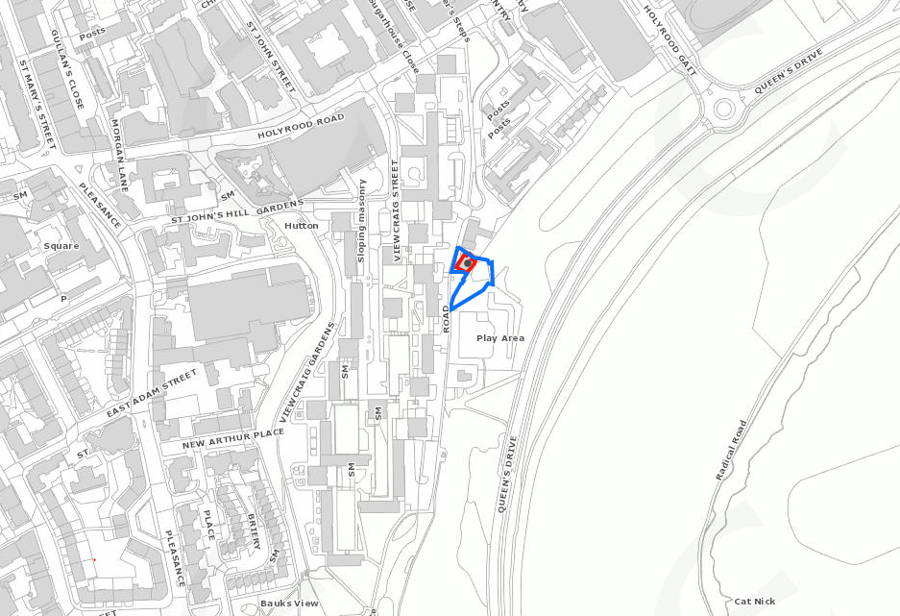
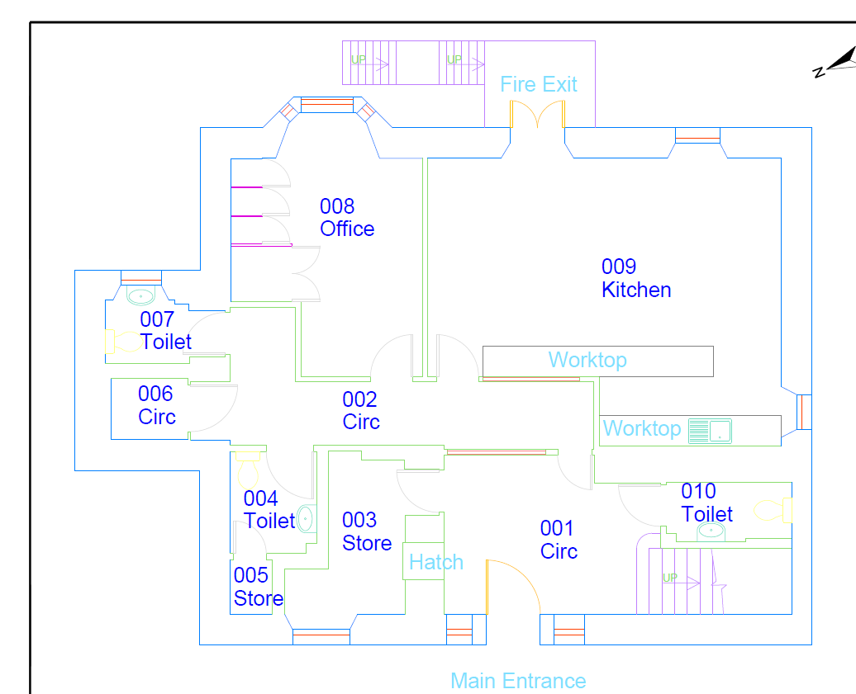


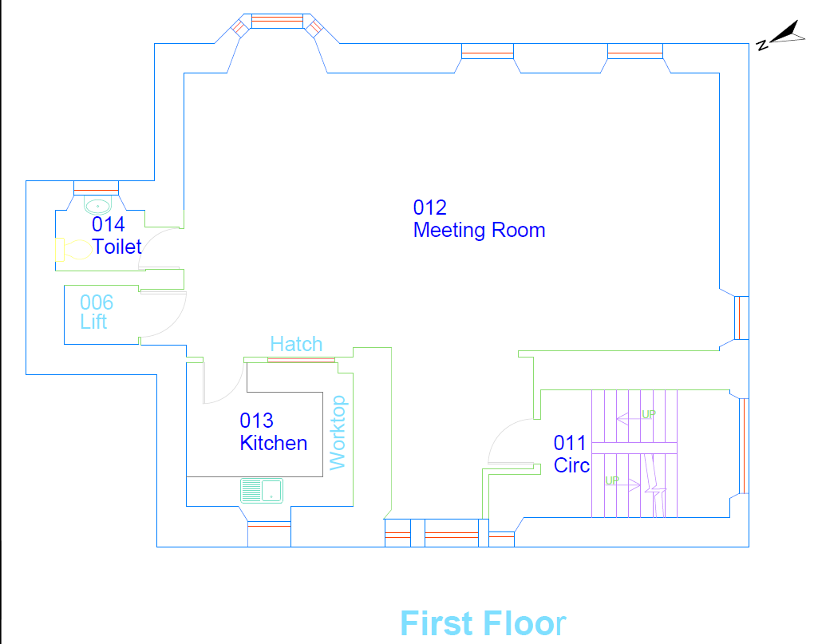

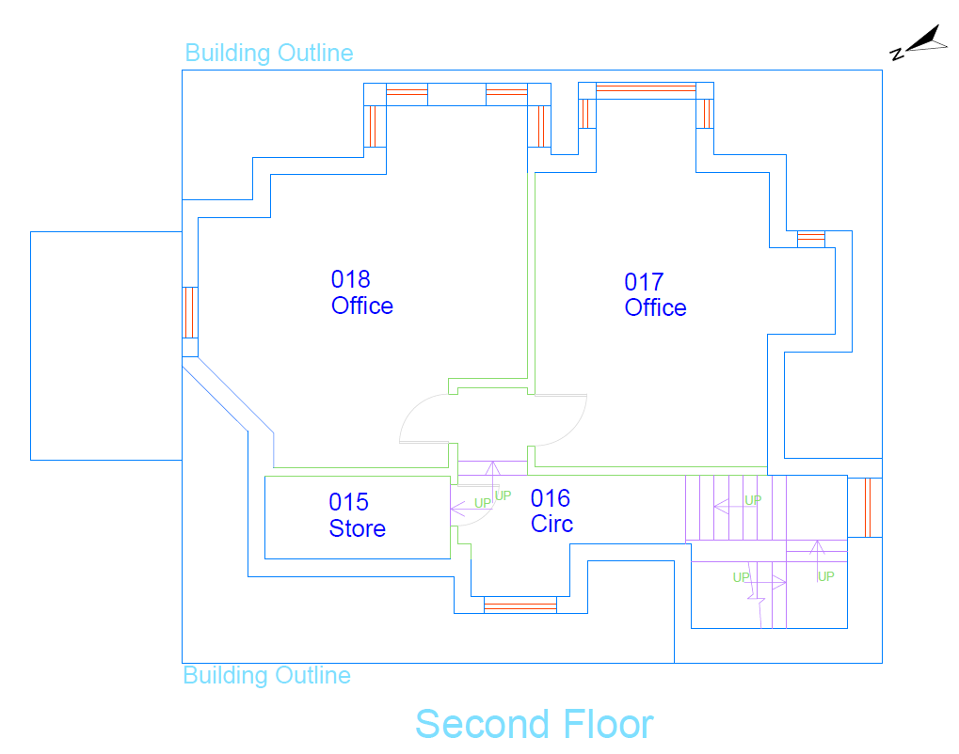

You can get this document on tape, in Braille, large print and various computer formats if you ask us. Please contact ITS on 0131 242 8181 and quote the property address. ITS can also give information on community language translations.

These particulars do not form part of any contract and none of the statements contained in them regarding the property is to be relied on as a statement or representation
of fact.
Any intending purchasers must satisfy themselves, by inspection or otherwise, as to the correctness of each of the statements contained in these particulars.
In accordance with the terms of the Requirements of Writing (Scotland) Act 1995, these particulars are neither intended to create nor to be relied upon as creating any
contractual relationship or commitment.
Any contract shall only be entered into by way of an exchange of missives between respective solicitors.

