
To Let

Ratho Park One

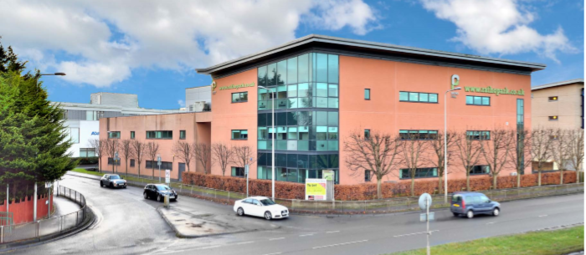
88 Glasgow Road, Newbridge, EH28 8PP

Location
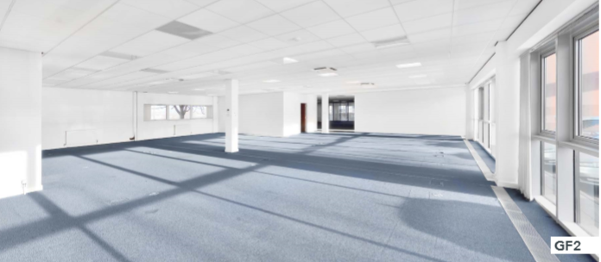
Ratho Park is an established business park, strategically situated on the west side of Edinburgh, approximately 1 mile from Edinburgh International Airport and less than half a mile from Newbridge Interchange. Ratho Park provides direct access to the national motorway network.

The building occupies a highly visable location situated on the A8 dual carriageway. This position provides excellent road access to the capital and towards Glasgow and the North. Ingliston Park and Ride is also within close poximity to the building and is served by 14 bus routes.
The building also provides excellent branding opportunities, with approximately 47,000 vechicles passing the building daily.
Ratho Park is close to the retail leisure facilities of the Gyle Shopping Centre and Edinburgh Park with convenience shopping available in the immediate vicinity.
Office occupiers within the park include; Robertson Group, Emtec, Laser Vision and Travelodge with café, bar and restaurant facilities is also located on site.
Description
Ratho Park One provides high quality, open plan office space which benefits from the following outline specification.
Full raised 150mm access floors, VDU compatible lighting throughout, Displacement ventilation system (comfort cooling can be retro-fitted), Male female and disabled WC’s, shower facilities, lift access, DDA compliant, car parking ratio of 1:450 sq ft, bike parking, on site Travelodge with café, bar and restaurant facilities, high quality existing fit-out. Example photos for information purposes only.

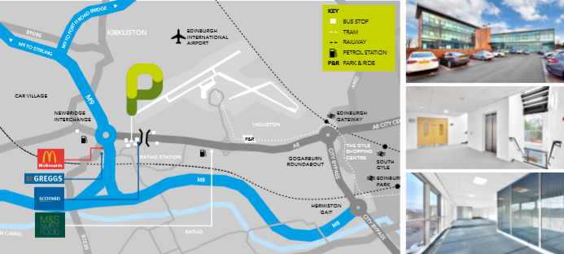

Accommodation
The NIA of the property extends to 353 sq m (3,795 sq ft).

Rateable Value
We have been verbally advised by Lothian Valuation Joint Board that the Ratable Value of the subject is £30,900 per annum. Further details can be obtained from the Assessor on (01310 3442500 or alternatively www.saa.gov.uk.

Planning
The premises will benefit from a Classes IV business use as defined in the Town and Country Planning (Use Class) (Scotland) Order 1997.

Applicants must satisfy themselves as to any planning requirements relating to their proposed use by contacting the Council’s Planning Section at Waverley Court, 4 East Market Street, Edinburgh, EH8 8BG. They can also be contacted by telephone on 0131 529 3550 or emailed at planning@edinburgh.gov.uk.

Terms
The office suite is available on flexible lease terms.

Rent
£35,000 per annum. Exclusive of Service Charge, Non Domestic Rates and Insurance.

Energy Performance Certificate
The building is rated as E+.

Viewing
Viewing appointments can be made by via email or telephone. Estates Surveyor Andrew McCurrach on andrew.mccurach@edinburgh.gov.uk
Legal Cost
Any ingoing tenant will be responsible for their own legal costs together




Details for submitting offers
- Notes of interest should be registered with the Council’s surveyor using the contact details above in order that interested parties may be advised of a closing date.
- When a closing date is set all offers must be received by 12 noon on the closing date. The Council will not accept late offers under any circumstances.
- Offers must be submitted using an Offer to Let Form (attached) and sent by email to commercial.property@edinburgh.gov.uk. The subject line of the email should state ‘Closing Date Offer – GF Ratho Park Phase 1 to ensure it is recorded as a formal offer. No emails will be read until the closing date has passed.
- An email acknowledgement will be issued on receipt of the offer. You are responsible for confirming the offer has been safely received, and we recommend doing so a minimum of 24 hours prior to the closing date
- Hand delivered offers and offers by post will not be accepted
- The Council does not bind itself to accept the highest or any offer.
- Prior to submitting an offer, you are strongly recommended to take appropriate professional advice.
- The successful bidder will require to provide sufficient proof of identity within a reasonable timeframe prior to entering into any legal agreement in order to comply with money laundering regulations.



You can get this document on tape, in Braille, large print and various computer formats if you ask us. Please contact ITS on 0131 242 8181 and quote the property address. ITS can also give information on community language translations.

These particulars do not form part of any contract and none of the statements contained in them regarding the property is to be relied on as a statement or representation of fact. Any intending purchasers must satisfy themselves, by inspection or otherwise, as to the correctness of each of the statements contained in these particulars. In accordance with the terms of the Requirements of Writing (Scotland) Act 1995, these particulars are neither intended to create nor to be relied upon as creating any contractual relationship or commitment. Any contract shall only be entered into by way of an exchange of missives between respective solicitors.

