Example: Community Council Annual Account
COMMUNITY COUNCIL ANNUAL ACCOUNTS

Name of Community Council | Example Community Council
Accounting period | Accounts for the period 1 April 2024 to 31 March 2025
Income and Expenditure Account

INCOME | 2025 | 2024
City of Edinburgh Council Administrative Allowance | £0.00 | £0.00
Gala day cake sales | £0.00 | £0.00
Village disco ticket sales | £0.00 | £0.00
Bank interest | £0.00 | £0.00
INCOME TOTALS | £0.00 | £0.00
EXPENDITURE | 2025 | 2024
Laptop purchase for Treasurer | £0.00 | £0.00
Meeting room hire | £0.00 | £0.00
Online meeting platform costs (MS Teams) | £0.00 | £0.00
Insurance for community council | £0.00 | £0.00
Information commissioner fee | £0.00 | £0.00
Production of community council newsletter | £0.00 | £0.00
Notice board repairs | £0.00 | £0.00
EACC membership fee | £0.00 | £0.00
EXPENDITURE TOTALS | £0.00 | £0.00
Surplus of income over expenditure | £0.00 | £0.00
Surplus brought forward | £0.00 | £0.00
Surplus carried forward | £0.00 | £0.00
Independent Examiner Full Name (in capitals) | JACKIE WHITE
Signature of Independent Examiner (in ink) | 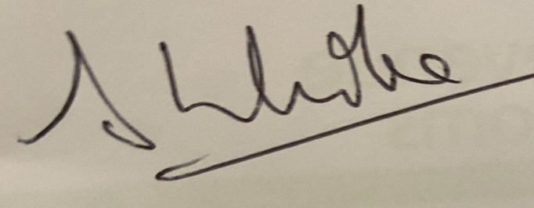
Date Independent Examiner Approved Accounts | 14 July 2025
Treasurer Full Name (in capitals) | BRYAN BROWN
Signature of Treasurer (in ink) | 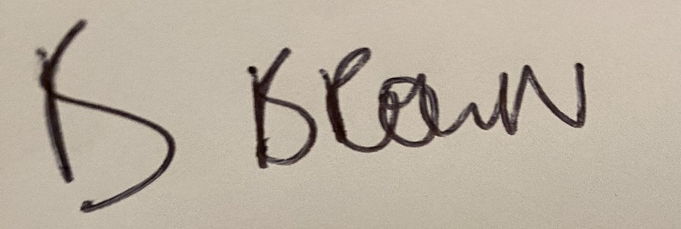
Date Treasurer Approved Accounts | 14 July 2025

